
Admin Manual
Part 1 Basic settings
Table of Contents
This manual is the first part of a two-part administrator's manual.
The introduction describes the prerequisites for the configuration of this system and how to sign in, and part 1 describes the basic settings.
Introduction 2
1. System configuration 1
2. Supported browsers 1
3. Login 2
4. Fiscal year start date settings 2
5. Admin screen configuration 3
Part 1 Basic settings 4
1. [Settings] overview 5
2. Configure organization settings 8
2.1. [Division settings] 8
2.1.1. Add a Division 8
2.1.2. Add divisions by importing data 10
2.2. [Time Recorder settings] 13
2.2.1. The 2 types of Time Recorder 13
2.2.2. Descriptions 15
2.2.3. Edit 16
2.2.4. Send Time Recorder URL 18
2.2.5. About Certificate 19
2.2.6. Add help 20
3. Add an Administrator 22
3.1. Admin settings 22
3.1.1. Add an administrator 22
3.1.2. Admin login info 26
3.1.3. Operations 26
3.1.4. Send Email 27
3.2. Request approval flow settings 29
3.2.1. Setting instructions 29
4. Add employee accounts 30
4.1. Employee type settings 30
4.1.1. Add an Employee type 30
4.2. Employee settings 39
4.2.1. Add [Employee] 39
4.2.2. Import Employee Data 43
4.2.3. Operations 46
4.2.4. Send Email 47
5. Prepare for Schedule management 50
5.1. Leave type settings 50
5.1.1. Setting instructions 50
5.1.2. Display settings 54
5.2. Paid leave feature settings 56
5.2.1. Function 56
5.2.2. Paid Leave-related Settings 60
5.2.3. To perfom paid leave feature settings 62
5.2.4. Registering the remaining number of annual paid leaves 62
5.3. Pattern settings 63
5.3.1. Create schedule patterns 64
5.3.2. Normal (regular) work day pattern 65
5.4. Holiday settings 68
5.4.1. To add Japanese national holidays 68
5.4.2. Add custom holidays manually 70
5.5. Auto schedule settings 71
5.5.1. Descriptions 71
5.5.2. Setting instructions 72
5.5.3. When auto schedule settings are reflected 72
6. Workstyle reform-related settings 73
6.1. Set the upper limit regulations of overtime 73
6.1.1. Set the [Contract limit] and [Alert] for overtime 74
6.1.2. Alert target/subject 77
6.1.3. To check which employees have reached the alert and maximum standards 77
6.2. Set up the Highly Professional Worker’s Program settings 81
6.2.1. To perform the Highly Professional Worker’s Program settings 82
6.2.2. To check which employees have reached the alert and maximum standards 88
6.3. To perform the 5 Days Mandatory Leave setting 90
6.3.1. Steps for 5 Days Mandatory Leave setting 90
6.3.2. Period and number of mandatory leaves 91
6.3.3. Cases in which the period and the number of mandatory leaves remain the same 91
6.3.4. Cases in which the period and the number of mandatory leaves vary 92
6.3.5. Check who is alerted 93
7. Use the Email notification feature 96
7.1. Missing time record notification 96
7.2. Unsubmitted overtime notification 99
7.3. Alert notification 100
7.4. Leave Expiration Notification 101
7.5. [Attendance data error notification] 102
7.6. Attendance Closing Notification 103
7.7. 5 Days Mandatory Leave Notification 104
8. Alert Setting 105
8.1. Alert Setting 105
8.2. Complex condition alert 107
9. Start operating 110
9.1. Configure Time Recorder settings 110
9.2. Log into Employee screen 110

Introduction

The Introduction describes system configurations and instructions to sign in.

- System configuration
The attendance management system Kinkakuji consists mainly of 3 features. Admin, Time Recorder, and the Employee screen.
[Admin] screen is used for basic settings, reviewing time record data and calculated information.
[Time Recorder] is for recording, clock-ins, and outs. There are several types of Time Recorders to choose from.
Employees can review their Time Card from the [Employee] screen.
Time Recorder
Admin screen

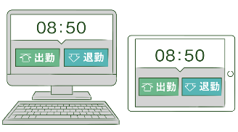
Clock-in/out
Basic info
Schedule management
Attendance data
Approve requests
Data export


Cloud
Server

Employee screen
View time card
Submit Various Requests




This manual covers the setting procedures on the Admin screen.
Some of the features described may only be accessible to users with the 1st Master Admin or Master Admin privileges.
If the item described is disabled or not shown on the screen, please check your Admin authorization settings.

- Supported browsers
The Admin screen supports the following browsers. Please use the latest version.

  Google Chrome |   Microsoft Edge
Windows
Mac
- Login
Use the system login URL to access the screen below.
Please use the login ID and password given to your company.

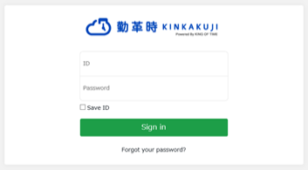
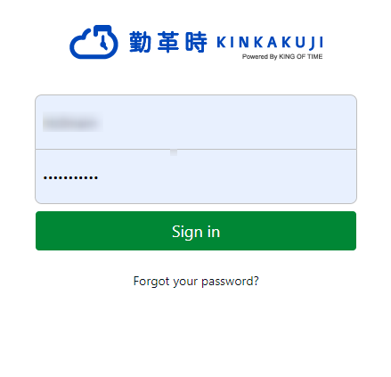
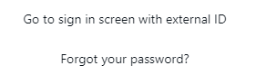


We recommend bookmarking the login URL.

- Fiscal year start date settings
If you are signing in for the first time, the Edit company details screen will be displayed. The fiscal year start date you set here will be the starting date for displaying monthly and yearly data.
* To change the settings later, you will need to contact the Support Center.

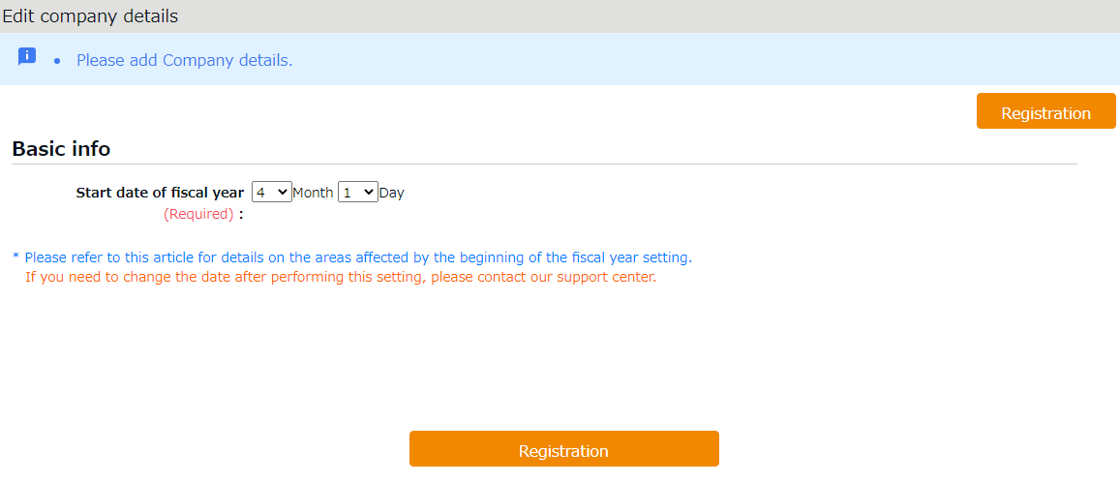

- Admin screen configuration
Start from [Home] after login.
5
4
3
1
2
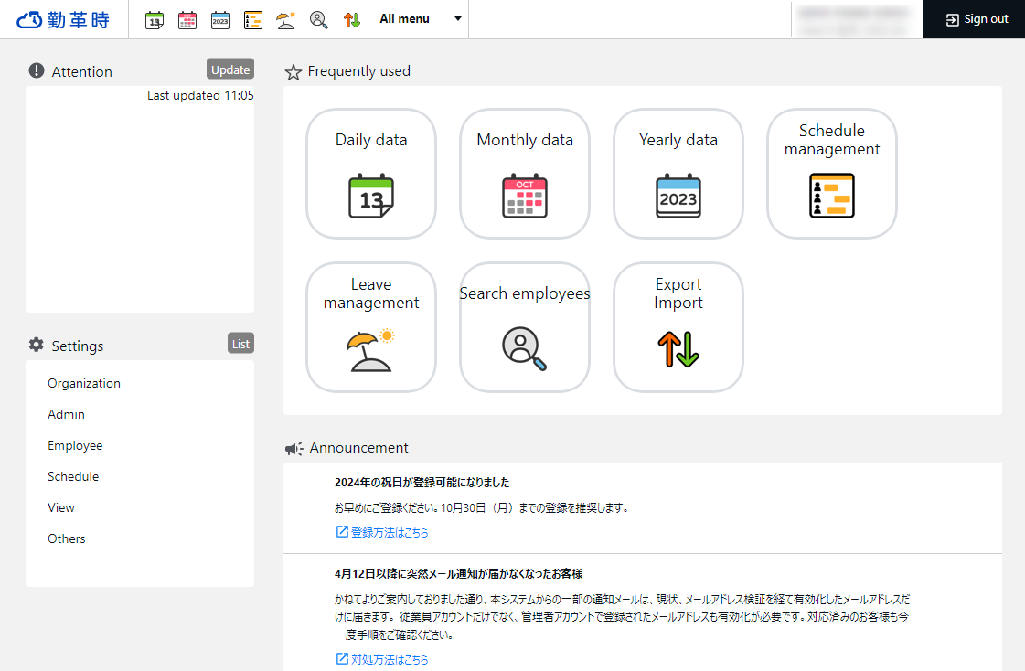
1 | Frequently used menu | Shortcuts to frequently used features.
2 | All menu | Check attendance data and schedule.
3 | Attention required | Check attendance data error and requests from your employees here. Click [Update] for the latest status.
4 | Settings | Configure various settings from here.
5 | Announcement | The Announcement feature is only available in Japanese.

Part 1 Basic settings
Part 1 describes the basic settings.

It provides information on organization and employee data settings, administration flow settings and constituting a base for schedule management.

[Settings] overview
Perform basic settings in [Settings] at the left column of the Home screen, displayed after login.
The settings are classified under 6 categories. Click [List] to show all categories.


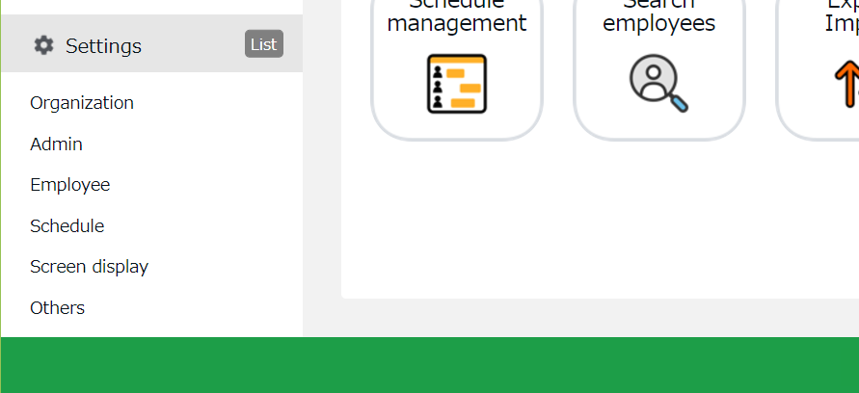
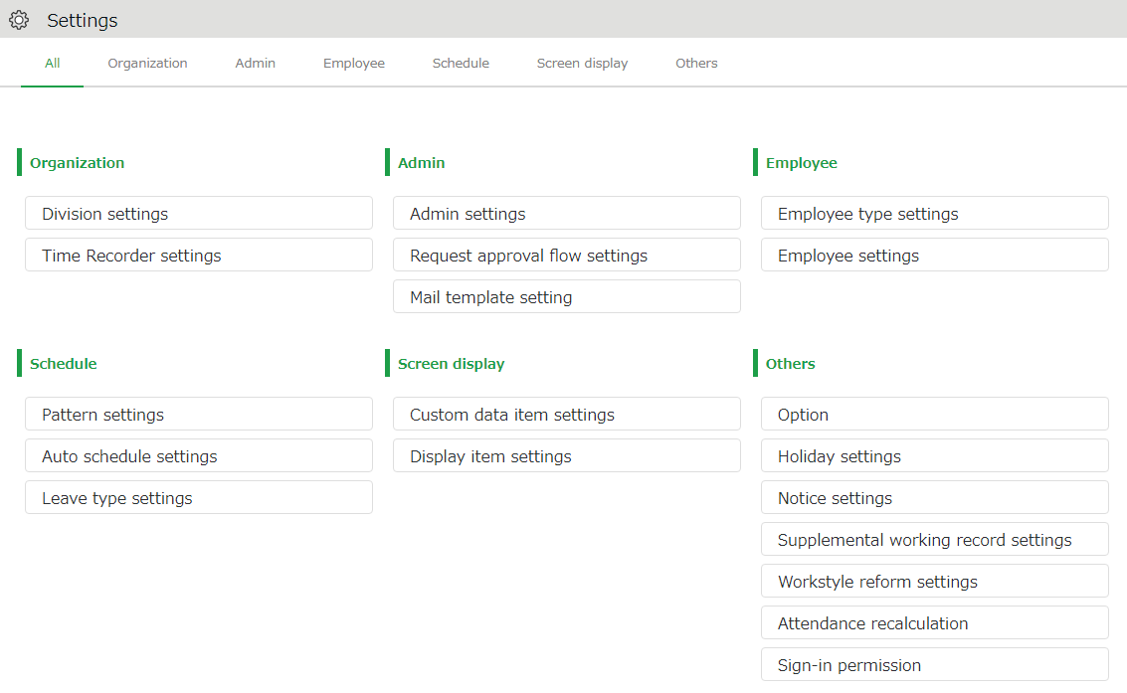

Below are descriptions of each setting screen.

Organization
Division settings | [Division settings] perform settings for [Division], a unit for managing employees. | p.8
Time Recorder  Settings | Provides Time Recorder setup info.  Perform Time Recorder display settings from here. | p.13

Admin
Admin settings | Creates Admin account. | p.22
Request approval flow settings | Performs approval flow settings for processing time record and schedule requests. | p.29

Employee
Employee type settings | Creates employee types such as “Full time” and “Part time”.  Set calculation rules here. | p.30
Employee settings | Enter the name, division and hired date of the employee. | p.39

Schedule
Pattern settings | Create schedule patterns here. | p.63
Auto schedule  Settings | Perform settings related to the auto scheduling feature. | p.71
Leave type settings | Creates leave types for administration.  Create leave types for administration. You can create new leave types such as “Special holiday” and “Maternity leave”. | p.50

Screen display
Custom data item settings | You can configure attendance data items that show on the Time Card screen. | -
Display item settings | Performs settings for the items on your Time Card.  You can hide unnecessary items. | -
Alert Setting | You can filter attendance data that is over or under a certain number on the daily or monthly data screens. | p.105

Others
Options | Turns optional functions on/off. | -
Holiday settings | Add national holidays and closing days of your company. | p.68
Notification settings | Set Email reminders for those who have forgotten to clock-in/out. | p.73
Supplemental working record settings | You can create additional Supplemental items (e.g. travel expense and benefits). | -
Workstyle reform-related settings | Perform settings for items related to Work Style Reform (Japan's plan to redress long working hours and disparities). | p.73
Attendance recalculation | Recalculates attendance data.  Be sure to run this feature the number of after changing basic settings that affect calculations (Employee type settings, Pattern settings, etc.), if you want to apply the changes to past calculation data as well. | -
Login permission | Grant access to our support center operators to log in to your environment from here. | -

Configure organization settings
This section describes the Organization settings. Instructions for [Time Recorder] settings are also included.
- [Division settings]
- [Time Recorder settings]

[Division settings]
Settings > Organization > Division settings
A [Division] is a unit for managing employees, which you can set at [Division settings].
You can think of Divisions as locations (example: branch stores and offices) to install Time Recorders.
If you are enabling the Request approval feature, note that approval flows are set by division. If you have different approval flows within a single division, we recommend creating individual divisions for each flow.

Add a Division
- Go to [Settings > Organization > Division settings].
- Click [New Registration] or [Edit] to open the registration page.
Specify the display condition

Specify the number of displaying items.
Click [Show] to view data.

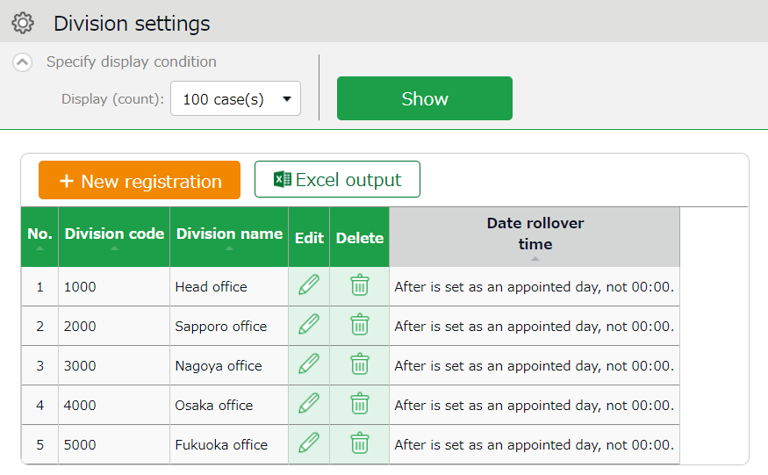

Export displayed data to Excel format.
Excel output

New registration

Creates new Division.

Edit | Edit Division data from here.
Delete | Deletes Division data.

Buttons

- In the Add division screen, enter the required info and click [Save] to save.

Copies settings and creates new Division.
You cannot use existing codes and names.
Register as

Saves changes and returns to the previous screen.
Save

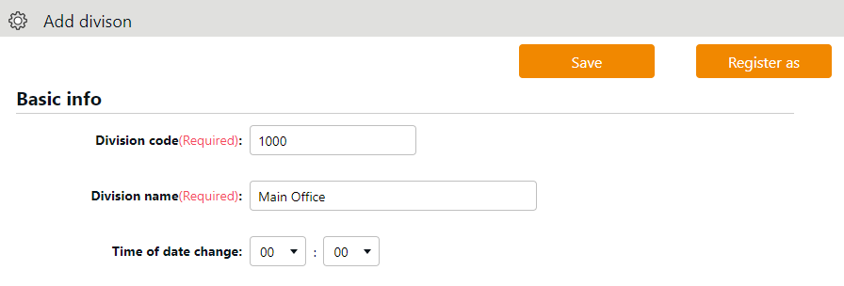

Details of the setting items are described below.

Division code | Set a code for identifying division. Enter in 3-10 alphanumeric characters. You cannot use existing codes.
Division Name | Enter the name of the division. (In 100 characters or less.)
Time of date change | Any clock in before specified time is regarded as time record of the day before.  The date of [Clock out] and [Start/End of Break] record depend on their preceding Clock in date. However, time record date is determined by [Time of date change] if no clock-in record is found within 48 hours.
Display language | Performs Time Recorder language settings. Japanese and English versions are available.

Please feel free to use our preset sample data.

Add divisions by importing data
Division settings can be registered in batches using CSV data.

Create import file layout
- Go to [All menu > Export / Import > Input data (Import) ] and click [Create import layout] next to Division/Time Recorder data [CSV].
- Click [Create new] and enter the required details.

Layout name | Name the layout as needed (Example: New Division Registration)
Applied type/category | To add new division, select [New/Update].  * Select [Update only] to layouts used for updating existing division data only. To import time recorder settings into existing divisions, select [Update only].

- At [Entry items], select employee info to import.
Select importing items from the [Available items] list, then click [Add].
The items added are shown in the [Items selected] list.
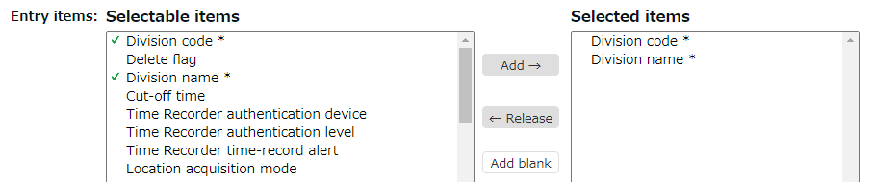

- Click [Save] to save the layout settings.
You can copy or save existing layouts under a different name with the [Register as] button when in Edit mode.
Layout settings for importing the list of [Divisions] are provided by default. Please edit and save as needed.

Create CSV data
Prepare the CSV data to be imported.
- Go to [All menu > Export / Import > Input data (Import) ] and click [Create import layout] next to Division/Time Recorder data [CSV].
- Select the layout created in the previous step under [Select layout]. .
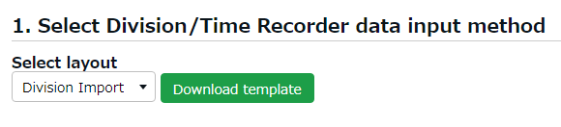

- Click [Download template] to download the template in CSV format. Save in on your desktop or in any folder appropriate.
- Open the CSV file with Notepad or Excel. Enter required information as specified in the first row, then save the data in CSV format.
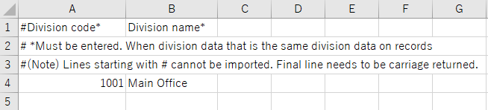


Please refer to the following FAQ content for information on how to enter values and creating the file.
https://n_help.kingtime.jp/h-t/web5/Detail.aspx?id=1989

Import
Import the CSV data you have prepared.
- Go to [All menu > Export / Import > Input data (Import) ] and click [Create import layout] next to Division/Time Recorder data [CSV].
- Select the layout created in the previous step under [Select layout].
- Click the [Select file] button and select the CSV file that you have prepared.
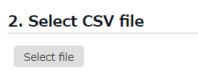

- Click [Upload].
- The confirmation screen will show. Then click [Save] to proceed. Import will start.
- If you see a list of errors, please modify the CSV file, delete all error elements, and re-upload the file.
- If the data contains an existing division code, the data corresponding data will be updated.

[Time Recorder settings]
Settings > Organization > Time Recorder settings
Perform settings for your Time recorder.

The 2 types of Time Recorder
There are 2 types of Time Recorder available on our system: [Personal Time Recorder] and [Division Time Recorder].

Personal Time Recorder
You can use Personal Time Recorders on your mobile phone and PC.

Time Recorder name | Time recording method | Details
My Recorder | Click-authentication using a browser | Log in to Time Recorder with a smartphone or PC browser.
Mobile browser  Recorder | Click-authentication using a browser | Employees are given individual URLs to clock in and out with their feature phone browser.  Also available for smartphone browsers.  Not available for PC browsers.

Division Time Recorder
This is a Time Recorder shared by multiple employees.
Division Time Recorders are usually placed in office entrances.
Time Recorder name | Time recording method | Details
Time Recorder (Desktop version) | Hybrid fingerprint authentication | Connect the biometric scanner to the PC where you have installed the app. Place your finger on the device.
Time Recorder (Desktop version) | IC authentication | Connect the IC card reader to the PC with the app installed. Place your IC card over the device to clock in/out.
Time Recorder (Desktop version) | Password authentication | Clock in/out by entering your password into the PC with the app installed.
iPad Time Recorder | Face authentication  Face authentication + Chameleon code authentication | Clock-in/out by facial image capture and Chameleon codes.
Cloud Time Recorder | Click authentication using a browser | Access the Time Recorder URL from the WEB browser. Enter your password to clock-in/out.
Pit Touch Series | Time recording device  (IC authentication) | Clock in/out using a dedicated device.
BT Series | Time recording device  (IC card/Hybrid fingerprint authentication) | Clock in/out using a dedicated device.

Descriptions
Settings > Organization > Time Recorder settings
Go to [Time Recorder settings] for Time Recorder setup, and to check Division Time Recorder setup info.

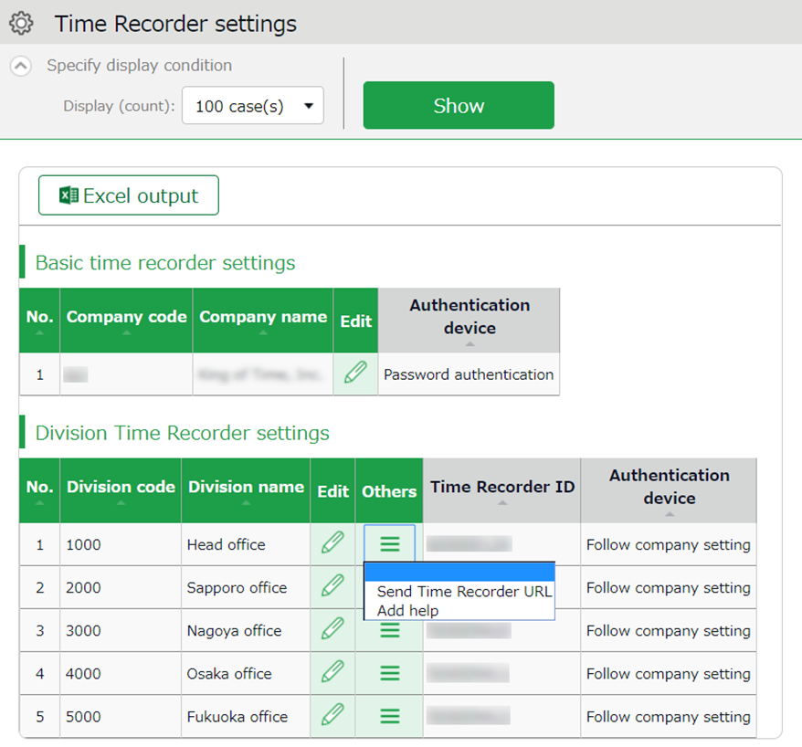
Edit

Select the type of Division Time Recorder.
You can also change operations and display settings of the Time Recorder.
To perform settings for the entire company, go to [Basic time recorder settings > Edit].
To perform settings for each division, go to [Division Time Recorder settings > Edit].



Click [ Ξ ] to open the drop-down menu.

Time Recorder  Send Time Recorder URL | Provides Division Time Recorder setup info.  You can download manuals for each Time Recorder types from here.
Add help | This permits employees from other Divisions (guest employees) to use the Time Recorder beforehand.

Others

Edit
Settings > Organization > Time Recorder settings
Perform operation and display settings for your Time Recorder.
You can also choose the type of Division Time Recorder.

For Division Time Recorders
The main setting items are described below. The displaying items vary by different authentication devices.
Please refer to the corresponding Time Recorder manual for details.
Time Recorder manuals are described in the following pages.

Authentication device | Select the type of Division Time Recorder. (IC card authentication, fingerprint authentication, etc.)  [Send Time Recorder URL] provides setup info and a Time Recorder manual for the specified authentication device.
Time record button settings | You can also set operation modes from here.
Display Time Card button | Display/hide Time record button. Employees can review their attendance data and submit requests from their Time Cards.
Add help  Display button | Display/hide [Add help] on the Time Recorder menu. By adding Help, employees from other divisions can use the Division Time Recorder.

For Personal Time Recorders
Configure operation settings for [My Recorder] and [Mobile browser recorder].

Location acquisition mode | This setting determines whether to acquire location info when recording time. Turn the [Disable time records when location info cannot be obtained] checkbox on to keep employees from clocking-in/out from browsers without location info and detects an error when attempting clock in/out.  * The accuracy of the location info depends on the positioning accuracy level of the user’s device.  * If [Obtain location info] is selected, the Time Recorder may not function on non-GPS devices.  * If [Obtain location info] is selected, the Time Recorder may not function on non-GPS devices.
Mobile browser time recorder - login password | Determines whether to require password on Mobile browser recorder.
My Recorder  Password-required function | Determines whether to require password when employees record time from My Recorder and reviews Time Card.  Determines whether to require password.
Select clock-in/out division for My Recorder | Determines whether to allow employees to select which division to clock in/out, when using My Recorder.

Send Time Recorder URL
Settings > Organization > Time Recorder settings
Provides Division Time Recorder setup info.

- Select the division where the Time Recorder is installed. Click [Send Time Recorder URL].
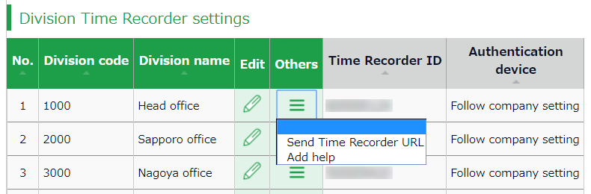

- Enter the Email address and click [Send email].
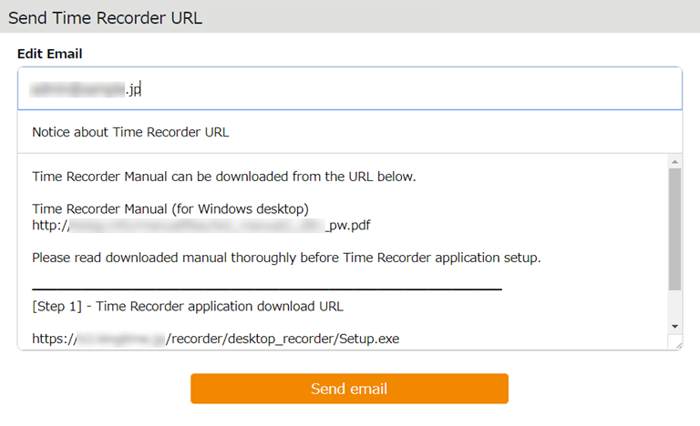
Enter Email address
- Details of Time Recorder settings are sent to the Email addresses specified in the step above. A link to the Time Recorder Manual will be shown in the Email.
Please follow the setup instructions in the manual.

The sender of the Email is [no_reply@kingtime.jp].
The Certificate URL is only valid within 48 hours from accessing the [Send Time Recorder URL] page. Ensure that employees access the URL before it expires.

Personal Time Recorder URL is available from [Settings > Employee > Employee settings]. (p.47).

About Certificate
Settings > Organization > Time Recorder settings
The Desktop Time Recorder requires a certificate. A certificate is a digitally issued word string which you cannot alter. It is used to verify the user company and divisions' identity when the Time Recorder connects to into server. When a server receives an invalid certificate, it denies the access. You cannot start the Time Recorder.

You can enhance the Time Recorder’s security by updating its certificate.
By updating it periodically, you can prevent malicious third parties from activating the Time Recorder.
Select the division where the Time Recorder is installed. Click [Send Time Recorder URL].

Then click [Show certificate].
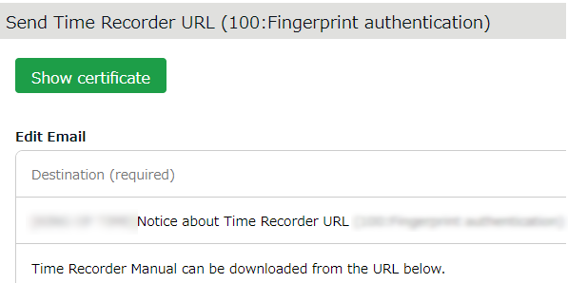

Please read each description. By turning on all checkboxes, you can activate the button at the bottom of the page.
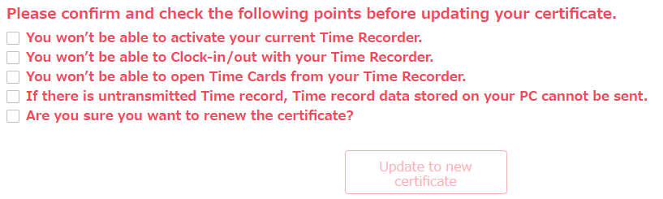
Please note that you cannot use the Division Time Recorder after updating
the certificate.
Send a notification about the new certificate through [Send Time Recorder URL].

Add help
Settings > Organization > Time Recorder settings
A Division Time Recorder is usually installed per Division. The initial setting does not allow clock-in/outs by employees from other divisions.

Division B

Division A

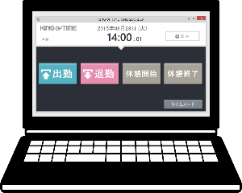
Division B
Time Recorder
Division A
Time Recorder

Available
Available
Not available



To allow employees from other Divisions (guests employees) use the Time Recorder, go to [Add help] to permit clock-in/out.
This is also useful when multiple divisions need to share a single Time Recorder.

Division A
Available

Division A
Time Recorder

Division B

Add help

Available

The Add help feature is also available from the [Add help] button on the Time Recorder screen. However, please note that the settings from this button are reset every time you close the Time Recorder screen.
If employees need to use a Time Recorder outside of their division frequently, we recommend you change the [Add help] settings from the Admin screen. Instructions to [Add help] in the Admin screen are described in the following pages.

[Add help] from Admin screen
- Select the division where the Time Recorder is installed. Click [Add help].

- Click [Add new] in the next screen.
- Select employees and click the [Save] button.
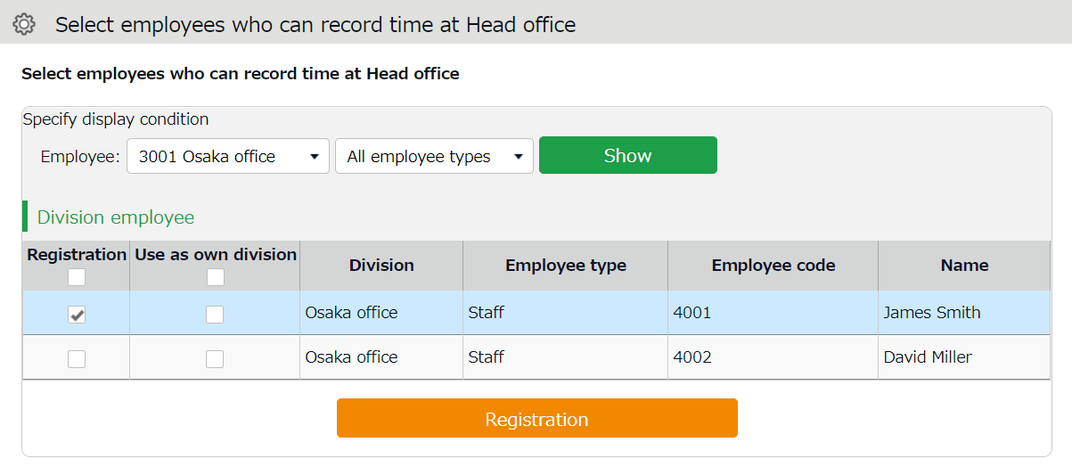

Save | The selected employee can the Division Time Recorder. Work time recorded on this Time Recorder is regarded as work outside of their division.
Use as own division | The selected employee can use the Time Recorder. Work time is regarded as work in their own division. In this case, you cannot identify which division the work time had been recorded.
You can perform the same settings in [Settings > Employee > Employee settings > Employee data edit > Time recorder info category > Division available for Time record].

Add an Administrator
This section describes authorization-related settings, such as adding Admin and setting request approval flows.
- Admin settings
- [Request approval flow settings]

Admin settings
Settings > Admin > Admin settings
You can create multiple Master Admin and General Admin accounts. A General Admin can view and edit within their limited permissions. A Master Admin has nearly the same permissions as the 1st Master Admin (certain operations, such as handling inquiries and changing company information, are exclusive to the 1st Master Admin).
* The 1st Master Admin is an administrator that exists from the time the account is issued. It cannot be additionally created.

Add an administrator
Perform Admin account settings (Name, Email address, etc.) and set authorizations.
- Go to [Settings > Admin > Admin settings].
- Click [New Registration] or [Edit] to open the registration page.
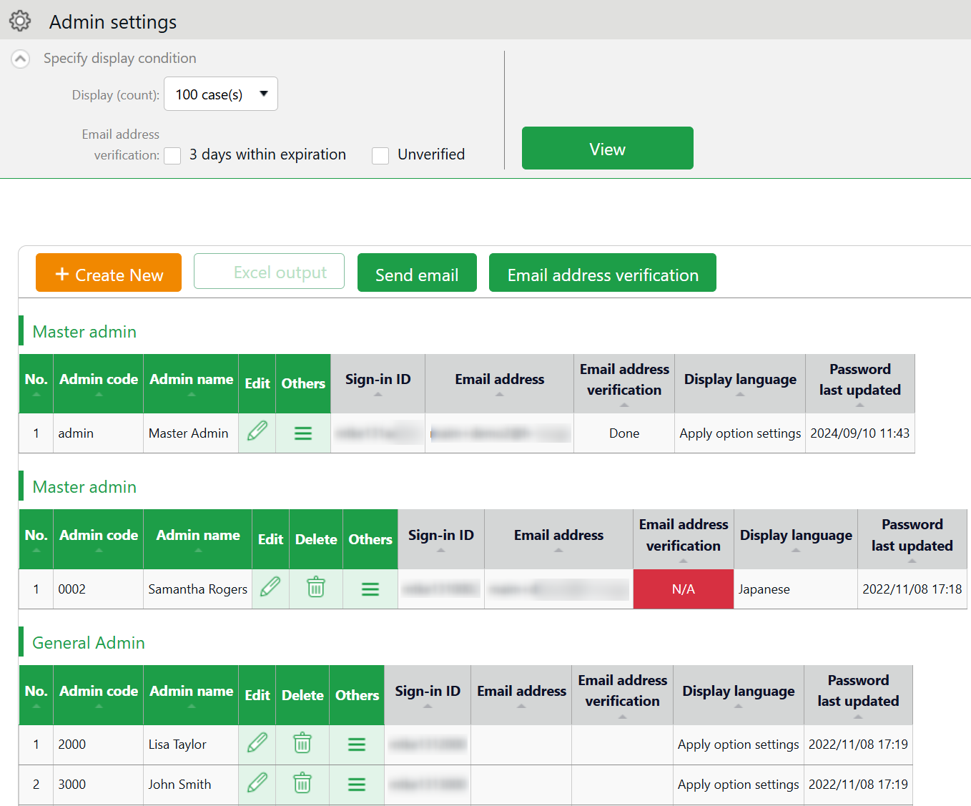

Creates Admin account.
New registration

Edit

Edit Admin data from here.

* Other buttons are described in p.26.
- Enter required info, then click [Save] to save the settings.
Details of the setting items are described below.

Basic info
Enter basic Admin info.

Admin code | Enter code for identifying the Admin user. Enter in 3-10 alphanumeric characters. You cannot use existing codes.  This code serves as a part of the user’s login ID.
Admin Name | Enter name of the Admin user. (In 100 characters or less.)
Login password | Enter login password. Enter in 6-35 alphanumeric characters. The password policy can be configured in [Settings > Others > Options].  * You cannot check the password set. If you forgot your password, please have the 1st Master Admin or the Master Admin change or reset the password.
Email address | The Admin's Email address is used for the following purposes:  Receive request notifications from employees  Password reset notification
Display language | You can select Japanese or English.
Admin authorization | The account is granted Master Admin privileges by putting a check on the check box.  * This operation can only be performed by the 1st Master Admin.

Master Admins can:
- Create/Edit admin accounts
- Login on behalf of Admin and Employee accounts
- Request approval flow settings
- Display item settings

A 1st Master Admin can:
- Perform all the above
- Promote/demote General Admins to Master Admins
- Delete Master Admin accounts
- Contact our Support Center

Authorization for basic settings
Set permissions to configure basic settings.
There are 3 authorization levels.

○ View / Edit - Enables viewing and editing.
△ View only - Allows viewing corresponding items.
× No authorization - Corresponding items are hidden.

Options | Option features that are configured in [Settings > Others > Options] and can be activated/deactivated.  The export layout feature at [All menu > Import/Export] is enabled when [〇 View / Edit] is set.  The feature supports Monthly, Daily and Time Card data.
Division/Time Recorder settings | Sets authorization to operate [Settings > Employee > Time Recorder settings]. Required for creating and editing Divisions and sending Time Recorder URL.
Employee type settings | Sets authorization to operate [Settings > Employee > Employee type settings].  Required for adding and editing Employee types and calculation methods.
Pattern settings | Sets authorization to operate [Settings > Schedule > Pattern settings]. Required for creating and editing Schedule patterns.
Login password  Login password change rights | Go to [Settings > Admin > Admin settings] to permit changes to Admin password.

Division/Employee type Authorization
Configure authorization levels by combining [Division management] and [Employee type management] authorizations. This defines the level of authorization and range of operations the administrator can perform.

- Select authorization levels for each operation in [Division Management Rights].
(A) Perform settings at [All divisions] row to assign administrative tasks across divisions.
(B) To assign administrative tasks for a specific division, select a division from the [Please select division] drop-down list.
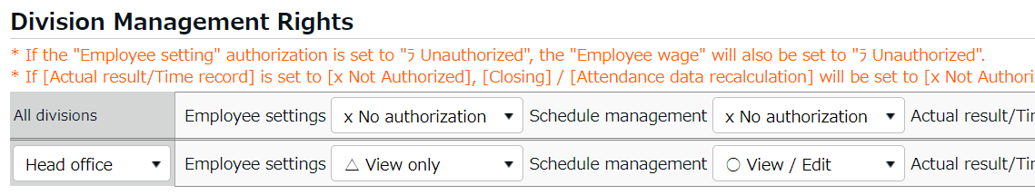
(A)
(B)

- Select authorization levels for each operation in [Employee type management authorization].
You can apply authorization settings to all or selected employee types.
- The combination of these settings defines the range of operations that administrators can perform. Lower authorization levels are recommended.
There are 4 authorization levels.

○ View / Edit - Enables viewing and editing.
■ View / Request - Enables creating or editing data with permission from a higher-rank Admin.
△ View only - Allows viewing only.
× No authorization - Corresponding items are hidden.
* [－Inherit upper level setting] will inherit [All divisions] or [All employee types] authorization settings.

The setting items are described below.
Employee settings | Sets authorization to create and edit Employee data.  The [〇 View / Edit] permission allows sending Email from the Employee setting screen.
Schedule management | Set authorization to edit schedules.  To create schedules, the [〇 View / Edit] privilege is required.
Actual result/Time record | Set authorization to manage Time record data.  To edit or delete time record, the [〇 View / Edit] privilege is required.
Data export | This setting is related to various data export features and data import actions in the [All menu > Export / Import] screen.
Closing | Set authorization to close attendance data.  Employees and General Admins can’t edit closed attendance data.  As an exception, the 1st Master Admin and Master Admins are allowed editing.
Attendance recalculation | Set authorization to recalculate attendance data. Attendance recalculation applies new attendance-related settings to past attendance data.

Admin login info
By creating Admin accounts, users can sign in as that Admin created.
Inform the Admin account user of the following login info. "You can also send login information via email (please refer to p.27 for sending Email).

Login info
Login URL | Same as 1st Master Admin login URL.
Login ID | Generated automatically. Company code + 1+ Admin code (e.g. xyz11000) You can confirm login info in the Admin settings screen.
Login password | Set a password when creating an Admin account.  If the password is forgotten, you can change or reset it in [Settings > Admin > Admin settings > Edit > Password].

Operations
1st Master Admin or Master Admins can perform the following tasks in the Admin setting screen.

1
2
3

4
5

No. | Buttons | Description
1 | 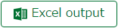 | Downloads Admin setting screen in Excel format.
2 | 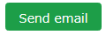 | Sends sign in credentials and URL for changing passwords to multiple admins.
3 | 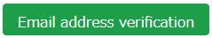 | You can check if the registered e-mail address is valid. It displays the verification status of Email addresses and secondary Email addresses, and allows you to manually send verification Emails.
4 | (Delete) | Deletes unused admin data.  * You can’t delete if the Admin belongs to a [Request approval flow].  * Deleted Admins are hidden from the attendance data edit screen and request approval logs.  * Only the 1st Master Admin can delete a Master Admin.
5 | (Others) | Click here to open the drop-down menu.  Edit history reference  Shows attendance data change log of each Admin (History is available up to 10 years in the past).  Employee allocation  Links employee account with the admin account. You can add a feature that allows users to go to the management screen directly after signing in as an employee.  Request message  Sets authorization to operate [All menu > Message management].  Login  Logs in on behalf of the Admin user.

Send Email
You can send notifications to multiple administrator accounts at once from Settings > Admin > Admin settings. In addition to editing the body of the email, you can also reset the password when you send it or add a link to change the password in the edit screen if needed.

- Click the [Send email] button.
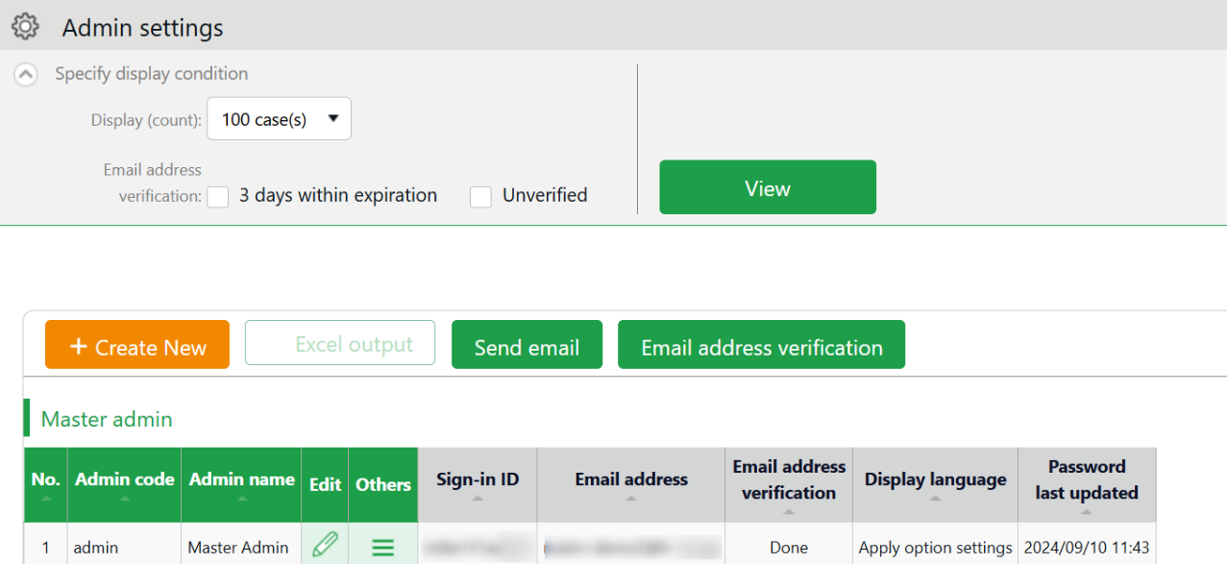

- Select an Email template, then click [Apply].
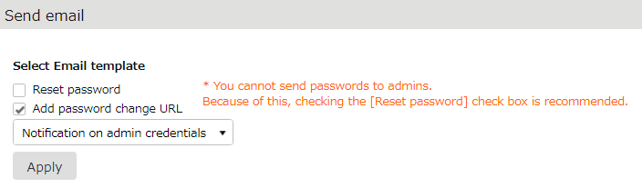

- Confirm details at the edit screen and edit if needed.

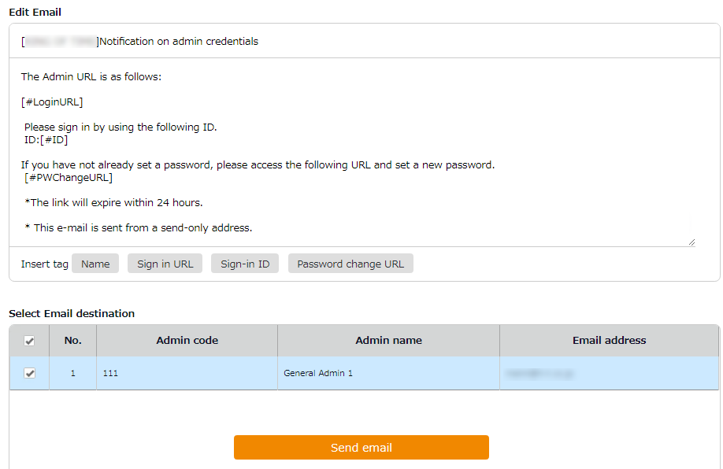

If you have deleted a tag from the text, you can insert it again from here.
Insert tags

- Click the [Send email] button, and once again in the confirmation dialog.

The sender of the Email is [no_reply@kingtime.jp].

Request approval flow settings
Settings > Admin > Request approval flow settings
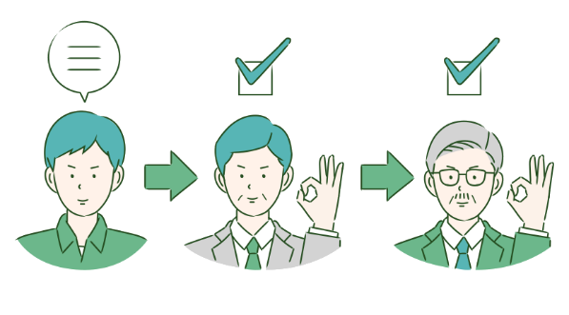
You can receive Attendance data/Schedule edit requests from employees and other administrators by using the Request approval feature.
Follow the instructions below to assign an Admin to a request approval flow.

Setting instructions
- Go to the Request approval flow settings screen, then press the [Edit] button of a division.
- Select an Admin to assign the approver role. Then click the [Save] button.
- If there are multiple levels in a flow, add Approver 2, 3, etc. accordingly.
You may add up to 5 layers, but you do not necessarily need to do so.
- When settings are complete, click [< Return] on the upper left of the screen to return to the previous screen.
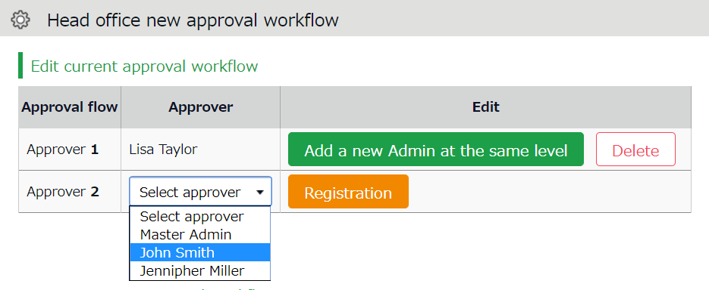

To assign multiple approvers in a level
You can assign more than one approver to the same level.
In that case, either one needs to approve the request before passing it on to the next level.

To add another approver, click [Add a new Admin at the same level], then select an administrator from the list of approvers.

Create an approval flow for each division.

Admins (Master Admin included) who aren’t added to the approval flow cannot confirm nor approve requests. The same rule applies to 1st Master Admins and Master Admins.

Add employee accounts
This section describes settings related to employee data.
- Employee type settings
- Employee settings

Employee type settings
Settings > Employee > Employee type settings
Creates employee types e.g. “Full time” and “Part time”. Employee type settings include attendance calculation settings. If you have several different calculation methods, create Employee types for each method.

Add an Employee type
Click [New Registration] or [Edit] to go to the registration screen.
Enter required info and click [Save] to save.

Copies settings and creates new Employee type. You cannot use existing names and codes.
Register as
Save

Saves changes and returns to the previous screen.

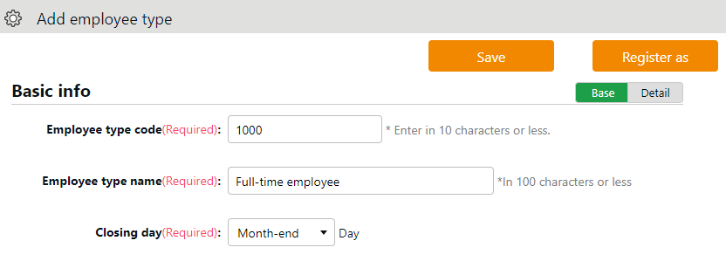

Detail

Shows advanced settings. Perform advanced settings from here.

Two preset Employee sample data are available. The sample data is a typical calculation setting. Please feel free to use it and customize accordingly.
Setting items are categorized.
Additional items in [Details] are also described in this manual.

Basic info
Employee type code | Enter a code for identifying the Employee type. Enter in 10 characters or less. You cannot use existing codes. | Basic
Employee type name | Enter the name of Employee type. in 100 characters or less. | Basic
Closing date | Set the day of settling (closing) attendances. You can select from the 1st to the end of the month.  For example, if you select [15th], the Time Card shows attendances from the 16th to the 15th of the next month. | Basic
Daily contract hours | Required for calculating deemed working hours during Paid leave. For details, please refer to the following article:  https://n_help.kingtime.jp/h-t/web5/Detail.aspx?id=2327 | Details
Discretionary Overtime of the Month | Required if your company only pays overtime beyond a specified amount of time.  This item is available at Custom data item settings and Monthly data export. | Details
Weekly closing date | Select a weekday for closing attendance data. For example, if you select [Saturday], the week starts with Sunday and ends with Saturday. | Details
Display language | Set language settings for Employee screen (Time Card) and My Recorder. You can select Japanese or English. | Details


Hmm…
There are so many items. Seems complicated, does not it?
Why don’t you try focusing on [Basic items] at first?
[Details/Advanced features] are for advanced settings, but not all companies need these settings. You can also use the sample data.


Workstyle
Working hours | You can choose between the regular working hours system and the variable working hours system. | -
Working hours | If you select "Variable Working Hours", the [Variable Working Hours] button will appear, enabling you to make detailed settings. The following options will be displayed.  Variable working hours per month  Automatically sets the recommended settings for monthly variable work and related calculation settings (*).  * Late night work hours slot, Late-night extra hours classification, Overtime start time, Weekly legal (statutory) working hours, How to handle leave hours and discretionary work hours on holiday and Weekly variable working hours (Carry-over)  Variable working hours per year  Specify the starting month and the monthly working hours.  Flextime per month  Automatically sets the recommended settings for flextime work in monthly increments and related calculation settings (*).  * Late night work, Late-night Extra Hours Classification, Overtime start time, Extra Hours Work start time, Extra Hours Work allocation type, Weekly legal working hours, Bonus wage overtime, How to Handle leave Hours  Manual setting (flextime and others)  You can customize the variable working hours setting. Select this option if you want to set up flextime settings for multiple months. | -
Working hours | If you select “Discretionary labor system”, in addition to enabling detailed settings, the following items will be displayed.  Workday types  You can select the target workdays for the Discretionary labor system.  * You cannot uncheck weekdays.  Presumed working hours per day  Please enter the Presumed working hours per day.  Apply the presumed working hours per day as working hours during paid leave  You can choose whether to apply the presumed daily work hours as Discretionary leave hour. | -

Break-related
Time-record break | By setting this, employees can use the Time Record to record their break time. If [Do not approve] is set, recording break time by Time Record is disabled. | Basic
Break time 1-3 | With this setting, employees can take breaks automatically. Enter in alphanumeric characters. This feature takes break time automatically when work hours reach the specified time. Break time are deduced from working hours. If the item is blank, break time is not taken automatically. Click [Add break] to add a new row. | Basic
Priority of Employee type break to subtract from | Specify which attendance category to subtract [Break time 1-3] (auto-break) from. | Details
Break time priority | Perform settings on how to handle break time if manual break time record and auto-break mode coexist.  Auto-detection (default)  Compares [Time-record break + Break specified by Schedule pattern] and break time specified by Employee types. The longer of the two is applied.  Prioritize time record break  If breaks are recorded by Time Recorder, select “Time-record break” only.  Sum up each break type  Adds up break taken by time record, break planned in Schedule, and break time specified by employee types. | Details

Types of break
There are 3 ways to take breaks.

- Time-record break
Employees take break by Time Recorder.
This is suitable for recording actual break time.
To disable it, you can change configurations in [Time-record break] in Employee type settings.

- Auto break
Takes break time automatically when daily work hours exceed specified time.
Configure settings in [Break time 1-3] in Employee type settings.

- Scheduled break
Adds schedule for break time.
Suitable for taking different types of breaks depending on work shift.
See “Pattern settings” (p.63) for details.

Choose a method that fits your company.
You can also combine different break types. When combining break types, configure the break priority settings in [Employee type settings > Break related > Details - Priority order of break].

Night work
Late night work slot | Any work during this time of the day is regarded as Assigned Late-night hours, Unassigned Late-night hours or Late-night overtime. Enter in [hh:mm] or [hhmm] format. | Basic
Unassigned Late-night work hour allocation type | Settings for handling unassigned work (neither included in schedule nor under Overtime/Late night time slot), that occur during the time specified above. | Details

Daily overtime calculation
Overtime start time | Work time past the specified time during this day counts as [Overtime].  Turn the check box on before entering Overtime start time. To regard work hours that are past schedule as overtime work, check the box below. | Basic
Overtime (cumulative) time for early-in | Working time that exceed the specified number of hours are regarded as overtime work. This setting determines whether to start counting the working hours from actual clock-in time (if an employee comes in earlier than scheduled time). | Details
Overtime (cumulative) time for late-in | Working time that exceed the specified number of hours are regarded as overtime work. This setting determines whether to start counting the working hours from actual clock-in time (if an employee comes in after scheduled time). | Details
Unassigned work (hrs) start time | The system generally handles work time that are neither included in schedule, nor under Overtime/Late night time slot, as [Overtime work (Unassigned work)]. However, by configuring this item, any work outside the schedule can be regarded as overtime work. This setting is unnecessary if schedules are set every day. | Details
Unassigned work hour allocation type | Settings for handling unassigned work (neither included in schedule nor under Overtime/Late night time slot) if there are any. | Details

If you need to calculate overtime work by month, go to [Settings > Others > Options > Attendance management settings > Flex work setting]. Select [Apply].
[Flex work] is added under [Employee type settings > Monthly overtime work summary]. Here, you can specify when overtime work begins, every month.

Weekly overtime calculation
Weekly legal working hours | The system handles working hours that exceed the specified value as Overtime. | Basic

Schedule
Days applied to Auto schedule | Set the number of days to apply Auto schedules (p.71). | Basic
Handling of work before clock-in schedule [early-in] | This setting determines whether to count work before scheduled clock-in time as work time. | Basic
Handling of work after clock-out schedule [overtime] | This setting determines whether to count work after scheduled clock-out time as work time. | Basic
Handling of clock-ins coinciding with scheduled time | To regard clocks-ins that are exactly on scheduled time as “late-ins”, select [Treat as late-in time record]. | Details

Leave related
The following are leave related settings.
Paid leave grant | Click the [Annual leave related settings] button to open the settings window (see p.60).  * Available if the Paid vacation grant function is enabled. | Basic
unit for vacation (by hour) | Specify the number of hours to take on each leave. The minimum unit is 1 hour * Available if the leave by hours feature is enabled. | Details
Addition to Fixed time when obtaining half-day or hourly leave | Determines whether to regard half-day leave and hourly leave as Fixed time (work time). Checked leave types are handled as work time when employees take half-day and hourly leaves during “Fixed time” hours. | Details
How to Handle Leave Hours | Determines how to handle deemed working hours during paid leave that are added up to work time, when calculating overtime.  - Do not include： Excludes deemed working hours during paid leave when calculating overtime work.  - Include (Not included in overtime)：  Includes deemed working hours during paid leave when calculating overtime. However, the system will not include discretionary holiday work hours that are past the time specified in [Overtime work start].  - Include (Include in overtime):  Include discretionary holiday work hours when calculating overtime. The system includes discretionary holiday work hours that are past the time specified in [Overtime work start], when calculating overtime.  * Item labeled as [Discretionary holiday work hours overtime calculation] depending on the internal setting. | Details
Increase/Decrease of Comp. leave leaves when Working days on holiday is taken | Determines whether to grant compensatory leaves working on holidays.  You can perform , general settings in [Settings > Schedule > Leave type settings], but to perform settings by Employee type, you can do so from here. | Details
Discretionary Holiday Work Hours Setting | Determines whether to calculate deemed working hours during paid leave.  You can perform general settings in [Settings > Schedule > Leave type settings], but to perform settings by Employee type, you can do so from here. | Details

Advanced features
You can perform more advanced attendance management and calculation settings.
Click on the category name to show setting items.

Time-record edit by employees | By selecting [Approve], employees can edit their time record from their Time Cards. To require employees to submit edit requests, select [Do not approve].
Detect attendance data error in discretionary work | The system may detect error, if overlapping time records exist on the day [Discretionary work pattern] (such as direct-visit/no-return work) is applied.  If you select [Don't detect], clock-ins/outs are recorded without error. (This data won't affect attendance calculation results.)
Time Card output format | You can export Item Time Cards in PDF from [All menu > Daily data > Time Card > EXCEL]. You can also set different layouts by employee types.

Employee settings
Settings > Employee > Employee settings
You can add basic employee data in the Employee settings screen.
It also provides details on Personal Time Recorder setup, login info and password for accessing the Employee screen (Time Card). Such info can be sent to employees by Email.

Add [Employee]
Enter employee data such as Name, Hired date and Employee code.

- Go to [Settings > Employee > Employee settings].
- Click [New Registration] or [Edit] to open the registration page.

Specify the display condition

Specify the number of displaying items.
Click [Show] to view data.

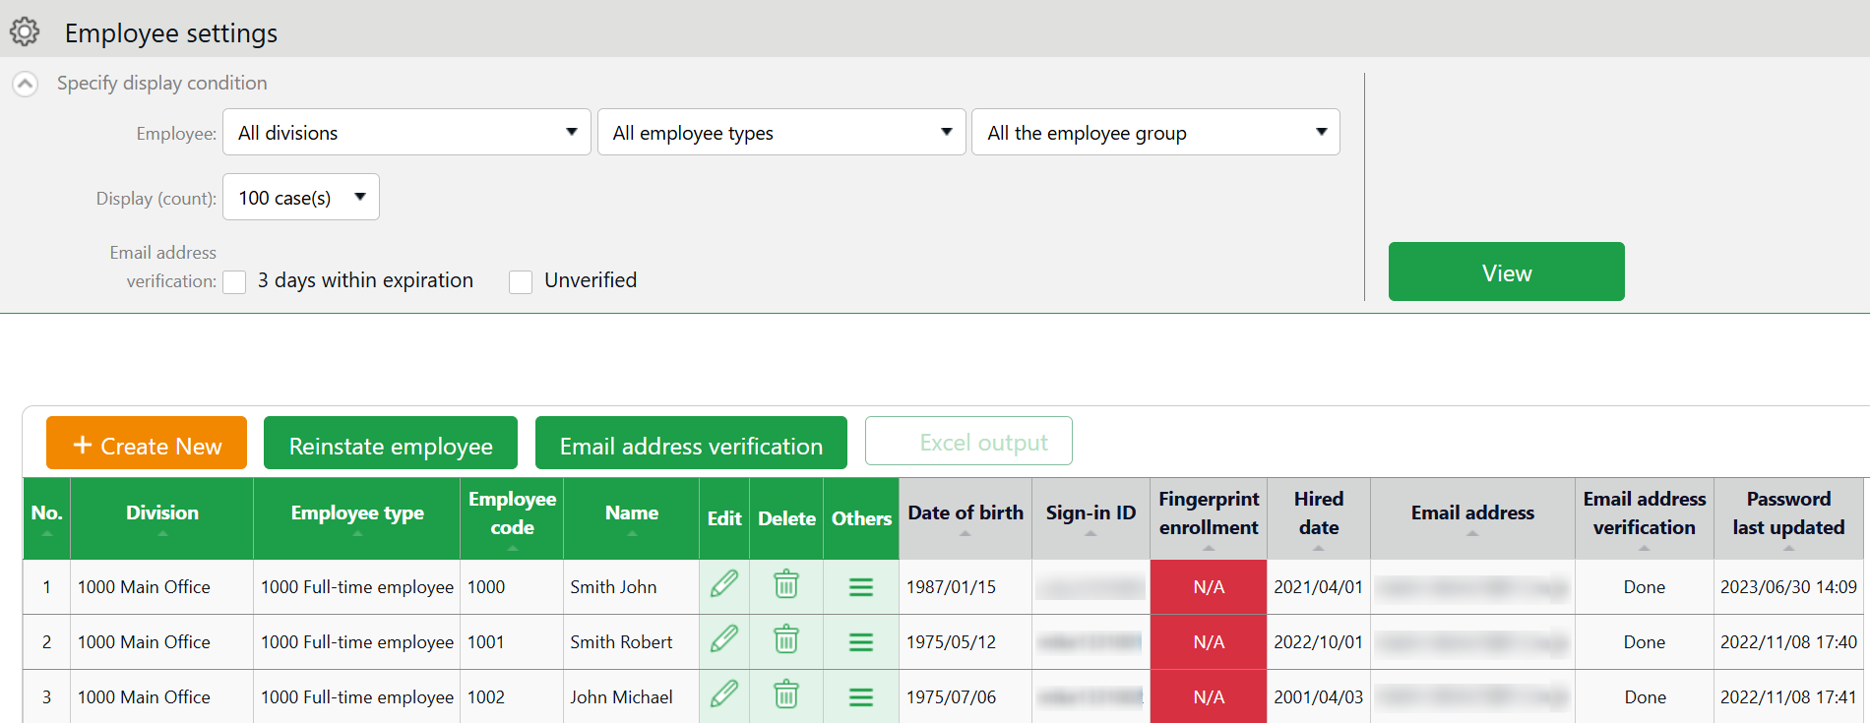

Edit

Click [Edit] to edit employee data.

Creates employee account.
Create New

* Other buttons are described in p.46.

- In the Add division screen, enter the required info and click [Save] to save.
Save

Saves changes and returns to the previous screen.

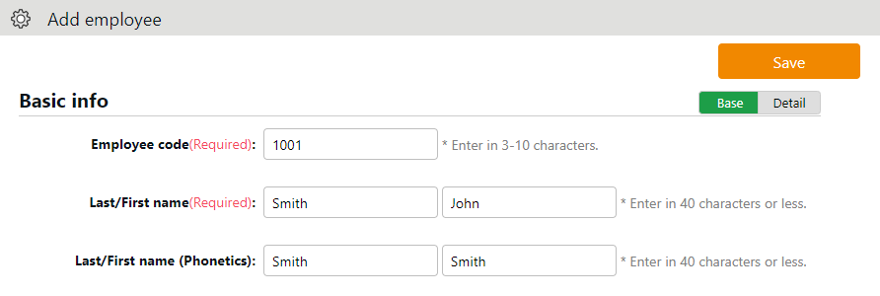

Shows advanced settings. Perform advanced settings from here.
Detail

Details of the setting items are described below.

Basic info
Employee code | Set a code for identifying employees. Enter in 3-10 alphanumeric characters. You cannot use existing codes. | Basic
Last/First name | Enter the name of employee. (In 100 characters or less.) | Basic
Last/First name (Phonetics) | Enter name phonetics. (In 100 characters or less.) | Basic
Email address | The Email address is used for the following purposes:  - To notify employees of approved/rejected requests.  - To notify missing time record  - To send employees info about their Time Recorder URL and Employee screen (Time Card) login info.  - To notify employees that their password had been reset by their administrator. | Basic
Password | Required for logging into Employee screens and clocking-in/out by password authentication.  * When this is left blank, [Employee code] is used as the employee’s password.  * The password entered here are temporary. When employees are using the temporary password on Time Records or in Attendance requests, a password reset screen is shown. | Basic
Gender | Select male or female. | Details
Date of birth | Enter the date of birth. | Details

Employment info
Division | Select employee’s Division. | Basic
Employee type | Select an Employee type. | Basic
Hired date | Required for paid leave administration, etc. You can’t record attendances before hire date. | Basic
Resignation date | Enter when the employee resigns. The employee will be hidden from Daily and Monthly data after the resignation date, but past attendance data will remain. You can’t record attendances after resignation date. | Details
Daily contract hours | Required for calculating deemed working hours during Paid leave. The same item exists in [Employee type settings], but the settings in [Employee settings] are prioritized. | Details
Weekly contract work days | Enter the number of days per week the employee is contracted to work. Note that this item is not referenced as the [Designated work days per week] under [Paid vacation grant function]. | Details
Discretionary Overtime of the Month | Required if your company only pays overtime beyond a specified amount of time.  The same item exists in [Employee type settings], but the settings in [Employee settings] are prioritized. | Details
Other employees  Admin code 1 and 2 | Enter code in 50 characters or less as needed. This item can be exported from the Export menu. This item is not required for running attendance calculation. | Details

Time Recorder info
The following are related to Time Recorder.

Personal  Time Recorder button | Choosing [Display] will enable a button that allows the employee to access his/her Time Recorder from the Time Card screen.  Link to My Recorder or Mobile Browser Time Recorder appears on [Time Card > Menu] depending on your settings.  * Available if you are using My Recorder or Mobile Browser Time Recorder.
available for Time record  Existing divisions | Employees can use Division Time Recorders from different divisions by changing settings from here. This way, the employee can use the Division Time Recorder without changing the [Add help] settings from the Time Recorder.
___ registration status | Indicates whether authentication info (Hybrid authentication data, IC card, etc.) had been registered.  If registered, a [Delete] button is displayed.  Authentication info can be re-registered after deleting. Deleting the authentication info won’t affect the employee’s attendance data.

Import Employee Data
All menu > Export / Import
You can import employee data in CSV format.

First, create an import file layout. You must arrange the content of the CSV file as specified in the Layout Setting. You can add employees easily by importing this file.

Create an import file layout (Only required once)
- Go to [All menu > Export / Import] and click [Create import layout] next to Employee data [CSV].
- Click [Create new] and fill in the following items in the Create employee data layout screen.

Layout name | Name the layout. (Example: New employees)
Applied type/category | To add new employees, select [New/Update].  * Select [Update only] to layouts used for updating existing employee data only. In this case, [Employee code] is the only mandatory item.

- At [Entry items], select employee info to import.
Select importing items from the [Available items] list, then click [Add]. The items added are shown in the [Items selected] list.

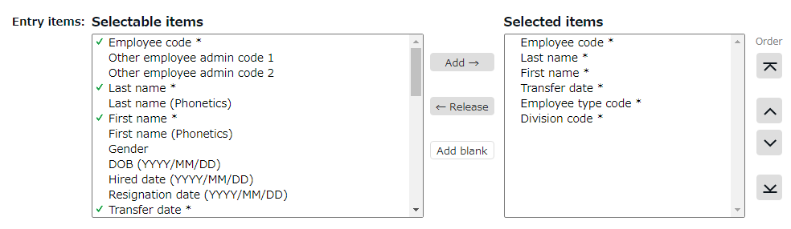

Add | Adds an item to the [Items selected] list.
Release | Removes item from the [Items selected] list.
Add blank | Adds a blank column to the [Items selected] list.  This adds a blank column to the CSV template.
Orders | Changes the order of items in the [Items selected] list.
Note | Entries are displayed on the layout settings screen and the data import (Employee data, Division/Time recorder data and Schedule data import) screen.

- Click [Save] to save the layout settings.
You can copy or save existing layouts under a different name with the [Register as] button when in Edit mode. Layout settings for importing Employee data, Remaining number of leaves are provided by default. Please edit and save as needed.

Import employee data
- Go to [All menu > Export / Import > Employee data] and click [CSV].
- Set following items.

Layout name | Select the layout created in the previous step.
Handling of empty items | This setting is applied when updating data of existing employees. If you select [Delete registered data], empty CSV items will clear away the items saved on the system.  * This setting won't interfere with importing new employees.

- Create a CSV template. If you already have one, please proceed to No.4.

Click [Download template] to download the template in CSV format. Save the file to your computer and open it with Excel or Notepad.
Enter required information as in the first row, then save the data in CSV format.
* For more information on entering data and creating files, please refer to [Read first] in the top of the Employee screen.
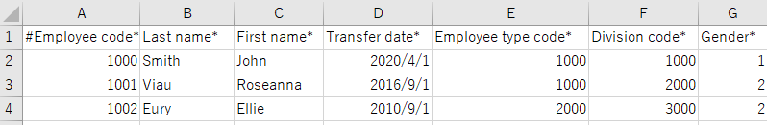

- Select importing CSV file. Click the [Select file] button and select the CSV file that you have prepared.
- Click [Upload]. Then click [Save] to proceed. Import will start.


This causes the [Too many items] error. A comma in the end of the last item adds unnecessary items.
This causes the [No matching ___ found.] error. The comma below the last row adds unnecessary items.
Check your data with a text editor
If you created your data with Excel, please note that unintended commas (,) and spaces (blank) in the file may cause upload error in rare cases. Be sure to use a text editor to check your CSV file.
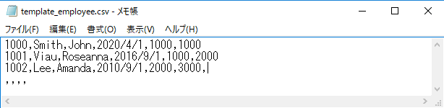

Please refer to the following FAQ content for information on how to enter values and creating the file.
https://n_help.kingtime.jp/h-t/web5/Detail.aspx?id=1989

Operations
Settings > Employee > Employee settings
In addition to adding/editing employee data, you can perform the following tasks in the Employee settings screen.
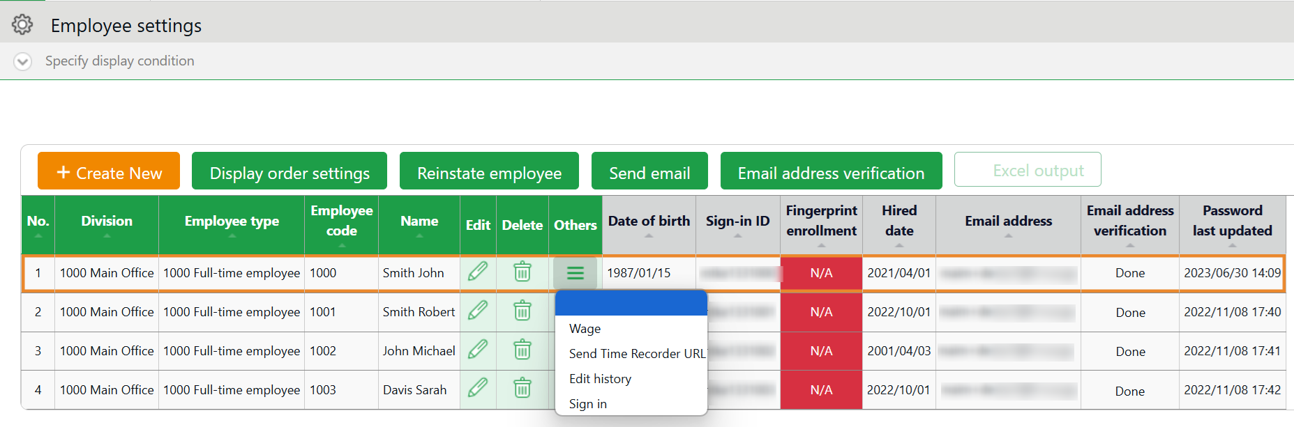
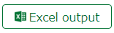

1ｚ
2

4
3

No. | Buttons | Description
1 | 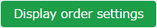 | If the employees belong to the same division, you can change the display orders.  * Only available if one division is selected.
1 | 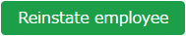 | Shows the list of deleted employee data. By clicking [Recover data] in the Deleted employee screen, you can return the data to the list of active employees.  * This button is only visible to the 1st Master Admin and other Master Admins.
1 | 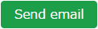 | Sends Time Recorder instructions to multiple employees by Email. Sends details on Personal Time Recorder setup, login info and password change URL. Please refer to the following pages for details (*).  * Only available if one division is selected.
1 |  | You can check if the registered e-mail address is valid. It displays the verification status of Email addresses and secondary Email addresses, and allows you to manually send verification Emails.
2 |  | Downloads Employee setting screen in Excel format.
3 | (Delete) | Deletes unused employee data. Deleted employees are removed from the attendance data edit screen and request approval logs.  * Please use this feature when you registered mistaken Employee info, etc. As for the resigned employees, click [Edit] and expand [Detail] on the Employment data category. Then enter [Resignation date].  * Deleting the employee will also delete related authentication data such as Bio-information.
4 | (Others) | Click here to open the drop-down menu.  Send Time Recorder URL  Sends details on Personal Time Recorder setup to Employees by Email, individually.  Edit History  Display the edit history of employee data  (the history can be viewed for up to one year).  Login  Logs in on behalf of the Employee.  * This button is only visible to the 1st Master Admin and other Master Admins.

Send Email
Settings > Employee > Employee settings
Go to [Home page > Settings > Employee > Employee settings].
Then, select a division from the under 1 and click [Show].
Click the [Send email] button displayed on the screen. Sends details on Personal Time Recorder setup, sign-in info and password change URL.
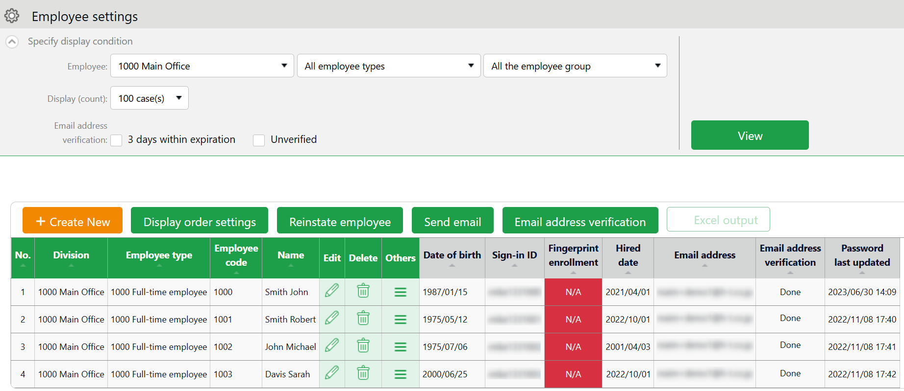


The sender of the Email is [no_reply@kingtime.jp].

Send My Recorder URL by Email
- Go to the Send email screen. Select [For My Recorder] from the Email template list, then click [Apply].
- Select destination and click [Send email] in the bottom of the screen.

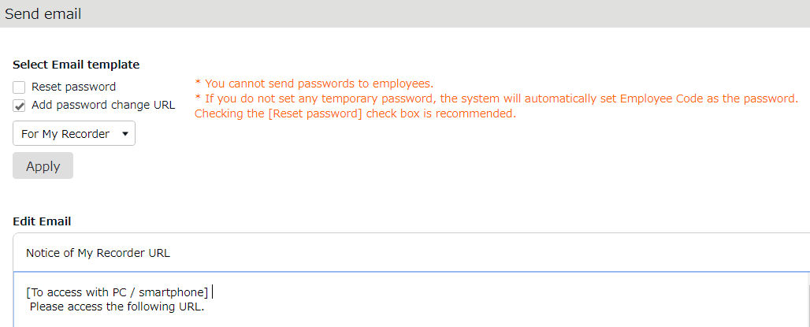

Employees can start using the Time Recorder by following the instructions sent by Email. Please refer to the [Employee manual] for information on My Recorder.

Send Login info by Email
- Go to the Send email screen. Select [For Time Card] from the Email template list, then click [Apply].
- Select destination and click [Send email] at the bottom of the screen.

Reset Password and Send Password Change URL
To clock-in/out by password authentication, every employee needs a password.
Please follow the following steps to have employees set their passwords.

- Select a Division or Employee type from [Specify display condition] at the Employee settings screen.
- Click [Send email].
- To reset password, select [<<Reset password>>]. If you do not want to reset password, only check [<<Add password change link>>].
- Then click [Apply].
- Enter subject and content of the Email accordingly.
You can also add various items from [Insert tag] if needed. The tag is replaced by corresponding employee info during delivery.

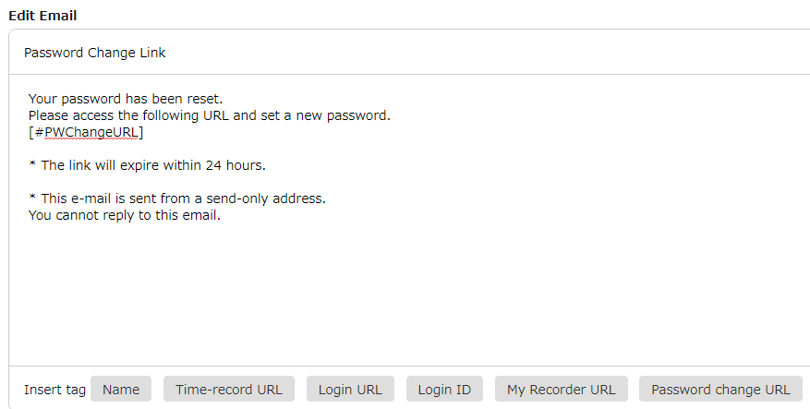

- Select destination and click [Send email] in the bottom of the screen.

If no password is set to a new employee account, the initial password is the same as the Employee code.

Prepare for Schedule management
This section describes the settings related to Schedule management, such as work hours and leaves.
- Leave type settings
- Paid leave feature settings
- Pattern settings
- Holiday settings
- Auto schedule settings

Leave type settings
Settings > Schedule > Pattern settings
A Leave type is a unit for calculating leaves.
When you create a Leave type, a summary column is added to the Time Card screen.
By setting a leave type to a schedule, you are taking a full day leave. This action will affect the remaining leaves in the summary column.

Setting instructions
This section describes the [Leave type] settings.

Click [New Registration] or [Edit] to go to the registration screen.
Enter required info and click [Save] to save.
The setting items are described below.

Name | Enter the name of the leave. (Examples: Paid leave, Compensatory leave, Special leave, etc.)
Half-day leave | By selecting [Apply], users can take half-day leave.
Calculating obtained leaves | Choose either of the following to specify the leave calculation method.  Subtract (Subtraction)  Manages the number of granted leaves, leaves taken (used), and remaining leaves.  Generally used for managing paid leaves.  Add (Addition)  This setting can be used for managing leaves that only needs monitoring of the numbers taken.  This is generally used for managing absences and legal holidays.
Increase/Decrease of Leaves when Working days on holiday is taken | * Only available for Comp leave.  If you select [Increase by time-off clock-in], compensatory leaves are granted automatically, if working hours during [Legal or Non-legal time off] exceed specified hours.
Grant substitute time-off/  Comp Leave Request | * [Comp Leave Request] is displayed when [Leave Count Calculation Method] is set to [Add], and [Grant substitute time-off] is displayed when it is set to [Subtract].  Comp leave request  Selecting [Apply] allows employees to apply for both the Substitute Workday and the Comp leave simultaneously on the employee screen.  For details on settings and how to submit requests, please refer to the FAQ (Japanese) content below.  https://n_help.kingtime.jp/h-t/web5/Detail.aspx?id=3630  Grant substitute time-off  Selecting [Apply] displays the [Substitute Workday] field on the schedule registration screen.  A Comp Holiday is automatically granted when the work performed on a day selected as a [Substitute Workday] exceeds the standard hours.  For details, please refer to the FAQ (Japanese) content below.  https://n_help.kingtime.jp/h-t/web5/Detail.aspx?id=1568
Allow negative numbers | * Only shown if [Calculation method of leaves when obtained] is set to [Subtract].  By selecting [Disable leave when it reaches zero], the system restricts leave requests that exceed the available balance. This setting also enables the detection of insufficient leave balance errors.
Valid period | * Only shown if [Calculation method of leaves when obtained] is set to [Subtract].  Leaves are available from its grant date until the period specified in this setting. You can’t take leaves after this period. You cannot leave the item blank.
Leave Expiry Period | * Only shown if [Calculation method of leaves when obtained] is set to [Subtract].  You can edit the valid period in the Leave details screen.
Comp leave request | * Only shown if [Calculation method of leaves when obtained] is set to [Add (Addition)].  Perform setting if you are using the Comp leave request feature.  Please refer to the following article for details on the Comp leave request feature (Japanese).  https://n_help.kingtime.jp/h-t/web5/Detail.aspx?id=3630
Leave by hours | By selecting [Apply], users can take hourly leaves.  You can take Hourly leaves from the f[Subtraction] type leaves as well (maximum of 1 to 5 day’s leave). This setting can limit the amount of hourly leaves that employees can take within a year.  In addition, if the [Daily contract work hours] is specified, you can check the [Usable hourly leaves] in the leave details screen.  Daily contract work hours less than 1 hour  Under Japan’s Labor Standards Act, annual paid leave must be rounded up if there are a fraction of contract working hours for less than one hour. However, for holidays other than paid leave, you are allowed to choose between “Round up” or “Do not round up”.
Full day leave Type Count | Set if you are using the leave unit [Full-day Leave (Half-day)].  Use this option to take a full day leave in place of the originally planned half-day work.
Display leave Type Color | Sets the display color of the schedule column for leave days.
Image upload for Leave Application Request | Employees can attach doctor’s note when requesting sick leaves. You can select [Required], [Optional] or [Not Required] for each leave types.
Override Workday Type if schedule is set to Full-day Leave | You can specify the weekday type of the leave day.
Leave Type-only Schedule Request | This setting determines whether employees must request leaves by choosing a leave category alone or also specify the schedule.  If no work schedule (scheduled clock-in/out) is set, the system cannot calculate deemed working hours during paid leave.
Calculate Discretionary Holiday Work Hours | Determines whether to calculate deemed working Attendance hours during paid leave or count as working hours.  - Do not calculate(*): Does not count deemed working hours during paid leave.  - Calculate: [(Name of leave type) hours] will be available for output in Custom data items, Time card [PDF], Daily data [CSV], Monthly data [CSV]. The hours will count as working hours.  - Only perform calculations for each leave type (*): [(Name of leave type) hours] will be available for output in Custom data items, Time card [PDF], Daily data [CSV], Monthly data [CSV]. The hours will not count as working hours.  *If this item is selected, the [Tally under Schedule time] check box will appear. Checking on this will tally break time on schedule time.
Carryover setting | * Only available for Paid leave.  This setting automatically grants expired paid leaves as carryover leaves.
Leave of absence feature | If this item is enabled in a leave type, you can manage the start and end date of the absence period in the [Leave of Absence] in the leave management screen. The following three options are available.  1. Use for postpartum paternity leave *1  2. Use for paternal leave program *1  3. Use for customized extended leave / leave of absence *2  *1: Only one leave type can be set for this item.  *2: You can only set this item for a newly created leave type.

Drag-and-drop
On the Time Card screen, for example, leave types are displayed in the order in which they were created.
To rearrange the order, click the [Display Order Setting] button on the Leave type setting screen to open the display order setting screen.
After rearranging the order by dragging the label of leave type, click the [Save] button to reflect the display order.
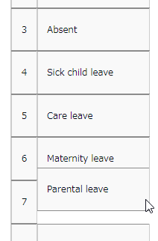

Display settings
You can restrict leave types to employees of certain divisions or employee types.
Summary of such leave types are hidden from Time Cards of employees who are not allowed access. This prevents general admins and employees from editing and sending requests on those leave types.

This section describes settings.

- Click [ Ξ ] of the leave type to open a drop-down menu. Click [Settings display target].

- Enter required info, then click [Save] to save the settings.
The setting items are described below.

Restricting division | Select the division to permit use of the leave. You can select multiple choices.
Restricting employee type | Select the employee type to permit use of the leave. You can select multiple choices.
Display on employee Time Card | If you select [Enable], the leave type will be hidden from the summary column in the Time Card screen for employees who belong to the division or employee type that does not match the condition.  * It will be displayed if the Time Card is accessed through the administration screen.
Request by employee | If you select [Enable], employees who belong to the division or employee type that does not match the condition will become unable to submit leave requests under that leave type.
Request by admin | This setting applies to admins whose Schedule management authorization is set to [■ View / Request]. If you select [Enable], the general admin will become unable to submit leave requests on behalf of the employees who do not match the condition.  * The restriction does not apply to 1st Master Admin and Master Admins.
Edit by Admin | This setting applies to admins whose Schedule management authorization is set to [○ View / Edit]. If you select [Enable], the general admin will become unable to schedule leaves for employees who do not match the condition.  * The restriction does not apply to 1st Master Admin and Master Admins.  * The restriction does not apply to granting remaining leaves.

IMPORTANT:
- This feature does not cover Time Card [PDF] and Monthly data [CSV].
If you wish to export the leave types according to the division or employee types, please create a separate layout.
- If you have disabled the setting under the Action category, the display and operation restriction applies to all employees (Condition category setting is not referenced).

Paid leave feature settings
This feature calculates the grant date and the number of eligible paid leaves. You can also send notifications related to leaves.

Function
When the grant day comes, [Eligible for annual leave] will appear under [Attention required] in the home page. By clicking this item, employees eligible for paid leaves are listed.
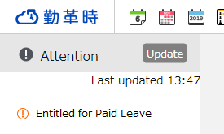
The screen shows grant date, number of days granted, and calculation method. Please confirm details and proceed.
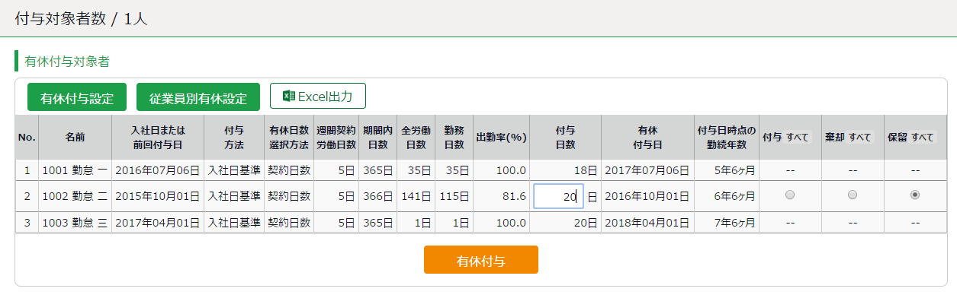
IMPORTANT:
The system will alert paid leaves that occur in the days after all settings described in the following pages have been completed.
Please note that you can’t grant leaves back from the past date point.
To grant leaves in past date points, please do so manually (*)
We also recommend granting leaves manually, if your company has leave regulations that our system (refer to specifications in the following pages) does not cover.
*Please refer to the following article for details on the Comp leave request feature (Japanese). https://n_help.kingtime.jp/h-t/web5/Detail.aspx?id=1557

[Specification 1] Paid leaves granted
There are two methods of managing paid leaves.
- Grant paid leaves based on hired date
- Grant paid leaves by grant date

You can also use the "Divided leave” feature to grant a portion of days in advance after a specified number of months from the hire date, and a feature to determine the first and second half of the year based on the grant date. This section describes the settings for each method.

Grant paid leaves based on hired date
The system grants leave for the first time after the specified number of months from the hire date. Thereafter, leaves are granted on the same date each year.
Leaves granted (first time) : March 1
Leaves granted (second time) : March 1
Leaves granted (third time) : March 1
January 1st
December 31st
Hired date: September 1st

If an employee is hired on September 1st
and the first grant date is set 6 months after the hire date

Grant paid leaves by grant date
The system grants leave for the first time after the specified number of months from the hire date. Thereafter, leaves are granted on the same specified date every year.
Leaves granted (first time) : March 1
Leaves granted (second time) : April 1
January 1st
December 31st
Hired date: September 1
Leaves granted (third time) : April 1

If an employee is hired on September 1st and the fixed grant date is set to April 1st

Grant paid leaves based on grant date (Divided leave)
A year's worth of paid leave will be granted in two installments, one on the "divided annual leave grant date (first time)" and the other on a "1st base date (second time)". You can set the following year's base date as "divided grant date".
December 31st

January 1st

Hired date: September 1

Leaves granted (first time) : December 1

Leaves granted (second time) : March 1

Leaves granted (third time) : December 1

In case which an employee joins the company on September 1 and leaves are granted on December 1 and March 1
In case the divided annual leave is applied - first set of leaves are granted three months after the hired date and the rest are granted six months after the hired date

[Specification 2] Paid leaves calculation method
To manage paid leaves, you can choose from following two methods.

- Set the weekly contract work days.
- Calculate the weekly contract work days based on the number of workdays per year and total workdays

This section describes how paid leaves are calculated in each method.

Set the weekly contract work days.
Leaves are granted according to the table of proportional paid leaves. The employee’s number of years worked and workdays per week serves as the reference value to determine the number of leaves. For leave entitlement, the employee’s attendance rate must be over 80%.
If the minimum attendance is less than the specified rate, the user is entitled 0 leaves.

Calculate the weekly contract work days based on the number of workdays per year and total workdays
Paid leaves are granted according to the estimated weekly contract work days, which is based on the employee’s annual total of working days (does not refer to attendance rate).. We recommend using this setting if the workdays per week is not fixed and you cannot set it for each employee.

Example of an employee:
* Worked for 6.5 years
* The year’s total of actual work days: 200 days
In the Proportional grant day table (see below), the employee is assumed to be working 4 days per week, giving him/her 15 leave days. (200 workdays fall under the 169-217 category)

Table - Example of proportional grant days (Statutory)
Designated number of working days per week | Designated number of working days per year | Timing for granting leave
Designated number of working days per week | Designated number of working days per year | 0.5 years | 1.5 years | 2.5 years | 3.5 years | 4.5 years | 5.5 years | 6.5 years and above
5 days and above | 217 days | 10 days | 11 days | 12 days | 14 days | 16 days | 18 days | 20 days
4 days | 169 days | 7 days | 8 days | 9 days | 10 days | 12 days | 13 days | 15 days
3 days | 121 days | 5 days | 6 days | 6 days | 8 days | 9 days | 10 days | 11 days
2 days | 73 days | 3 days | 4 days | 4 days | 5 days | 6 days | 6 days | 7 days
1 days | 48 days | 1 days | 2 days | 2 days | 2 days | 3 days | 3 days | 3 days

Paid Leave-related Settings
You can open the settings related to annual leave from the following screens.
- Employee type settings
- Employee settings

Pre-configuration
Go to [Home page > Settings> Others > Options> Schedule settings] category. Ensure that [Paid vacation grant function] is set to [Apply].

Items
Click the [Annual leave related settings] button at the Employee type settings screen.

1. Set the designated weekly contract work days (Required)
Items | Function
Designation of the number of days | Specify the designated weekly contract work days.
Calculate the weekly contract work days based on the number of workdays per year and total workdays | Calculates the weekly contract work days based on the number of workdays per year and total workdays.

2. Set the first reference date (Required)
Items | Function
Grant leave for the first time x months after hire date and set as grant date every year: | Leave will be granted after the specified number of months from the employee's hire date.
Divided Annual Leave | The system grants the designated number of leave days after the specified number of months from the hire date.
Based on divided annual leave grant date | This option is available once the Divided Annual Leave is enabled. After granting leave for the first time, leaves are granted on the specified date.

3. Set a second reference date (Optional)
You can set the second reference date together with the first.

Items | Function
Fix grant date to m/d | Set a fixed grant date once a year.
Divide the fiscal year into two parts, based on the grant date | For example, if the fixed grant date is set to "April 1", the following applies.  First half of the fiscal year (April - End of September)  Grant date: October 1 (Applicable to employees whose hire date is in the first half of the year)  Second half of the fiscal year (October - End of March)  Grant date: April 1 (Applicable to employees whose hire date is in the second half of the year)
Prioritize the second reference date | Grant leave on the second reference date.  For example, under the following conditions, the first grant date would be April 1.  ・Hired date： March 1st  ・First reference date: 6 months after hired date  ・Second reference date: Fixed grant date is April 1st

4. Set the proportional number of leaves
The proportional number of leaves are granted by the employee’s Designated number of working days per week times the years of tenure.
By filling in the items, the system grants annual leaves based on the estimated workdays per year (calculated from each employee's Designated number of working days per week).
Legal standard is applied to default settings, but you can make configurations that fits to your company’s rule.

5. Set the number of working days and the number of total working days.
This is used for calculating attendance rates (Number of working days / Total working days × 100).
You can select [Weekday work], [Legal holiday work], [Non-legal holiday work], and other leaves.

To perform paid leave feature settings
Please complete the following settings before starting.

Options
Go to [Home page > Settings > Others > Options > Schedule settings] category. Ensure that [Paid vacation grant function] is set to [Apply].

Employee type settings
Go to [Home page > Settings > Employee > Employee type settings]. Click the [Edit] button of the employee type.
- Click on the [Annual leave related settings] button.
- Set the method for granting leaves. Please refer to [Specification 1] in p.57.
- Specify the designated number of working days.
- Set the reference date. Please refer to [Specification 2] in p.58.
- Set the number of workdays and total working days.

Employee settings
Go to [Home page > Settings > Employee settings > Edit] and enter [Hired date].
If the [Hired date] is empty, the employee will not be entitled to paid leaves.

The system will start notifying paid leaves granted from the following day of completing all settings above. Please note that you can’t grant leaves back from the past date point.

Registering the remaining number of annual paid leaves
Please refer to the following article for information on how to register the number of days and hours of paid leave remaining at the time you are implementing our system (Japanese).
https://n_help.kingtime.jp/h-t/web5/Detail.aspx?id=1554

Pattern settings
Settings > Schedule > Pattern settings
This section describes the Schedule pattern settings.

About [Schedule]
By setting schedules, administrators can organize works shifts (e.g. Create early and late shifts) as well as set late-in/early-out, break time, configure overtime calculation process, etc.

Overtime start (8 hours) * Employee type settings
Clock-in
10:00
Clock-out
8:00 PM
Overtime work
Working hours
Example of a calculation (No schedule applied)
In this example, the time between clock-in and clock-out is regarded as working hours.

Overtime start (8 hours, break time not included) * Employee type settings
Clock-in
10:00
Clock-out
8:00 PM
Clock-in schedule
9:00 AM
Clock-out schedule
6:00 PM
Overtime work
Unassigned work
Late-in
Break schedule
12:00-1:00 PM
Break time
Work time
Example of calculation (No schedule applied)
The difference between clock-in schedules and actual clock-in records is calculated as [Late-in time].
In addition, any work that exceed scheduled time, but finished earlier than overtime hours, are calculated as [Unassigned work]. Schedules can be used to run various calculations.

Why do we create Schedule patterns?
It is hard to set clock in/out schedules manually every day. You can make it easier by creating a pattern for schedules and shifts. You can set clock-in/out schedules and related settings just by applying the pattern you created.

2 types of schedule patterns
There are two types of schedule patterns. Each function differently.

Schedule type | Function
Normal work | This is a clock-in/out schedule pattern.  By setting clock-in/out schedules, late-ins and early leaves are calculated.  You can also set break schedules.
Discretionary work (Deemed work) | This schedule pattern handles a day as workday, even if employees haven’t used the Time Recorder. This is useful when employees cannot use the Time Recorder during their business trip.

Create schedule patterns
Settings > Schedule > Pattern settings
Click [New Registration] or [Edit] to go to the registration screen.
Enter required info and click [Save] to save.

Saves changes and returns to the previous screen.
Save

You cannot use an existing Pattern code if you are saving it under another name.

Register as

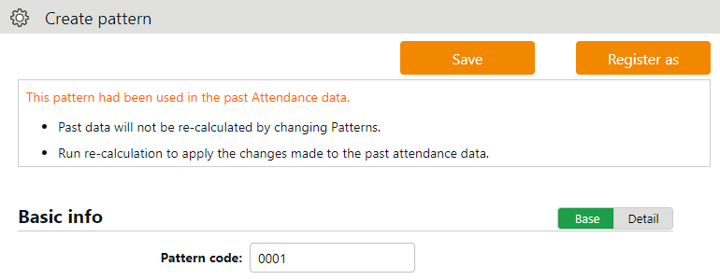

Shows advanced settings. Perform advanced settings from here.
Detail

Normal (regular) work day pattern
Settings > Schedule > Pattern settings
This section describes settings to create regular work day pattern.

Basic info
Pattern code | Enter the code for identifying schedule patterns. Enter in 3-10 alphanumeric characters. Schedule patterns are arranged in ascending order of pattern codes. You cannot use existing codes. | Basic
Pattern name | Enter the name of the pattern in 100 characters or less.  * PDF may not be exported properly if full-byte and half-byte characters are mixed. | Basic
Schedule type | Select [Normal work].  * Once you create a pattern, you can’t edit the associated schedule type. | Basic
Pattern color | Set a color of the pattern. You can set background and font colors. Colors can be used to distinguish different schedules on the Schedule management screen. | Basic
Division to apply | Select divisions that can use this pattern. | Details
Employee type to apply | Select employee types that can use this pattern. | Details

Plan
Clock-in schedule  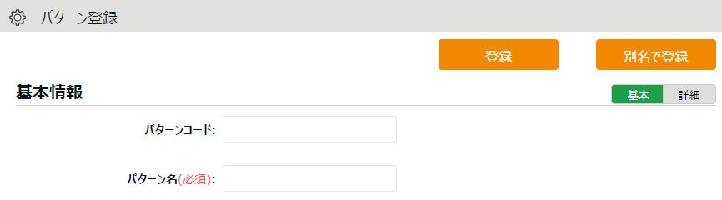  (Core-time start) | Set a clock-in schedule.  Clock-ins later than this time are regarded as late-in. | Basic
Clock-out schedule  (Core-time end) | Set a clock-out schedule.  Clock-outs earlier than this time are regarded as early-out. | Basic
Late-in/Early-out judgment | This counts late-ins and early-outs. Select [N/A] when not in use. | Details
Work fixed start time | This specifies the range of attendance calculation. Regardless of clock-in time, only the hours after the specified time are calculated as work time. | Details
Work fixed end time | This specifies the range of attendance calculation. Regardless of clock-out time, only the hours before the specified time are calculated as work time. | Details
Discretionary work (Deemed work) | Select the calculation method for discretionary work hours during leave. By selecting [Calculate discretionary work hour], the system calculates the deemed work hours during leave based on [start/ end time] | Details

Break schedule
Break setting 1-3 | Employees can take breaks automatically at the specified time.  To add up discretionary work hours, specify how many hours to regard as working hours. Click [Add break] to add a new row. | Basic
Break schedule (hrs) | Specify the duration of auto-break time in minutes. | Details

Half-day work
Add AM work pattern | Add a schedule to take half-day leave in the afternoon.  Click [Settings] to open a pop-up window.
Add PM work pattern | Add a schedule to take half-day leave in the morning.  Click [Settings] to open a pop-up window.

Advanced features
Click on the category name to show setting items.
Force settings of workday type | This pattern overwrites Workday type settings.
Leave category allocation | Selecting [Disable allocation] will prevent the allocation of leave categories when using this pattern.
Note | Enter a description for this pattern.
About [Workday type]
There are 3 types of workday: [Weekday], [Legal time off], and [Non-legal time off].
Workday types determine whether to count working time as regular workday or as work on holiday (legal/non-legal).

Set Workday types as follows.
The priority order is 1 > 2 = 3 > 4 > 5.

1. Override schedule pattern (Force workday type)
2. Set workday type when setting schedules manually
3. Set workday type by submitting schedule requests
4. Set workday type by auto schedule (p.71)
5. Don’t set any workday type

If none of 1 to 4 are specified, workday type is automatically set to [Weekday].
* Workday types are always set to workdays that have schedules or attendance records. You cannot set it to [None].

Holiday settings
Settings > Others > Holiday settings
To handle national holidays as regular holiday or distinguish from other weekdays, perform settings from here.

To schedule national holidays, please refer to [Auto schedule settings] in the following pages.
Holidays are indicated in red font color in Time Card screens, etc.

To add Japanese national holidays
Japanese holidays can be registered automatically or manually.

Auto registration
Holidays for the following year can be automatically registered for the division of your choice. Click on [Auto-registration setting for Japanese national holidays], select the division you want to apply the setting to, and click [Save].
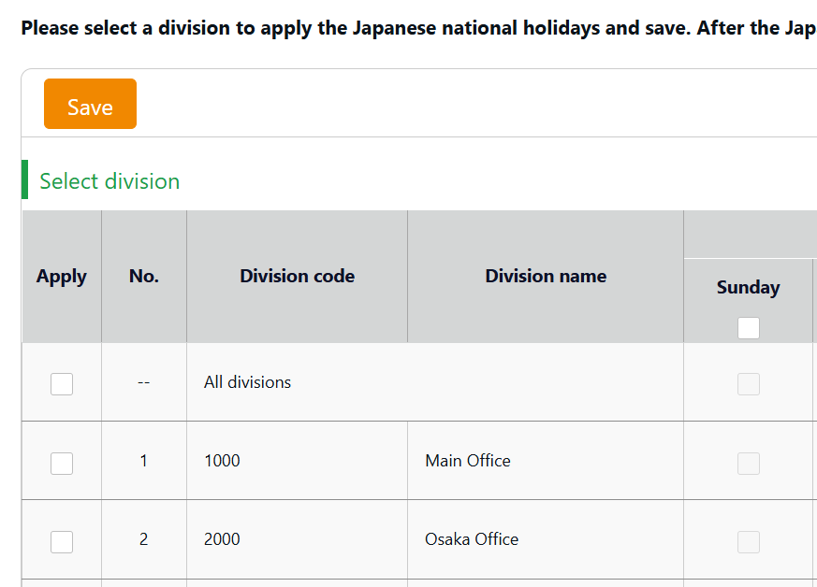

To exclude specific days, please uncheck the corresponding day of the week under Days of the week for auto-registration.
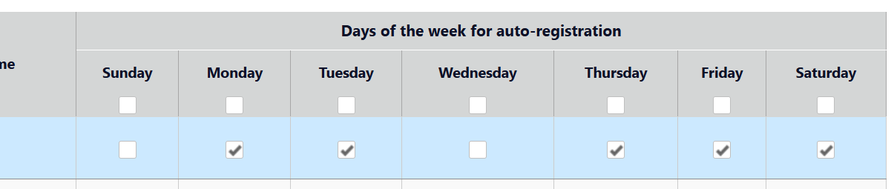
The auto registration takes place before dawn on the first day of each month.

Manual registration
Japanese holidays can be registered manually at any time.
To add Japanese national holidays, click [Add Japanese national holiday] to view the list of national holidays.
Select division(s) to apply the holidays and click the [Registration] button.

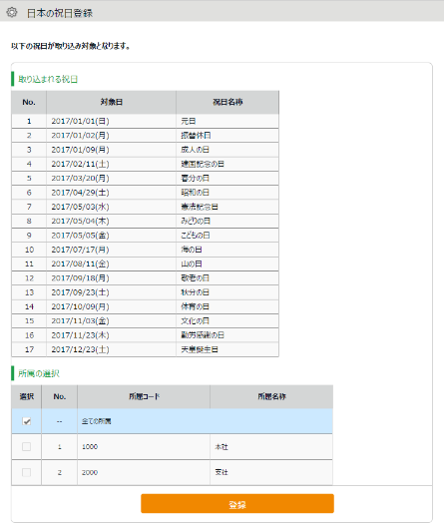
※This screenshot shows the Japanese version of the screen.
Around mid-February each year, the server side of this system will prepare the following year's holiday data. Then, you are ready to apply the holidays manually.

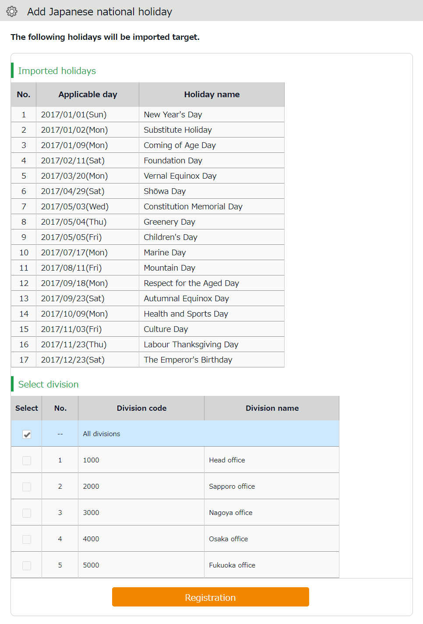

Add custom holidays manually
To add custom holidays such as your corporate anniversary, click [New registration].
Enter the name, date of the holiday, and select divisions to apply the holiday. Click the [Save] button.

Auto schedule settings
Settings > Schedule > Auto schedule settings
This feature adds schedules automatically.
Set schedules for each day of the week. The schedules are created according to different employee types and division.

Descriptions
Specify the display condition

Specify a division, employee type, etc.
Click [Show] to view data.

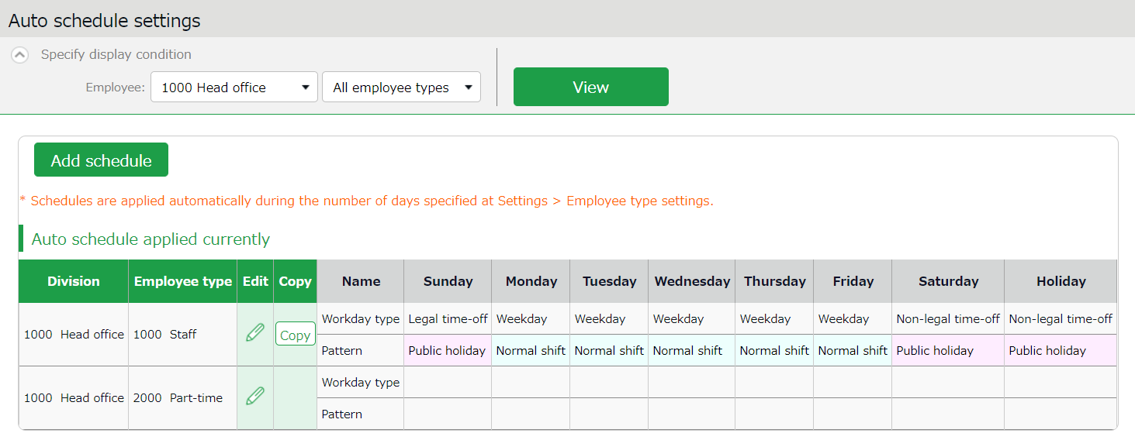

1ｚ
2ｚ

Currently applied auto schedules

Shows Auto schedule.
The schedules are created by different employee types in each division.

No. | Buttons | Description
1 | 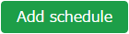 | Adds a schedule to all employees displayed on the screen.
2 | (Edit) | Configures settings for employee types in each division.
2 | 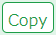 | Copies auto schedule settings to different employee types and divisions.

Setting instructions
Click [Add schedule] or [Edit] in the Auto schedule settings screen.
Specify a [Workday type], [Pattern] or a [Leave type] for each weekday.

Workday type | There are 3 types: [Weekday], [Legal time off], and [Non-legal time off].  Workday types determine whether to count working time as regular workday or as work on a holiday (legal/non-legal).
Patterns | Set a schedule pattern you want to set automatically.
Leave type | Set a leave type you want to set automatically.

When auto schedule settings are reflected
Auto schedule settings are registered under the following circumstances.

When clocking-in/out
Schedules are added automatically when employees clocks-in/out or edits the attendance data.
This won't overwrite existing schedules.

Once a day (night time)
The schedules of the employees are registered when the system runs a regular update (takes place once a day during night).
Settings in [Home page > Settings > Employee type settings > Edit screen > Days to apply Auto schedule] are needed before beginning. The settings are enabled from the following day of the setting.
You can’t apply new auto-schedules to past records and existing schedules.
You cannot apply auto schedules to employees with Resignation date set in
the Employee setting page.

Workstyle reform-related settings

Set the upper limit regulations of overtime
Until now, when a "36 Agreement" has been concluded, the upper limit for overtime work was set "in principle, no more than 45 hours per month and no more than 360 hours per year," and any overtime work more than this limit was considered illegal.
However, "special clauses" made it possible to have unlimited overtime work.

The "Overtime Work Limit Regulation” stipulates overtime work limit based on 36 agreements, and sets an upper limit for overtime in work that applies to special clauses as well.

After revision

◆Overtime work under 36 agreements shall be limited to 45 hours per month and 360 hours per year in principle.

◆Special clauses exceeding 45 hours may only be applied up to 6 times a year.

◆Even in the case of special clauses, overtime shall be less than 100 hours per month including holidays,
and the maximum overtime hours per year shall be 720 hours or less.
* In case of business operations involving automobile driving, 960 hours per year

◆The average total hours of overtime and holiday work for multiple months (two to six months)
must not exceed 80 hours.
* Does not apply to business operations involving automobile driving.

This product allows you to manage your employees' overtime work.

Set the [Contract limit] and [Alert] for overtime
Set the [Contract limit] and [Alert] for overtime as follows.

Employees who have worked a certain number of overtime hours are listed, allowing the admin to grasp the actual status of employee work and prevent excessive overtime work.

To set the upper limit regulations of overtime
1. Go to the Admin home screen > Settings > Others > Workstyle reform settings > Upper Limit Regulations of Overtime and click [Create New].
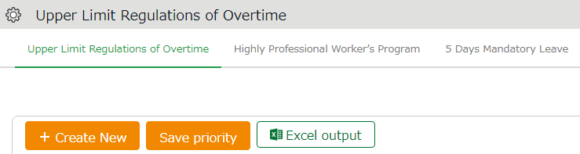

- Enter the Basic info.
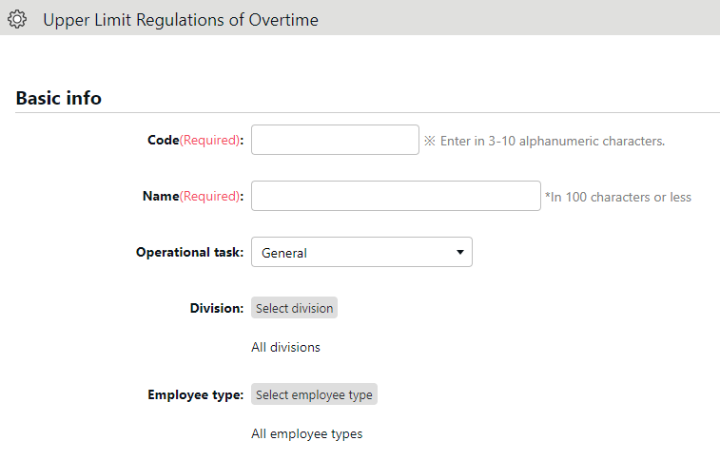

  - Specify the Code and Name to identify the setting about to be used.
  - Choose [General] or [Automobile driving operations] for the operational task.
  - Filter the applicable employees by division or employee type.

Choose [General] or [Automobile driving operations] under [Operational task]. Your choice will cause differences as follows.
*Hidden when [Automobile driving operations] is chosen.
*720 hours/960 hours
You can perform optimal setting for your business by switching the options at [Operational task].

- Set the basic overtime work limitation. The default for Contract limit is set to the upper limit of the 36 Agreement, and the default for Alert is set to 80% of the maximum value, respectively.
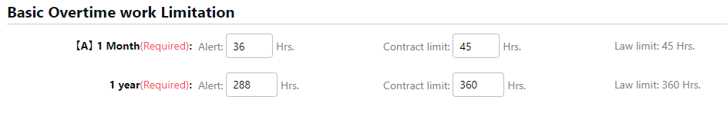

- Set the [Overtime plus holiday working limitation].
*Hidden when [Automobile driving operations] under [Operational task] is chosen.
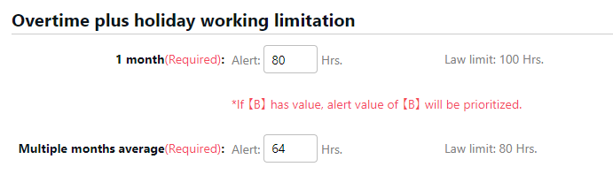

The default for Contract limit is set to the upper limit of the 36 Agreement, and the default for Alert is set to 80% of the maximum value, respectively.

If the Contract limit is entered and the Alert time is unspecified, a time equivalent to 80% of the Contract limit is automatically set as Alert time.

The values that can be entered are as follows
- [Alert] -> Value less than the contract limit
- [Contract limit] -> Number within the law/legal limit

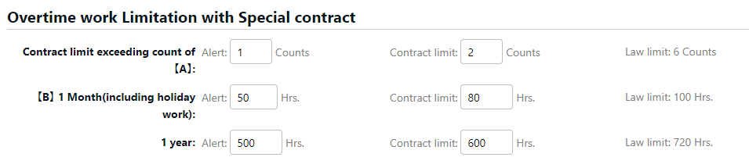
5. Set the [Overtime work Limitation with Special contract].
If [General] is selected under operational task

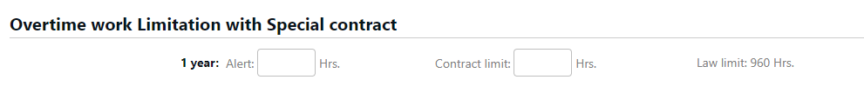
If [Vehicle driving tasks] is selected under operational task
The values that can be entered are described below.
- [Alert] -> Value less than the contract limit
- [Contract limit] -> Number within the law/legal limit
Please enter values for all special clauses.

Alert target/subject
Employees who have reached the number of hours set for each alert and employees who have "exceeded" the limit for each report will be listed as alert targets.
Specifying the legal limit in the "Upper Limit" item will inform you of the members who are subject to penalty.
If you wish to receive notice of the upper limit before penalty applies, we recommend that you enter an upper limit value that is less than the legal limit. Employees who reached the legal limit of 1 month’s [Overtime plus holiday working limitation] or has exceed the legal limit of [Multiple months average] are also subject to the alert.

To check which employees have reached the alert and maximum standards
To check for employees who have reached the alert and maximum standards, follow the description below.

Click on the [All menu] in the top of the management screen and click [Workstyle reform alert].
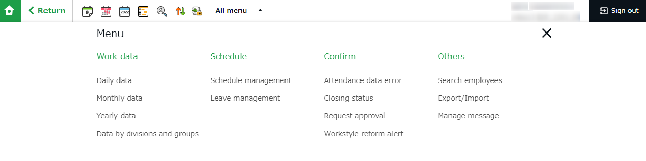

Click [View] to show the list of employees who have reached the alert and maximum criteria.

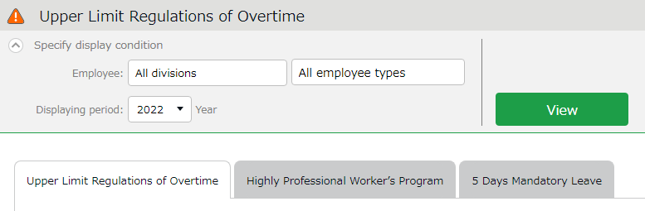

Click on [Detail] to the right of the employee's name to see which alert and upper limit criteria have been reached.
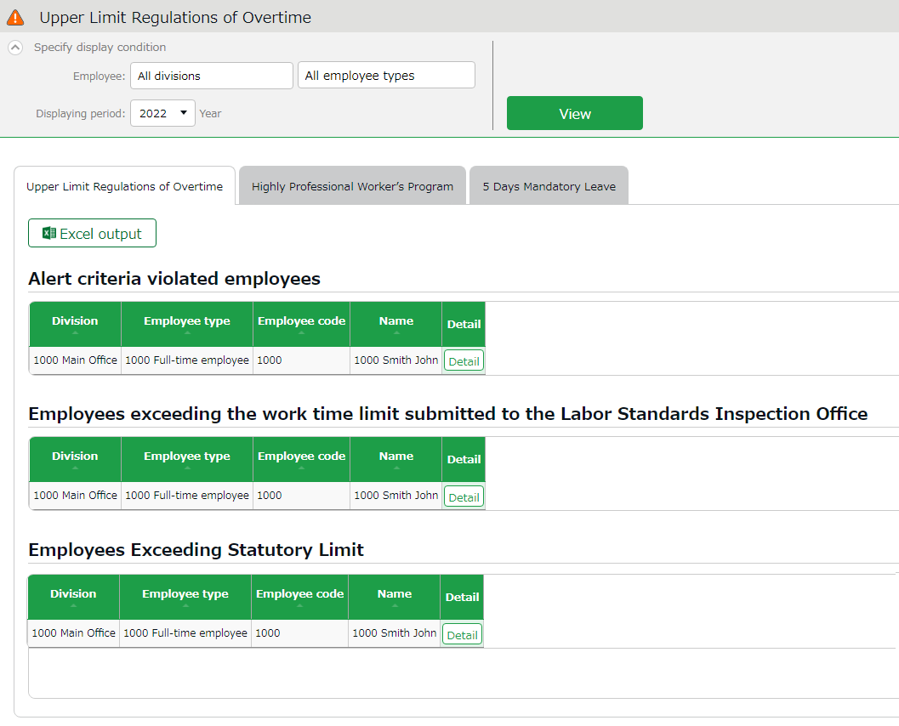

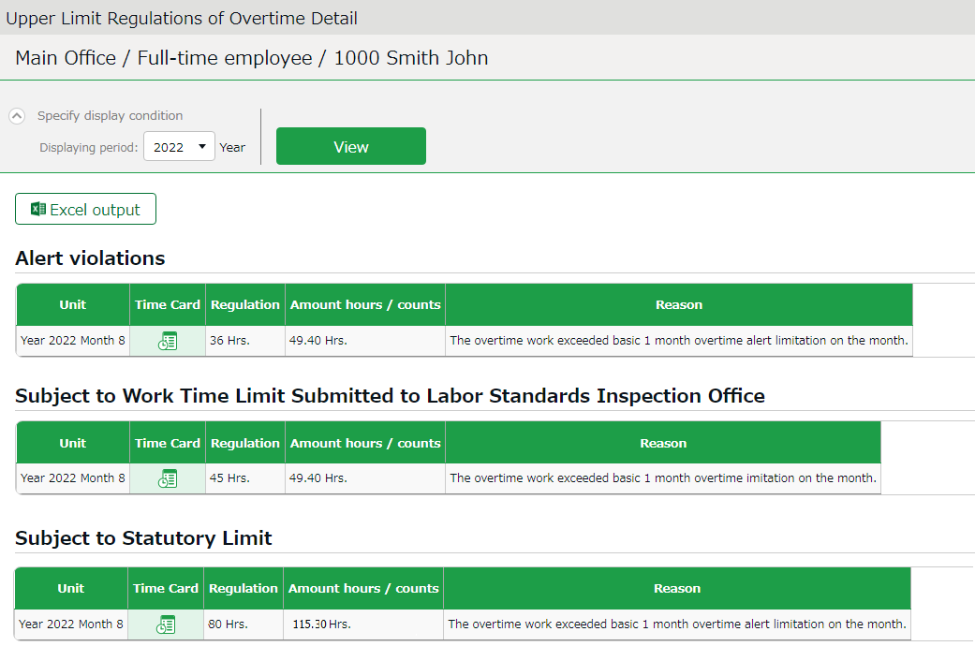

Shows the time record data in subject.
Unit

Shows the Condition Time/Count set.
Condition Time/Count

Shows the actual data.
Time/Count

Shows which alert and upper limit criteria have been reached.
Reasons

Time Card

Click here to open the Time Card for the corresponding month.

If any employee has reached the warning or limit criteria, an alert will also appear in the [Attention] section of the Home screen.
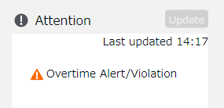

You can also click here to go to view the list of employees.
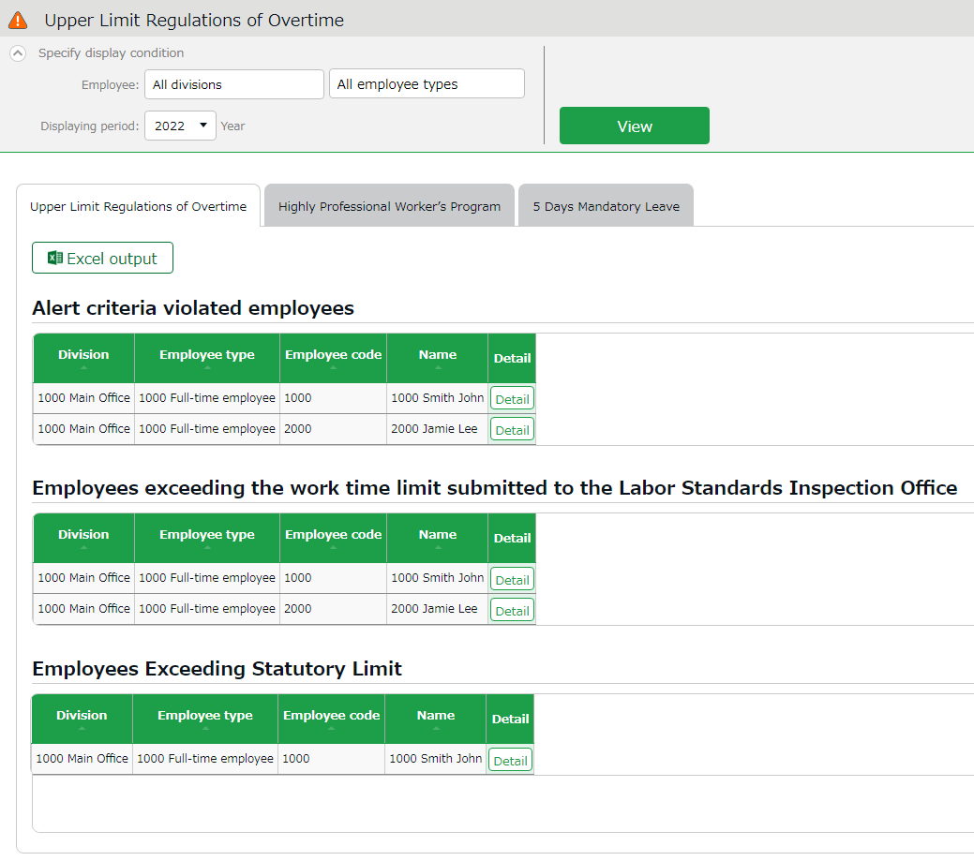

Set up the Highly Professional Worker’s Program settings

Japan’s “Highly Professional Worker’s Program” exempts "workers with a high level of expertise and a certain annual income" from regulations concerning extra wages for overtime, holidays, and late-night work, and pays them based on the value of their work, not on the hours they work.

When applying the Highly Professional Worker program, a labor-management committee must be established at the workplace and a resolution must be passed by four-fifths or more of the workforce, and the consent of the eligible workers themselves is required.

Violations are subject to penalty.

Applicable occupations
Development and dealing of financial products, analyst, consultant, research and development work, etc.
*Specified by Ordinance of the Ministry of Health, Labor and Welfare.

Eligible Workers
Workers with an annual income of 10.75 million yen or more, a level considerably higher than three times the average salary based on statistics from the Ministry of Health, Labor and Welfare.

In addition, the following health measures are required.
◆ Obligation
At least 104 days off per year

◆ Optional (Implementation of one of the following)
・Maximum time in the office
・Intervals between work
・2 consecutive weeks of vacation (104 mandatory holidays + 2 consecutive weeks of leave)
・Non-regular health checkup

This product allows you to set up and manage the "Highly Professional Worker's Program" for each employee.
You can set the minimum number and the alert threshold of the mandatory days off, the employees to be covered, and the health measures to be applied.
By displaying the list of employees who apply to the above settings and alerting managers, overwork can be prevented before it occurs.

To perform the Highly Professional Worker’s Program settings
- Go to the Admin home screen > Settings > Others > Workstyle reform settings > [Highly Professional Worker’s Program].
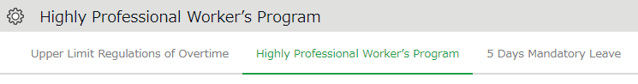



- After clicking [Create New], the following screen will appear.
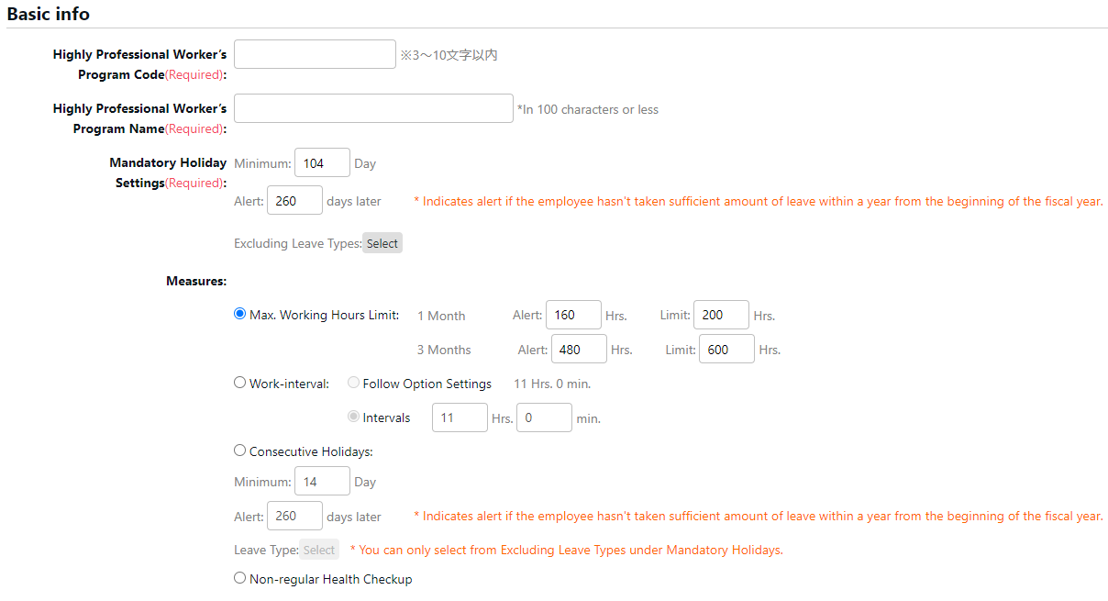

2. Enter the code and name for the setting.
The easier it is to understand which health measures to be selected, the divisions and employee types to be covered, the easier it will be to make subsequent employee selections.

Example: Highly Professional Worker’s Program Code: 001, Highly Professional Worker’s Program Name: Consecutive leave
Highly Professional Worker’s Program Code: 002, Highly Professional Worker’s Program Name: Laboratory S
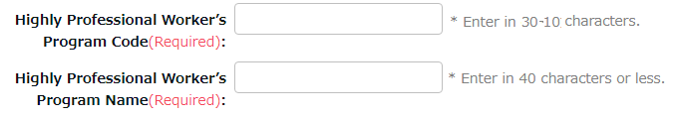

3. Perform the [Mandatory Holiday Settings] setting.
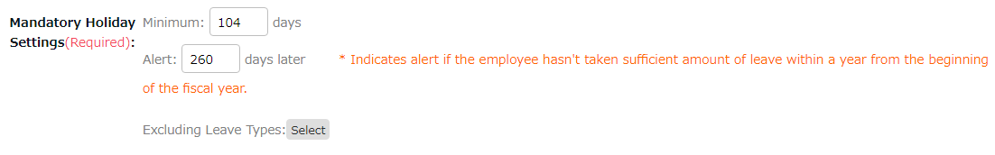

Calculate one year from the beginning of the fiscal year.

Since mandatory holidays are required by law to be at least 104 days, the minimum range of values you can set is 104 to 360.

Set the number of alert days to notify the manager when an employee has not reached the minimum number of days off. The range of values you can set for the alert is 1 to 360.

In addition, you can click on [Excluding Leave Types] and select [Absent] or other types of leave that does not count as mandatory holidays.



Depending on the number of days set for [Alert], unused holidays may not be fully taken at the time the warning message has appeared.
Example: In case of setting [330] days for alert.
After 330 days, an alert had appeared, but the employee in question had taken only 60 days off.
The employee must take the remaining 44 days off, but there are not enough days left until the end of the year (35 days left).

Please be sure to set a manageable number of days.

4. Set the [Measures].
In Measures, select one of the four options to set up.
Click on [Save] when finished.
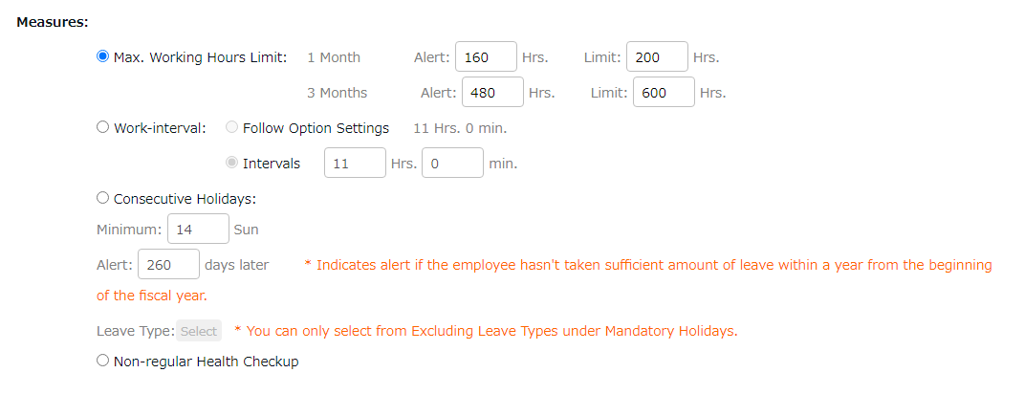

Max. Working Hours Limit
This feature covers the [Hours in office].
Please refer to the Definitions section in the contents below to determine which hours are calculated for time in office.
https://support.ta.kingoftime.jp/hc/en-us/articles/360038341594

Set the [Contract limit] value and the [Alert] value to notify the hours in office for [1 month] and/or [3 months].
The [Contract limit] time can be set to the [1 month setting] or [3 month setting], and the [Alert] time can be set to notify the admin when an employee’s total hours in office is likely to reach the [Contract limit].

There is no legal provision for the number of hours specified in [Contract limit].
Please set the number of hours in consideration of your company’s upper limit regulations of overtime.

If [Alert] time is unspecified, a time equivalent to 80% of the [Contract limit] is automatically set.

Work-interval
Set the number of hours required between the end of the previous day's work and the beginning of the next day's work.
To apply the same settings in Home screen > Settings > Options > [Count shortages of intervals between work], select [Follow Option Settings].
For details on the [Count shortages of intervals between work] setting, please refer to the following article.
https://support.ta.kingoftime.jp/hc/en-us/articles/360038340954

To apply a different setting, select [Intervals] and set the number of hours.
The range of values you can set for the alert is 0 hours 1 minutes to 12 hours 0 minutes.

Consecutive Holidays
Set the minimum number of consecutive leaves to be taken.
The minimum value you can set is [14] days.

In [Alert], set the number of days to notify the admin if an employee has not taken the minimum number of days of leave specified. This can be set in the range of 1 to 360.

You can select which type of leave to count as consecutive leave from [Select].
Since you are required to manage them separately from the 104 days of Mandatory Holidays, only leave types that are not specified as Mandatory Holidays are displayed in the Consecutive Holidays field.

Consecutive holidays are regarded as consecutive if the leaves have no workday in between.
Therefore, consecutive holidays are still regarded as consecutive even if an employee takes a leave type not specified as consecutive or mandatory holiday in between.

Example: Select only "Special Leave" in [Select].

× Do not count as consecutive leave
April 01 | April 02 | April 03 | April 04 | April 05 | April 06 | April 07 | April 08 | April 09 | April 10
Special leave | Special leave | Special leave | Special leave | Workday | Workday | Special leave | Special leave | Special leave | Special leave

〇 Count as consecutive leave
April 1 | April 2 | April 3 | April 4 | April 5 | April 6 | April 7 | April 8 | April 9 | April 10
Special leave | Special leave | Special leave | Special leave | Public holiday | Public holiday | Special leave | Special leave | Special leave | Special leave

Non-regular Health Checkup
Apart from the options, no special settings are required here.
Since health checkups cannot be managed within this product, alerts cannot be displayed.
Please manage this separately in another product.

5. After providing the details for the setting, the new Highly Professional Worker’s Program setting will be displayed. Click on [Select employee].
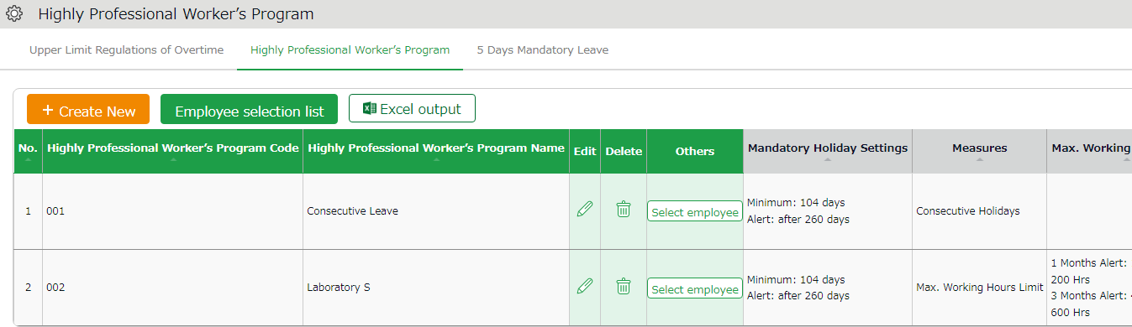

6. In the following screen, select the employees to apply the Highly Professional Worker’s Program.
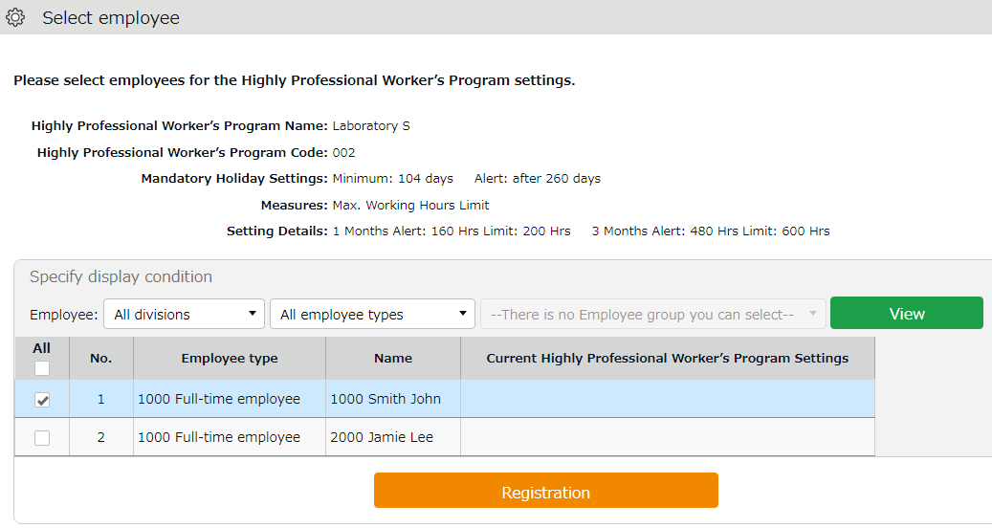

To check which employees have reached the alert and maximum standards
To check for employees who have reached the alert and maximum standards, follow the description below.

Check

Click on the [All menu] in the top of the management screen and click [Workstyle reform alert].

Click on the [Highly Professional Worker’s Program] tab.
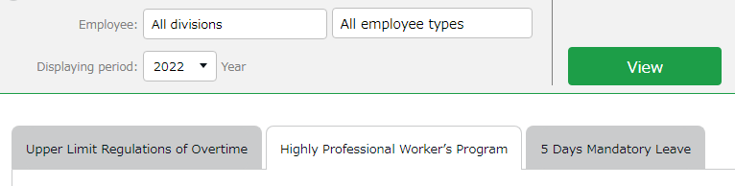



Employees who have reached the warning criteria are displayed in a list.
* Employees who have reached the limit are shown in the [Employees in Breach of Contract] list.
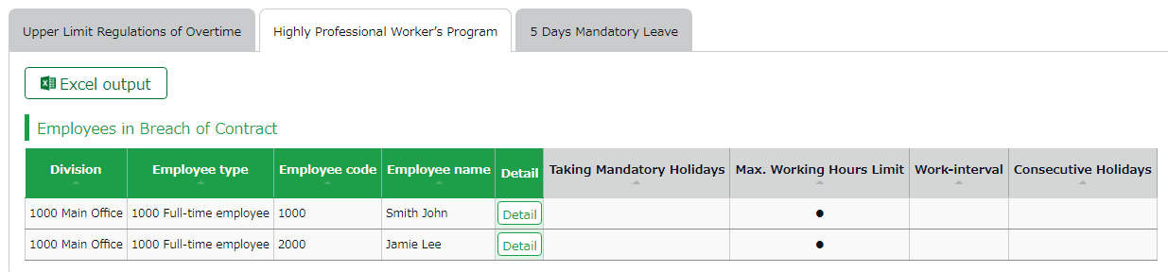

* Since health checkups cannot be managed within this product, items are unavailable.

Click on [Details] to the right of the employee's name to view which alert and upper limit criteria have been reached.
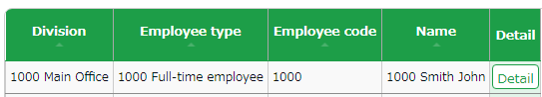

The [HL Pro Program Alert] alert in the Attention of the home page indicates that there are one or more, based on Employee data.
You can also click here to go to view the list of employees.
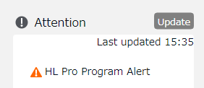

To perform the 5 Days Mandatory Leave setting
Compared to other countries, Japanese people tend not to take time off from work, and few take paid leaves out of consideration for the workplace or out of hesitation.

To improve this situation, it has become mandatory for employees who are granted 10 or more days of paid leaves per year to take at least 5 days of paid holidays per year.
Violations are subject to penalties.

This product can alert managers at any time of the year of employees who have not taken 5 or more days of paid leave per year.
Employees who have been granted 10 or more paid leaves using the Paid vacation grant function are eligible for this feature.
If an employee does not take 5 or more days in a year, an alert will be displayed, and a list of employees who require attention can be viewed.
The timing of the alert can be set as needed.

Steps for 5 Days Mandatory Leave setting

1. Go to the Admin home screen > Settings > Others > Workstyle reform settings > [5 Days Mandatory Leave].

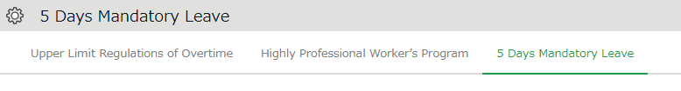

2. Set the timing for the alert and click [Save].
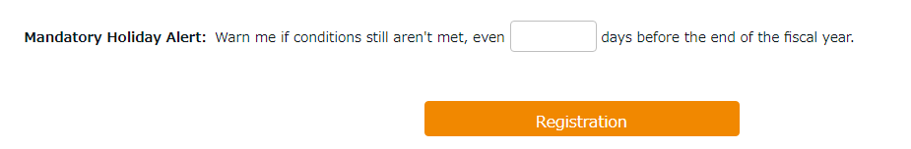


We don't want a lot of employees to take off all at once, so we must set up a generous number of days.
Let’s take the busy season into account and consider the number of days carefully!

Period and number of mandatory leaves
Basically, it is obligatory to take at least 5 days of paid holidays in a year from the date the paid holidays are granted (i.e., the base date). The number of days required to be taken is calculated as follows.

Cases in which the period and the number of mandatory leaves remain the same

◆1 In case at least 5 days of leave must be taken within one year from the grant date (Starting October 1 until September 30 of the following year).
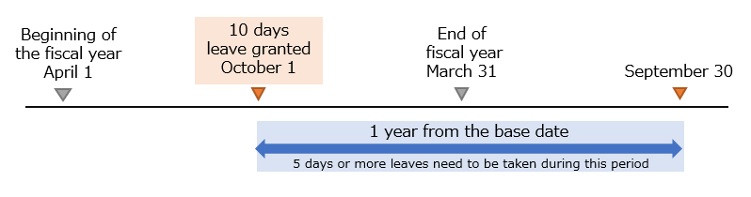

◆2 In case more than 10 days of leave scheduled to be granted on October 1 were granted in advance on April 1.
At least 5 days of leave must be taken within one year from the base date (Starting April 1 until March 31 of the following year).
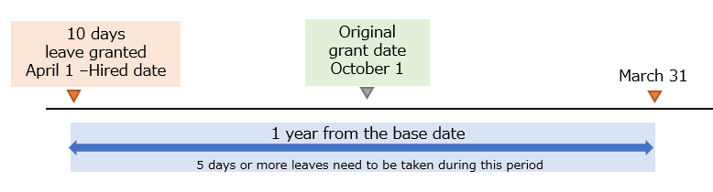

Cases in which the period and the number of mandatory leaves vary
The period and the number of days required to be taken may vary in cases where some leaves are granted in advance, or in cases where more than 10 days are granted multiple times within a year and the effective periods overlap.

◆3
In case more than 10 days leave have been granted more than twice within a year (on October 1 and April 1 in the following year).
The performance period shall be from the beginning of the first period (October 1) to the end of the latter period (March 31 of the following year). At least the equivalent of 5 days per year (18 months ÷ 12 × 5 = 7.5 days must be taken within that period.
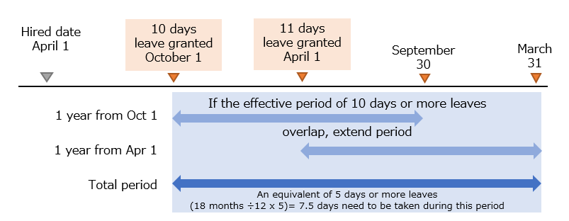
The base date for the end of the alert period is the end date of the last period (March 31 of the following year).

* The above pattern is likely to be applied when the first and the second set of leaves are granted using the [Grant based on the approval date] method under Paid leave grant method.

◆4
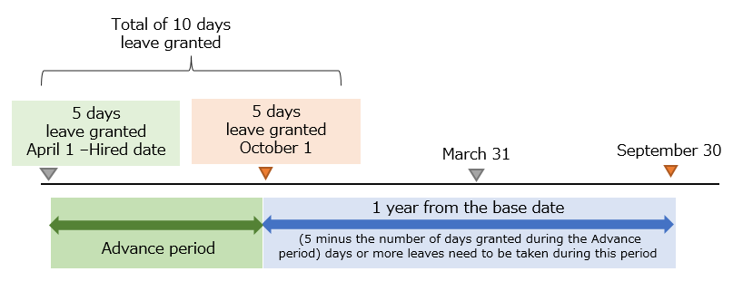
In case 5 days of leave were granted in advance (on April 1), and 5 days granted on the original grant date (October 1). As the latest grant date as the base date, the employee must take the number of leaves granted in advance (04/01) minus the number of days granted on the base date (10/01).
The specified number of days must be taken within a year (from October 1 until September 30 of the following year).

Example: If 3 days are taken between April 1 and October 1, then 5-3 = 2 days need to be taken between October 1 and September 30 of the following year.

The system can send Email notifications to admins and employees if they have not taken a minimum of 5 days of annual leave before the specified number of days.
For details, please refer to p.104.

Check who is alerted
Identify employees who have not taken at least 5 paid holidays per year.

How to check

Click on the [All menu] in the top of the management screen and click [Workstyle reform alert].

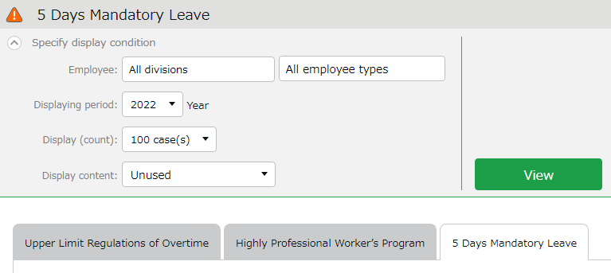
Click on the [5 Days Mandatory Leave] tab.

You can check the info not covered by the alert from this menu.
Unused (Before alert)
Displays employees who have not yet reached the alert date and have not taken their 5 days mandatory leave.
Used
Shows the employees who have taken the 5 days mandatory leave.
Click [View] to show the list.
Display content
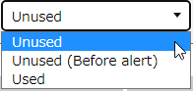

The following list of employees will be displayed.
(This is an example of a screen from the Japanese version)
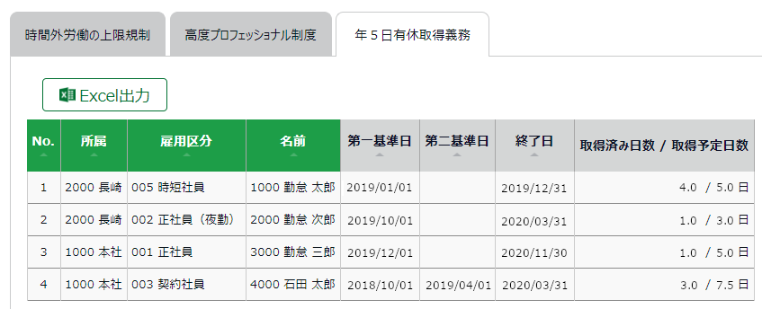

*1

*2

*3

*1 Same as in ◆1 (Cases in which the period and the number of mandatory leaves remain the same)
Here is the basic period and the number of leave days expected to be taken.
5.0 days (= Planned Leaves) must be taken between January 1, 2019 (= First base date) and December 31, 2019 (= End date). Currently, 4.0 days (= Leaves Taken) are taken.

*2 Same as in ◆2 (Cases in which the period and the number of mandatory leaves vary)
This is the case where some number of leaves are granted in advance.
3.0 days (= Planned Leaves) must be taken between October 1, 2019 (= First base date) and March 31, 2020 (= End date).
(-> 2.0 leaves are taken between the advance grant date and October 1, 2019.)
Currently, 1.0 days (= Leaves Taken) are taken.

*3 Same as in ◆3 (Cases in which the period and the number of mandatory leaves vary)
This is the case where more than one set of 10 (or more) leaves are granted within a year.

First, 10 or more days are granted on October 1, 2018 (= First base date), then 10 or more days are granted on April 1, 2019 (= Second base date).

7.5 days (= Planned Leaves) must be taken between October 1, 2018 (= First base date) and March 31, 2020 (= End date).
(→ 18 months ÷ 12 months × 5.0 days = 7.5 days)
Currently, 3.0 days are taken.

If any employee has reached the warning criteria, [5 days mandatory leave] alert will appear in the [Attention] section in the home screen.
You can also click here to view the list of employees.

Use the Email notification feature
The "Notification Settings" allows employees and managers to be notified by e-mail if they have forgotten to clock in or failed to apply for overtime work.
Seven types of notification settings are explained.

Missing time record notification
The system can send notifications if no time record is made by the scheduled time.
You can also send Emails to remind employees to clock-in/out before time.

Basic info
Specify when and who to notify.

You can set notification conditions by Time record types. (Clock-in/out, Start/End break, etc.)
The system sends notification [0 to 60] minutes [before/after/before and after] the scheduled time has passed.
You can set it [Before], [After] and [Before and after] the scheduled time.
Before | The system sends notification __ minutes before the scheduled time.  This is useful to prevent employees from forgetting to clock-in/out.
After | If no clock in/out is recorded by the specified time, the system sends a notification ___ minutes after the schedule. Use this setting to notify employees that they have forgotten to clock-in-out.
Before and after | The system will send notification ____ minutes after and before the scheduled time.
* The Missing Time record notification feature only supports Japan time.
Notification timing

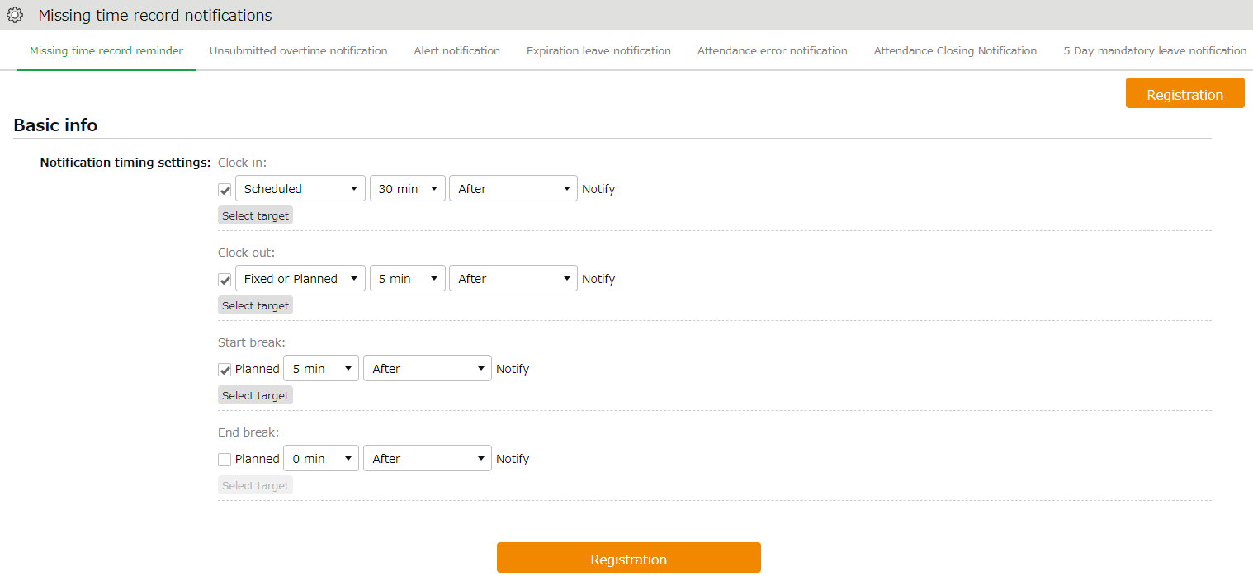
Notification ON/OFF

Select notifying Time record type.

Select notifying/monitoring users. (see following pages)
Select target notifying/monitoring users.

Saves changes.
Registration

Choose [Schedule] or [Fixed or planned].
Example: Send reminder 5 minutes after specified time.
1st drop-down: Select [Fixed or planned]
2nd drop-down: Select [5 min]
3rd drop-down: Select [After]
Select Schedule

Select notifying/monitoring users.
From the [Select target] button, you can confirm the list of notifying employees.
The same instruction applies to all notification related settings.
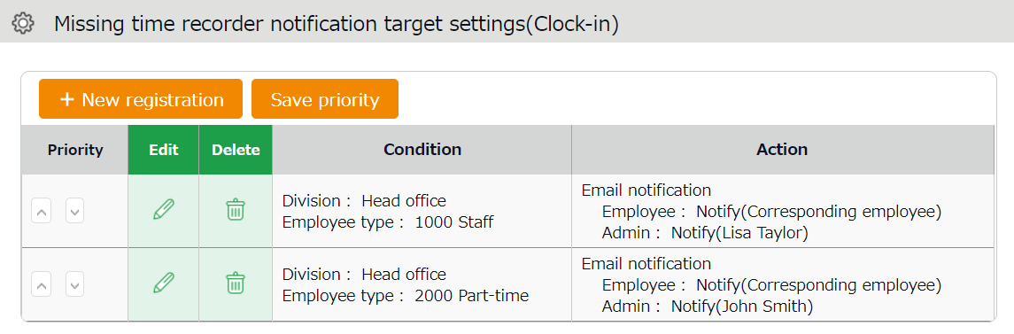
2ｚ
1ｚ

3ｚ
4ｚ

No. | Buttons | Description
1 | New registration | Creates notification target setting.
2 | Save priority | Saves changes to priority.
3 | Priority | Set priority if you have multiple conditions. The one closer to the top is prioritized. You can change the order using the up and down buttons. Click [Save priority] to save changes.
4 | Edit / Delete | Edit or delete condition.

You can set Notification target settings from [+ New registration] or the (Edit) button.
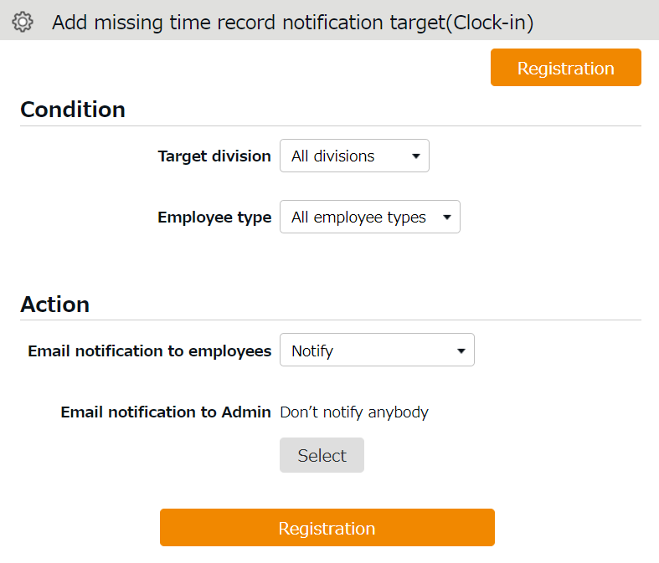
1ｚ

2ｚ

3ｚ

No. | Item | Description
1 | Condition | Shows Division and Employee type to notify.
2 | Action | Shows whether you notify specified employees and Admins or not. You can decide which Admin to notify, from the [Select] button.
3 | Save | Saves changes.

Unsubmitted overtime notification
The system can notify unreported overtime in the previous day and unapproved overtime requests by Email.

Basic info
By selecting [Apply], at [Notification feature], you can set Notification Timing.
Click the [Save] button to save (Note: The system will reset existing Email template upon saving this setting.).

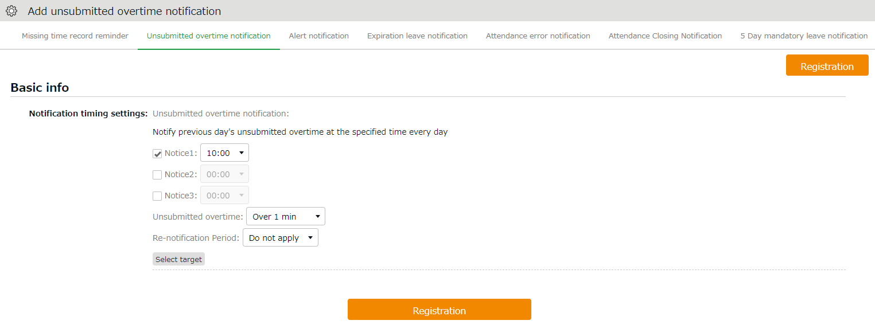
Cl
Notification timing

You can choose from every 30 minutes throughout the day (*).

The system will notify unreported overtime that exceeds the specified amount of time. You can choose the amount of time ranging from [1 minute or more] to [120 minutes or more].
Unsubmitted overtime

Same as in Missing time record notification (p.96).

Select target

* [09:00] and [09:30] are disabled to reduce server load. Existing notifications set to these options will function, but you cannot re-select the same option once you change the setting.

Alert notification
Settings > Others > Notification settings > Alert
Notifies you by Email when the attendance data exceeds the specified value.

Basic info
Set up email notifications using the conditions set in Settings > Screen display > Alert settings (p.105). To receive a notification when the attendance data reaches or exceeds the threshold, check the box next to the name of the alert setting (Email notifications are not available for conditions set to [or less] or [less than] the specified time).

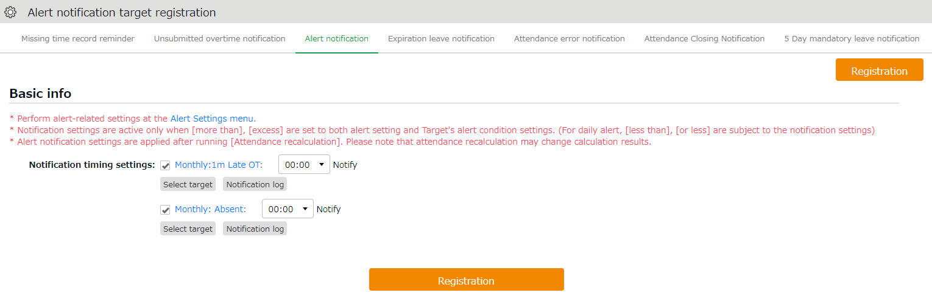
Notification Log

If the alert setting applies for monthly data, you can check the notification results in the Alert Notification Target screen.

You can choose from every 30 minutes throughout the day (*).
Notification Timing Settings

Select target

Same as in Missing time record notification (p.96).

* [09:00] and [09:30] are disabled to reduce server load. Existing notifications set to these options will function, but you cannot re-select the same option once you change the setting.

Alert notification target
If the alert setting is aimed at monthly data in the Alert settings screen (（p.105), you can check the notification log in this screen. You can use this feature to check how the alert notification was sent.
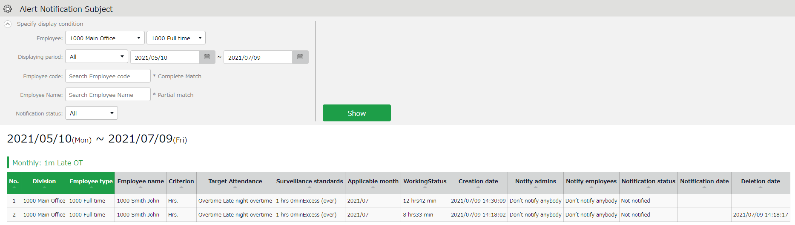

You can also narrow down your search by various criteria other than divisions and employee types.
Notification status:
- Notified (Notification Email sent)
- Not notified (Notification Email not sent)
Specify the display condition
* There may be a time lag of a few minutes
between the notification time setting and the actual notification date.

Settings > Others > Notification settings>
Expiration Leave Notification

Leave Expiration Notification
This setting alerts leaves that are expiring soon.

Basic info
To enable the leave expiry notification, ensure the following.
- [Calculation method of leaves when obtained] is set to [Subtract].
- [Valid period] is specified. Click the [Save] button to save the settings.
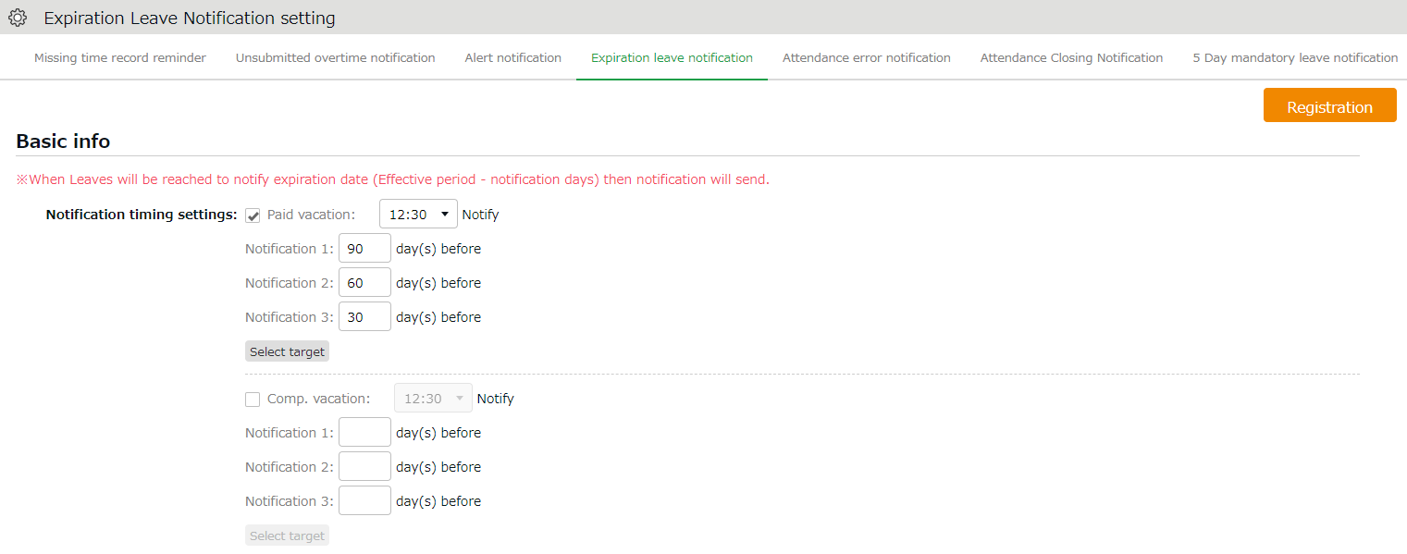

You can choose from every 30 minutes throughout the day (*).
Notification timing

Specify when to send the notification (__ days before expiration).
Notify _ days before expiry date
Select target

Same as in Missing time record notification (p.96).

* [09:00] and [09:30] are disabled to reduce server load. Existing notifications set to these options will function, but you cannot re-select the same option once you change the setting.

[Attendance data error notification]
- Settings > Others > Notification settings >
- Attendance data error
The system can send notifications to employees and administrators when attendance error occurs.

Basic info
The system can send notifications to employees and administrators when attendance error occurs.
The following are notified:
- Attendance data error
- No time record/ Schedule set (*1)
- Time record/ Schedule not set (*1)
- Consecutive work (*2)

*1 To enable this feature, select [Display] at Options > Attendance data error settings.
*2 The system will keep sending the notification every day, in case the number of consecutive working days reaches the threshold.
nsecutive w aches the threshold.
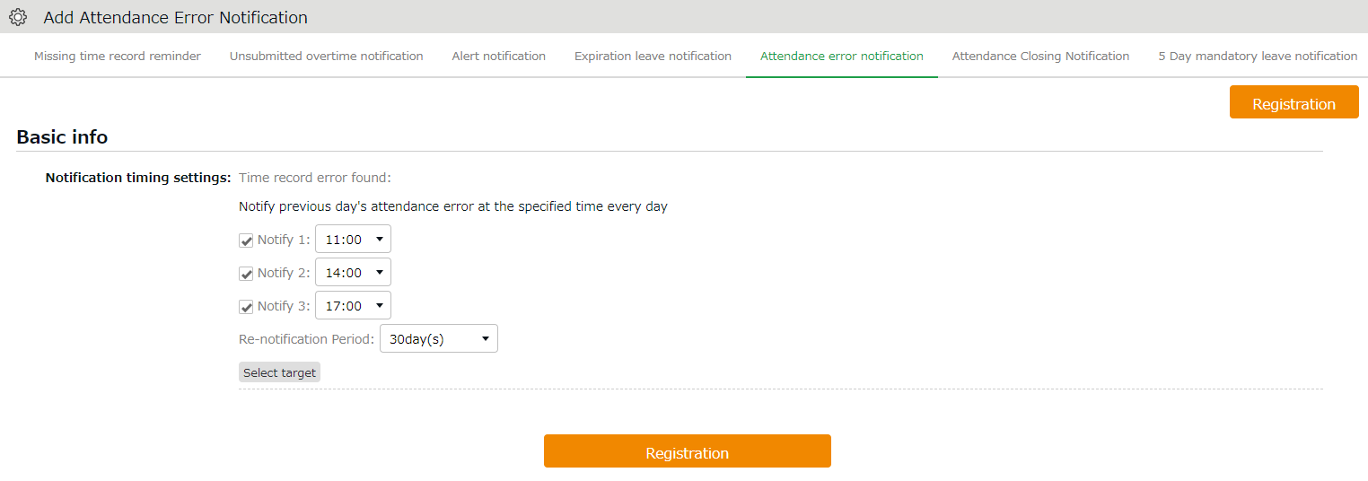

You can set notifications up to 3 times a day, in minimum 30 minutes intervals (*).

Notification timing

If you select an option other than [Do not use], you receive Email notifications regarding attendance data error ranging from the specified number of days until the day before.
The system continues to send the notification until the error is corrected.
Renotification Period

Same as in Missing time record notification (p.96).

Select target

* [09:00] and [09:30] are disabled to reduce server load. Existing notifications set to these options will function, but you cannot re-select the same option once you change the setting.

Attendance Closing Notification
- Settings > Others > Notification settings >
Attendance Closing Notification
If the Close Attendance feature is active, you can send remind admins by Email. If the Attendance Confirmation feature is active, you can send the reminder to admins and employees.

Basic info
The system can send notifications to employees and specified Admins when attendance data have not been closed or confirmed.
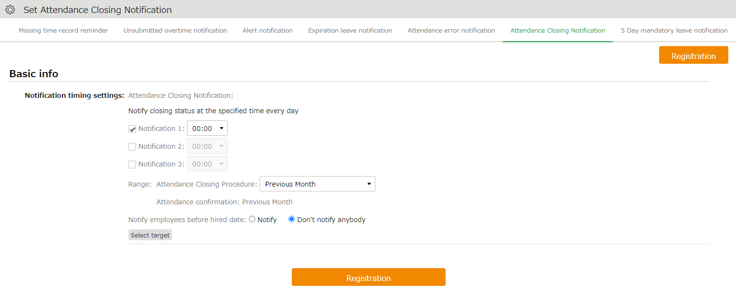

Notification Timing Setting

You can choose from every 30 minutes up to 3 times per day (*).

Specify the check range. Available options depend on the settings.
Range

Notify employees before hired date

Same as in Missing time record notification (p.96).
Select target

Specify whether to notify employees before the hired date.

*1: [09:00] and [09:30] are disabled to reduce server load.
*2: Not available if the Close Attendance feature is disabled.

5 Days Mandatory Leave Notification
- Settings > Others > Notification settings >
5 Days Mandatory Leave Notification
The system can notify admins and employees of the 5 day mandatory leave by Email.
This will encourage employees who have taken less than 5 days of annual leave to take more leave. Admins can also check the alert on the admin screen, but Email notifications allow them to keep track of their employees’ mandatory leave status even while they are not logged in.

Basic info
The system can send Email notifications to admins and employees if they have not taken more than 5 days leave within a year.
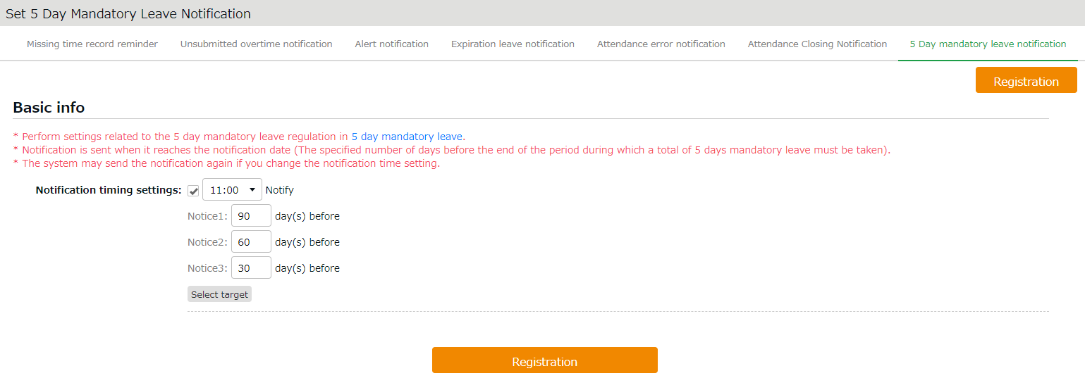
Select target

You can choose from every 30 minutes throughout the day (*).
Notification timing

Notify _ days before end of year

Specify when to send the notification (__ days before the end of the 5 day mandatory leave period).

Same as in Missing time record notification (p.96).

* [09:00] and [09:30] are disabled to reduce server load. Existing notifications set to these options will function, but you cannot re-select the same option once you change the setting.

Alert Setting
By using Alert settings (Settings > Screen display > Alert settings), you can filter attendance data that has exceeded or under a certain value on the daily or monthly data screens. You can also combine this feature with the alert notification setting（p.100）to send Email notifications when attendance data reaches the conditions specified in the alert setting.
* You cannot use the Email notification feature if the condition is set to "or less" or "less than".

Alert Setting
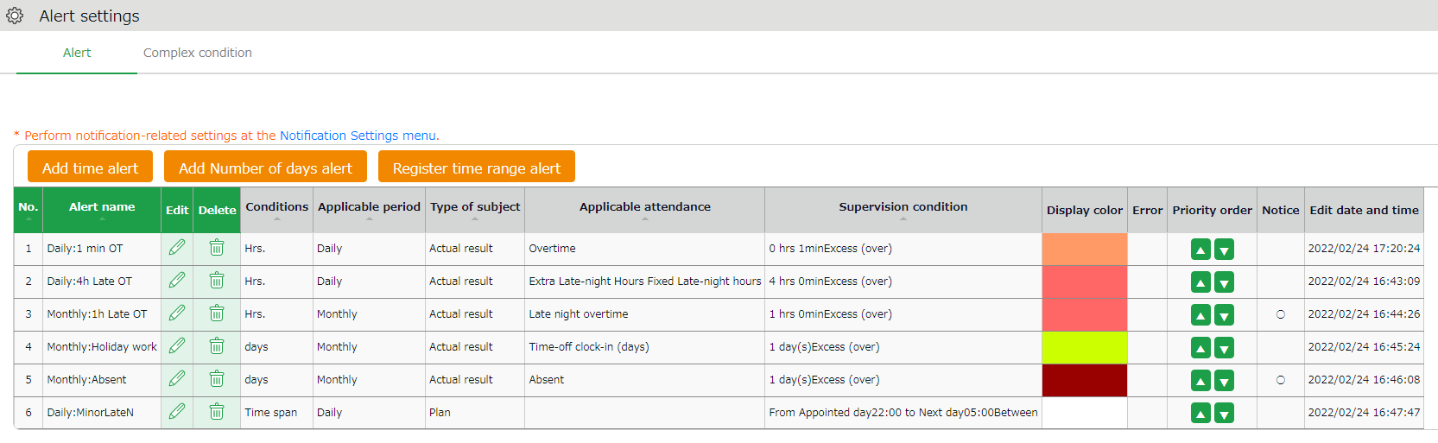
4
3
2
1

1 | Register time alert | Add an Alert setting for filtering attendance data that is over or under a certain number of hours.
2 | Register number of days alert | Add an Alert setting for filtering attendance data that is over or under a certain number of days.
3 | Register time range alert | If you want to be alerted when someone is scheduled to clock in/out during a specific period, you can register an alert setting here.
4 | Break time priority | Changes the order of the alert.
5 | Notification | Alert settings that are used in the Alert notification settings are marked [○].

Alert Registration Screen
To register an alert, click the corresponding button of the alert needed. You can set alerts by hours, days, or for a specific time range. Set the following items as needed. The items displayed will vary depending on the type of alert you are setting.
Alert name | Set the name of the alert.
Condition | Displays the condition for the alert (number of hours/days).
Applicable period | You can choose from [Daily], [Weekly] and [Monthly].
Alert type | * The item will only appear in time range alerts.  You can choose between [Arbitrary time period] and [When the workday type spans over midnight].  Arbitrary time period  This is used for alerts that specify an arbitrary time range.  When the workday type spans over midnight  Use this if you want to trigger an alert when work spans across different workday types (e.g., from a weekday to a statutory holiday).
Type of subject | * The item will only appear in time range alerts.  You can choose between "Actual" and "Planned".  Actual  The actual attendance record (clock in/out data) is subject to the alert.  Plan  The scheduled attendance is subject to the alert.
Error detection | * The item will only appear if you select [Plan] as the Type of subject.  You can select from [Handle as error (default)] and [Handle as alert].  Handle as error (default)  Error occurs to prevent registration when attempting to register a schedule that applies to the alert condition.  Error detection  You can check for any schedule treated as alert in All menu > Attendance error.
Alert target attendance | * The item will be hidden if you select [Plan] as the Type of subject.  Select the attendance data subject of the alert.
Alert target custom item | Select custom data items from here.
Alert | Specify the threshold of the alert.
Display color | Select a color in the palette. The color selected is used to indicate the data has reached the specified threshold.
Select employee | Specify the age or gender of the employee.
Select employee type and division | Specify the employee type or the division of the subject.
Monthly data screen
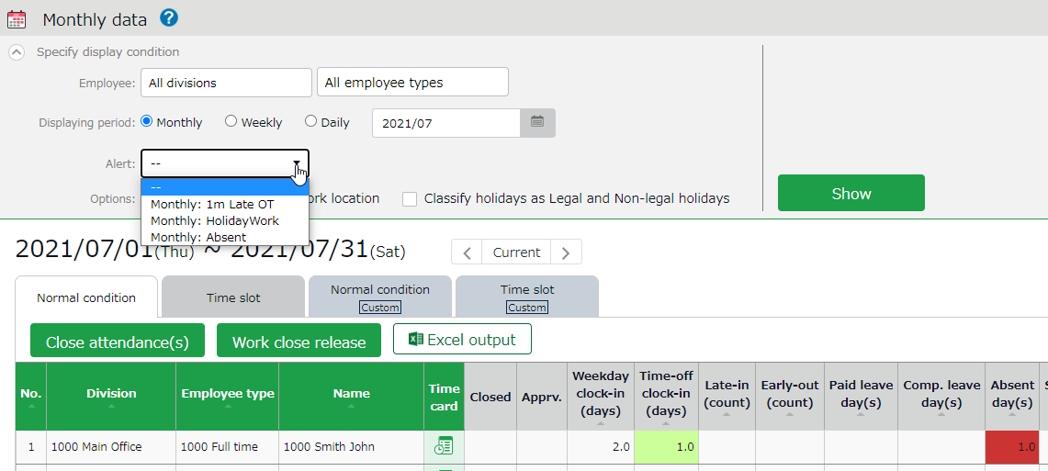
On the Monthly and Daily data screens, attendance data matching the conditions are highlighted in the specified display color. In the Monthly data screen, you can filter the data that matches the condition from [Specify display condition].

Complex condition alert
This feature is useful when you want to combine multiple alerts to create under 1 single condition.
For example, the following Complex condition can filter employees who have worked overtime for more than 1 minute but less than 4 hours.
- Alert 1: More than 1 minute of overtime occurred
- Alert 2: Less than 4 hours of overtime occurred
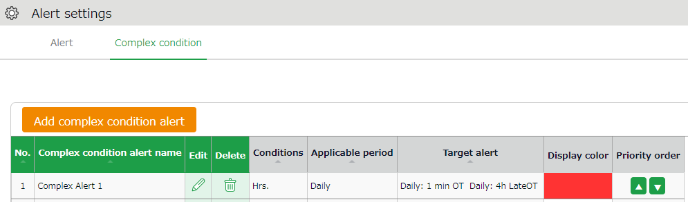

Complex Condition Alert Registration Screen
To create a complex condition alert setting, go to [Alert settings > Complex condition alert] and click on the [Add complex condition alert] button. Set the following items as needed.

Complex condition alert name | Set the name of the complex alert.
Condition | Select either [Hours], [Days] or [Time range].
Applicable period | You can choose from [Daily], [Weekly] and [Monthly].
Alert | Select the conditions you want to combine from the alerts you have already created.  You can only select alerts that match the period specified in the [Condition] and [Applicable period] on the same screen.
Display color | Select a color in the palette. The color selected is used to indicate the data has reached the specified threshold.

IMPORTANT:
Alerts used in combined alerts will no longer work on their own.

Start operating
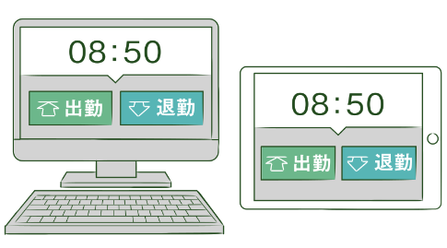
If you’ve completed the basic settings, get ready to share them with your employees.

Configure Time Recorder settings
Log into Employee screen

Configure Time Recorder settings

Personal Time Recorder
Send information on Personal Time Recorder setup to employees by Email (p.47).

Division Time Recorder
Send Division Time Recorder setup info to employees by Email (p.18).
Please follow the setup instructions in the manual (link available from Email).

Log into Employee screen
You can receive Attendance data/Schedule edit requests from employees through the Request approval feature. Please instruct the employees to submit requests from the Employee screen. There are 2 ways to log in.

Send login info to employees by Email
Sends login info to employees by Email. (p.47)

Log in from Time Recorder
Press the [Time Card] button on the Time Recorder and authenticate by fingerprint, IC cards or passwords. If the authentication succeeds, the employee’s Time Card displays.
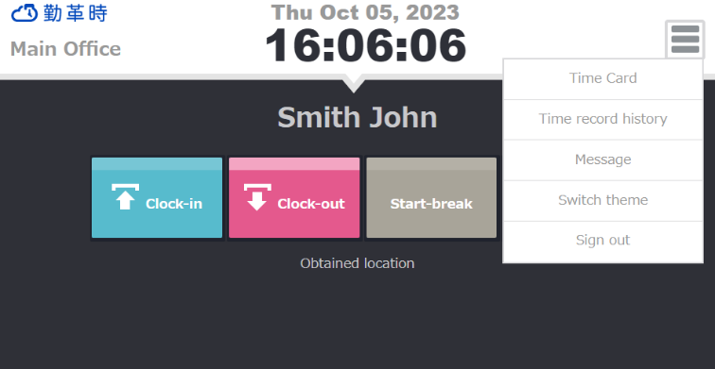
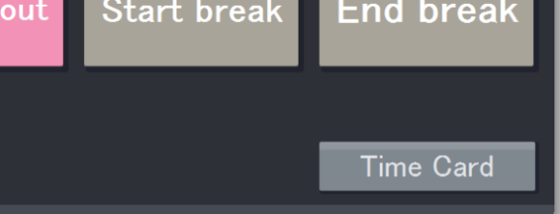

Please note that you can't log into Time Cards from dedicated devices such as the PitTouch series.

Unauthorized copying and replication of the contents of this guide, text and images are strictly prohibited.
The contents of this guide are subject to change without prior notice, for revision and further improvement.

Last Updated – March 9, 2026

