
Admin Manual
Part 2 Operation method

s
Table of Contents
This manual is the second part of a two-part administrator's manual.
Part 2 describes the operation method.
Part 2 Operation method 4
1. All menu 5
2. Check attendance data 8
2.1. Check daily data 8
2.1.1. Descriptions 8
2.1.2. Operations 10
2.2. Check monthly data 11
2.2.1. Descriptions 11
2.2.2. Operations 12
2.3. Check Your Time Card 13
2.3.1. Descriptions 13
2.3.2. Operations 14
2.4. Check Yearly Data 15
2.4.1. Descriptions 15
Operations 15
2.5. Confirm data by divisions and employee types 16
2.5.1. Descriptions 16
2.5.2. Operations 16
3. Edit attendance data 17
3.1. To edit attendance data 17
3.1.1. Descriptions 17
3.1.2. Operations 20
3.2. Check attendance data errors 21
3.2.1. To correct errors 22
3.3. Check attendance outside working years 23
3.3.1. To correct errors 24
4. Close attendance data 26
4.1. To close attendance data 26
4.2. Who can close attendance data 26
4.3. To check the closing/confirmation status 27
4.3.1. Descriptions 27
5. Approve requests 28
5.1. Check requests 28
5.1.1. Descriptions 28
5.2. Approve requests 29
6. Manage schedules 30
6.1. Set schedules 30
6.2. Set schedules 31
6.2.1. Descriptions 31
6.2.2. Operations 32
6.2.3. Set schedules 33
6.2.4. Set schedules to each employee 34
6.2.5. Set daily schedule 35
7. Manage leaves 37
7.1. Take leaves 37
7.2. Check the number of leaves taken/remaining 37
7.2.1. Descriptions 37
7.2.2. Operations 41
7.3. Grant leaves to each employee 42
7.3.1. Descriptions 42
7.3.2. Grant leaves 43
7.4. Grant leaves to multiple employees at once 44
7.5. Check the number of leaves taken each month 44
7.6. Grant leaves by auto-calculation 45
7.6.1. Instructions 45
7.6.2. Descriptions 46
7.7. Manage long-term leave 47
7.7.1. Descriptions 47
7.7.2. Operations 48
7.7.3. Registering leave periods and workable days 49
8. Export data 51
8.1. The Export menu 51
8.1.1. Descriptions 52
8.2. Create export file layout 53
8.2.1. Create custom items 54
8.3. Export 56
8.3.1. Time range of data 57
9. Table of Attendance Data Items 58

Part 2 Operation method
Part 2 describes the operation method.
This section describes how to manage time record data, schedules, and leaves.

All menu
Perform day to day operations from [All menu] at the top of the screen.
Here, you can review and edit attendance data, set schedules, manage leaves, and export data.


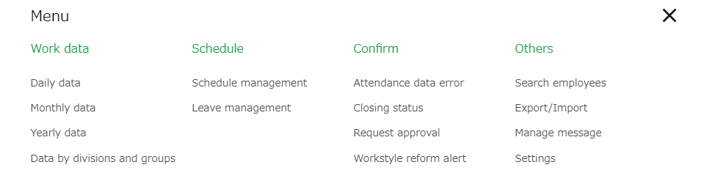
Descriptions for each item are provided below.

Attendance data
Daily data | Shows daily time record, schedules, and auto-calculated attendance data. | p.8
Monthly data | Shows monthly data such as the number of days/hours of work and leave. | p.11
Yearly data | This screen shows up to 12 months' data. It provides the summary of days/hours worked and leaves taken. | p.15
Data by divisions and groups | This screen shows monthly data calculated by divisions and employee types. | p.16

Schedule
Schedule management | Check and add schedules from here. | p.30
Leave management | Check the number of leaves taken/remaining from here. | p.37

Check
Attendance data error | Shows errors in attendance data (incorrect data caused by missing time records and lack of remaining leaves, etc.). | p.21
Closing/ Confirmation status | Check the closing or confirmation status of the attendance data.  * If you are not using the Attendance confirmation feature, this is shown as [Closing status]. | p.27
Request approval | Approve/reject requests from employees and other administrators. | p.27
Workstyle reform | Shows employees subject to Workstyle reform-related Alert (Upper Limit Regulations of Overtime, Highly Professional Worker’s Program and 5 Day Annual Mandatory Holidays). For details, please refer to Part 1 Basic settings of the Admin Manual. | -

Others
Search employees | Search employees by name or employee code.  You can perform the following tasks from the results.  - View Time Card screen  - Edit employee data  - Send Time Recorder URL (Personal Time Recorder)  - Export daily data  - Export Time Card  - Delete employee data  - Sign in on behalf of the user (1st Master Admin and Master Admins only) etc. | -
Export /  Import | Exports and imports data.  You can export data such as Daily data, Monthly data and Time Card data.  In addition, Employee data can be imported through this feature. | p.47
Message management | You can use this feature to show messages on [Time Recorder (Desktop version)] and [My Recorder]. | -

Some items can also be accessed from the [Frequently used] menu.
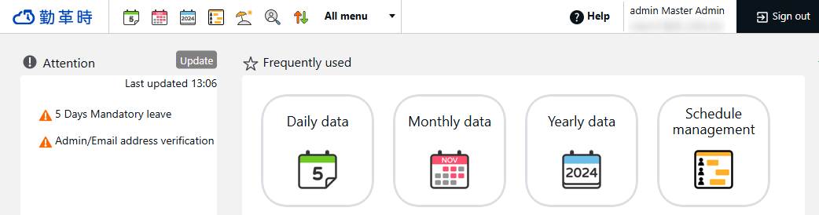

Check attendance data
This section describes the steps to check attendance data recorded on the system. Data are available by day, month, and year.

Check daily data
Shows daily time record, schedules, and auto-calculated attendance data.

[Where to look] “Frequently used” menu > Attendance data > Daily data

Descriptions

Set a division, employee type or date.
Click [Show] to view data.

Options:
Display by employee work location - Show data of employees who worked in a division.
Gather time-record - Arranges time record data to a single cell.
Display location information -Displays the location info associated
Display the total value of all items displayed - In the “Total” of the last row, the total of all items displayed on the page as well as the total of all target items will be displayed.

Specify the display condition

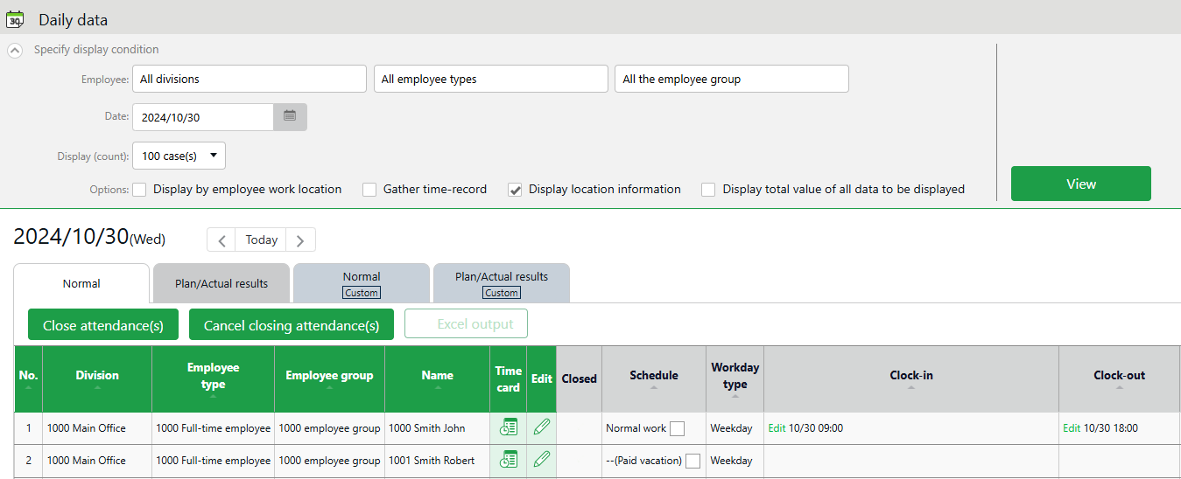

Daily data

Shows the time record, schedules and auto-calculated attendance data that correspond to the specified day.
Please refer to the following pages for details.

Daily data items
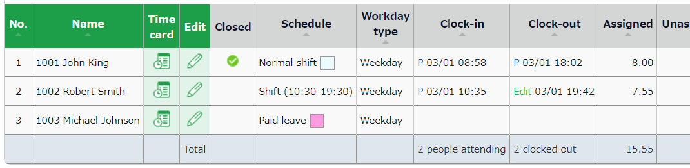

Cl.(Close) | If the user’s attendance data is closed (p.26), a check mark () shows in the corresponding date.
Schedule | Shows schedules and leaves. If an Admin creates and applies a Pattern) to a schedule, the name of the pattern shows in the grid. [Shift] indicates the schedule doesn't belong to any pattern.
Workday type | Workday types are displayed.
Clock-in/out | Clock-in/out time and method are shown.  Please refer to p.17 for the abbreviations of time record method.
Note | Enter notes or comments at the Attendance data edit screen (p.16), if needed. You can also choose whether to reflect request messages to the text field when performing request approvals (p.29).


Please refer to p.59 for the table of attendance items.

Operations
You can perform the following tasks in the Daily data screen.
1ｚ
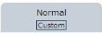
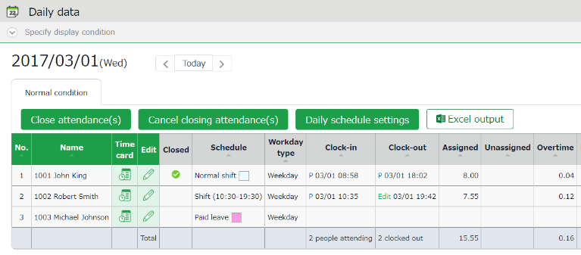
2ｚ
3
4

No. | Buttons | Description
1 | Tab | Select the tab to view different items.  Normal work  Shows the default attendance data.  Normal (Custom)  Displays attendance items created in the custom data item settings.
2 | 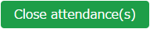  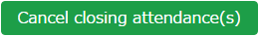 | Closes or uncloses attendance data (p.26).  * Available to administrators with closing privileges.
2 | 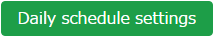 | You can check and edit schedules of the selected day by divisions (p.35).  * Only available if one division is selected.  * Available to administrators with schedule management privileges.
3 | 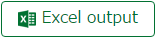 | Monthly data can be downloaded in Excel format.  * Available to administrators with data export privileges.
4 | (Time Card) | Shows the Time Card screen (p.13).
4 | (Edit) | Edits attendance data (p.16).

Check monthly data
Shows monthly data such as the number of days/hours of work and leave.

[Where to look] “Frequently used” menu > Attendance data > Monthly data

Descriptions

Select a division, employee type or display period.
Click [Show] to view data.

Displaying period
Monthly - Shows work data by month.
Weekly - Shows work data by week.
Daily - Shows Daily data of the specified period (up to 3 months).

Options:
Display by employee work location - Show data of employees who worked in a division.
Classify holidays as Legal and Non-legal holidays - You can check holiday work hours according to workday type.
Display the total value of all items displayed - In the “Total” of the last row, the total of all items displayed on the page as well as the total of all target items will be displayed.
Specify the display condition
Specify the display condition

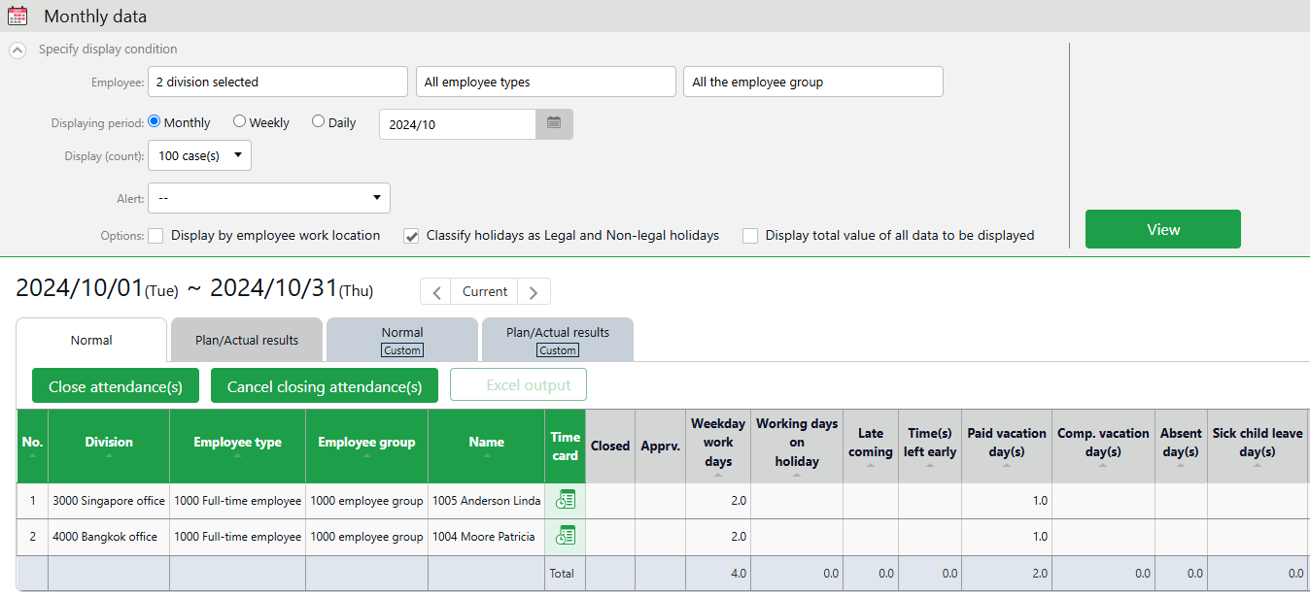

Shows data such as the number of working days/hours and leaves taken.
[Closed] - Indicates closing status (p.27).
In the Monthly data screen, the mark is shown only if all days within the period have been closed.
[Apprv.] - Shows the attendance confirmation status.
A mark is shown if the attendance data has been confirmed by the employee.

Monthly data

Operations
You can perform the following tasks in the Monthly data screen.

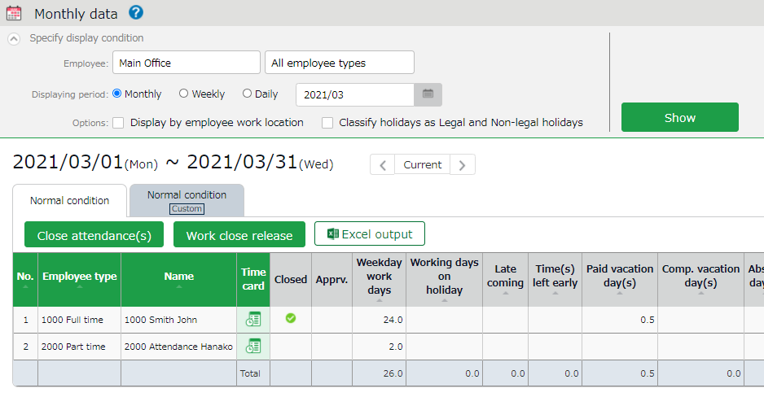
1ｚ
4
3
2ｚ

No. | Buttons | Description
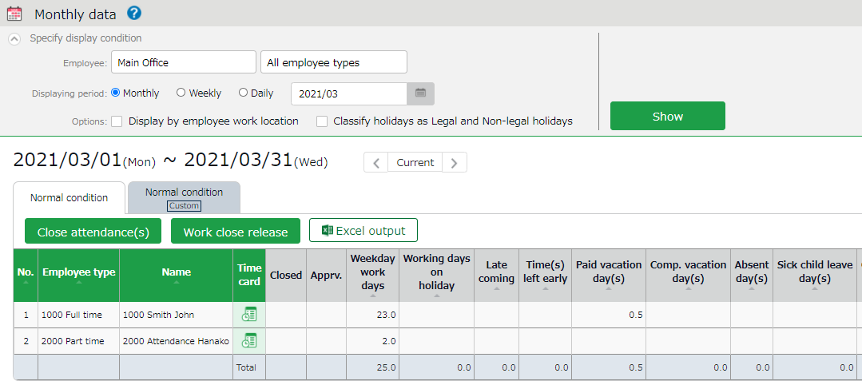  1 | Tab | Select the tab to view different items.  Normal work  Shows the default attendance data.  Normal (Custom)  Displays attendance items created in the custom data item settings.
2 | 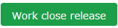 | Closes or uncloses attendance data (p.26).  * Available to administrators with closing privileges.
3 |  | Monthly data can be downloaded in Excel format.  * Available to administrators with data export privileges.
4 | (Time Card) | Shows the Time Card screen (p.13).

Check Your Time Card
The Time Card screen shows daily or monthly attendance data of each employee.

[Where to look] “Frequently used” menu > Attendance data > Monthly data > Time Card button
* The Time Card button is also available in the Daily data and Schedule management screens.

Descriptions

Select a month. Click [Show] to view data.
Options:
Gather time-record - Arrange time record data to a single cell.
Week aggregate - Shows the overtime hours after applying the statutory working hours per week.
Display location information - Shows the location data at the time of clock-in/out.
Classify holidays as Legal and Non-legal holidays - You can check holiday work hours according to workday type.
Show remaining leaves as of today –
On: Shows the number of leaves remaining as of today.
Off: Shows the number of leaves as of the end of the month. (
* Only available on the current month’s time card.）

Specify the display condition

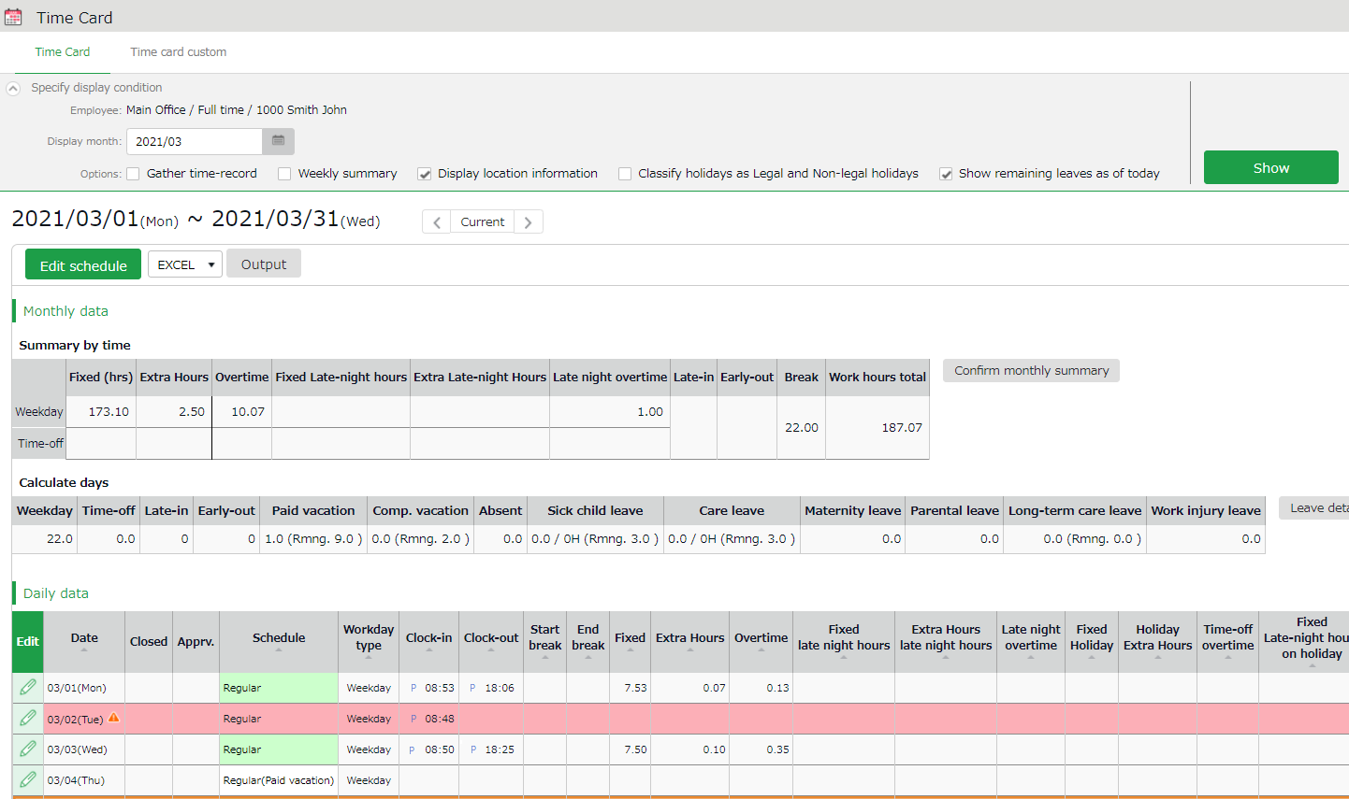
Monthly data

Shows data such as the number of working days/hours and leaves taken.

Daily data

Check time record, schedules, and attendance calculations.
The mark next to a date indicates Attendance error that need resolving. They are highlighted in light red.

Operations
You can Perform the following tasks in Time Card.

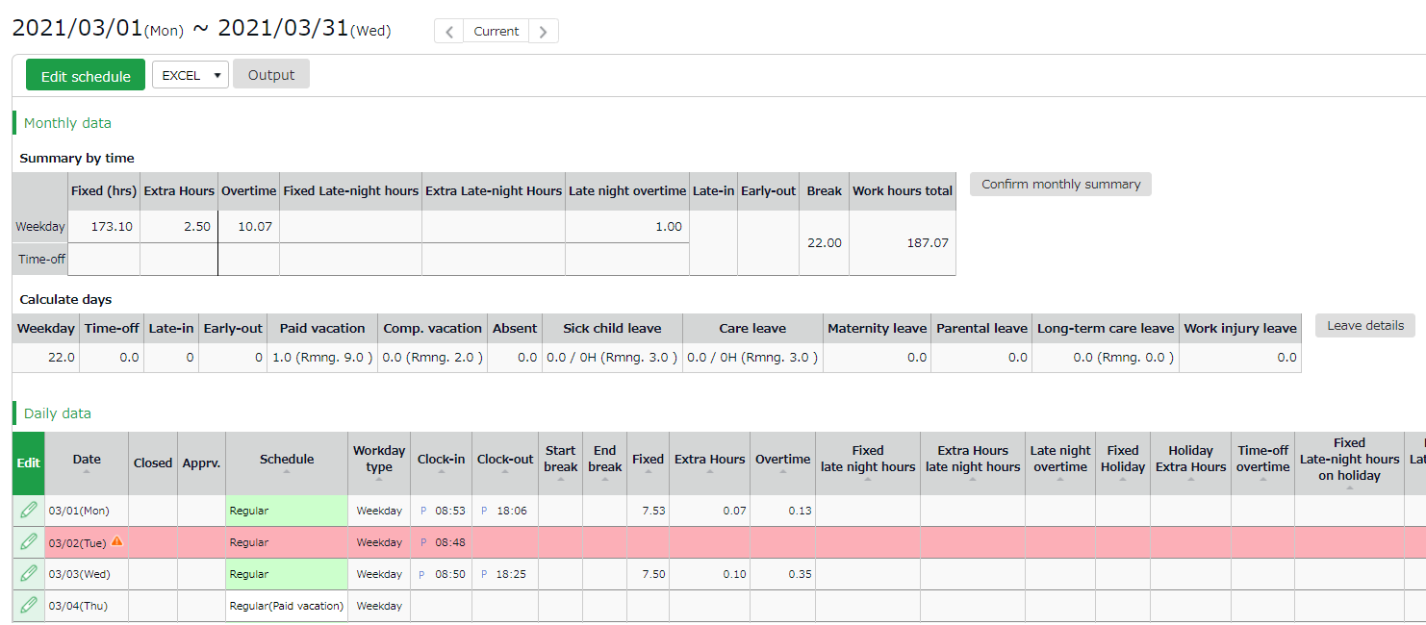
1ｚ
2
3
5
4

No. | Buttons | Description
1 | 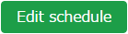 | You can bulk-edit a month’s schedule (p.34).  * Available to the 1st Master Admin and Master Admins, General Admins with [Schedule settings: Request] or higher privileges.
2 | 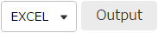 | You can download Time Card data in Excel format.
3 | 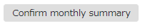 | You can check the value of each item added up for each day, before calculating bonus wage overtime.  * Only available to the 1st Master Admin and Master Admins.
4 |  | Shows Leave details (p.42).
5 | (Edit) | Edits attendance data (p.16).

Check Yearly Data
This screen shows up to 12 months' data. It provides the summary of days/hours worked and leaves taken.

[Where to look] “Frequently used” menu > Attendance data > Yearly data
* Before viewing Yearly Data, you need to press the [Show] button on the Monthly Data screen for every month.
The results on the Monthly Data screen directly affects the info on Yearly Data screen.

Descriptions

Select a division, employee type or specify the display period (up to 12 months).

Click [Select] to select attendance data items.
Select items as needed.

Display the total value of all items displayed - In the “Total” of the last row, the total of all items displayed on the page as well as the total of all target items will be displayed.
Specify the display condition

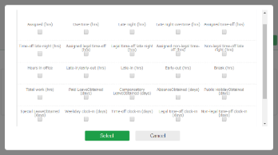

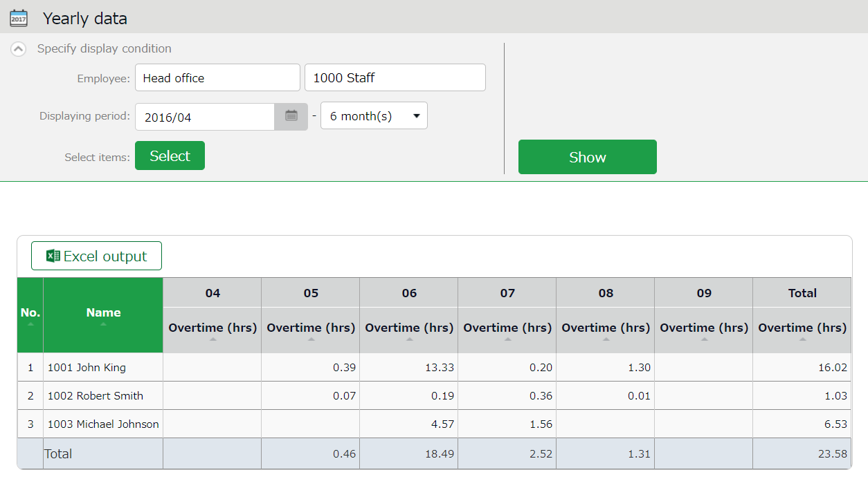
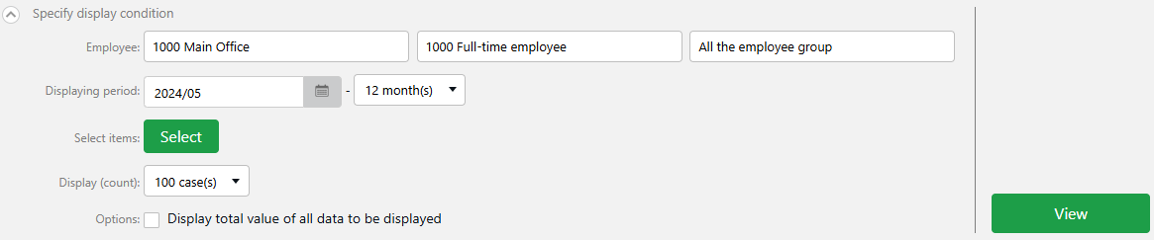

Shows the summary of the specified month.
Yearly data

Operations
You can download Yearly data in Excel format.

Confirm data by divisions and employee types
This screen shows monthly data calculated by divisions and employee types.

[Where to look] All menu > Attendance data > Data by divisions and groups

Descriptions
Specify the display condition

Select a division, employee type or display period.
Click [Show] to view data.

Summerize attendance data by
Select a calculation unit, such as a division, employee type, etc. You can select multiple options.

Options:
Display by employee work location - Show data of employees who worked in a Division.
Classify holidays as Legal and Non-legal holidays - You can check holiday work hours according to workday type.

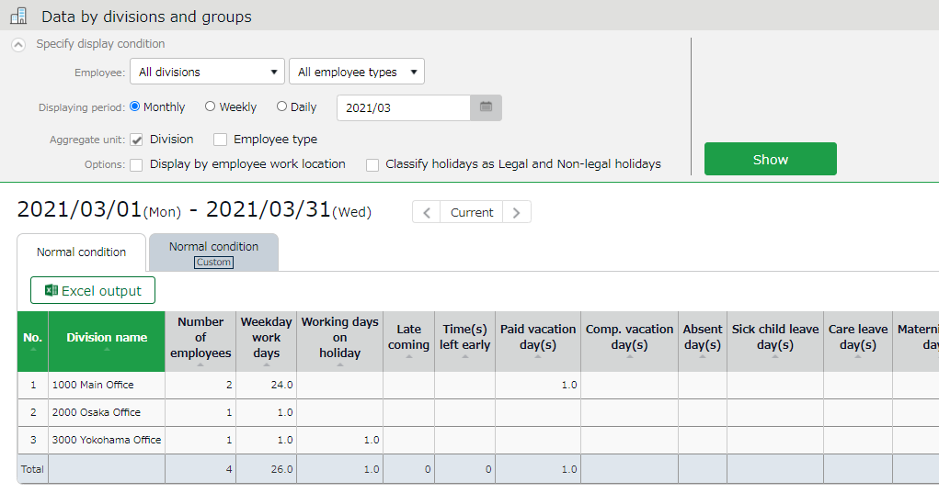

Data by divisions and groups

Shows data such as the number of days/hours of work and leave. The data is displayed by divisions or employee types.

Operations
Downloads data by organizations (divisions, employee types) in
Excel format.

Edit attendance data
You can correct errors caused by missing time records and schedule errors.

To edit attendance data
This section describes the Time record and Schedule screens in edit mode.
Specify the display condition

Select a division, employee type or display period.
Click [Show] to view data.

Summerize attendance data by
Select a calculation unit, such as a division, employee type, etc. You can select multiple options.

Options:
Display by employee work location - Show data of employees who worked in a Division.
Classify holidays as Legal and Non-legal holidays - You can check holiday work hours according to workday type.
[Where to look] “Frequently used” menu > Attendance data > Daily data > [Edit] button
* The Time Card button is also available in the Time Card screen.

Descriptions
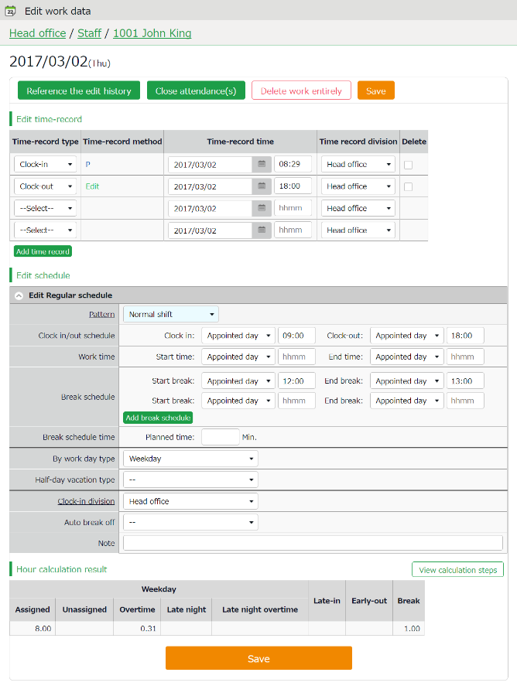
Hour calculation result

Shows daily summary. Press the [View calculation steps] button to confirm the calculation process.

Saves changes.
Save
Edit time record
Edit schedule

Edits time record data.

Edit time record data.

Edit time record
Edit time record data.
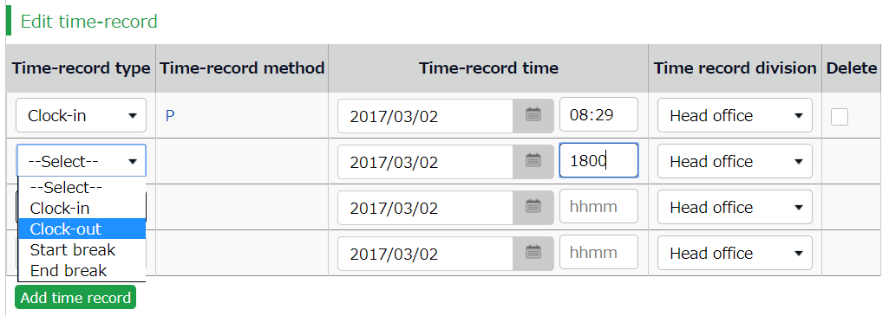
Time-record type | Select a time record such as Clock in, Clock out, Start break and End break.
Time record method | Time-record method is displayed automatically.
Time-record time | Shows time record. To edit, enter the time in the field.  Enter in [hh:mm] or [hhmm] format.
Time record division | The Division Time Recorder being used is applied automatically.
Delete | Turn on the check to delete time record data.
Add time record | Press this button to add a new time record field.

The following time record method are available.
Face | Face authentication recorder
Face CC | Face authentication + Chameleon recorder
HB | Hybrid finger scanner or BT-2000
IC | IC card reader, Pit Touch series, BT-2000
P | Password authentication
C | Click authentication (No password required)
Mobile | Time record using smart phones and mobile phones *
Location | Time record with location info
SL | Time record by Secure Login
A | Time record by External system through Web API service
Edit | Indicates edited time record
Approve | Indicates edited time record approved by the administrator
* If the employees have not provided location information and password when clocking in/out, it is defined as Click Authentication.

Edit schedule
If you select a [Pattern], the scheduled time in Pattern settings is applied.
You can enter items directly as well.

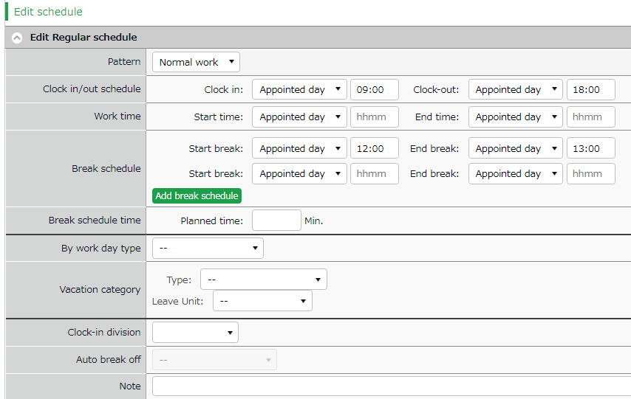

Patterns | Select a pattern. You can create patterns at [Pattern settings].
Clock-in/out schedule | Set a clock-out schedule.
Work time | Specifies when to run attendance calculations.  Any work before scheduled clock-in time and after clock-out time will not be included in the calculation.
Break schedule | The time between [Start break] and [End break] are regarded as break time.
Break schedule (hrs) | Calculates the entered amount of time as break time.  You cannot specify a time-slot for break time.
Workday type | Determines whether the work took place during holiday or not. If none is specified, workday type is set to [Weekday].  If you choose [Non-legal time off] or [Legal time off], work time during that day will be added up to [Legal time-off work days], [Assigned time-off (hrs)], [Unassigned time-off (hrs)], [Assigned Late-night hours on holiday], and [Unassigned Late-night hours on holiday].
Leave type | Select the leave type and the unit (such as All-day, AM leave, PM leave and Leave by Half-day leave).
Clock-in division | Shows where the employee clocked-in.  The name of the Division Time Recorder last used is applied automatically.
Auto break off | This will disable the Auto-break feature and break time setting by schedule.
Note | Enter comments or notes in 100 characters or less if needed.

Operations
Description for the buttons in Attendance data edit screen are provided below.
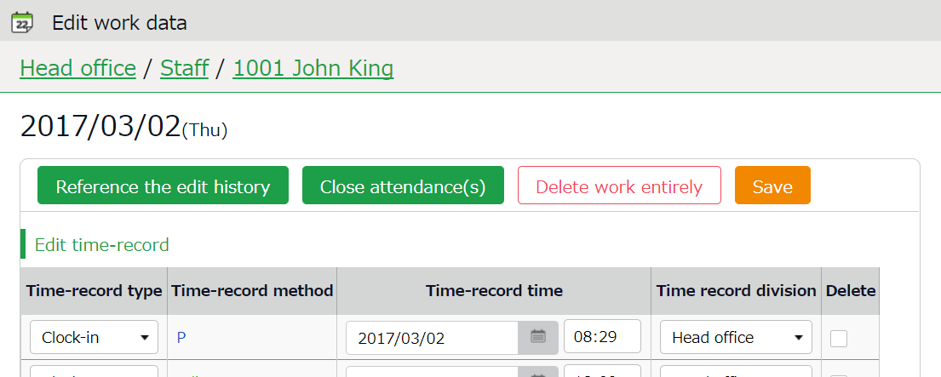
2
1ｚ

No. | Buttons | Description
1 | 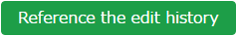 | Shows attendance data edit log.  * Available in edited attendance data screens.
1 |  | Closes the attendance data (p.26).  * Available to administrators with closing privileges.
1 | 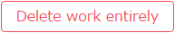 | Deletes all attendance data of the day.  However, change logs will remain.
2 | 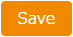 | Saves changes. To return to the previous screen after saving, click [Return] in the top of the screen.

Check attendance data errors
Errors in attendance data are caused by missing time records and lack of remaining leaves, etc.

The [Attention required] []mark in the home page indicates that there are one or more errors in the attendance data.
By clicking these items, the corresponding attendance data error screens are displayed.
You can also access from [“Frequently used” menu > Attendance data error].)
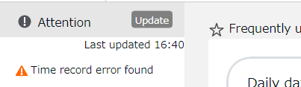
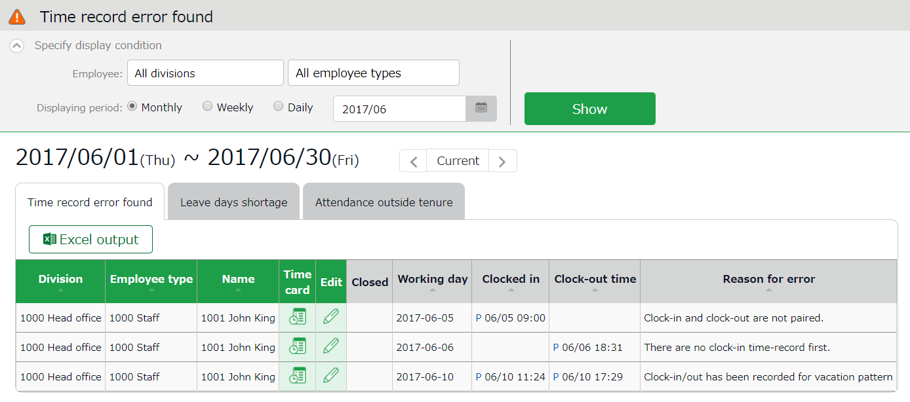

Time Card | Shows the Time Card screen.
Edit | Edits attendance data.

Buttons

The screen shows the list of the type of Attendance data error you selected on the Home screen. You can also view data under different error types by switching tabs.
Switch tabs

To correct errors
This section describes the steps to correct errors in attendance data.

Attendance data error
The causes and solutions for common errors are described below. Time record or schedules need to be corrected.

Cause of error | To correct errors
Clock-in time-record is consecutively recorded. | There is an inconsistency in the time record.  Correct any errors in the attendance data by editing or submitting change requests.
Clock-in and clock-out are not paired.
No clock-in time record has been made first.
There is a clock-in/out data  in a full-day leave. | The system detects error if time record exists in a day with a holiday/leave schedule pattern.  By changing the day’s schedule pattern from holiday/leave pattern to a workday pattern, the system can run the calculations correctly.

Shortage of leave days
More than remaining number of leaves have been taken.
Please adjust the number of remaining leaves in the Leave Management screen (p.37).
* Only leave types with [Disable leave when it reaches zero] checked under the following path are subject to insufficient leave balance error detection:
Settings > Schedule > Leave Type Settings > [Edit] > Disable leave when it reaches zero

The [Attention] mark in the home screen
- The [Attention] mark in the home page indicates there are one or more errors within the past 2 months of attendance data.
- [Attendance outside tenure] is shown at [Attention required] in the home page if there are any attendance record exist outside of working years(tenure), within three months less the present time.

Check attendance outside working years
[Attendance outside tenure] are time records and schedule data that are dated before hire date or past resignation date (includes data 3 months prior to present).

If there are any attendance record outside of an employee's working year (tenure), [ Attendance outside tenure] mark will show in [Attention required]. From here, you can check the [Attendance outside tenure] tab in the Attendance error screen.
You can also access from [“Frequently used” menu > Confirmation > Attendance data error > Attendance outside tenure tab].)
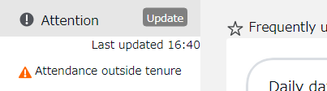
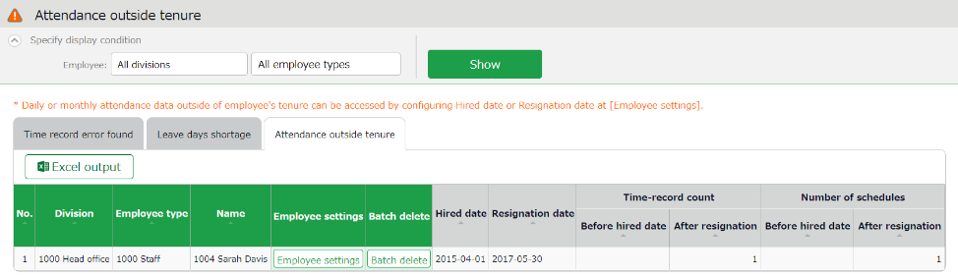

Employee settings | Shows the Employee settings screen.
Batch delete | Deletes all data before hired date/after resignation date completely.

Buttons

Shows the following data before hired date/after resignation date.
- Number of days with time record
- Number of days with schedule
Time-record count/
Number of schedules

To correct errors
You can correct an [Attendances outside of tenure] error by using any of the following methods.

Confirm details and correct resignation date or attendance data
- From the [Attendance outside tenure] screen, click [Employee settings] to edit the employee’s data.
Press the [detail] button under the Employment info category. To correct the employee’s resignation (or hired) date, delete the existing dates first and then re-enter.
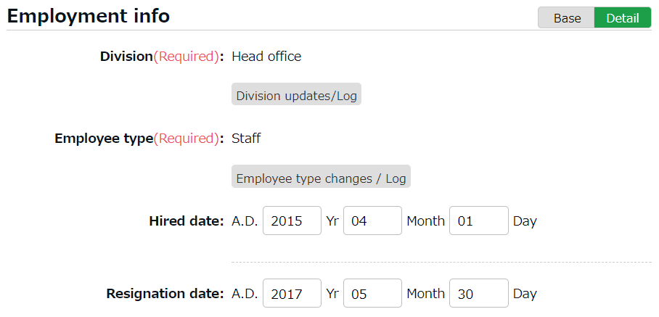

- Go to [“Frequently used” menu > Attendance data > Monthly data], then press the [Time Card] button of the employee.
By deleting the resignation (or hired) date in the previous step, attendance data after the resignation date (or before the hired date) are shown. Check the details.
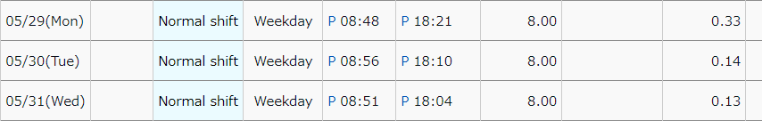

- If the resignation date is incorrect, return to the Employee settings screen and enter the correct date.
If the attendance data is mistaken, delete the data and re-enter the employee’s resignation date.

Delete all attendance data outside working years
To delete all attendance data after resignation and before hired date, click [Bulk delete] in the Attendance outside tenure screen. Confirm deletion to delete all attendance data before hired date and after resignation date.
This operation won’t affect other employee data nor other attendance data within the period.

If there are any attendances recorded by mistake, please delete attendance and schedule data outside tenure (changes are recorded as change log).

Close attendance data
You can lock your attendance data by closing it.
This prevents employees and administrators from making further changes. Only Master Admins can edit closed attendance data.
Locking the attendance data prevents attendance data from being modified after payroll calculations, etc.
The closing/ confirmation status can be viewed in the Admin and employee screens.

To close attendance data
[Where to access]
You can close attendance data by either of the 3 screens described below.
- “Frequently used” menu > Attendance data > Daily data
- “Frequently used” menu > Attendance data > Monthly data
- Daily data or Time Card > Edit attendance data

Press the [Close attendance] button in the screen. The process is complete when the confirmation screen is shown. You can't close the attendance data if there are any data errors in the specified period.

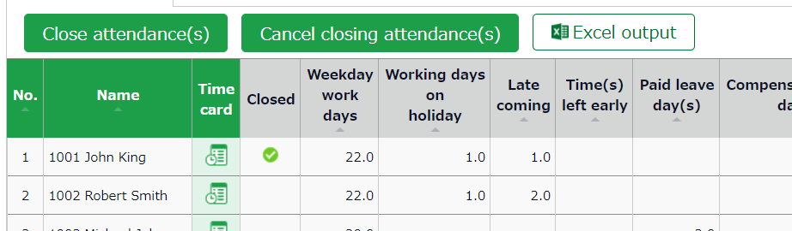

The mark in the [Closed] column (Daily data and Time Card screens) indicates that attendance is closed. In the Monthly data screen, the mark shows only if all days within the period are closed.

Who can close attendance data
Only the 1st Master Admin, Master Admins and General Admins with the [Close: Close Attendance] or higher privileges can edit closed attendance data.
The [Close attendance] and [Cancel closing attendance] buttons
are available only if you log in as an administrator with closing privileges.
You can assign the privilege by creating an Admin account in the Admin settings screen.

To check the closing/confirmation status
You can check the closing/confirmation status of the attendance data at the Closing/Confirmation status screen.
[Where to look] “Frequently used” menu > Confirm > Closing/Confirmation status（*）
* If you are not using the Attendance confirmation feature, this is shown as [Closing status].

Descriptions

Check the checkbox to include employees before their first day in the office (hired date).
Include employees before hired date
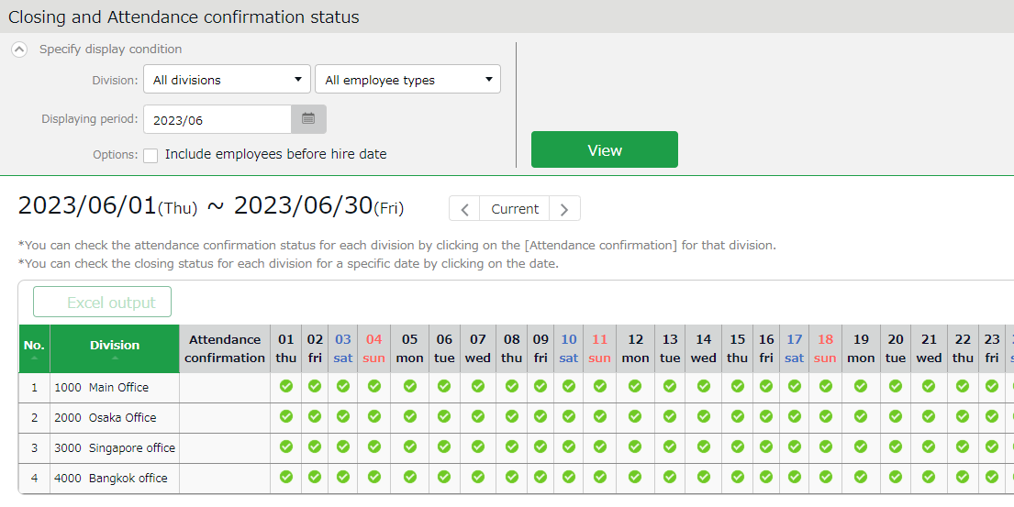

You can check daily closing status by divisions.
The mark indicates that attendance data of all employees in the division are closed.
Closing status

Shows the attendance confirmation status by division.
The mark indicates that attendance data of all employees in the division have been confirmed.
Attendance confirmation status

You can check closing status (whether attendances are settled or unlocked) in a pop-up window, by clicking on a date.
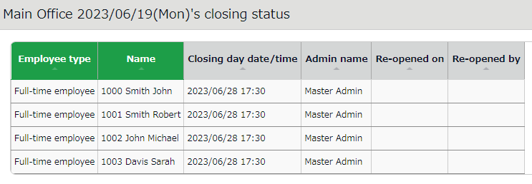

Approve requests
You can receive attendance data/schedule edit requests from employees and other administrators through the Request approval feature.

Check requests
Check request progresses in the Request approval screen.

[Where to look] “Frequently used” menu > Confirm > Request approval

Descriptions
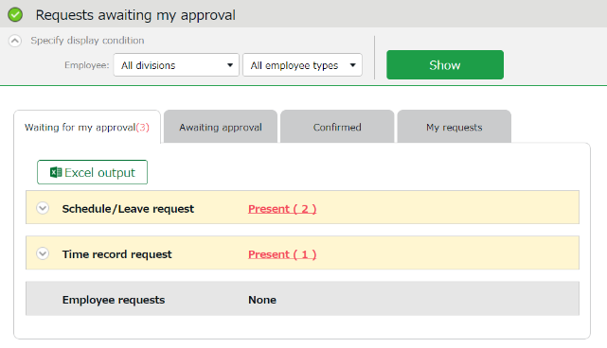

Select a division, employee type or display period.
Click [Show] to view data.

You can search request messages by entering keywords, for example, “private matter” and “attend wedding”.
Specify the display condition

Request info are arranged in 4 tabs, each representing the request approval process.
Tab name | Description
Waiting for my approval | Shows the requests that need your approval.
Awaiting approval | Shows any requests that include you in its Approval flow.  - Requests that require confirmation by a higher approver after your approval  - Requests that require your approval after the lower approver’s
Confirmed | Confirmed requests that include you in the approval flow. Requests are regarded as confirmed when it is approved or rejected by you or the final approver.
My requests | This area shows the progress of requests which you, an administrator, have submitted on behalf of employees.  Administrators with [View / Request] privileges (Admin settings screen) can submit requests on behalf of employees.

Request approval menu

Approve requests
- Any requests that require your approval are shown in [Attention required], in the home screen. They are shown as [Schedule /Leave request] and [打刻Time record request].
Click the items to show requests that need your approval.
You can also access from [“Frequently used” menu > Confirm > Request approval]
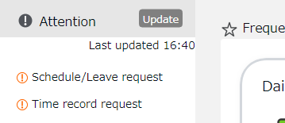
Set the display condition and click [Show]. Details are shown by clicking [Present].

From here, you can either [Approve] or [Reject] requests (actions here are processed instantly).
If either of [Request message] or [Admin’s comment] under [Copy data into time card] is checked when the final approver operates, either of the comments are copied to the [Notes] field in the employee's Time Card.
Operation details

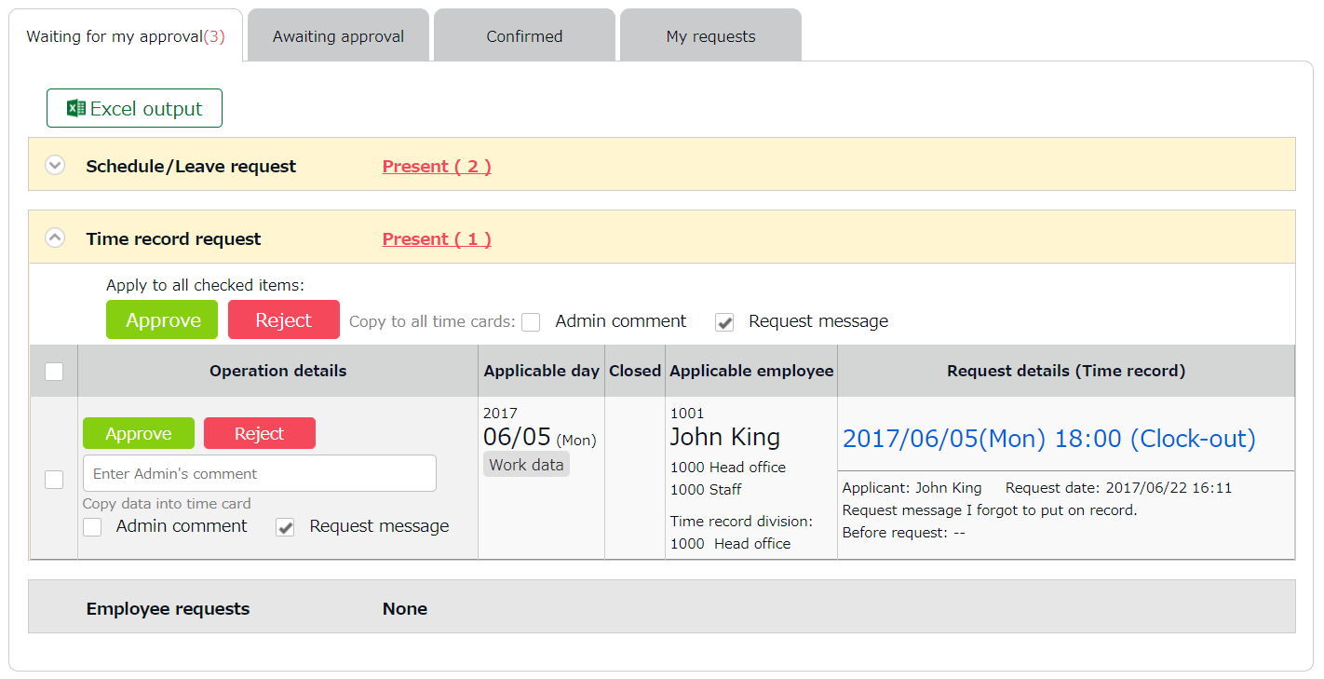

Check for attendance data details.
Attendance data
Approve all requests that are checked.

- An email notification is sent to the administrator when submitting a request. When a request is approved or rejected, employees are notified by email.
- Administrators and employees must set Email addresses to their accounts, to receive notifications by Email.

Manage schedules
This section describes the Schedule management feature.

Set schedules
You can create schedules by any of the four methods listed below.

Apply schedules automatically
Basic schedules set to each weekday are applied automatically by performing the Auto schedule settings in advance. For details, please refer to this article (Japanese).
https://n_help.kingtime.jp/h-t/web5/Detail.aspx?id=1566

Schedule request
Employees can submit schedule changes the through their Time Cards.
This feature is useful to take leaves and submit shift change requests.

Set schedules
You can set schedules manually through the admin screen. The instructions are in the following pages.

Import schedules
You can also set schedules by CSV file import in [“Frequently used” menu > Export / Import > Input data (Import) > Schedule data CSV].

Set schedules
Set or confirm schedules from the Schedule management screen.

[Where to look] All menu > Schedule > Schedule management

Descriptions
Specify the display condition

Select a division, employee type or display period.
Click [Show] to view data.

Displaying period
Monthly - Shows schedule data by month.
Weekly - Shows schedule data by week.
Daily - Shows Schedule data of the specified period (up to 3 months).

Options
Do not shorten pattern name - Names of schedule patterns are not abbreviated when displayed.
Display the total value of all items displayed - In the “Total” of the last row, the total of all items displayed on the page as well as the total of all target items will be displayed.

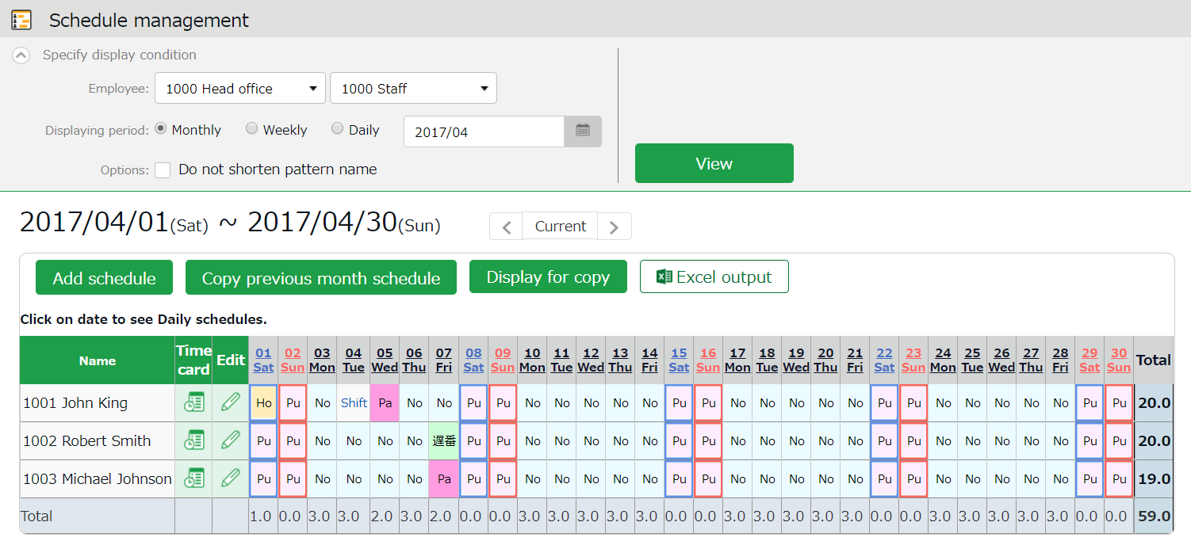
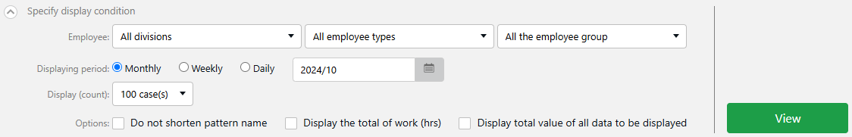

Shows existing schedules.
[Shift] indicates a schedule that does not belong to any pattern.
Workday types are indicated in different colored lines:
Legal time off - Red
Non-legal time off - Blue
The [Total] on the last row indicates the total number of attending employees, based on the schedule.

Schedules

Operations
You can perform the following tasks in the Schedule management screen.

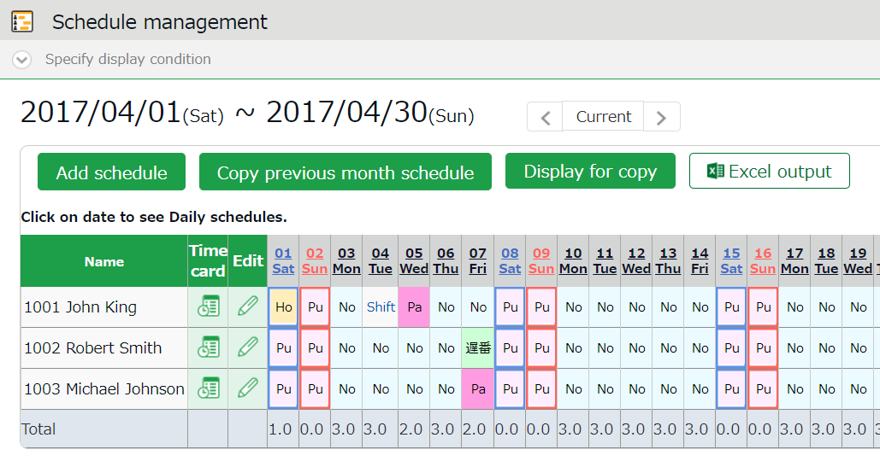

2
4
1ｚ
3

No. | Buttons | Description
1 | 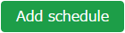 | Bulk-registers schedules by divisions (see following pages).  * Only available if one division is selected.
1 | 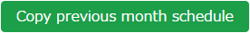 | Copies schedules of the previous month. The same schedules may be used repeatedly.  * Only available if one division is selected.
1 | 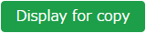 | Shows the page for printing out.  * To print in color from Google Chrome, go to [Chrome menu > Print > Page Setup > Print Background Colors and Images] and check the check box.
2 |  | You can download data on the schedule management screen in Excel format.
3 | (Time Card) | Shows the Time Card screen (p.13).
3 | (Edit) | Shows the Monthly schedule edit screen (p.34).  Sets schedules for each employee.
4 | (Date) | Available only when you select one division. Daily schedule edit screen (p.35) is shown by clicking on the date. You can edit schedules of the selected day by divisions.

Set schedules
This section describes the steps to create a work shift table by divisions.

- On the schedule management screen, click the [Schedule Registration] button.

- The schedule set to [Original schedule] applies to the checked day's attendance data.
Repeat this step to complete the month’s work shift table.
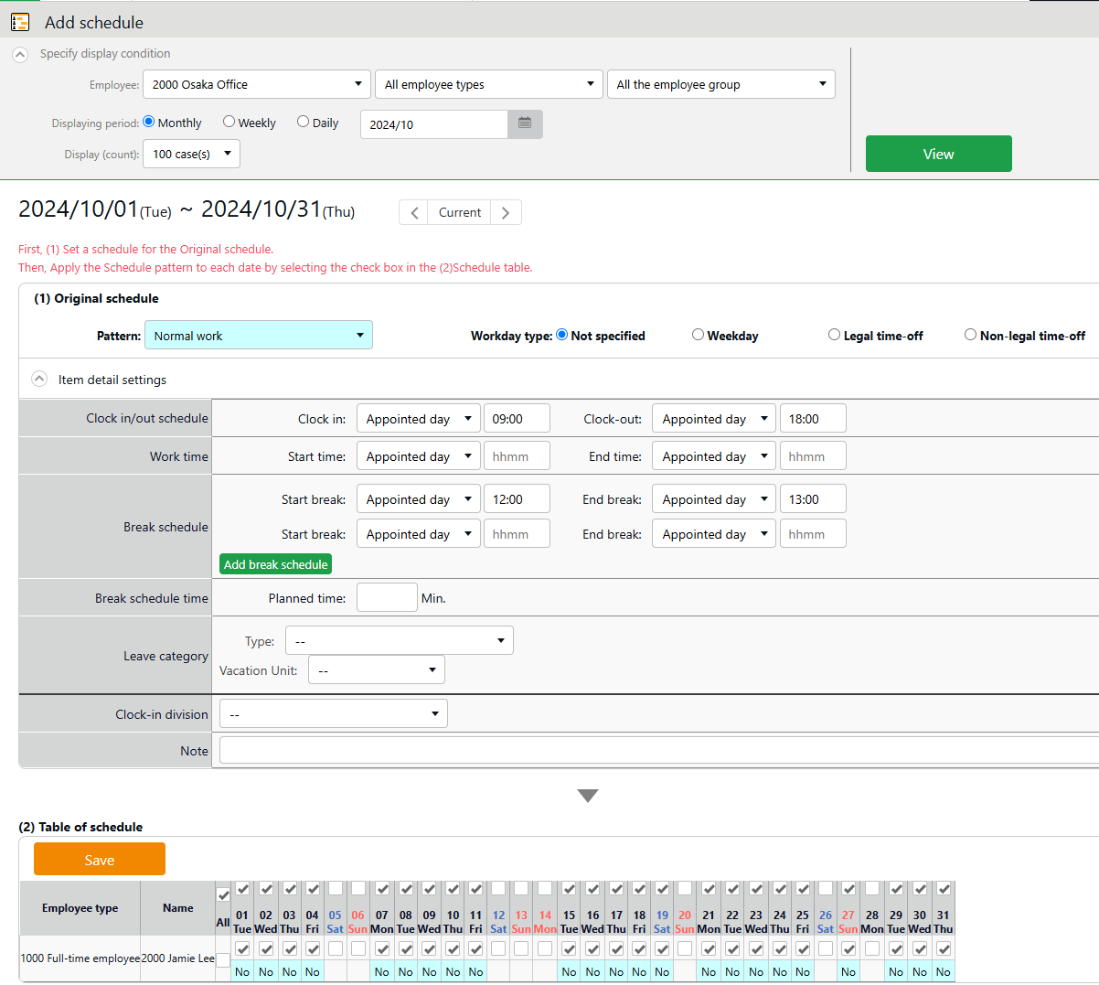
Original schedule

Enter schedule. To apply pre-configured time schedule, select a pattern.
You can also enter the items manually by clicking [Item detail settings].

Apply

The list of employees and applying dates are shown.
The schedule set to [Original schedule] is applied to the checked day.
If you check [All], the schedule settings are applied to all employees and dates below.
Target



- Click [Save] to save the schedules.

Set schedules to each employee
This section describes the steps to set schedules for each employee.

- Press the [Edit] button in the Schedule management screen.
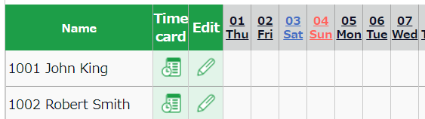

- The Monthly schedule screen is shown. The schedule set to [Original schedule] is applied to the checked day's attendance data.

Enter schedule. To apply pre-configured time schedule, select a pattern.
You can also enter the items manually by clicking [Item detail settings].
Original schedule
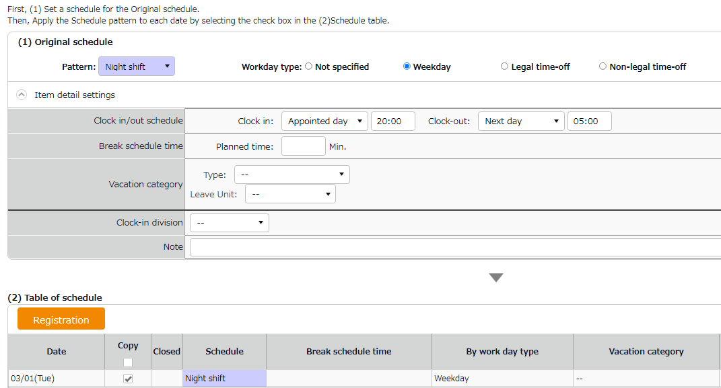



The list of applying dates are shown.
By putting a check, the schedules set above are applied to the selected day.
Target
Apply

- Click [Save] to save the schedules.

Set daily schedule
When setting up a schedule, you can check the number of attendants in the time-slot and division.

- Go to the Schedule management screen, then select one division.
Click on a date.
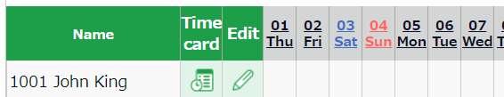

- The Daily schedule screen is shown.

Set a division, employee type or date.
Click [Show] to view data.

Displaying period
You can choose display period from appointed day (24 hrs today), previous day, next day and [Previous day - Today - Tomorrow (72 hrs schedule)].

Options:
Include time-record - Show actual time record as well.
Shift only - Show schedules only.
Do not shorten pattern name - Shows non-abbreviated schedule pattern names.
Clock-in order display - Sorts schedule by clock-in schedule ascending order.
Display by employee work location - Show data of employees who worked in a Division.
Specify the display condition

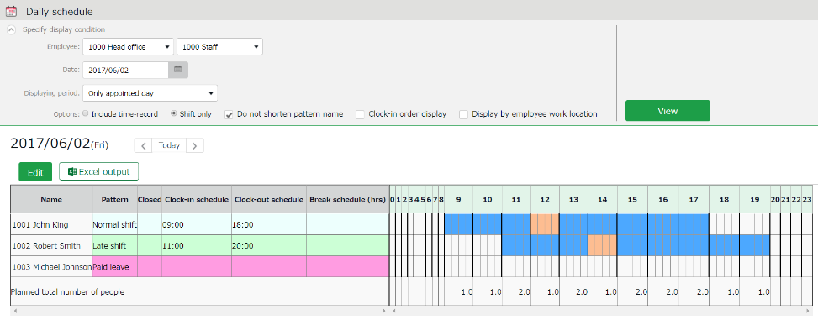

Edit Schedule
Edit

Visualizes schedules and actual time record.

The [Total] on the last row shows the total number of employees attending in each time slot.

Schedule
Blue - Scheduled working hours
Orange - Break time
Daily schedule
Actual working hours
(Shown when [Include time-record] is selected in the display condition)
Black - Working hours (Actual time record)
Red - Break time (Actual time record)

- Press the [Edit] button to edit schedule. You can edit Schedules at the [Add daily schedule] screen.
Edit your schedule here.
Either select a pattern or enter clock-in/out schedule.
Click [Detail] to open the [Break time settings] window. Enter the break time schedule.

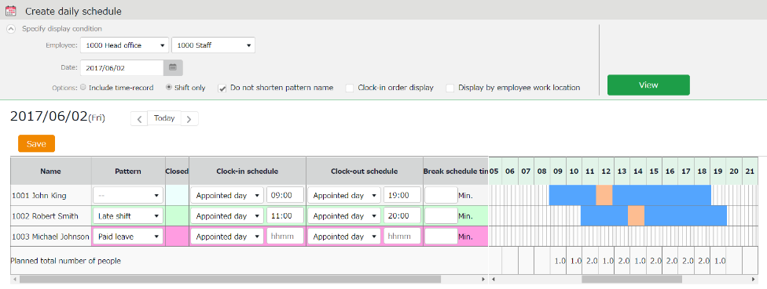
You can also extend/shorten the time by grabbing it with your mouse cursor.

- Click [Save] to save the schedules.
To return to the previous screen, press the [Return] button in the top of the screen.

Manage leaves
This section describes the Leave management feature.

Take leaves
On the Schedule management screen (p.31), the number of leave days taken is recorded in the Aggregate (days) column by registering the [Leave type] and its [Unit] on the day of the leave.

[Where to look] “Frequently used” menu > Schedule > Schedule management

Check the number of leaves taken/remaining
You can check the number of leaves taken/remaining in the Leave management screen.

[Where to look] “Frequently used” menu > Schedule > Leave management

Descriptions
You can switch contents from [Leave type] .

If [All leaves] is set
[All vacations] in [Leave type] shows the number of remaining or taken leaves.

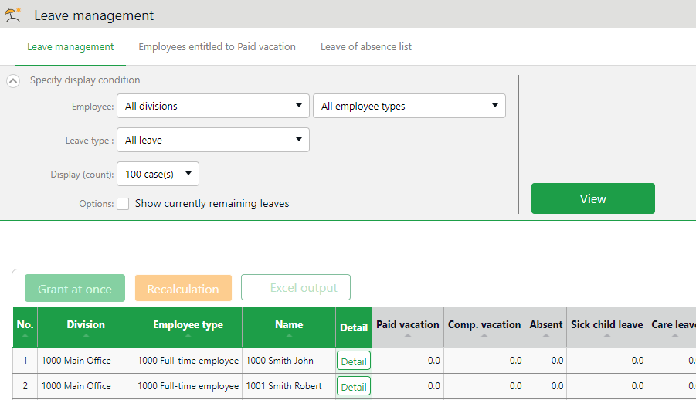

If the leave is a [Subtract] type (the leaves taken are subtracted from the remaining leaves), number of currently remaining leaves are shown.
Remaining leaves
Select [All leave]

Leaves taken

If the leave type is an [Add] type, the total number of leaves taken this fiscal year are shown.



About Subtract and Add leave types
[Subtract] and [Add] are leave calculation methods specified in [Home page > Settings > Schedule > Leave type settings > Calculation method of leaves when obtained]. For details, please refer to this article.
https://n_help.kingtime.jp/h-t/web5/Detail.aspx?id=1645

Filter data by leave type
To filter data, select a [Leave type] under [Specify display condition].
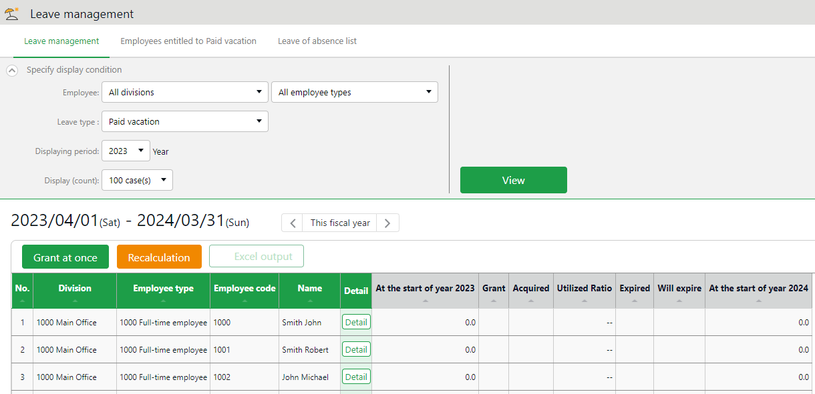
You can check the number of leaves taken, remaining, and expired during the fiscal year (if it is an “Add” type, leave it only shows the number of taken leaves).
Leave data

Check the total number of leaves taken/remaining from here. The items are described below.
Select a leave type

At the start of year | Shows the number of remaining leaves at the start of the year.  This does not include leaves granted at the start of the year.
Grant | Shows the number of leaves taken this year.
Acquired | Shows the number of leaves taken this year.  * For “Add” type leaves, this is the only item available.
Utilized Ratio | This shows the percentage of leaves (rounded off to the nearest whole number) taken during the specified period.  It doesn’t count carry-overs from the previous year.
Expired | Shows the leaves that are expiring/has expired during this period.  Data collection period depends on the fiscal year being displayed.  - If past year’s data is displayed - Data are collected from the beginning of the year until the end of the year.  - If this year’s data is displayed - Data are collected from the beginning of this year until now.
Will expire | Shows the leaves that expired during this period.  Data collection period depends on the fiscal year being displayed.  - If this fiscal year’s data is displayed - Data are collected from now until the end of this fiscal year.  - If future year is displayed - Data are collected from the beginning of the year until the end of the year.
(Next year) Start of year | Shows the number of remaining leaves at the start of the year. This does not include leaves granted at the start of the year.

Operations
You can perform the following tasks in the Leave management screen.
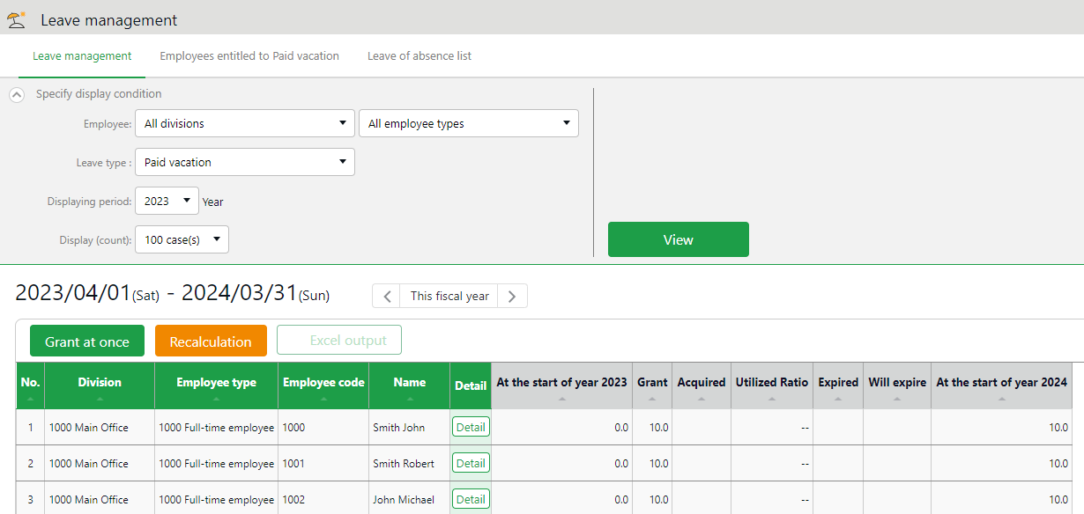
4
3
1ｚ
2

No. | Buttons | Description
1 | 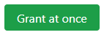 | Grants leaves to multiple employees at once (p.44).  * Available when a “Subtract” leave type is set to the display condition.
2 | 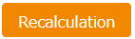 | This button shows when ’Leave Type’ is specified in the Display Condition settings.  Recalculates leave data.
3 |  | The Leave management screen can be downloaded in Excel format.
4 |  | Confirm leave grant/obtained date of each employee.  You can also grant leaves here. Please refer to the following pages for details.

Grant leaves to each employee
The screen described below shows the details of each employees’ leaves.

[Where to look] “Frequently used” menu > Schedule > Leave management > Employee [Detail] screen

Descriptions
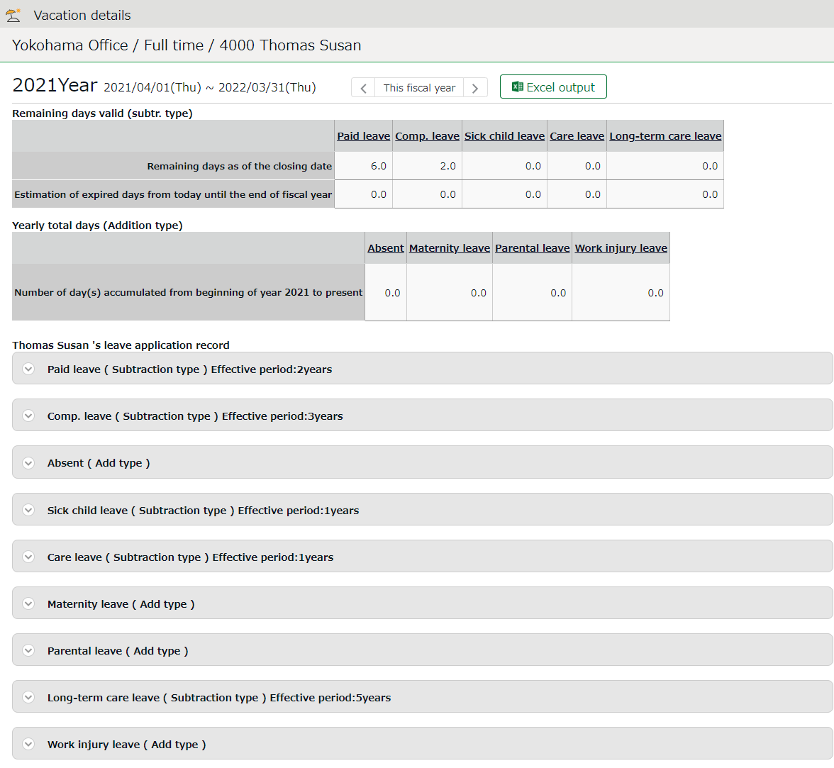

Shows the number of leaves remaining as of the closing date and leaves that are expiring from this day until the end of the fiscal year.
Remaining days valid (subtr. type)

Click here to show when the leaves were granted or taken.
You can also grant leaves from here.
Shows the number of leaves remaining as of the closing date and leaves that are expiring from this day until the end of the fiscal year.
Leave application record

Shows the total leaves taken this year.
Yearly total days (Addition type)

Grant leaves
- Go to the Vacation details screen for leave details.
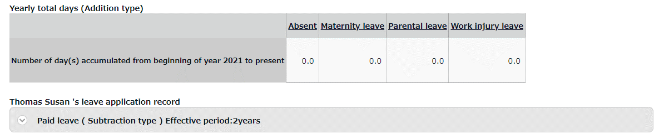

- Enter [Grant date] and [Grant days]. Click [Save].
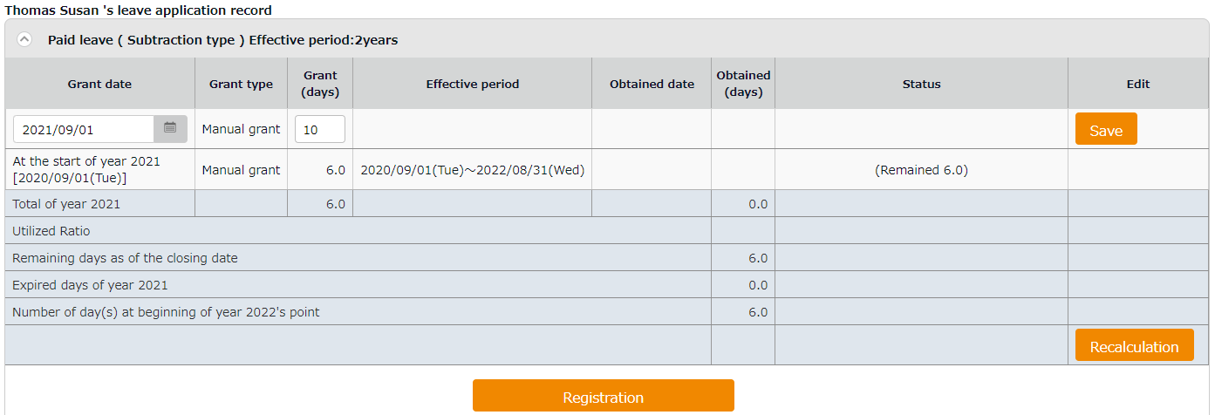
The total number of leaves taken/remaining are shown.

Item | Description
Total of (year) | Total leaves granted and taken during the year, regardless of expiration date.
Utilized Ratio | This shows the percentage of leaves (rounded off to the nearest whole number) taken during the specified period.  It does not count carry-overs from the previous year.
Number of days remaining as of the closing date | Shows the number of leaves remaining as of the closing date.
Expired days of (year) | Shows the number of leaves expiring this year. The [Status] column shows the total of remaining leaves that are labeled as [Expiring].
Number of day(s) at beginning of (next year)'s point | Shows the number of remaining leaves at the start of the next year.  These are carried over to the next year.

Grant leaves to multiple employees at once
- Go to the Leave management screen, then select a [Leave type] under [Specify display condition] to filter data.
Press the [Grant at once] button displayed.
- Enter a value in [Increase/decrease grant (days)] in the next screen.
To apply the value to all employees displayed in the screen, click [Copy].
- Click [Save] to save the settings.

Check the number of leaves taken each month
To check how many leaves are taken every month, go to the Yearly data screen (p.15).

[Where to look] “Frequently used” menu > Attendance data > Yearly data

Grant leaves by auto-calculation

Please complete the Grant paid leave settings in advance. For details, please refer to this article (Japanese).
https://n_help.kingtime.jp/h-t/web5/Detail.aspx?id=1534 lp.kingtime.jp/h-t/web5/Detail.aspx?id=1534

The [Attention required ] mark in the home page indicates there is an employee entitled to paid leaves, based on the grant policy. Click this item to view the list of employees who are eligible for paid leaves. You can also access from [“Frequently used” menu > Leave management > Employees entitled to Paid leave].)

Instructions
- Confirm the employee’s [Grant days] and [Grant date].
Grant days are automatically calculated. However, you can also edit the values manually.
- Select the [Grant] radio button on the right.
- Click [Grant paid vacation]. Click [Apply] in the next screen.
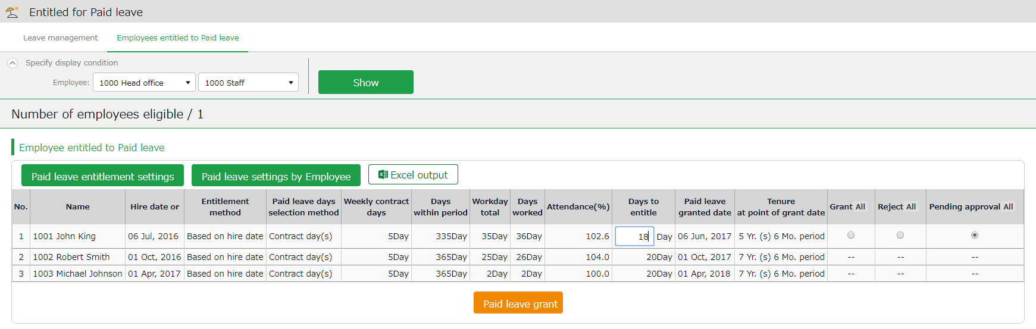

Change paid leave grant policies from here. These settings can also be performed in the Employee type settings screen and Employee settings screen.
Paid leave entitlement settings/Paid leave settings by employee
Number of employees eligible

Shows the number of employees that are entitled to paid leave.

Shows the employees entitled to paid leaves, grant policy (condition), and the reference attendance record.
Please refer to the following pages for details on related items.

Descriptions
Here are descriptions of terms in the [Entitled for Paid leave] screen.

Hired date or Last granted | The employee’s hired date is displayed until leaves are granted for the first time. After them, the date last granted will be shown.  Instead of the past grant date, the grant date may also be calculated from Paid Leave-related settings and Hired date.
Grant method | The paid leave grant method specified in the Paid Leave-related settings is shown.  This is either [Hired date] or [Grant date criterion].
Paid leaves grant selection method | The selection method for the number of leaves, specified in the Paid Leave-related settings is shown.  This is either [Contract days] or [Work days].
Weekly contract work days | Weekly contract work days are shown, based on the settings in Employee type settings > Paid Leave-related settings > [Set the number of workdays designated per week (Required)].  - If you set the number of days: Displays the number of workdays designated per week  - If you select [Calculate the total working days per year based on the designated number of working days per week]: Displays the calculated number of workdays designated per week  If the number of days worked is not enough to calculate the number of days in a given workweek, the number is displayed in yellow.
Days within period | Shows the number of days of period required for granting leaves.
Total working days | The number of days specified as [Total working days] (see Paid Leave-related settings) during the period.
Working days | The number of days specified as workday (in Paid Leave-related settings) during the period.
Attendance rate (%) | Number of days worked / Total working days = Attendance rate  Yellow indicates that the number of attended days is less than the minimum attendance required (80%).
Granted days | Shows the number of leaves to grant. Pink indicates zero leaves.
Grant date | Shows the date of when the paid leaves were granted.
Tenure at point of grant date | Shows the number years the employee worked at the grant date’s point.

Manage long-term leave
Prior settings are required to register the leave period. For details, please refer to the following articles (Japanese).
Childcare Leave:
https://n_help.kingtime.jp/h-t/web5/Detail.aspx?id=4998
Postpartum Paternity Leave:
https://n_help.kingtime.jp/h-t/web5/Detail.aspx?id=4996

Descriptions
Specify display condition

Specify division, employee type, etc. You can also filter by employee code, employee name, leave type, and year.

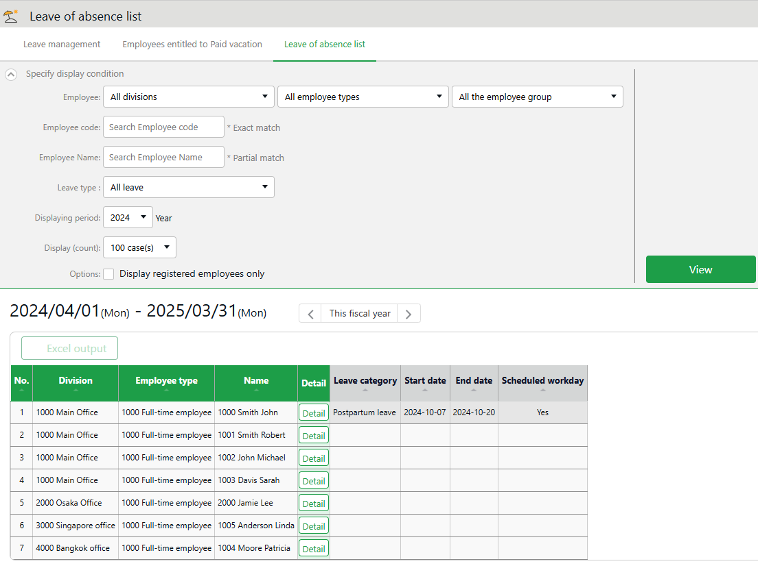

Check the registered leave periods and whether there are any scheduled workdays for each employee (only for “Postpartum Paternity Leave (Childbirth Leave)”).
List of long-term leaves

Operations

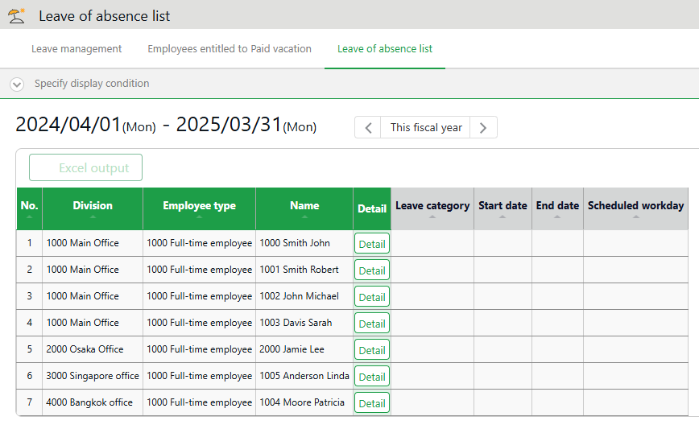
2
1

No. | Buttons | Description
1 |  | Download the data shown in the leave of absence screen in Excel format.
2 |  | Display the leave details screen. You can set the start and end dates of the leave, among other details.

Registering leave periods and workable days

- On the leave details screen, open the details of the relevant leave category.
- Enter the “Leave Start Date”, “Leave End Date”, and “Scheduled Workdays”, then click [Save].
*Note: “Scheduled Workdays” can only be entered for “Postpartum Paternity Leave (Childbirth Leave)”.
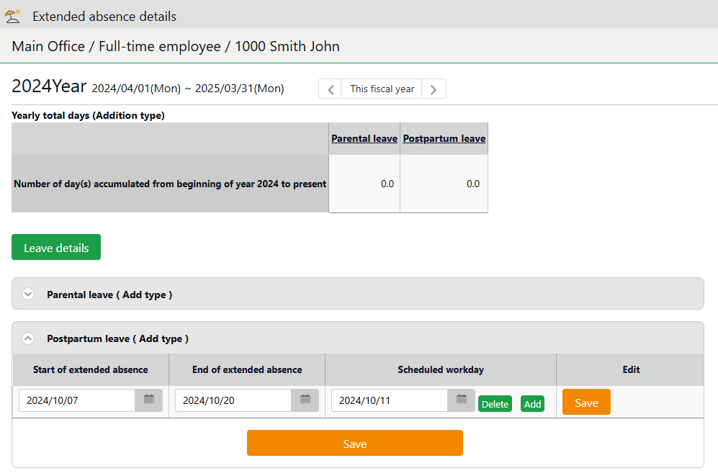
- The leave category for the relevant leave will be automatically assigned for the period from the registered “Leave Start Date” to “Leave End Date” (excluding “Scheduled Workdays” and non-working holidays).
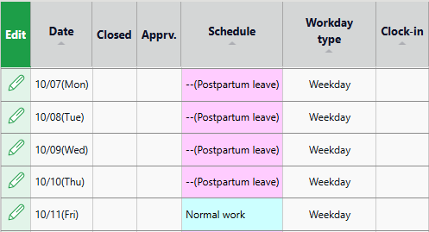
What are Non-Working Holidays?
Leave categories that are not checked as “All Working Days” in the following menu are treated as non-working holidays. The leave category for the relevant leave will not be automatically assigned on non-working holidays, even during the leave period.

Settings > Employees > Employment Category Settings > Edit the relevant category > Leave Category > Paid Leave Grant > [Paid Leave Grant Related Settings] > Set the number of working days and all working days to be counted as the basis for granting.

For example, in the diagram below, “Substitute Holiday”, “Public Holiday”, and “Alternative Leave” that are not checked as “Full-day work” are considered non-working holidays.
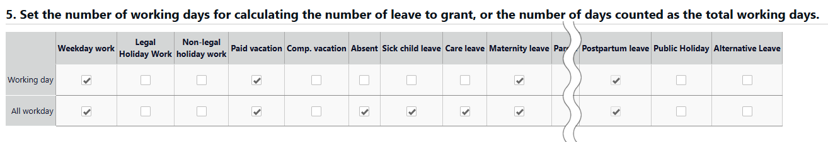

Export data
This section describes the data export feature.

The Export menu
You can export time record, auto-calculated attendance data and employee data from the Export/Import screen.

[Where to look] “Frequently used” menu > Others > Export / Import

Initially available data
Item name | Function | Format
Monthly data | Exports data that correspond to the specified period (3 months or less).  Used for integrations with payroll software. | CSV
Daily data | Exports data related to everyday work, such as attendance data and schedule. | CSV
Time Card | Export Time Card. | PDF
Employee data | Exports Employee data in Excel format. | CSV
Data by divisions and groups | Exports attendance data (calculated by Divisions and Employee types) that correspond to the specified period (3 months or less). | CSV
Supplemental Working Records | Exports Supplemental Working Record registered in Schedule. | CSV
Admin data | Exports Admin permission data. | CSV
Annual Paid Leave Management Data | Exports annual paid leave data (details such as when it was granted and taken). | EXCEL
Admin-employee link data | Exports Admin-employee link data of employees who are assigned as administrators. | CSV
Request approval flow data | Exports all Request Approval Flow data in a single CSV file. | CSV
Image for Leave Application Request | Export request info and files attached to leave requests. | ZIP

Descriptions
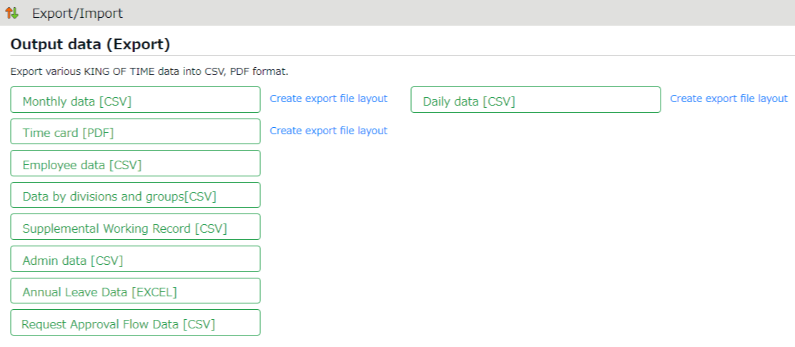

When exporting monthly, daily and time card data, you must first perform its layout setting.
You can use the basic layout for Time Card data export, but you can also create your own layout.
Create export layout

Exports data
Export menu

Create export file layout
The export file layout specifies the display order of data within the export file.

- Go to [“Frequently used” menu > Export / Import] and click [Create export file layout] next to Monthly data [CSV] (or Daily data [CSV], Time Card [PDF]).
Click [Create new] in the next screen.
- Enter the items required.

Layout name | Enter the layout name in 100 characters or less.
Data orientation | This defines the arrangement of the data. Data is generally arranged vertically.  * Only available in the Monthly data layout setting screen.
Export item name | This determines whether to include title row (e.g. Assigned hours, Overtime work, etc.) in the file.  To change the name of the items, enter the items in the [Custom item name] field, each separated by a comma (,).  * Available in Monthly data and Daily data export layout settings screen.
Quoted string | This determines whether to enclose every data with quotation marks (“).  * Available in Monthly data and Daily data export layout settings screen.
Time display format | You can select the time format from here. To configure settings for the third decimal place, go to [Home > Settings > Options] and change [The handling of the third decimal place for 10 decimal display].
Signed name | Enter the names required in the signature line.  * This only shows in [Time card layout settings].

- Select items from the [Available items] list as needed, then click [Add].
The [Add blank] button adds a blank column to the [Items selected] list.
Preview is available in the bottom of the screen.
- Select items as needed and click [Save].
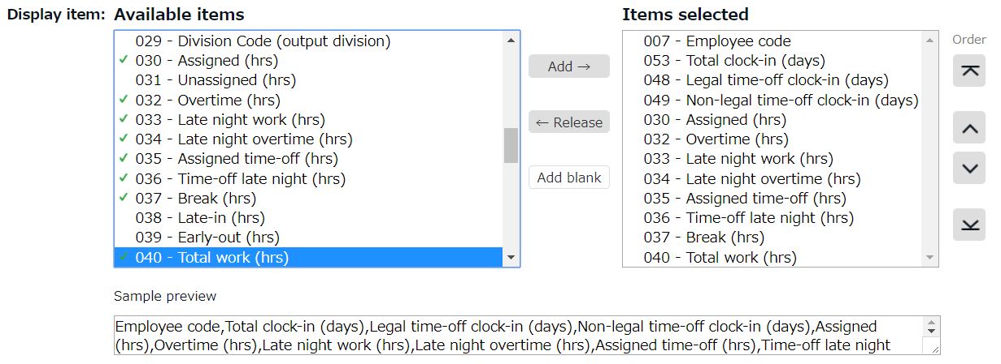
- To specify as the default layout template, press the [Set to default] displayed on the list. The selected layout is specified as default when exporting the data.
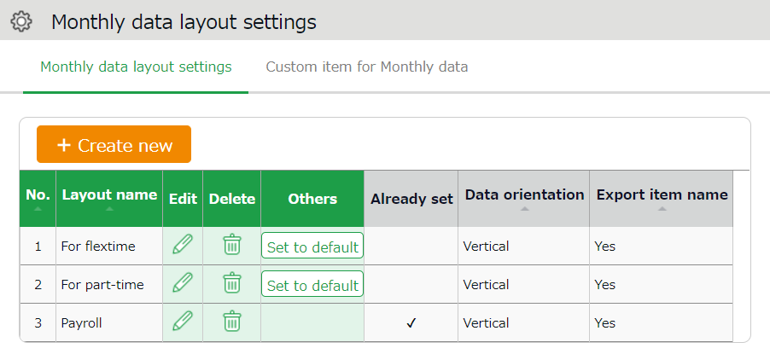

Create custom items
You can create original export items by combining existing attendance-related items (e.g. An item that adds up Overtime work and Late-night overtime work).

- Go to [“Frequently used” menu > Export / Import] and click [Create input layout] next to Monthly data [CSV], Daily data [CSV] or Time card [PDF].
Then, click [Custom item for Monthly data (Daily data custom item/Customize Time Card items)].
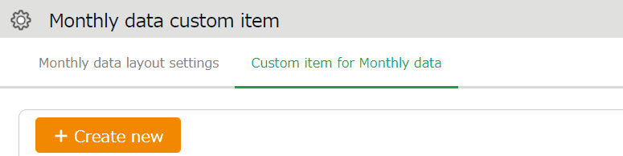
- Click [Create new] and enter the items required.

Basic info
Custom item name | Enter custom item name in 100 characters or less.
Calculation unit | Select either [Hrs.(Time)] or [Day].
Results | If you turn on the checkbox at [Don't export negative values], calculation results with negative numbers are displayed as 0.

To apply fixed value
Fixed value | Enter any value in 50 characters or less.
Apply to calculation value | This setting determines whether to add the fixed value to attendance related items (specified in the bottom half of the screen).  - [Don't use (Export fixed value)] - Fixed value is displayed/exported as specified.  - [Use (Sum up fixed value and attendance data item)] - Fixed value is added up to the attendance related items checked below.  - If you set it to [Use], please enter the Fixed value in minutes.  - If the [Export as 0 if total of items selected is 0 min/0 days] check box is turned on, the calculation results exports as 0 when the sum of the selected items are 0.

- Select items.
Check the [+] column to add up items, then check the [-] column to subtract items. You cannot choose items in different units (time/days/value) at the same time.
*The formula created here will also appear on the Output data custom items screen.
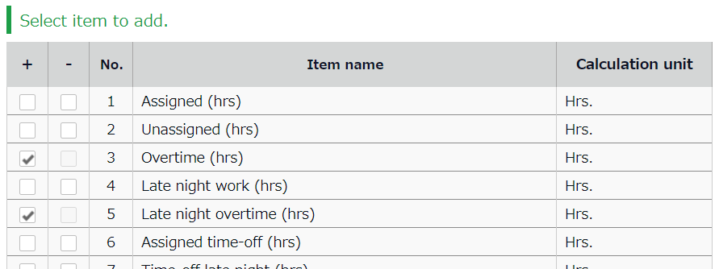

- Click [Save] to save the settings.
- The new custom is added to the [Available items] list.
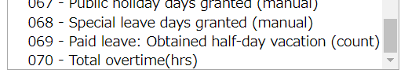

Export
This section describes the steps to export data.

- Go to the Export / Import screen and click [Monthly data CSV]

- Specify exporting conditions such as data period, export layout and division. Click [Data output].
- Displays the [Confirm data export] screen.
Confirm details and click [Data output] to download the data.
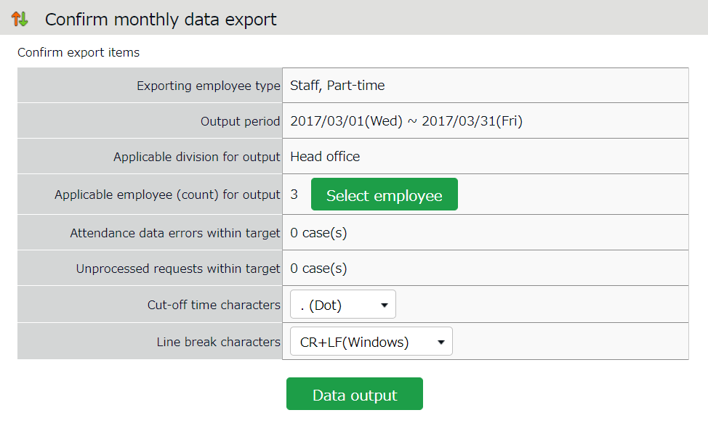

Applicable employee (count) for output | Shows the number of employees exporting. To export data of some of the employees, select employees from [Select employee].
Attendance data errors within target | Shows the number of attendance error data within the specified period.  You can export data regardless of attendance data errors. However, some data might be incorrect. Please make sure to check the details of the errors in the Attendance data error screen.
Cut-off time characters | You can use either dot (.) or colon (:) in the time format.  * Not available in Time Card output.
Line break characters | Change the newline character if needed. Please choose a character compatible with your system, especially if you are using an operating system other than Windows. * Not available in Time Card output.

Time range of data
You can also export data by month.

Set the time range of exporting data
Go to the Export data screen and click [Set date] in [Output applicable date].
You can specify any range of data less than 3 months.
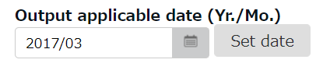

Export 5 Years’ Data
Up to 5 years of data (Daily data [CSV] and Time Card [PDF]) can be exported, if you are exporting 1 employee’s data at a time.

[Where to look] “Frequently used” menu > Others > Search employees

- Search an employee by name or employee code.
- Click [ Ξ ] of the employee to open a drop-down menu.
- Click [Export data by day] or [Time Card output] in the menu.
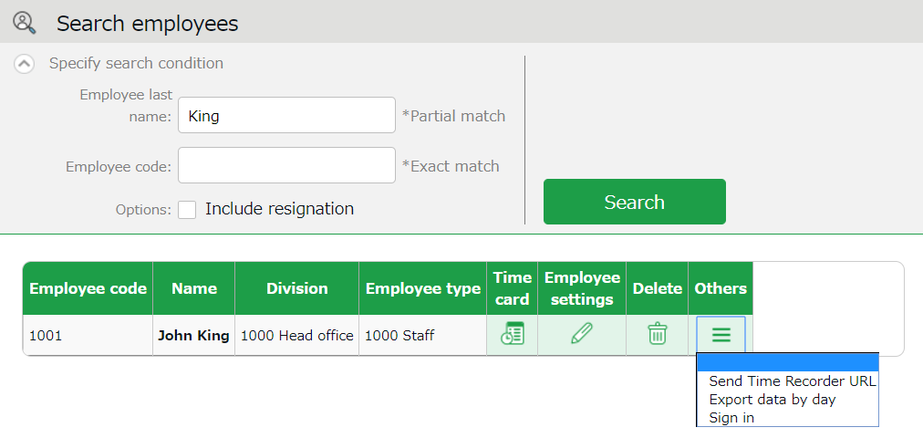

- Go to the Export data screen and click [Set date] in [Output applicable date]. You can set data period to a maximum of 5 years. For Time Card export: If you check [Calculate by closing date] under [Export options], monthly data will be organized in different pages.

Table of Attendance Data Items
The definition of attendance items in this system are described below.

Time calculation
Working time is defined by [Workday type], [Employee type] and [Time record].
Even if an employee clocks in/out several times throughout the day, working time calculates as 1 day’s work.

Attendance items | Details | Workday type
Work time | This is the work hours between clock-in and clock-out. The calculation is based on the calculation method specified in Schedule (clock in and out schedule) and Employee type settings. | Weekday
Unassigned work  (Unassigned work time) | Work time after scheduled Clock-in/out hours is regarded as [Unassigned work time]. However, working time past Overtime work start time is classified as [Overtime work]. Working time that takes place during Late night overtime work hours are classified as [Late night overtime work]. They are both calculated separately from [Unassigned work]. | Weekday
Overtime work | Overtime work is calculated according to the rule set in [Employee type > Overtime start time]. This is usually set to [8 Hrs. excess work will be counted as overtime]. This means working for more than 8 hours is regarded as overtime work. (Weekly and monthly overtime calculations are available by applying the Flextime work feature.) | Weekday
Assigned Late-night hours | Calculated according to the rule set in [Employee type > Late night work (hrs) slot]. This is usually set to 22:00 - 5:00 (following day). | Weekday
Unassigned Late-night hours | Work time after Late-night hours schedule is regarded as [Unassigned Late-night hours]. Work time past Overtime start time is counted as [Late night overtime hours]. | Weekday
Late night overtime hours | Sums up working hours that satisfies both [Overtime] and [Night work] conditions. [Overtime work] and [Late night work] are calculated separately and do not overlap. | Weekday
Assigned time-off hours  Time-off late night hours | Working hours during [Legal time off] or [Non-legal time off] workday types are regarded as [Assigned time-off hours]. This sums up working hours under Legal holidays and Non-legal holidays. The definition of “late night” is described above. | Legal time off  +  Non-legal time off
Unassigned time-off hours  Unassigned Late-night hours | Working hours during [Legal time off] or [Non-legal time off] workday types are regarded as [Unassigned time-off hours]. This sums up working hours during [Legal time off] and [Non-legal time off] days. The definition of “late night” is described above. | Legal time off  +  Non-legal time off
Assigned legal time-off hours/  Legal time-off late night hours | Working hours during the [Legal time off] workday type is classified under this category. The definition of “late night” is described above. Available in Data export. | Legal time off
Unassigned legal time-off hours/  Unassigned Late-night hours on Legal holiday/ | Unassigned working hours under [Legal time off] is classified under this category. The definition of “late night” is described above. Available in Data export. | Legal time off
Unassigned legal time-off hours/  Assigned Late-night hours on Non-legal holiday/ | Working hours during [Non-legal time off] workday type is classified under this category. The definition of “late night” is described above. Available in Data export. | Non-legal time off
Unassigned non-legal time-off / Unassigned Late-night hours on Non-legal holiday | Unassigned working hours under [Non-legal time off] workday type is classified under this category. The definition of “late night” is described above. Available in Data export. | Non-legal time off
Late-in | Early leaves. Compares clock-in schedule with actual time record. | -
Early leave | Early leaves. Compares clock-out schedule with actual time record. | -
Total work hours | Shows the total working hours. | -
Break time | Calculates break time from time records or employee types and schedules. Break time is subtracted from working hours. | -

Day calculation
A work day is counted as 1 day, regardless of how many hours the employee worked.
Even if an employee clocks in/out several times throughout the day, they count as working time if they are recorded on the same day.

Calculated items | Details | Workday type
Weekday clock-in days | Number of days worked on weekdays (i.e. Workday type set to [Weekday]). | Weekday
Time-off clock-in days | Number of days working on legal and non-legal holidays. Number of working days under [Legal time off] and [Non-legal time off] workday types. | Legal time off  +  Non-legal time off
Legal time-off clock-in days | Number of days worked under the [Legal time off] workday type.  Total days worked. | Legal time off
Non-legal time-off clock-in days | Number of working days under the [Non-legal time off] workday type.  Total days worked. | Non-legal time off
Total clock-in days | Total days worked. | -

Unauthorized copying and replication of the contents of this guide, text and images are strictly prohibited.
The contents of this guide are subject to change without prior notice, for revision and further improvement.

Last Updated – March 9, 2026

