
Employee Manual
Table of Contents
1. What can I do on Kinkakuji? 3
1.1. Use the Time Recorder 3
1.2. Check your attendance data 3
1.3. Submit requests 3
2. Using Time Card on PC 4
2.1. Supported browsers 4
2.2. Sign into Time Card 4
2.3. All menu 5
2.4. Check the Time Card 6
2.4.1. Description 6
2.4.2. Operation 8
2.5. Edit time record data 9
2.5.1. Description 9
2.5.2. Submit request 10
2.6. Edit Supplemental Item 11
2.6.1. Description of the Supplemental item request screen 11
2.6.2. To Submit Supplemental item request 12
2.6.3. Edit Supplemental item screen description 13
2.6.4. To edit supplemental item 13
2.7. Edit schedules/Take leaves (multiple requests at once) 14
2.7.1. Description 15
2.7.2. To Submit Request 16
2.8. Edit schedule and take leave (Detailed request) 17
2.8.1. Description 18
2.8.2. To Submit Request 19
2.9. To submit overtime requests 20
2.9.1. Description 21
2.9.2. To Submit Request 21
2.9.3. Important: When submitting the request 23
2.10. Confirm request log / Cancel requests 24
2.11. To resolve attendance errors 25
2.12. To change the attendance data status to [Confirmed] 28
2.13. To check the attendance confirmation status 30
2.14. Change password 31
2.14.1. To change password 31
3. Using Time Card on Mobile Browser 32
3.1. Supported browsers 32
3.2. Sign into Time Card 32
3.3. All menu 33
3.4. Confirm Time Record/Supplemental Items 34
3.5. Confirm Supplemental Items 35
3.6. Confirm schedule 36
3.7. Submit Various Requests 37
3.7.1. Schedule Request 37
3.7.2. Time record request 39
3.7.3. Overtime Request 41
3.7.4. Submit Supplemental Item Info 43
3.7.6. Edit Supplemental Item Info 45
3.7.6. Confirm or cancel request 47
3.8. To confirm attendance data 48
4. My Recorder 50
4.1. My Recorder 50
4.2. Supported devices and browsers 50
4.3. To access My Recorder 51
4.4. To Use My Recorder 52
4.4.1. Clock-in/out 53
4.4.2. Check Time record history 53
4.4.3. Display Time Card 54
5. Mobile browser recorder 55
5.1. What is a Mobile browser recorder? 55
5.2. Supported models and mobile carriers 55
5.3. To access Mobile browser recorder 56
5.3.1. Check Email settings 56
5.3.2. To access 57
5.4. Operating the Mobile browser recorder 58
5.4.1. Clock-in/out 59
5.4.2. Check attendance status 59
5.4.3. To Check Time Card 59
6. FAQ 60
6.1. I forgot my login info. 60
6.2. I submitted the wrong request. 60
6.3. I somehow logged out. How do I re-login? 60
6.4. [Admin] How do I send My Recorder URL? 60
6.5. What should I do if I receive an Email titled "Employee Email Address Verification Notice"? 60

What can I do on Kinkakuji?
Kinkakuji is an attendance management system.
You can keep attendance record, manage shifts and leaves.

Use the Time Recorder
In the Time Recorder screen, you can record clock-ins/outs, start/end of breaks.
Please refer to the [Time Recorder manual] for information on Time Recorder.
This manual describes 2 methods to operate Personal Time Recorder.

My Recorder
For smart phones and PC browsers - p. 48

Mobile browser recorder
For mobile phones and smart phones - p. 55

Check your attendance data
You can check your attendances and working hours by logging into [Time Card], with your PC or mobile phone.
Please refer to the following pages for instructions on Time Card.

Submit requests
You can submit schedule change requests by logging into [Time Card], with PC or mobile phone. Requests are reflected on Actual work data upon your administrator’s approval. Please refer to the following pages for instructions on Time Card.

What is Time Record Request?
This is a request to make changes to time record data
(clock-in/out time).
Employees usually submit time record requests when they forgot
to clock-in/out or have clocked-in/out by mistake.

What is Schedule request?
This is a request to edit schedules. You can take leaves from Schedule Request as well. Submit Schedule requests to change shifts or to take leaves.

Using Time Card on PC
You can review your attendance data, submit requests and change your password from Time Card. This section describes how to use it on a PC browser.

Supported browsers
The following browsers support Time Card.
Please use the latest version.

  Google Chrome |   Microsoft Edge
Windows
Mac

Sign into Time Card
There are 2 ways to access the Time Card screen; by entering your ID, and by using the Time Recorder.
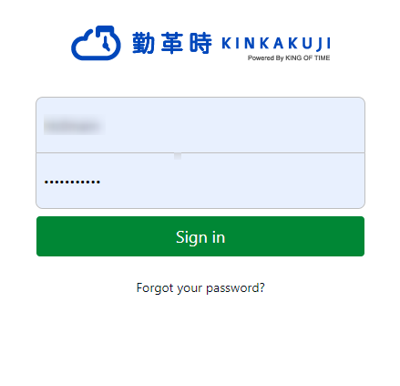
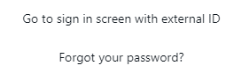

Sign in with ID
Start your browser and enter the Login URL. Enter your login ID and Password, then click [Login].
* Please use the login URL and ID issued by your administrator. Please be sure to set your password.

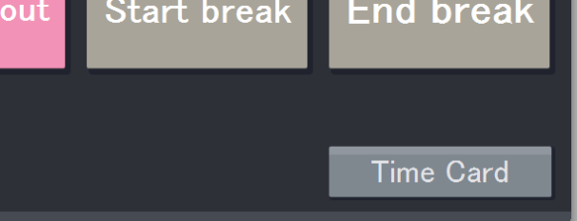
Sign in from Time Recorder
To access the Time Card screen, press the [Time Card] button on the Time Recorder and authenticate by fingerprint, IC card or password.
* Time Recorder design may vary by authentication type.

All menu
After login, select an item on All menu, in the top left of the screen.


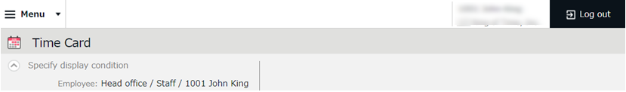
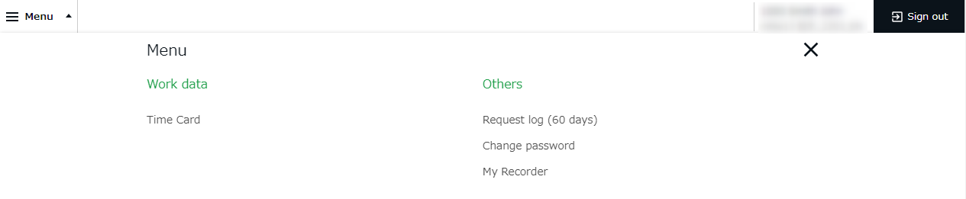

The following are available on Menu.

Time Card | Check your attendance data.  Submit time record edit requests and Schedule requests from here. | p.6
Request log (60 days)  Request log (60 days) | Shows the requests that you have submitted in the past 60 days.  You can cancel requests from here. | p.24
Change password | Change your password from here. | p.25

Check the Time Card
Check your time record, attendance data and reports in real time.
Time record edit requests and Schedule requests can be submitted from here as well.

All menu > Attendance data > Time Card

2.4.1. Description

Select a month. Click [Show] to view data.
Options
Gather time-record: Arrange time record data to a single cell.
Weekly summary: Displays overtime hours after applying statutory working hours per week.
Display by employee work location: Displays location information recorded when clocking in/out.
Classify holidays as Legal and Non-legal holidays: You can check holiday work hours according to workday type.
Specify the display condition

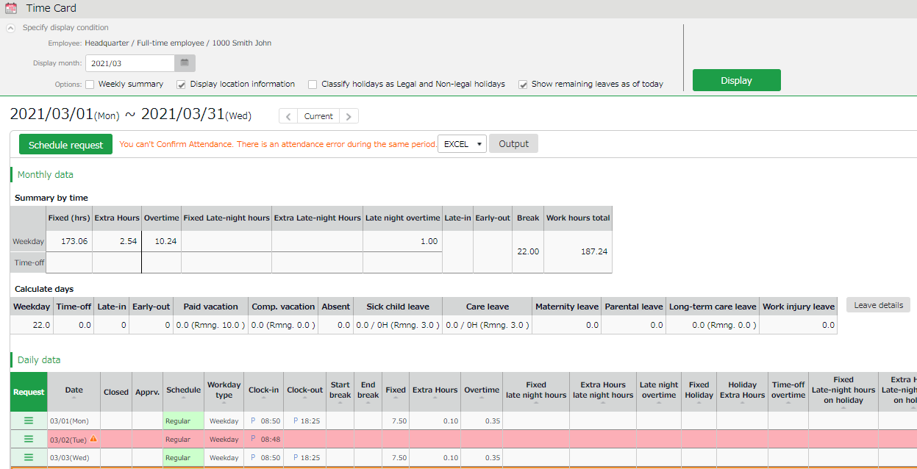

Shows calculated data, such as the number of working days/hours and leaves taken.
Monthly data
Daily data

Check time record, schedule and attendance calculations.

Check Daily data

Light red indicates Attendance error. To run calculations correctly, you need to fix the errors.
Attendance data error

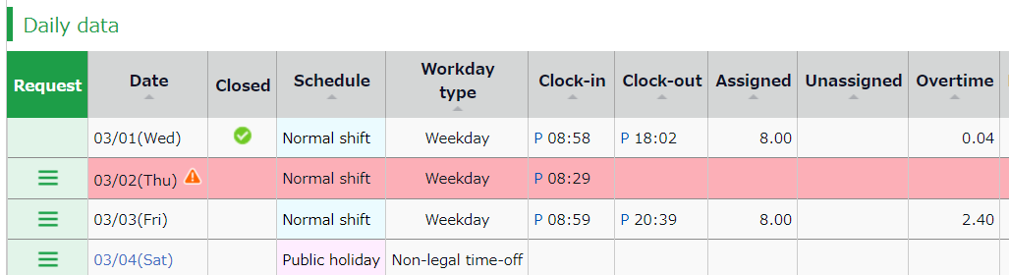

Click [ Ξ ] to open the Request menu.
Click [ Ξ ] at Request

 | This mark is shown next to dates with Attendance error, which is also highlighted in light red. It will be hidden once the error is resolved.
Cl.(Close) | You can check closing status.  The check mark () indicates that the attendance is settled (closed) by your administrator. You cannot submit Time record edits and Schedule requests.
Schedule | Shows schedules and leaves.  If an Admin creates and applies a Pattern to the schedule, the name of the pattern shows on the grid. [Shift] indicates a schedule that does not belong to any pattern.
Workday type | Either of the 3 types are applied: [Weekday], [Legal time off], and [Non-legal time off].
Clock-in/out | Clock-in/out time and method are shown.  P - Password, IC - Card reader, HB - Finger hybrid scanner,  Edit - Time record has been edited,  Approve - Changes to time record approved
Note | Comments from your administrator are shown. The administrator can choose whether to reflect your Request message to the Note field when processing the request.

2.4.2. Operation
You can Perform the following tasks in Time Card.
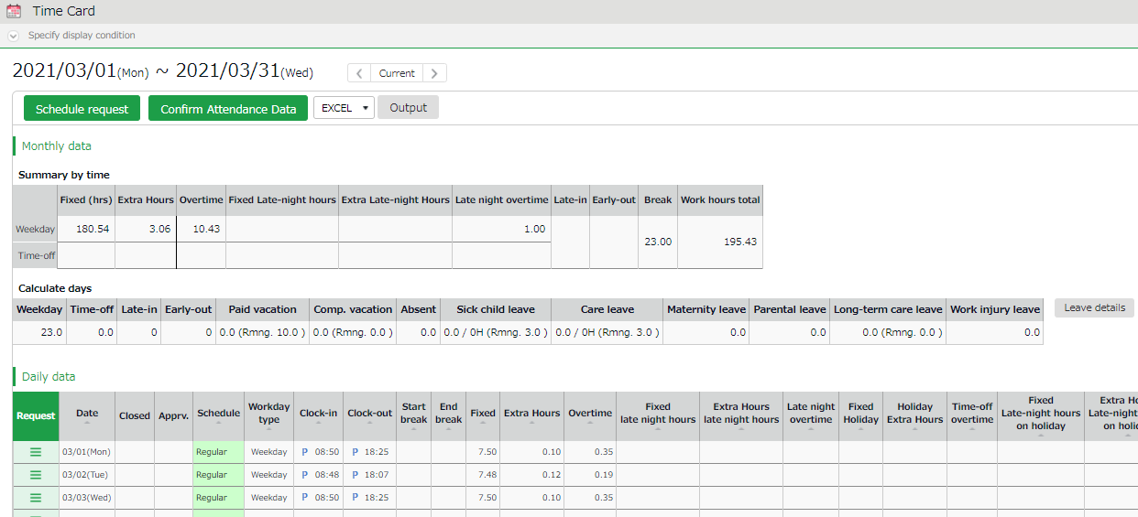

3
2
1ｚ

4

5

No.  1ｚ | Buttons | Description
1 | 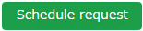 | Submit a month’s worth of schedule or leave requests at one time (p.6).
2 | 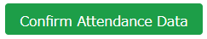 | Mark your attendance data for the displayed month as confirmed.  The button is displayed when there are no attendance errors or unapproved requests.
3 | 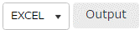 | You can download Time Card data in Excel format.
4 |  | Check the leaves taken/remaining.
5 |  | Submit request to edit time record (p.9).
5 | 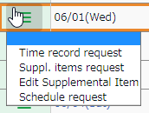 | Submit Supplemental item request (p.10).
5 |  | Edit Supplemental item data from here (p.13).
5 |  | Submit schedule or leave request by day (p.17).
5 |  | Submit overtime request (p.20).

The items shown in the screen may vary by settings.

Edit time record data
You can submit time record requests if you forgot to clock-in/out.
Go to the Time Card screen and click [ Ξ ] in the Request column of the corresponding date. Then click [Time record request].
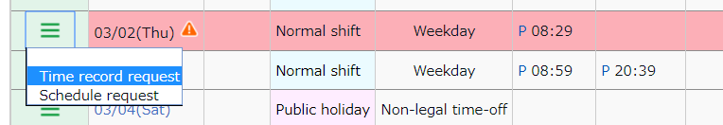

2.5.1. Description
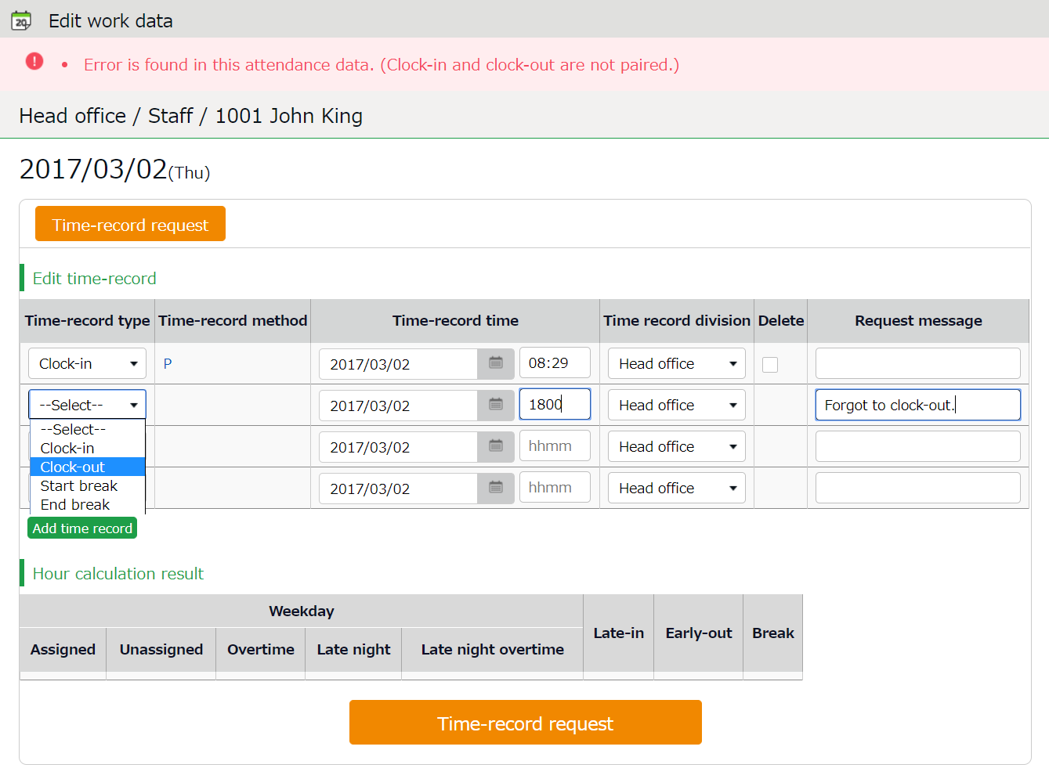
Time record request

Submit change request from here.

Edit time record data.

Time-record type | Select a time record type such as Clock-in, Clock-out, Start break and End break.
Time record method | Time-record method is displayed automatically.
Time record | Enter clock in/out time. Enter in alphabets (half-width characters).
Time record division | Select another division if you are clocking-in to another division as a guest.  Unless specified, your own division is set to default.
Delete | Turn the check box on to submit deletion request.
Request message | Enter the reason of request.  Your administrator will read this message when checking your request.
Add time record | Click here to add new fields.

Time record request

2.5.2. Submit request
Enter the items required and press [Time record request].

Delete time record
For example, you can delete time record data if you clocked in/out by mistake.
Put a check in the [Delete] column and enter [Request message].

Edit time record
For example, you can edit time record data if you selected the wrong Time record type (e.g. selected “Clock-in” when requesting changes to clock-out record by mistake).
Correct the existing data and enter [Request message].

Add time record
For example, you can add time record data if you have forgotten to clocked-in/out.
Enter the Time record type (clock-in/out) and time in the new row.
Enter [Request message] and submit.

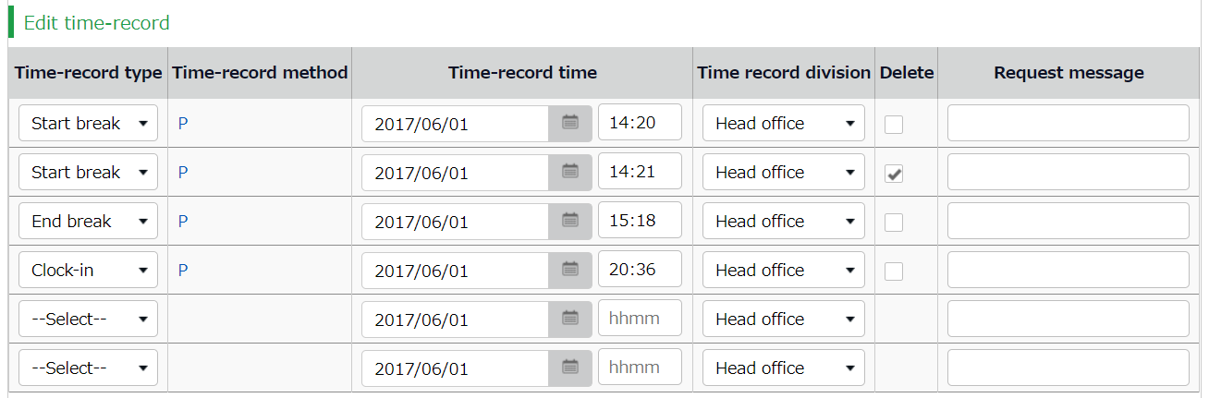
1
2
3

Edit Supplemental Item
You can edit or submit requests for clock-in/out data for urgent attendance work, transportation expenses, allowances, etc. This service is available only if the administrator has created the custom data item in advance.
Go to the Time Card screen and click [ Ξ ] in the Request column of the corresponding date. Then click [Suppl. items request] or [Edit Supplemental Item].
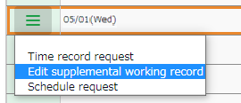

2.6.1. Description of the Supplemental item request screen

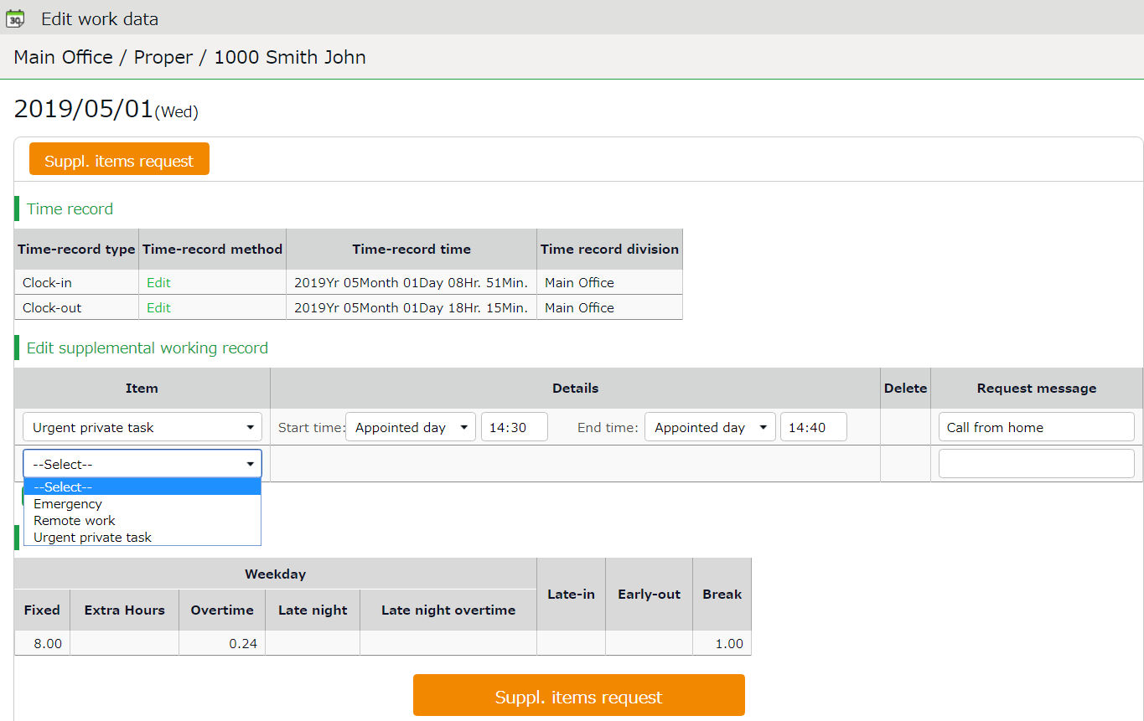

Submit change request from here.
Submit Supplemental items request

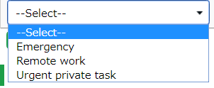

Enter the details of request.
Item | Select an item.
Details | Enter details accordingly.
Delete | Turn the check box on to submit deletion request for existing content.
Request message | Enter the reason of request.  Your administrator will read this message when checking your request.
Add record | Click here to add new fields.

Suppl. items request

Submit the request.

2.6.2. To Submit Supplemental item request
Enter required info, then press the [Request] button.

To add Supplemental Item
Enter the items, content, or message, then click the [Request] button.
To submit request for more than one data item per day, click the [Add record] button to add a new row.

To edit Supplemental Item
If you need to change an existing supplemental item, edit the data as needed, then enter the Request message and click the [Request] button.

3. To delete item
Delete the entire row as follows.
Turn the check on the [Delete] column and enter [Request message] before submitting.

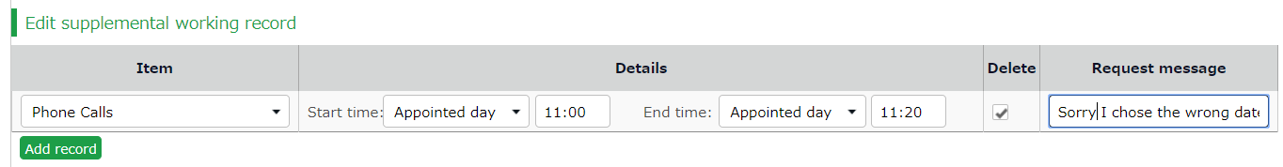

2.6.3. Edit Supplemental item screen description
You can add or edit supplemental item data without the approval of the admin.
* Available only if the registration feature has been enabled by the Admin.

Edit the supplemental item data as follows.
Edit supplemental working record
Submit change request from here.

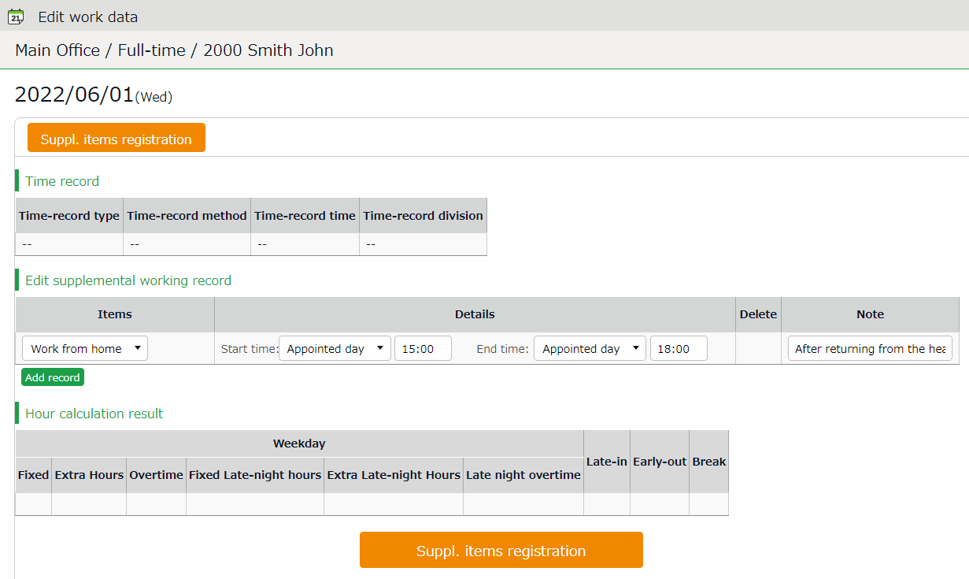

Enter the details.
Item | Select an item.
Details | Enter details accordingly.
Delete | Turn the check box on to delete existing content.
Note | Enter items as needed. This message is displayed along with the details of the item.
Add record | Click here to add new fields.

Edit supplemental working record

Submit the request.

2.6.4. To edit supplemental item
Enter required Details, then click [Suppl. items registration].
After saving it, you can edit or delete the item from [Edit supplemental item] (the procedure is the same as described in p.12). To delete the data, turn the check box on in the Delete column of the item.

Edit schedules/Take leaves (multiple requests at once)
This section describes the steps to submit a month’s worth of requests at once. Click [Schedule request] in the Time Card screen.

If an overtime work request (p.20) is pending, you cannot submit a schedule request. Please submit the schedule request after the overtime work request for the relevant day has been approved or rejected.

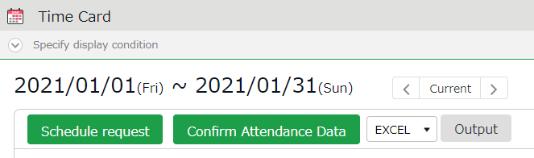

2.7.1. Description

Submit change request from here.
Request
Schedule request
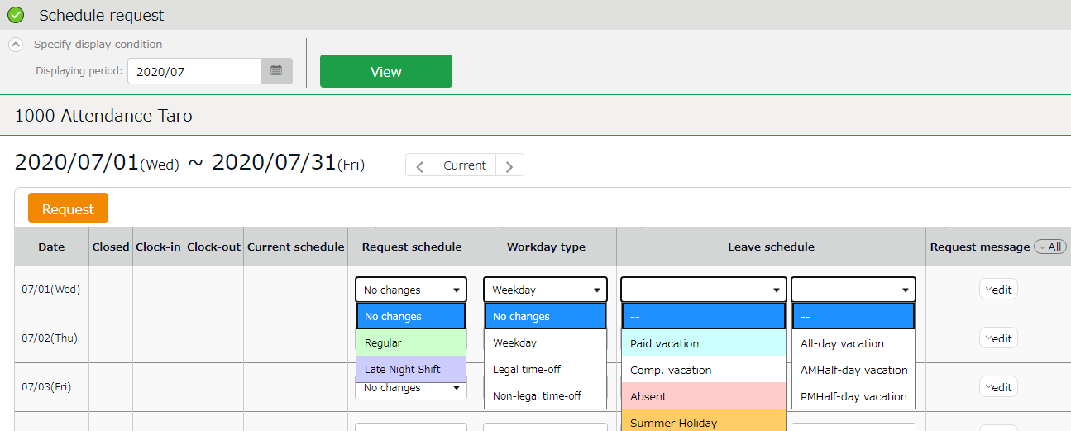

Enter the details of request.

Clock-in/out | Time record are displayed.
Current schedule | Existing schedules are shown.
Request schedule | Set a schedule pattern for intended day.
Workday type | You can choose from 3 types: [Weekday], [Legal time off], and [Non-legal time off].  If none is specified, this is set to [No changes].
Leave schedule | Take full day or half-day leaves (AM or PM leave) from here.
Request message | Enter the reason of request. Click [Edit] to enter Request message. Your administrator will read this message when processing your request.

2.7.2. To Submit Request
Enter the items required, then press the [Request] button.

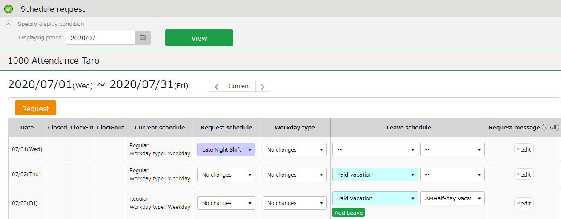
3
2
1

To edit schedule
Select a Schedule pattern for intended day.
Press the [Edit] button at [Request message] to enter the reason of request, etc.
Enter your message and submit.

To take full-day leave
To take leave, specify the leave type first, then select [All-day vacation] under [Leave schedule]. As an alternative, you can also use a leave pattern at [Request schedule] if there is one.

Edit schedule and take leave (Detailed request)
Submit schedule edit requests or leave requests. This section describes the steps to submit a detailed Schedule request for a single day.

If an overtime work request (p.20) is pending, you cannot submit a schedule request. Please submit the schedule request after the overtime work request for the relevant day has been approved or rejected.

Go to the Time Card screen and click [ Ξ ] in the Request column of the corresponding date. Then click [Schedule request].
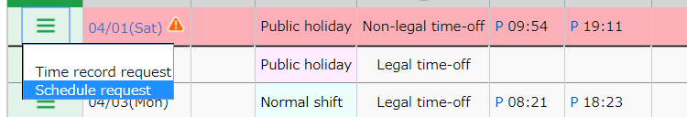

2.8.1. Description

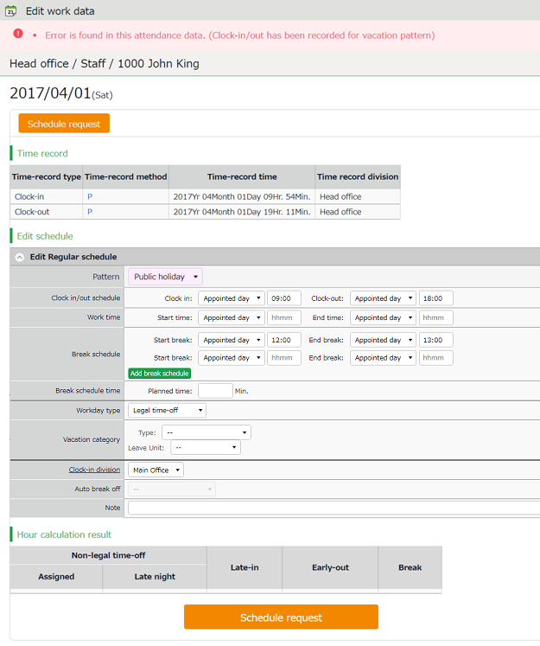
Schedule request

Submit change request from here.

Shows the time record data.
Time record data
Edit schedule

Edit your schedule here. Please refer to the following pages for details on each item.

Items in Edit schedule
Pattern | By selecting a pattern, the time set to the schedule pattern is applied to the schedule.  You can also enter the items manually.
Clock-in/out schedule | This sets the clock-in/out schedule.
Work time | Working time within this time range will be calculated.  Any work before scheduled clock-in time and after clock-out time will not be included in the calculation.
Break schedule | The time between [Start break] and [End break] are regarded as break time.  Press the [Add break schedule] button to add new fields.
Break schedule time | The specified time will be calculated as break time, automatically.
Workday type | Determines whether the work took place during holiday or not.  You can choose from 3 workday types: [Weekday], [Legal time off], and [Non-legal time off].
Vacation category | When taking leave, select its type (e.g., paid leave, comp leave, etc.) and the unit (e.g., full-day leave, AM half-day leave, PM half-day leave, time, etc.).
Leave by hours | If your company uses the ‘Pattern Method', this item appears in place of 'Vacation category'. Select the type of leave, start and end time.
Clock-in division | Shows where the employee clocked in.  The name of the last used Division Time Recorder is automatically applied.
Auto break off | Submit a request if you could not take break at the scheduled time.
Request message | Enter the reason of request.  Your administrator will read this message when checking your request.

2.8.2. To Submit Request
Enter the items required and press [Schedule request].
You can submit detailed schedules from here.

To submit overtime requests
You can submit overtime requests as follows.
Go to the Time Card screen and click [ Ξ ] in the Request column of the corresponding date. Then click [Overtime request].
- If a schedule request (p.14, p.17) is pending, you cannot submit an overtime work request. Please submit the overtime work request after the schedule request for the relevant day has been approved or rejected.
- On days when no schedule is registered, the “Overtime Work Request” option will not be displayed.

* [Overtime request] is hidden if no schedule is set.
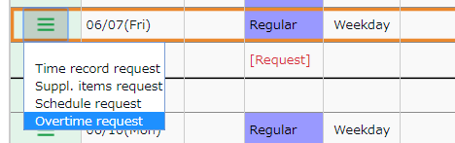

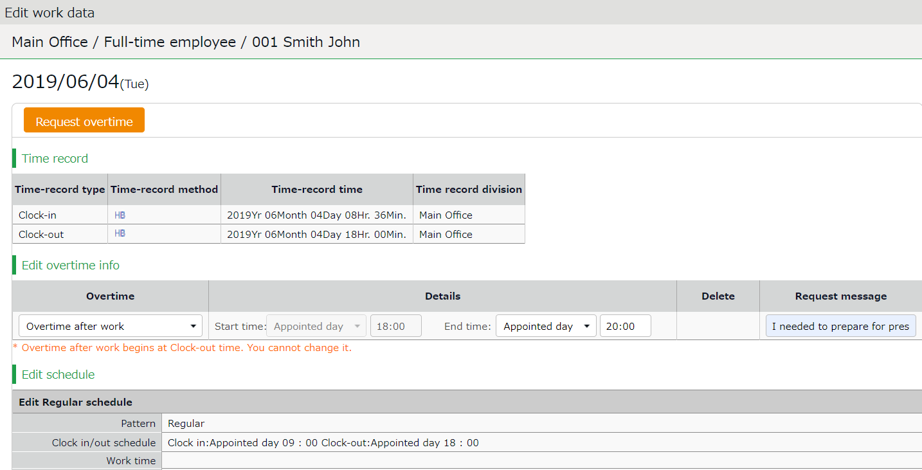
2.9.1. Description

Submit change request from here.
Overtime request

Time record data
Shows the time record data.

Shows the time record data.

First, check your regular clock-in/out schedule to decide between Overtime before work or Overtime after work. Please refer to the following pages for details on each item.

Edit overtime info

Overtime request
Enter Clock-in/out schedule and details of the request.
Request overtime before schedule | Enter the time before the Clock-in schedule.  *The End time field is disabled since it should be the same as the scheduled Clock-in time.
Request overtime after schedule | Enter the time after the Clock-out schedule.  *The Start time field is disabled since it should be the same as the scheduled Clock-out time.
Delete | Turn the check box on to request deletion.
Request message | Enter the reason of request.  Your administrator will read this message when checking your request.

2.9.2. To Submit Request
Here is how to submit requests for overtime before and after work schedule.

Request overtime before work
Example: If you have a schedule of 9:00 AM to 6:00 PM and overtime from 7:00 AM to 9:00 AM.

Select [Request overtime before work] and enter "Appointed day" and "07:00" for the "Start time". After entering your request message, click the [Request overtime] button.
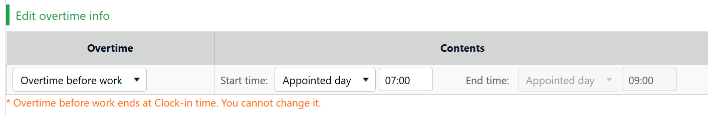

Request overtime after work
Example: If you have a schedule of 9:00 AM to 6:00 PM and overtime from 6:00 PM to 8:00 PM.

Select [Request overtime after work] and enter "Appointed day" and "20:00" for the "End time". After entering your request message, click the [Request overtime] button.
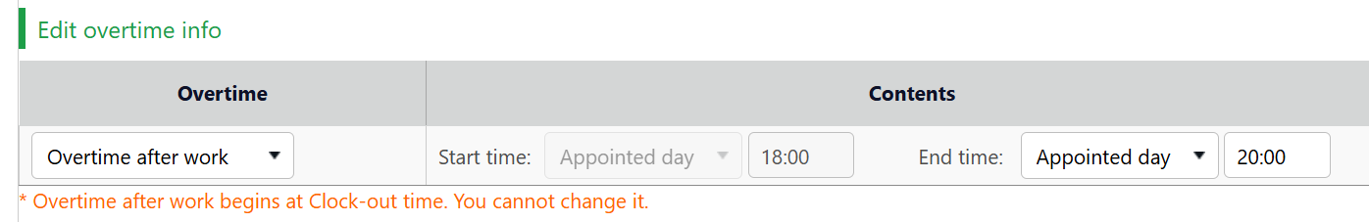

If your clock-out time is earlier than the requested overtime after work, your working hours will be calculated up to your clock-out time.

Example: If your clock-out time is 6:30 PM and the approved "Request overtime after work" end time is 7:00 PM
⇒ Working hours will be counted until your clock-out time of 6:30 PM.

If your clock-out time is later than the requested overtime after work time, your working hours will be calculated up to the approved overtime end time.

Example: If your clock-out time is 7:30 PM and the approved "Request overtime after work" end time is 7:00 PM
⇒ Working hours will be counted until the overtime end time of 7:00 PM.

* The same specifications apply to "Request overtime before work" requests.

2.9.3. Important: When submitting the request
When submitting both a schedule request and an overtime request on the same day, always submit the schedule request first. You should only apply for overtime after your schedule request has been approved by your Admin.

If you don't follow the steps mentioned, the following issues will occur:

If you submit the overtime request first, and then submit a schedule request before the overtime request is approved:
You will see an error message that says, "You cannot submit schedule requests on this date. An overtime request is still under process" And you will not be able to submit the schedule request.

If you submit the overtime request first, and then submit the schedule request the overtime has been approved:
When your schedule request approved, your standard clock-in/out schedule will change. This will invalidate (reset) your previously approved overtime application.

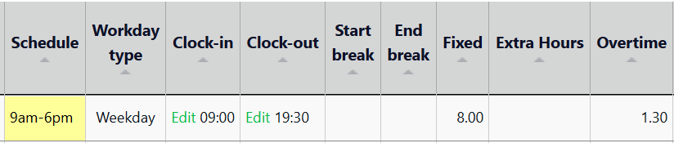

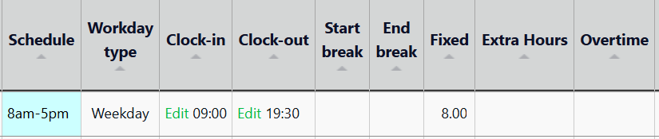

Confirm request log / Cancel requests
You can check requests that you have submitted during the past 60 days.
Requests that have not been approved yet can be canceled, by pressing the [Cancel submission] button.

All menu > Others > Request log (60 days)

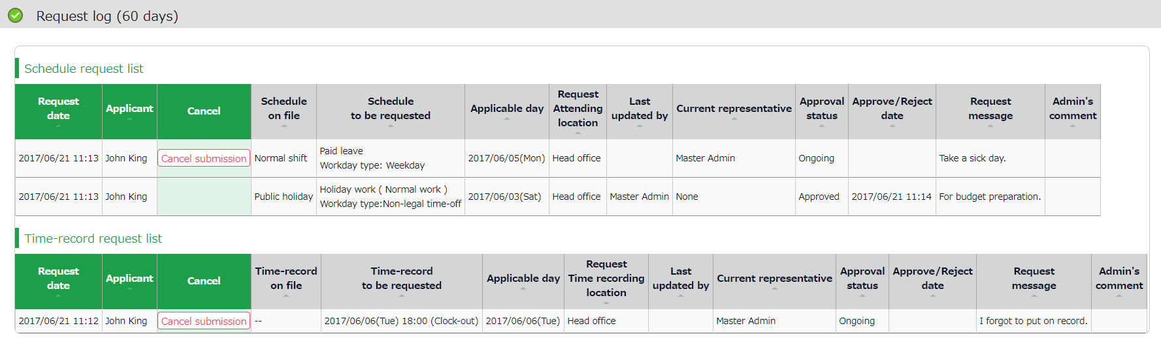

To resolve attendance errors
When an attendance error occurs, the corresponding day on the time card is displayed in red.
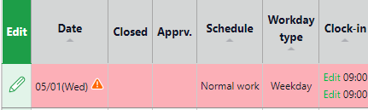

You can check for the cause of the error from the Attendance data edit screen (Click request [≡] and choose any of the request items).
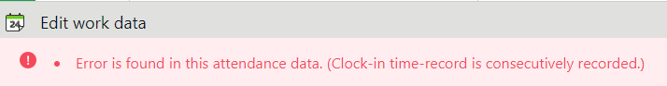

Please refer to the list of error causes below and submit a request to resolve the issue. The error will be resolved when your request is approved by the Admin.

Clock-in time-record is consecutively recorded.
This error indicates there are overlapping clock-in/out records within a short period.
Please submit a request to delete the unwanted time record.
To delete time record, please refer to “Delete time record” in p.10.

No clock-in time record has been made first.
This error indicates that you have clocked-out before the clock-in time. The clock-out time must be after the clock-in time.
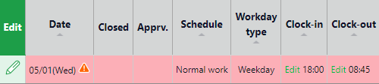
Please submit a request to correct the time record.
For details on submitting the request, please refer to “Edit time record” in p.10.

Clock-in and clock-out are not paired.
This error indicates the clock-in time and clock-out time are not paired.
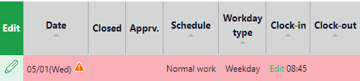
Please submit a request to add the appropriate time record that pairs with the other.
For details on submitting the request, please refer to “Edit time record” in p.10.

Obtained leave is exceeding the remaining leave.
This indicates you have taken more leaves than you have left.
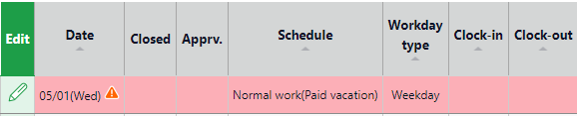
Please check again to see you have enough number of remaining leaves to submit the request. For details on submitting the request, please refer to “To take full-day leave” in p.16.

Attendance for only late-in/early-out.
This error indicates you have clocked-in/out outside of the scheduled hours.
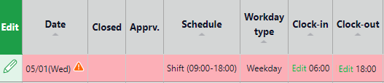

Please select the correct pattern or edit the clock-in/out schedule directly.
For details on submitting the request, please refer to “To edit schedule” in p.16.

Schedule has not been registered.
This error indicates the clock-in/out schedule is missing from the day you have clocked-in/out.
* This message may not show depending on the your company settings.
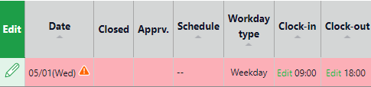
Please select the correct pattern or edit the clock-in/out schedule directly.
For details on submitting the request, please refer to “To edit schedule” in p.16.

There is no time-record.
This error indicates that a clock-in/out record is missing from your workday.
* This message may not show depending on the your company settings.
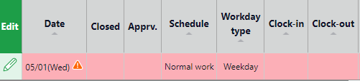
If you have forgotten to clock-in/out, please submit a request for your attendance record or submit a leave request.
To submit request to add your time record, please refer to “Add time record” in p.10.
To submit leave request, please refer to “To take full-day leave” in p.16.

Clock-in/out record exists in a holiday/leave day.
This error indicates you have an attendance record on your holiday.
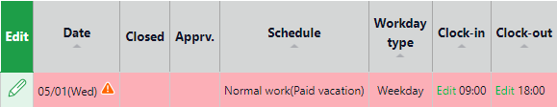
Please follow the steps below to undo the holiday.
For details, please refer to the notes on “To take full-day leave” in p.16.

To change the attendance data status to [Confirmed]
You can check your attendance data for the month and change the status to "Attendance confirmed".
Open the Time Card screen of the month and click [Confirm Attendance Data].
* This feature may not be available depending on the settings by your Admin.

- Click [Confirm Attendance Data].
* The button is hidden if there are any attendance errors or unapproved requests.
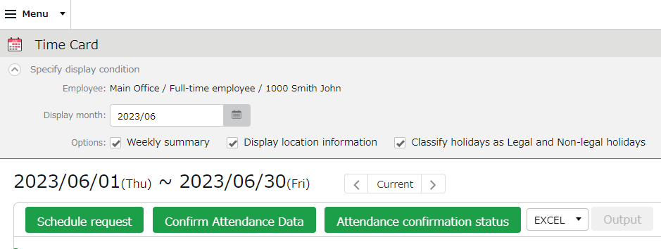

- The confirmation screen will be displayed. Check your total hours in office, working hours and break time. If there are no issues with your data, click [Confirm Attendance Data].
* Clicking on the button will not send off any notifications to your Admin.
* Items such as Hours in Office and Discretionary leave hours may not be displayed, depending on the settings by your Admin.
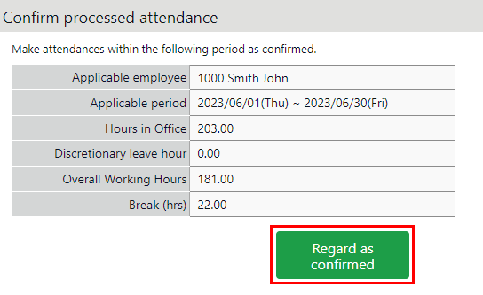

If there is a significant difference between the [Total working hours + Break time] and the [Hours in office + Discretionary leave hours], you may have an unsubmitted overtime request. Please click on [< Return] at the top left of the screen and return to your Time Card screen and check the details again. If needed, please submit your overtime request.
*Total working hours include Discretionary leave hours.

To check the attendance confirmation status
You can keep track of the date you confirmed your attendance data or when you canceled the confirmation. Open the Timecard screen of the month and click [Attendance confirmation status].
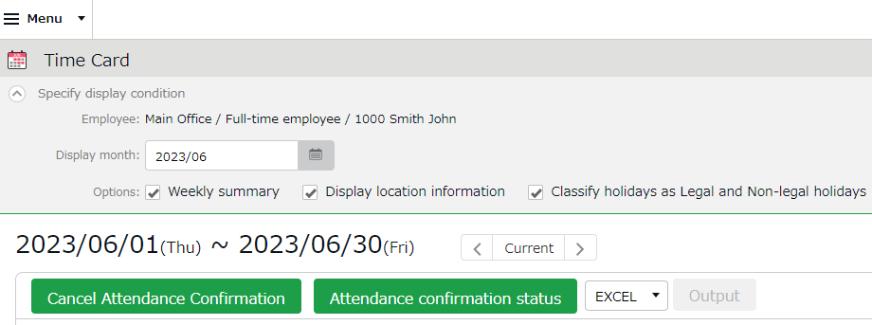

The date of the attendance confirmation, the date and the name of the person who made the cancellation.
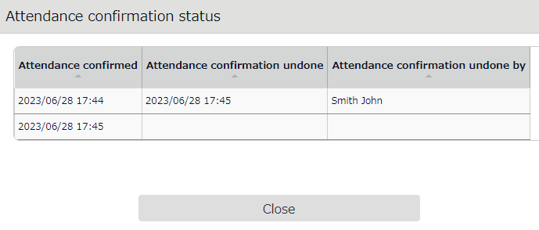

Change password
Change your password from here.

All menu > Others > Change password

2.14.1. To change password
- Enter your current password in the Password change screen. Then enter your new password.
- Press the [Change Password] button.
The next time you log in, use the new password.

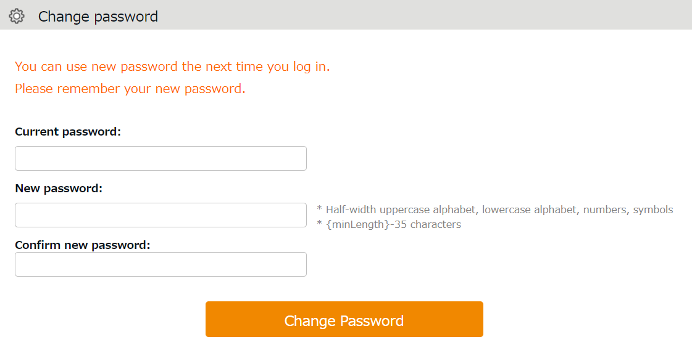

You need your password for the following purposes.
- Log into Employee screen
- To clock-in/out by password authentication (If Password Time-record is enabled)

If you forgot your password, please contact your administrator to have it re-issued.

Using Time Card on Mobile Browser
You can check your attendances, schedules, submit requests and change password from mobile phones or smart phones.

Supported browsers
The following browsers support Time Card.
Please use the latest version.

  Mobile Safari  iOS | Google Chrome for Mobile  Mobile phones  Android | Default browsers*

* Operations are not confirmed on all devices.

Sign into Time Card
There are 2 ways to access the Time Card screen; by entering your ID, and by using the Time Recorder.

Sign in with ID
Start your browser and enter the login URL in the address bar. Enter your login ID, password, then click [Login].
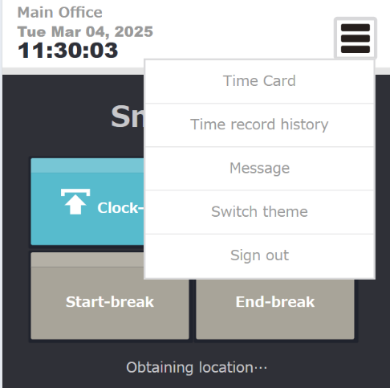
* The login ID and password are the same as those of PC browser version. * Please use the login URL and ID issued by your administrator. Please be sure to set your password.

Sign in from Time Recorder
To view your Time Card, go to the Mobile browser Time Recorder (or My Recorder) screen, open the menu in the upper right corner and select [Time Card].

All menu
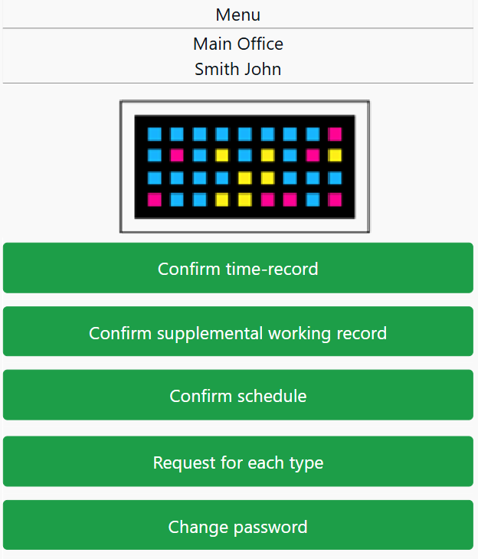

1ｚ

2ｚ

3ｚ

4ｚ

5ｚ

6ｚ

1 | Chameleon code | Shows your Chameleon code to use when clocking in/out.  * Only available when using the iPad Time Recorder app. | -
2 | Confirm time-record | Shows the time record data. | p.34
3 | Confirm Supplemental items | Shows Supplemental items data. | p.34
4 | Confirm schedule | Shows the current schedule. | p.36
5 | Request for each type | Submit requests from here. | p.37
6 | Change password | Change your password from here.  Enter your current and new password, then click [Change password]. | -

Confirm Time Record/Supplemental Items
Tap [Confirm time-record] in Menu. Light red indicates Attendance data error.

Confirm time-record
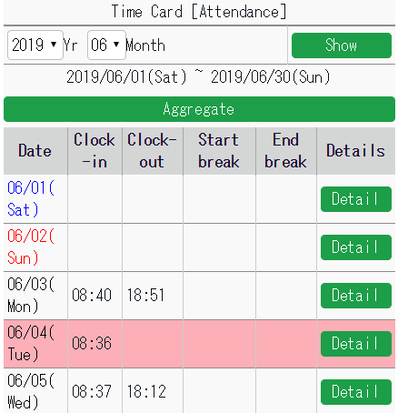
1ｚ

2ｚ

3ｚ

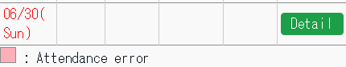

1 | Select Year and Month, then click [View].
2 | Calculation results of the corresponding period are shown by pressing the [Aggregate] button.
3 | To check daily time record, schedules and other info, press [Detail].

Confirm Supplemental Items
Tap [Confirm supplemental working record] to check Supplemental items.
Light red indicates Attendance data error.
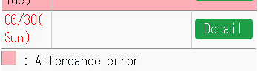
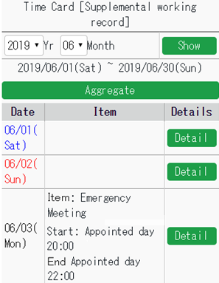

Confirm Supplemental items
1ｚ
2ｚ
3ｚ

1 | Select Year and Month, then click [View].
2 | Calculation results of the corresponding period are shown by pressing the [Aggregate] button.
3 | To check daily time record, schedules and other info, press [Detail].

Confirm schedule
To check your schedule, press [Confirm schedule] in Menu.
Light red indicates Attendance data error.

Confirm schedule
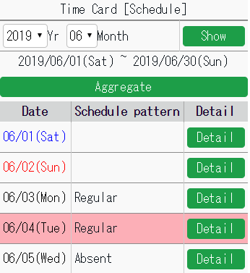
1ｚ

2ｚ

3ｚ

1 | Select Year and Month, then click [Display].
2 | You can check calculation results by pressing the [Aggregate] button.
3 | To check daily time record, schedules and other info, tap [Details].

Submit Various Requests
You can submit different kinds of requests.
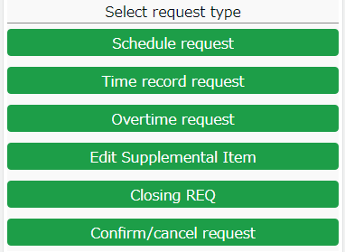

3.7.1. Schedule Request
Submit shift changes and leave requests from here.

- If an overtime work request (p.41) is pending, you cannot submit a schedule request. Please submit the schedule request after the overtime work request for the relevant day has been approved or rejected.
- If the submitted schedule request has not been approved, you cannot submit an additional schedule request for the same day. After it has been approved or rejected by the administrator, you can submit a schedule request again for the same day. How to check or cancel a request (p.47)
- If a date is already assigned as a comp leave or workday (including those with pending status), you will be unable to submit a schedule request for that day.

- Tap [Request for each type], then [Schedule request].
- Select a date from the calendar. You can also choose the date from [Target request date], then tapping [Select].
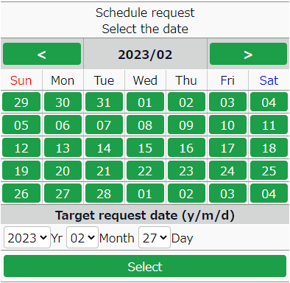

- Select a schedule pattern at [Request schedule].
To take leave, select [Full day leave] or [Half day leave]. If you have not taken any break, select [Auto break off]. Enter the [Request message], then tap [Submit].

Example1: Work schedule request Example2: Leave request
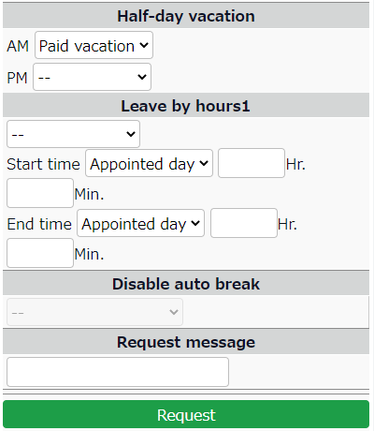
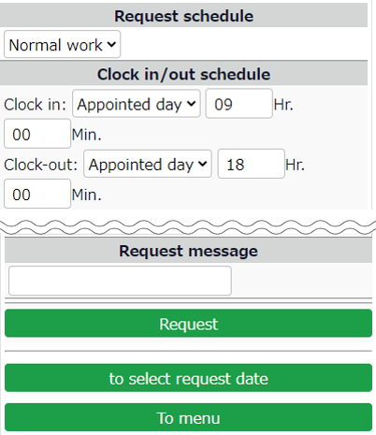

* If there are any unapproved schedule under the same date, you cannot submit another.
You can send new schedule requests only after your manager approves the previous request.
To confirm or cancel requests……………p.47

3.7.2. Time record request
You can submit time record requests in case you forgot to clock-in/out.
- Tap [Request for each type], then [Time record request].
- Select a date from the calendar. You can select the date from [Target request date], then [Select].
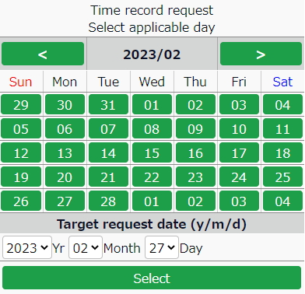

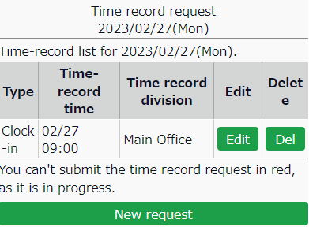
- Press the buttons accordingly.

[Edit] | Submit a request to edit the existing time record.
[Del] | Submit request to delete the existing time record.
[New request] | To add a new time record data, submit a request from here.

- Enter the Time-record type, Time, Request message then tap [Request].
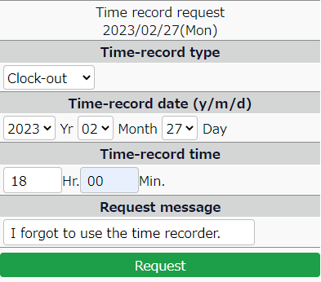

3.7.3. Overtime Request
If you have worked before or beyond normal working schedule, you can submit overtime requests as follows.

- If a schedule request (p.37) is pending, you cannot submit an overtime work request. Please submit the overtime work request after the schedule request for the relevant day has been approved or rejected.
- On days when no schedule is registered, the “Overtime Work Request” option will not be displayed.

This is useful for reporting early-ins and overtime work.
By performing the following steps, the system counts overtime as working hours.

- Tap [Request for each type], then [Overtime request].
- Tap either [Request overtime before schedule] or [Request overtime after schedule].
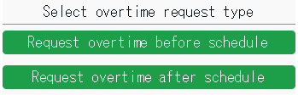

- Select a date from the calendar.
You can also choose the date from [Target request date], then tapping [Select].
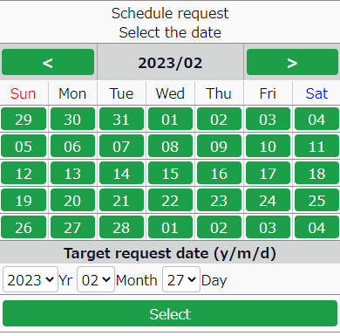
- If you are requesting overtime before schedule, enter [Start time].
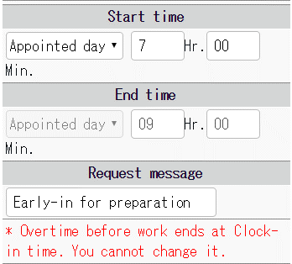

If you are requesting overtime after schedule, enter [End time].
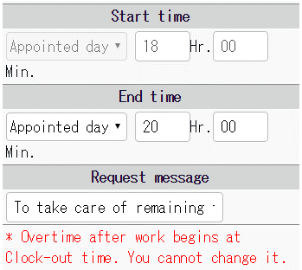

- Enter the [Request message], then tap [Submit].

Please note you cannot request overtime before schedule and after schedule at the same time.
To submit requests fo both, please do so one at a time.

3.7.4. Submit Supplemental Item Info
You can submit requests for clock-in/out data for urgent attendance work, transportation expenses, allowances, etc. This feature is available only if the administrator has created the Supplemental item in advance.

1. Tap [Request for each type], then [Suppl. items request].
2. Select a date from the calendar. You can also choose the date from [Target request date], then tapping [Select].

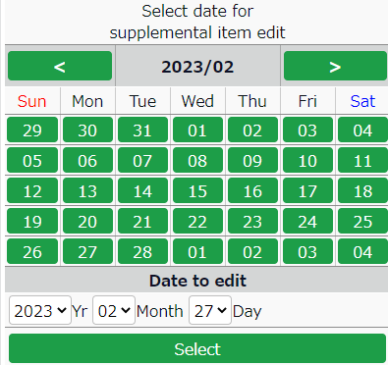

3. Press the buttons accordingly.
New request Screen with existing data
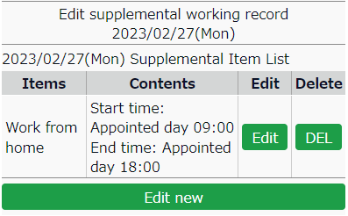
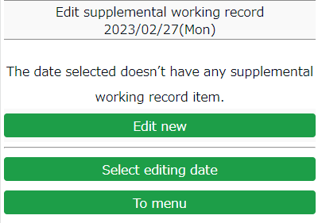

[Edit] | Submit a request to edit the existing data.
[Del] | Submit request to delete the existing data.
[New request] | Submit new request from here.

New registration
- After selecting a date, tap [New request].
(The number of items shown depends on settings by your admin.)
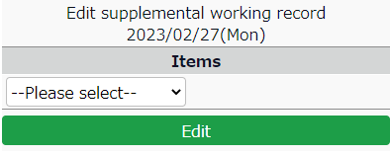

- Input method varies by the item selected.
Enter the items as required before submitting.
Dropdown
Time Span
Value
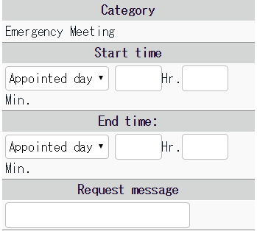
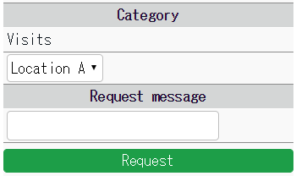
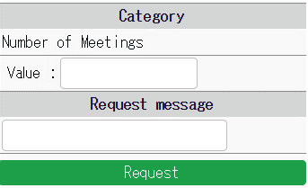

Edit Supplemental Item Info
You can add or edit supplemental item data without the approval of the admin.
* Available only if the registration feature has been enabled by the Admin.
1. Tap [Request for each type], then [Edit Suppl. Items].

- Select a date from the calendar.
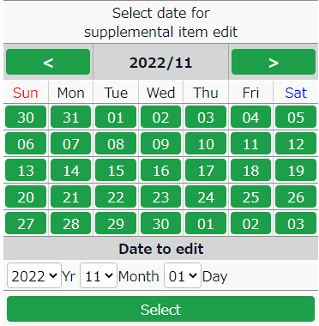

3．Tap on the buttons accordingly.

New request Screen with existing data

[Edit] | Edit existing Supplemental item info.
[Del] | Delete existing Supplemental item info.
[Edit new] | Register a new Supplemental item.

Edit new
- After selecting a date, tap [Edit new]. You can select items which are created by the Admin.
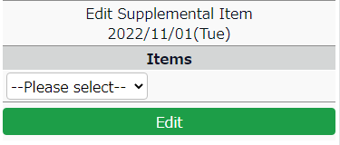

- The input method varies depending on the item selected. Enter the items as required before [Registration].
Time Span
Value
Dropdown

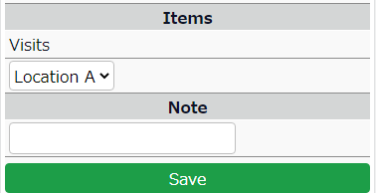
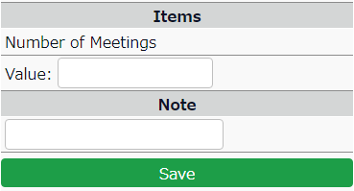
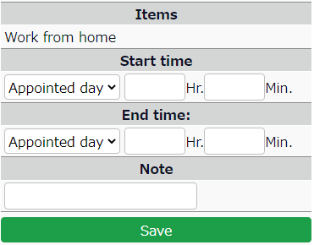

3.7.6. Confirm or cancel request
Confirm or cancel request.
Tap [Request for each type], then [Confirm/cancel request].
Dropdown
Value
Time Span
Here, you can confirm or cancel your requests.
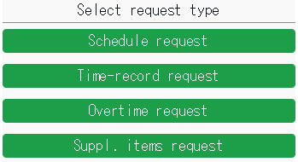

* You can check requests submitted during the past 60 days.
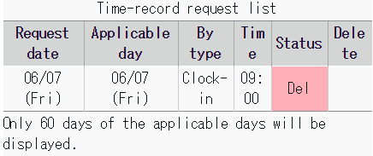
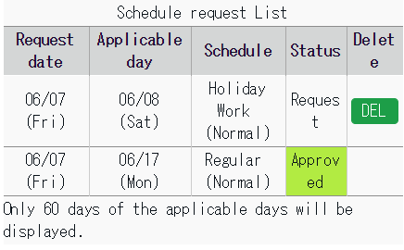

Request | This request has not been approved yet.  You can cancel the request by tapping the [DEL] button on the screen.
Approved | The request has been approved.
Del (Reject) | The request has been rejected.

To confirm attendance data
You can check your attendance data for the month and change the status to [Attendance confirmed].
* This feature may be unavailable, depending on the settings by your Admin.

- Tap on [Confirm time-record] or [Confirm schedule].
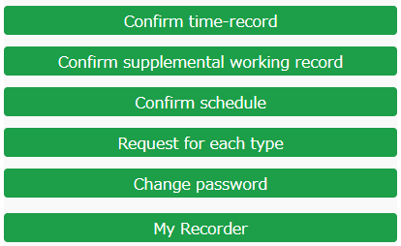

- Specify the year and month, and tap on the [Show] button. Scroll to the bottom of the screen and tap on the [Confirm Attendance Data] button.
* The button is hidden if there are any attendance errors or unapproved requests.
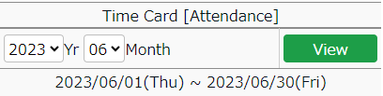
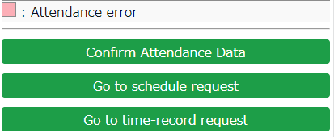

- The confirmation screen will be displayed. Check your total hours in office, working hours and break time. If there are no issues with your data, tap on [Confirm Attendance Data].
* Tapping on the button will not send off any notifications to your Admin.
* Items such as total hours in office may not be displayed, depending on the settings by your Admin.
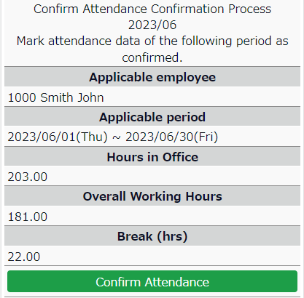

If there is a significant difference between the [Total working hours + Break time] and the [Hours in office + Discretionary leave hours], you may have an unsubmitted overtime request. Please click on [< Return] at the top left of the screen and return to your Time Card screen and check the details again. If needed, please submit your overtime request.
*Total working hours include Discretionary leave hours.

My Recorder
This section describes how to clock in/out on My Recorder.

My Recorder
My Recorder is a personal Time Recorder that you can access from your smartphone, tablet or PC browser. It can record time and location info.
* To use My Recorder, your administrator needs to send you the My Recorder URL and ID.
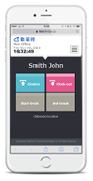
Please use your password to login.
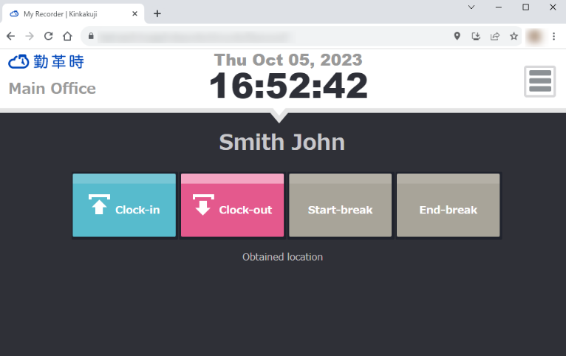



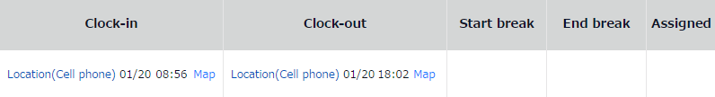

Supported devices and browsers
The following browsers support My Recorder. Please use the latest version. My Recorder is not available on feature phones (mobile phones).
Device | Browser
Windows PC | Google Chrome / Microsoft Edge /
Mac | Google Chrome / Microsoft Edge
Android smart phone | Google Chrome for Mobile
iOS (iPhone, iPad) | Mobile Safari
* The Location info feature is only available on devices with GPS function.

To access My Recorder
- Access the Time Recorder URL by following the instructions on the [Notice about Time Recorder URL/My Recorder URL] Email, sent from your administrator.
* The sender of the Email is no_reply@kingtime.jp.

- ID/password entry screen is initially displayed.
Enter your login ID and the password you have set, then click [OK].
If the authentication succeeds, Time Card is displayed.
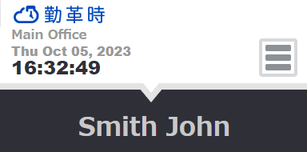
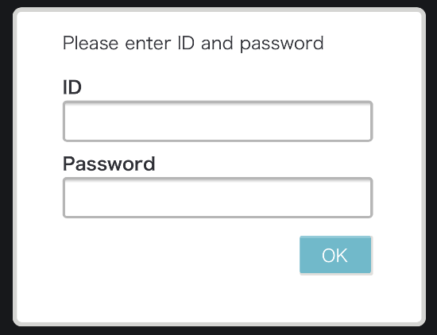

- If the [Obtain location info] mode is turned on at the Admin screen, the screen may show a location permission message. Please permit.
* Messages may vary by browser and version.

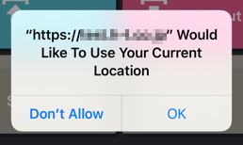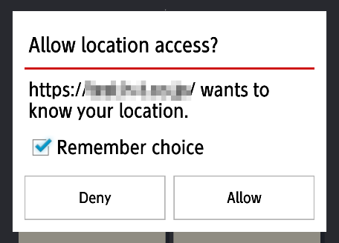
On Google Chrome
On Safari

Please bookmark the My Recorder URL and open it from the bookmark when you want to clock in/out.

To Use My Recorder
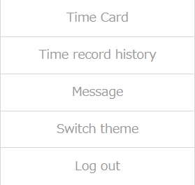
This section describes the steps to use My Recorder.
1ｚ
7
6
5
4
3

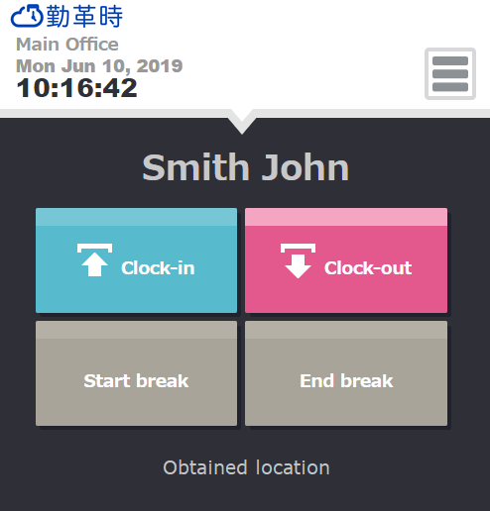

2

1 | Tap here to clock-in/out.  [Clock-in] [Clock-out]  [Start break] [End break]  * [Start break] [End break] buttons may or may not be displayed, depending on settings.
2 | Location info status is shown. (Available if the Obtain location info mode is turned on, in the Admin screen) Location info can be edited, if [Obtained location] is displayed.
3 | Displays Time Card. You can check attendances and submit requests from here.
4 | Shows the time record data performed on the browser.  * You cannot check data recorded from other Time Recorders.
5 | Shows updates related to Kinkakuji (System maintenances etc.).
6 | 2 themes are available. Please choose the one you like.  Changes to theme only apply to the browser that you are using.
7 | Log out of My Recorder from here.  After logout, ID and password are required to re-login.

4.4.1. Clock-in/out
- Access My Recorder URL from your bookmark.
- Tap [Clock-in].
If the clock-in succeeds, the screen shows the [Clock-in completed] message.
* Perform the same procedure to clock-out/start and end break.
* Depending on the settings, you may need to select your division before clocking in/out.

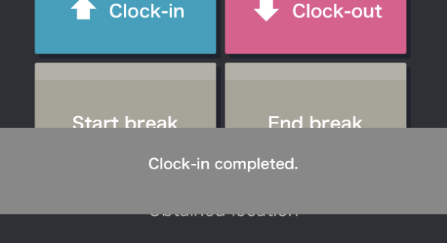

4.4.2. Check Time record history
To check time record log performed on the browser, click [Time record history] in the menu.
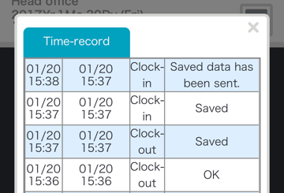
Status | Details
OK | Time record data has been submitted to the server successfully.
Save | Time record data has not been submitted. Instead, it has been temporarily saved on the device. This is displayed if the Time Recorder was off-line when the clock-in/out took place.
Saved data has been sent | Time record data temporarily saved on your device has been submitted to the server successfully.
* You cannot check edited data and data recorded from other Time Recorders.
If you clear your web browser's cache and cookies, Time record history will be cleared as well.

4.4.3. Display Time Card
To access Time Card, press the [Time Card] button in All menu.
For instructions, please refer to the following pages.

To access Time Card on PC - p.4
With Mobile device - p.32

Mobile browser recorder
This section describes how to use the Mobile browser recorder.

What is a Mobile browser recorder?
A Mobile browser recorder is a time recorder that you can use on your mobile phone or smartphone.
Employees can clock-in/out by using personal Time Recorders. The URL is issued to each employee. It can record time and location info.
* To use it, your administrator needs to issue a Time Recorder URL.
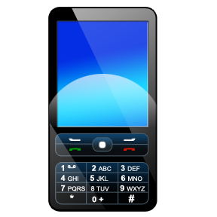
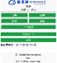
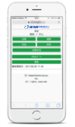

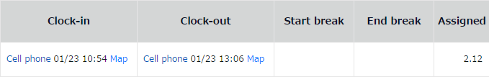

Supported models and mobile carriers
The following devices and environment support Mobile browser recorder.
Device | Mobile carrier/OS | Conditions required for Location info mode
Feature phones | docomo | Open area i-mode-compatible devices
Feature phones | au | Devices that support Location info by EZ Navi and  Device compatible with EZ Navi network types (device:gpsone)
Feature phones | SoftBank | Devices that support “location” scheme specified in “Action” attribute, under “form” element
Smart phones | Android | Browsers that support Geolocation API
Smart phones | iPhone | Browsers that support Geolocation API
* The Location info feature is only available to devices with GPS or cell location function.

To access Mobile browser recorder
This section describes how to go to the Time Recorder.

5.3.1. Check Email settings
Time Recorder URL Email notifications are sent by administrators from the Admin screen.
If you are using a Mobile phone, please check your Email settings beforehand.

Mobile carrier | To check Email settings (may not be applicable to some models)
docomo | iメニュー (i Menu) > お客様サポート (Customer Support) > 各種設定 (Settings) > メール設定 (E-mail settings) >  迷惑メール対策設定 (Spam Mail Prevention) > 詳細設定 (Detailed settings) > URL付きメール拒否設定 (Reject mail with URL) > [設定解除 (Undo settings)]
au | E-mail button > Eメール設定 (E-mail Setup) > メールフィルター (Filter Settings) > 個別設定 (Individual Settings) > その他の設定 (Other Settings) > URLリンク規制 (URL link restriction) > [規制しない (Do not restrict)]
SoftBank | E-mail button > 設定 (Mail setting) > メール・アドレス設定 (Address setting) > Enter security code >  迷惑メールブロック設定 (Spam mail settings) > [個別に設定 (Individual settings)]  URLリンク付きメール拒否設定 (Block E-mails with URL link) > [全て受け取る (Receive all)]

* Setup method may vary by software versions released from the mobile carrier. Display format may also vary by device models.

5.3.2. To access
Access the Time Recorder URL by following the instructions on the [Notice about Time Recorder URL/My Recorder URL] Email, sent from your administrator.
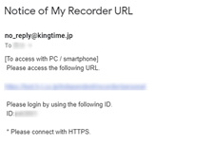
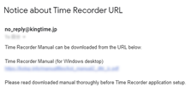
The sender of the Email is [no_reply@kingtime.jp] (send-only address). You cannot reply to this Email.

If there is a line-break in the middle, please fix it to one line before entering it into the address bar.

Bookmark the Time Recorder URL for easier access.
(If you use the Screen Memo function instead of bookmarking the URL, some features may not function correctly when updated.)

Operating the Mobile browser recorder
This section describes the steps to use Mobile browser recorder.

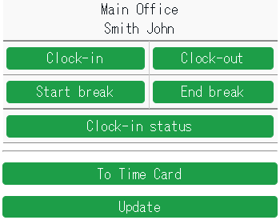
6
1ｚ
2
5
4
3

1 | Shows your name and division.
2 | Click here to clock-in/out.  [Clock-in] [Clock-out]  [Start break] [End break]  * [Start break] [End break] buttons may or may not be displayed, depending on settings.
3 | Shows present or past time record data.  * You cannot check data that were recorded from other Mobile browser recorders.
4 | Location info obtainment status is shown. (Available if the Obtain location info mode is turned on, in the Admin screen) Location info can be edited, if [Obtained location] is displayed.
5 | Displays Time Card.
6 | Reloads browser.

5.4.1. Clock-in/out
Go to Time Recorder URL from your bookmark.
2. Select [Clock-in]. Confirmation screen is displayed if clock-in succeeds.
* Perform the same procedure to clock-out/start and end break.
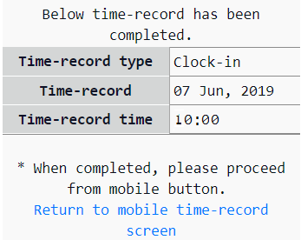
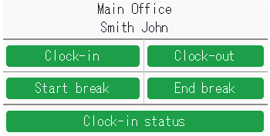

5.4.2. Check attendance status
You can check time record data by each day.

1. Tap [Clock-in status].
2. Select a date and tap [Display].
3. To return to the Time Recorder screen, select [Update].

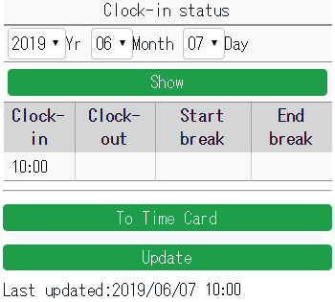

5.4.3. To Check Time Card
To check your Time Card, select [Time Card].
For instructions, please refer to p.32.

FAQ

I forgot my login info.
If you have forgotten your ID or password, please contact your administrator. The administrator can check your ID and re-issue your password.

I submitted the wrong request.
You can cancel requests if they have not been approved yet. Please cancel the wrong request, then submit a correct one. If the request has already been approved, please submit a new request. Make sure the same request date is set. Unless the administrator has closed the attendance data, you can submit requests for the same date as many times as you need.

I somehow logged out. How do I re-login?
If you clear your web browser's cache and cookies, you will log out of My Recorder. Please enter your login ID and password again.

[Admin] How do I send My Recorder URL?
First, log into the Admin screen. Go to [Home page > Settings > Employee > Employee settings].
Press [Send Email] to send.
If My Recorder Email template is not available, please contact the support center to add the function.
When using My Recorder, please check the version of your browser.

What should I do if I receive an Email titled "Employee Email Address Verification Notice"?
This Email is sent by the system to verify that the registered Email address is correct. By clicking the link in the Email, the Email address will be activated, and you will be able to receive various notification Emails from the system. If the link expires (after 7 days), please request a resend from the administrator.

Unauthorized copying and replication of the contents of this guide, text and images are strictly prohibited.
The contents of this guide are subject to change without prior notice, for revision and further improvement.

Last Updated – March 9, 2026

