New Specifications for Vacation Management Feature
Leave Management Manual
Table of Contents

1. Introduction 1
1.1. Difference in the Display of the Number of Remaining Leaves 1
1.2. Differences in How Leaves are Taken 2
2. Prepare for Schedule management 3
2.1. Leave Type Settings 3
2.1.1. Setting instructions 4
3. To Take Full or Half-day Leave 6
3.1.1. Full Day Leave Pattern Settings 6
4. To take hourly leave 7
4.1. The Pattern Method 7
4.2. The Leave Type Method 7
5. To Edit Attendance Data 8
5.1. To edit attendance data 8
5.1.1. Descriptions 8
6. To Plan Schedules 11
6.1.1. Set schedules to each employee 12
7. To Manage Schedules 13
7.1. Take leaves 13
7.1.1. Take Full Day or Half Day Leave (Pattern Method) 13
7.1.2. To Take Full Day or Half Day Leave (Leave Type Method) 14
7.2. Check the number of leaves taken/remaining 15
7.2.1. Descriptions 15
7.2.2. Operations 17
7.3. Grant leaves to each employee 18
7.3.1. Descriptions 18
7.3.2. Grant leaves 19

Introduction
There are "old" and "new" leave management versions.
The Admin Manual provides information on the older version of the leave management feature.
This manual explains the differences between the older and the new version.

How to Distinguish Between the Old and New
It is easy to distinguish between the two versions. Go to [All menu > Leave management].
If your leave management feature is the new version, the [Show currently remaining leaves] option shows below [Specify display condition].

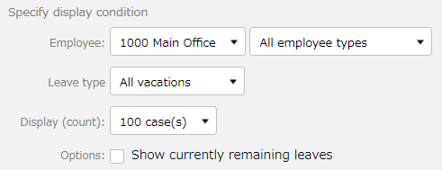
The option does not show if your leave management feature is the old version.

Difference in the Display of the Number of Remaining Leaves
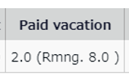
In the old version, the following do not reflect on Time Cards until the actual leave day comes.
- Number of leaves taken
- Number of remaining leaves The new version described in this manual takes future leave schedules into account, unlike the old version. 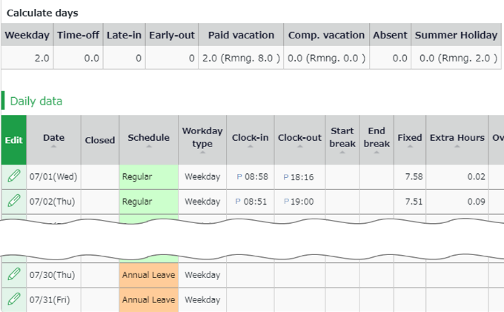
Please refer to p.3 for details.

Differences in How Leaves are Taken
This manual also describes the differences at the Schedule Management screen and how employees submit leave requests.
The new version has two display options when taking leaves.

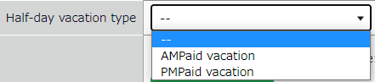
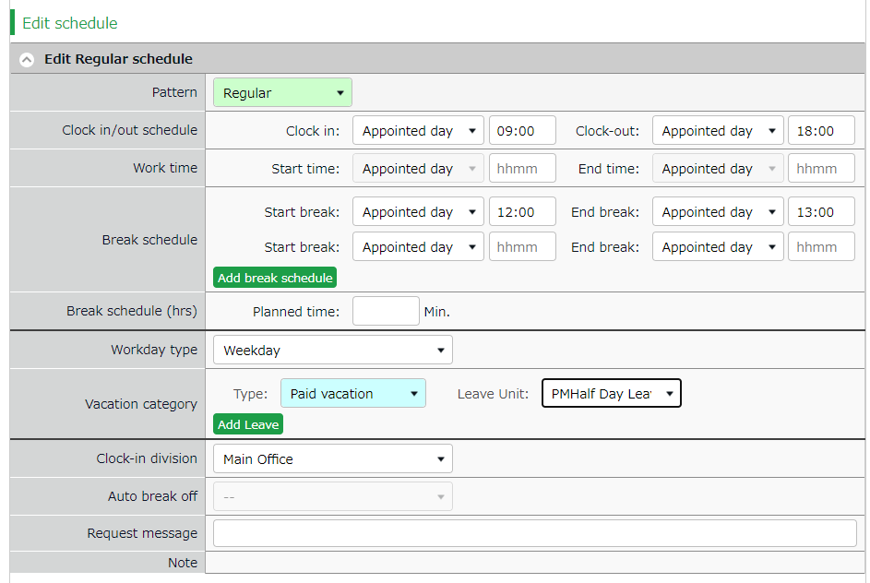
The Pattern Method
The Leave Type Method

Please refer to the following for details.
- To take hourly leaves（p.7）
- To take full or half day leaves（p.14）

Prepare for Schedule management
This section describes the settings related to Schedule management, such as work hours and leaves.

Leave Type Settings
Settings > Schedule > Pattern settings

A Leave type is used for calculating leaves.
When you create a Leave type, a summary column is added to the Time card screen.
In the old version, Admins need to link a "Leave Type" with "Full Day Leave Pattern" to schedule leaves. In the new version, users can also schedule leaves just by choosing the leave type, without using any leave pattern. Leaves are taken by choosing a leave type or a leave pattern at the schedule management/request screen. This action will affect the remaining leaves in the summary column.

The number of full day leave patterns or leave types set to the schedule are counted as the number of leave taken.
Leave type

Time Card screen

To take leave, set a full day leave to the schedule.
Full-day leave pattern

Setting instructions
This section describes the Leave Type settings under [Settings > Schedule].

Click [New Registration] or [Edit] to go to the registration screen.
Enter required info then click [Save].
The setting items are described below.

Name | Enter the name of the leave. (Examples: Paid leave, Compensatory leave, Special leave, etc.)
Half-day leave | By selecting [Apply], users can take half-day leave.
Calculating obtained leaves | Choose either of the following to specify the leave calculation method.  Subtract (Subtraction)  Manages the number of granted leaves, leaves taken (used), and remaining leaves.  Generally used for managing paid leaves.  Add (Addition)  This setting can be used for managing leaves that only needs monitoring of the numbers taken.  This is generally used for managing absences and legal holidays.
Increase/Decrease of Leaves when Working days on holiday is taken | * Only shows in [Compensatory leave].  If you select [Increase by time-off clock-in], compensatory leaves are granted automatically, if working hours during [Legal or Non-legal time off] exceed specified hours.
Grant substitute time-off | Perform settings here to use this leave type as compensatory leave.  If you select [Grant substitute time-off for substitute clock-in schedule], the [Substitute clock-in] (compensatory work day) item is available in the Add schedule screen. Compensatory leaves are granted automatically when working hours in [Substitute clock-in] exceed specified hours.
Allow negative number | This keeps employees from taking leaves when there are none left.  * Only available if [Calculation method of leaves when obtained] is set to [Subtract].
Valid period | Leaves are available from its grant date until the period specified in this setting. You cannot take leaves after this period. No validity period is set if the field is blank.
Leave Expiry Period | By checking the checkbox, you can edit the expiration period if the leave type has an expiration period.
Leave by hours | By selecting [Apply], users can take hourly leaves.  You can take Hourly leaves from the f[Subtraction] type leaves as well (maximum of 1 to 5 day’s leave). This setting can limit the amount of hourly leaves that employees can take within a year.  Daily contract work hours less than 1 hour  Under Japan’s Labor Standards Act, annual paid leave must be rounded up if there are a fraction of contract working hours for less than one hour. However, for holidays other than paid leave, you can choose between “Round up” or “Do not round up”.
Full day leave Type Count | By checking the checkbox, the [All-day vacation (Half day)] option become available. Use this option to take a full day leave in place of the originally planned half-day work.
Display leave Type Color | Specify the color of the leave type on Time Cards and Schedule Management screens.
Image upload for Leave Request | Employees can attach doctor’s note when requesting sick leaves. You can select [Required], [Optional] or [Not Required] for each leave types.
Override Workday Type if schedule is set to Full-day Leave | You can specify the weekday type of the leave day.
Leave Type-only Schedule Request | This setting determines whether employes take leaves by choosing a leave category alone or require pairing it with a work schedule.  The system cannot calculate deemed working hours during paid leave, if no work schedule (Clock in - clock out time) is set.
Calculate Discretionary Holiday Work Hours | Required for calculating deemed working hours during paid leave.

To Take Full or Half-day Leave

Full Day Leave Pattern Settings
Settings > Schedule > Pattern settings
If your are using the Pattern Method, first create a schedule pattern for taking leave. If you are using the Leave Type Method, employees can select leave types directly on the Schedule Requests instead of using a leave pattern. Each method has a different way of taking hourly leaves. Please refer to p. 7 for details.

Schedule Request Screen (Pattern Method)

To take a leave, set a full day leave pattern to the schedule.
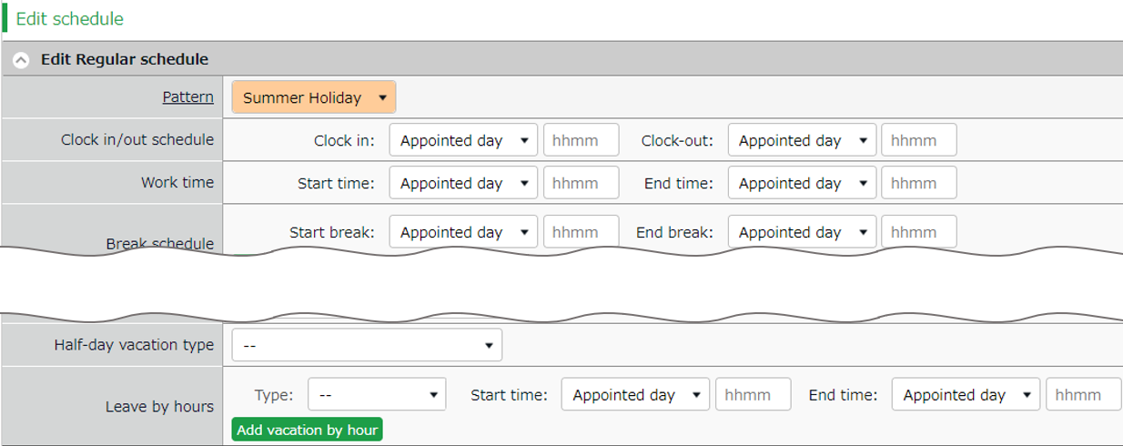

To take a half-day leave, select either [AM] or [PM].
Half-day vacation type

To take hourly leave, select the leave type at the [Type] dropdown box.
Leave by hours
Pattern

Schedule Request Screen (Leave Type Method)
To submit a leave request, select the type and the unit of the leave (All-day, AM or PM leave, hourly leave).
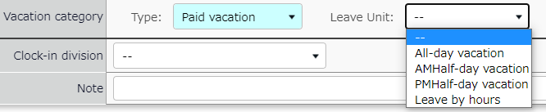
Leave type
■■■不要
Select a leave type at [Type] then select a leave unit.

To take hourly leave
In the old version, employees are required to enter the start time, then specify the number of hours (Obtained hours) when taking hourly leaves. In the new version, employees are required to enter the end time instead of the number of hours.

Hourly leaves request items:
- The old version: [Start time] and [Obtained hours]
- The new version: [Start time] and [End time]

The new version has two display options when taking leaves: “The Pattern Method”and the “The Leave Type Method”.
Here are the differences employees would see when they are requesting hourly leaves.

The Pattern Method
Items are shown in the [Leave by hours] category.
Employees are required to enter [Start time] and [End time].

The Leave Type Method
Items are shown in the [Leave by hours] category.
Employees need to select the unit, then enter [Start time] and [End time].

Please refer to p.14 for details on half day leave.

To Edit Attendance Data
You can correct errors caused by missing time records and schedule errors.

To edit attendance data
This section describes the Time record and Schedule screens in edit mode.

[Where to look] All menu > Attendance data > Daily data > [Edit] button
* The Time Card button is also available in the Time Card screen.

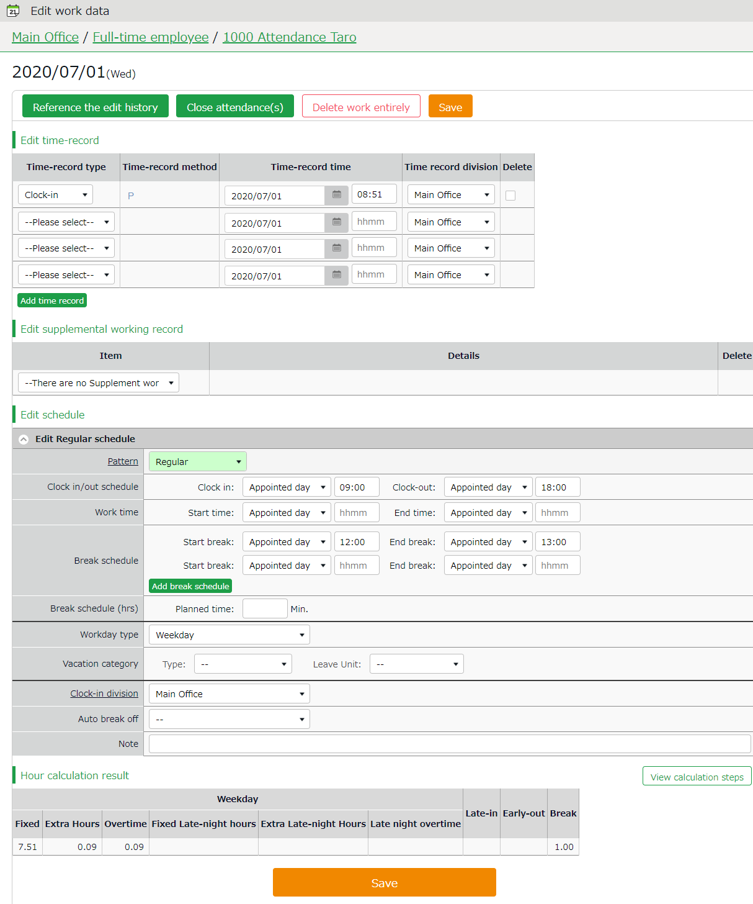
Descriptions
Edit schedule

Edits time record data.
Edit time record

Edit time record data.
Save

Saves changes.

Shows daily summary.
Press the [View calculation steps] button to confirm the calculation process.

Hour calculation result

Edit schedule
If you select a [Pattern], the scheduled time in Pattern settings are applied.
You can enter items directly as well.
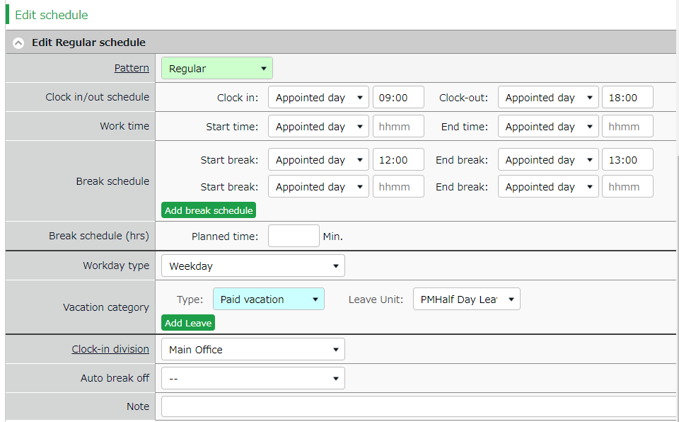

Patterns | Select a pattern. You can create patterns at [Pattern settings].
Clock-in/out schedule | Set a clock-out schedule.
Work time | Specifies the time to run attendance calculations.  Any work before scheduled clock-in time and after clock-out time will not be included in the calculation.
Break schedule | The time between [Start break] and [End break] are regarded as break time.
Break schedule (hrs) | Calculates the entered amount of time as break time.  You cannot specify a time slot for break time.
Workday type | Determines whether the work took place during holiday or not. If none is specified, workday type is set to [Weekday].  If you choose [Non-legal time off] or [Legal time off], work time during that day will be added up to [Legal time-off work days], [Assigned time-off (hrs)], [Unassigned time-off (hrs)], [Assigned Late-night hours on holiday], and [Unassigned Late-night hours on holiday].
Leave type | Select the leave type and the unit (such as All-day, AM leave, PM leave and Leave by hours) here.
Leave by hours | If your company uses the ‘Pattern Method', this item appears in place of 'Vacation category'. Select the type of leave, start and end time.
Clock-in division | Shows where the employee clocked in.  The system automatically applies the name of the division time recorder last used.
Auto break off | This will disable the Auto-break feature and break time setting by schedule.
Note | Enter comments or notes in 250 characters or less if needed.

To Plan Schedules

This section describes the steps to create a work shift table by divisions.

- Go to the Schedule management screen, then select one division.
Press the [Add schedule] button displayed on the screen.

The schedule set to [Original schedule] applies to the checked day's attendance data.
Repeat this step to complete the month’s work shift table.
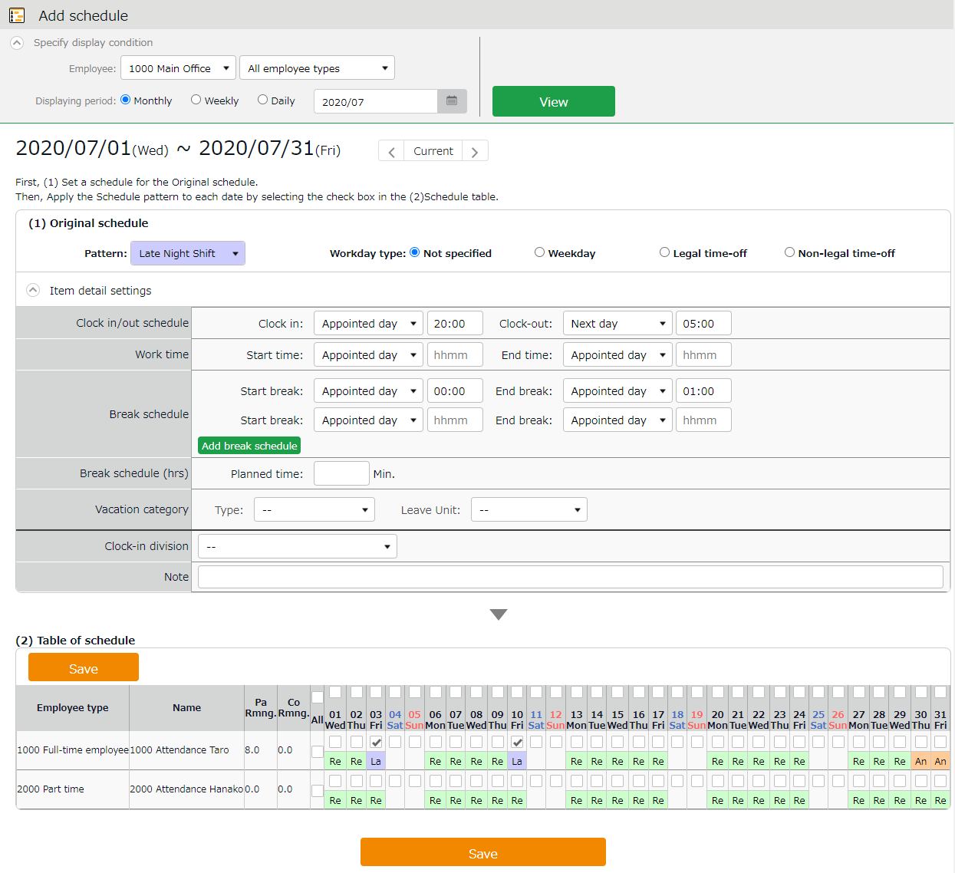

Enter schedule. To apply pre-configured time schedule, select a pattern.
You can also enter the items manually by clicking [Item detail settings].
Original schedule

Apply

The list of employees and applying dates are shown.
By turning the check on, the schedules set above applies to the selected day.
If you check [All], the schedule settings are applied to all employees and dates below.

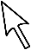

Target

- Click [Save] to save the schedules.

Set schedules to each employee
This section describes the steps to set schedules for each employee.

- Press the [Edit] button in the Schedule management screen.
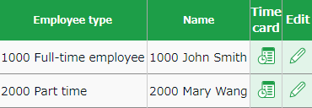

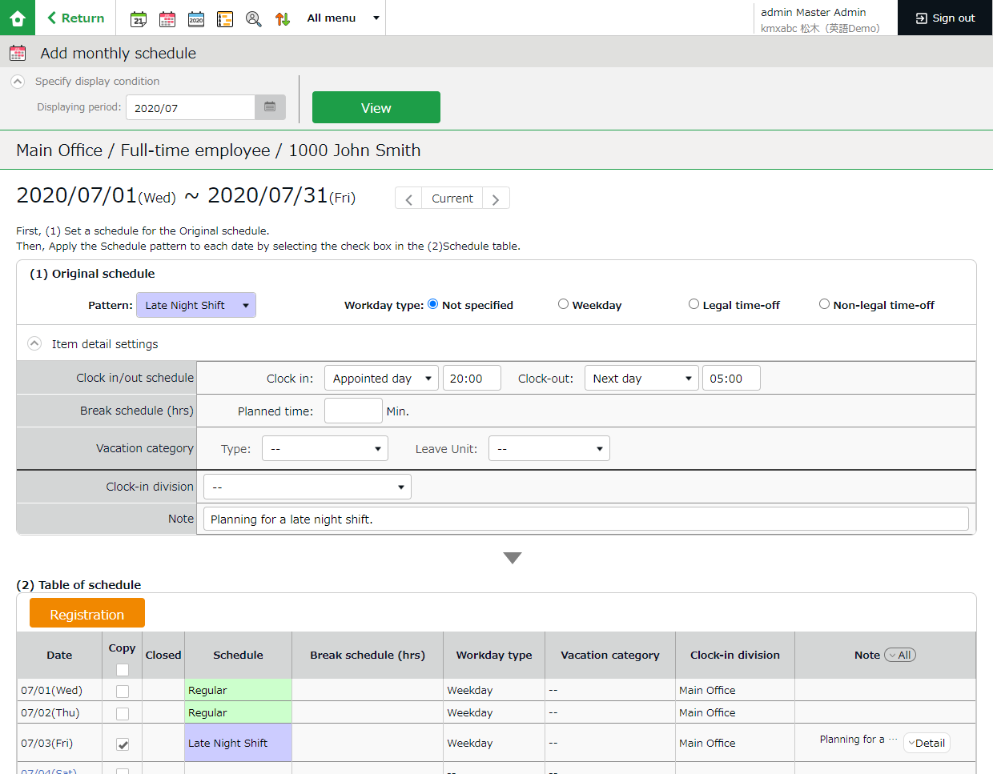
The Monthly schedule screen is shown. The schedule set to [Original schedule] is applied to the checked day's attendance data.

Enter schedule. To apply pre-configured time schedule, select a pattern.
You can also enter the items manually by clicking [Item detail settings].
Original schedule

Click [Detail] to open the [Note] text field.
Note

Apply

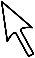

The list of applying dates are shown.
By putting a check, the schedules set above are applied to the selected day.
Target

- Click [Save] to save the schedules.

To Manage Schedules
This section describes the Leave management feature.

Take leaves
Plan leaves at the Schedule Management screen by selecting a leave pattern or a leave type under the desirable date.

[Where to look] All menu > Schedule > Schedule management

Take Full Day or Half Day Leave (Pattern Method)

Take full-day leave
Select a leave pattern under [Original schedule].

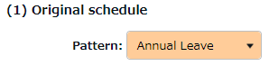

Take half-day leave
- To take a half-day leave, click [Item detail settings].
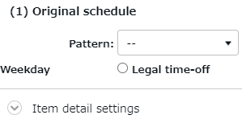

- Select [AM leave] or [PM leave] at Half-day vacation type.
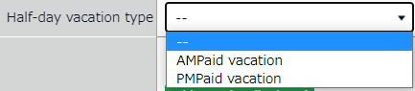

To Take Full Day or Half Day Leave (Leave Type Method)

Take Full-day Leave
If you have created a leave pattern, you can select a full-day leave pattern (Paid Leaves and Comp Leaves) at the [Pattern] column under [Item detail settings], then select [All-day vacation] at Leave Unit.

Take Half-day Leave
To set a half-day leave, select [AM leave] or [PM leave] at Leave Unit.

The name of the half-day leave will be shown in the corresponding day’s schedule.
If you check the summary of leaves taken, you can see that half-day leaves count as 0.5 days.

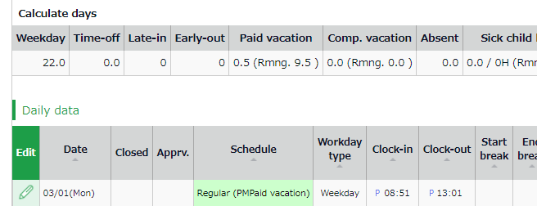

If you are using the new version of Leave Management, future leaves are counted.

Check the number of leaves taken/remaining
You can check the number of leaves taken/remaining in the Leave management screen.

[Where to look] All menu > Schedule > Leave management

Descriptions
You can switch contents from [Leave type] .

If [All leaves] is set
[All vacations] in [Leave type] shows the number of remaining or taken leaves.
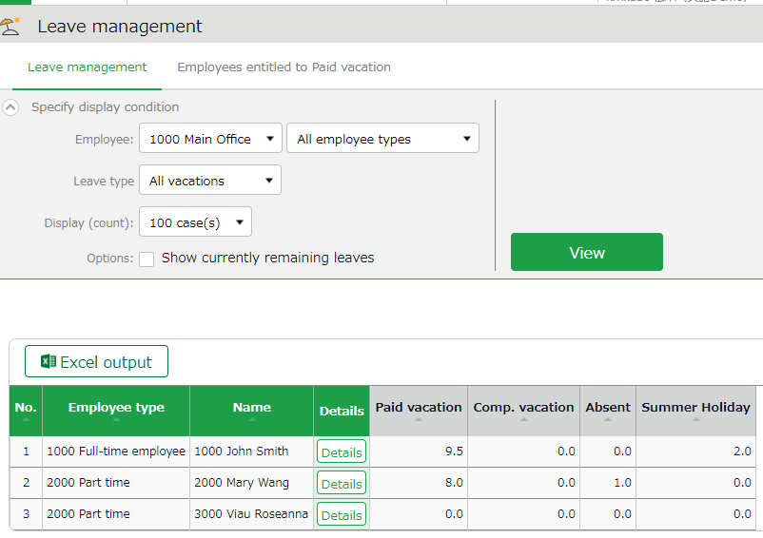
Select [All vacations]

If the leave type is set to [Add] , it shows the total number of leaves taken during this fiscal year.

If the leave type is set to [Subtract] (Subtracts leaves from remaining numbers), it shows the number of currently remaining leaves.
Remaining leaves
Leaves taken

About Subtract and Add leave types
Settings > Schedule > Pattern settings
Shows the setting status of [Calculation method of leaves when obtained].

Filter data by leave type
To filter data, select a [Leave type] under [Specify display condition].
You can check the number of leaves taken/remaining and expired during the fiscal year (if it is an “Add” type, leave it only shows the number of taken leaves).
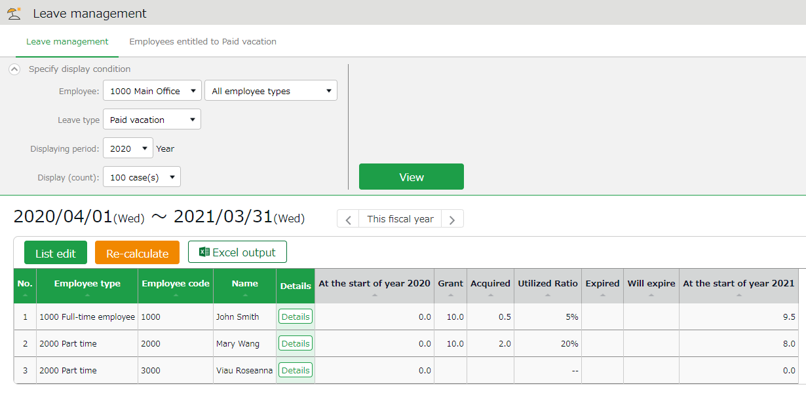
Select a leave type
Leave data

Check the total number of leaves taken/remaining from here. The items are described below.

At the start of year | Shows the number of remaining leaves at the start of the year.  This does not include leaves granted at the start of the year.
Grant | Shows the number of leaves taken this year.
Acquired | Shows the number of leaves taken this year.  * For “Add” type leaves, this is the only info provided.
Utilized Ratio | This shows the percentage of leaves (rounded off to the nearest whole number) taken during the specified period.  It does not count carry-overs from the previous year.
Expired | Shows the leaves that are expiring/has expired during this period.  Data collection period depends on the fiscal year being displayed.  - If past year’s data is displayed - Data are collected from the beginning of the year until the end of the year.  - If this year’s data is displayed - Data are collected from the beginning of this year until now.
Will expire | Shows the leaves that expired during this period.  Data collection period depends on the fiscal year being displayed.  - If this fiscal year’s data is displayed - Data are collected from now until the end of this fiscal year.  - If future year is displayed - Data are collected from the beginning of the year until the end of the year.
(Next year) Start of year | Shows the number of remaining leaves at the start of the year. This does not include leaves granted at the start of the year.

Operations
You can perform the following tasks in the Leave Management screen.

3
2
1ｚ

4

No. | Buttons | Description
1 |  | Grants leaves to multiple employees at once.  * Available when a “Subtract” leave type is set to the display condition.
2 |  | This button shows when ’Leave Type’ is specified in the Display Condition settings.  Recalculates leave data.
3 |  | The Leave management screen can be downloaded in Excel format.
4 |  | Confirm leave grant/obtained date of each employee.  You can also grant leaves here. Please refer to the following pages for details.

Grant leaves to each employee
The screen described below shows the details of the leave for each employee.
[Where to look] All menu > Schedule > Leave management > Employee [Detail] screen

Descriptions
Remaining days valid (subtr. type)

Shows the number of days remaining as of the closing date and leaves that are expiring from this day until the end of the fiscal year.

Shows the total leaves taken this year.
Yearly total days (Addition type)

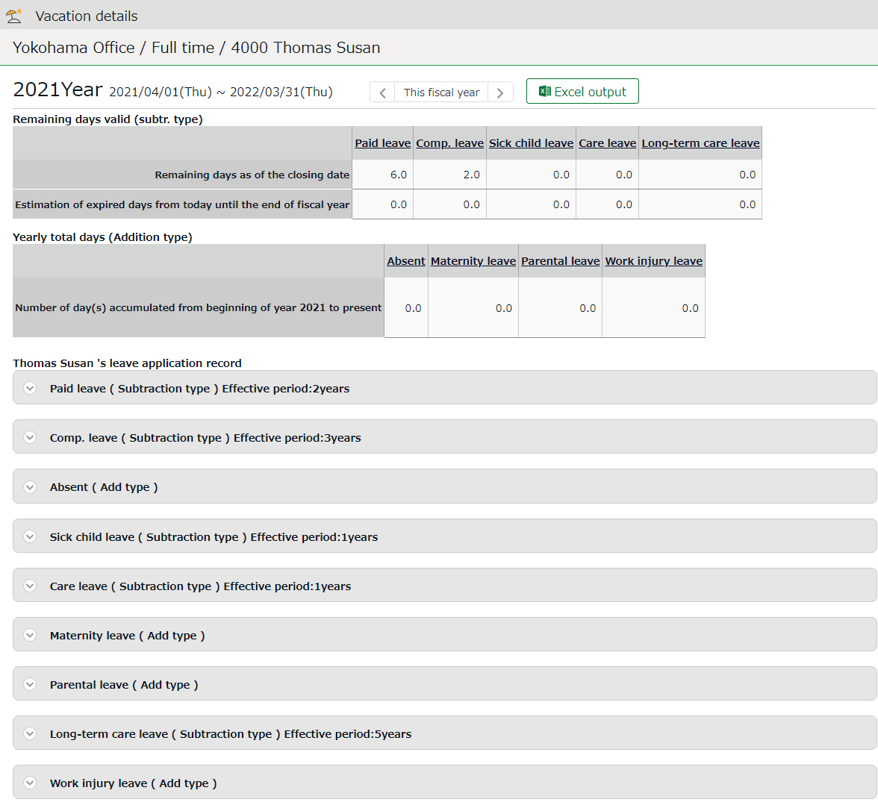

Click here to show when the leaves were granted or taken.
You can also grant leaves from here.
Shows the number of leaves currently remaining and leaves that are expiring from this day until the end of the fiscal year.
Grant leave/Leave record

Grant leaves
- Go to the Vacation details screen for leave details.
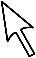
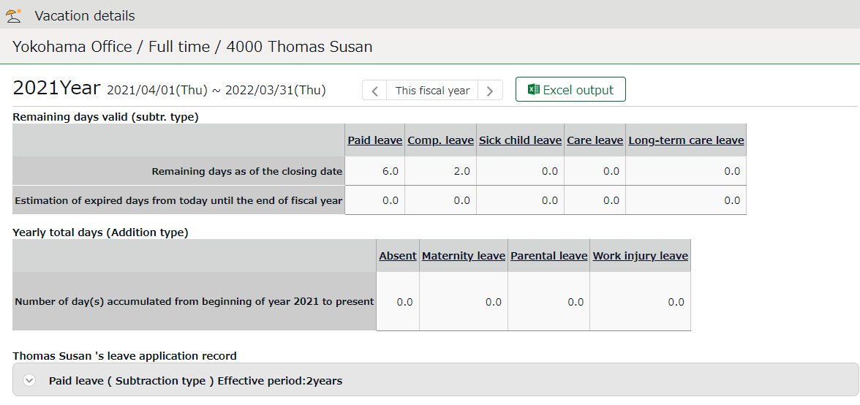

- Enter [Grant date] and [Grant days]. Then click [Save].
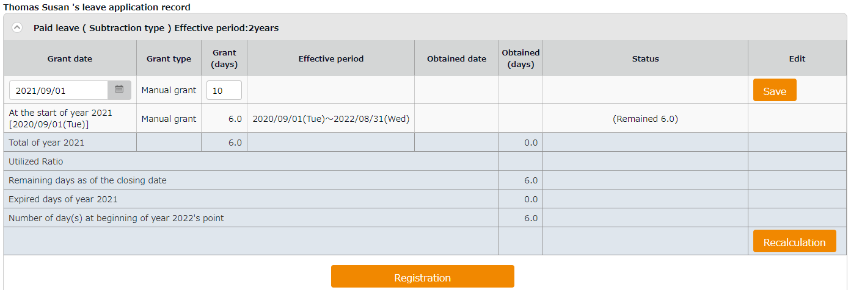
The total number of leaves taken/remaining are displayed.
Item | Description
Total of (year) | Total leaves granted and taken during the year, regardless of expiration date.
Utilized Ratio | This shows the percentage of leaves (rounded off to the nearest whole number) taken during the specified period.  It does not count carry-overs from the previous year.
Number of days remaining as of the closing date | Shows the number of leaves remaining as of the closing date.
Expired days of (year) | Shows the number of leaves expiring this year. The [Status] column shows the total of remaining leaves that are labeled as [Expiring].
Number of day(s) at beginning of (next year)'s point | Shows the number of remaining leaves at the start of the next year.  These are carried over to the next year.

Unauthorized copying and replication of the contents of this guide, text and images are strictly prohibited.
The contents of this guide are subject to change without prior notice, for revision and further improvement.

© 2021 Human Technologies, Inc.

Last Updated - July 11, 2021

