Admin Manual
Table of Contents
This manual consists of 3 chapters.
The Introduction describes system configurations and instructions to sign in. Chapter 1 describes the basic settings, and chapter 2 describes the frequently used features.

INTRODUCTION
1. System configuration 2
2. Supported browsers 2
3. Login 3
4. Fiscal year start date settings 3
5. Tutorial view 4
6. The Admin screen 5
7. Quick Start Guide 6
8. Online help 6
1. [Settings] overview 8
2. Configure organization settings 11
2.1. [Division settings] 11
2.1.1. Add a Division 11
2.2. [Time Recorder settings] 13
2.2.1. The 2 types of Time Recorder 13
2.2.2. Descriptions 15
2.2.3. Edit 16
2.2.4. Send Time Recorder URL 18
2.2.5. About Certificate 19
2.2.6. Add help 20
3. Add an Administrator 22
3.1. Admin settings 22
3.1.1. Add an administrator 22
3.1.2. Admin Sign-in info 26
3.1.3. Operation 26
3.1.4. Send Email 27
3.2. Request approval flow settings 29
3.2.1. Setting instructions 29
3.2.2. Import Request Approval Flow 30
4. Add employee accounts 33
4.1. Employee type settings 33
4.1.1. Add an Employee type 33
4.2. Employee settings 43
4.2.1. Add [Employee] 43
4.2.2. Import Employee Data 47
4.2.3. Operations 49
4.2.4. Send Email 50
5. Prepare for Schedule management 54
5.1. Leave type settings 54
5.1.1. Setting instructions 54
5.2. Paid leave feature settings 58
5.2.1. Function 58
5.2.2. Leave-related settings 62
5.2.3. Paid leave feature settings 64
5.2.4. Grant leaves by auto-calculation 64
5.3. Pattern settings 65
5.3.1. Create schedule patterns 67
5.3.2. Normal (regular) work day pattern 68
5.3.3. Discretionary work pattern 71
5.4. Holiday settings 72
5.4.1. To add Japanese national holidays 72
5.4.2. Add custom holidays manually 73
5.5. Auto schedule settings 74
5.5.1. Descriptions 74
5.5.2. Setting instructions 75
5.5.3. When auto schedule settings are reflected 75
6. Email notification feature 76
6.1. Missing time record notification 76
6.2. Unsubmitted overtime notification 79
6.3. Alert notification 80
6.4. Leave expiration notification 81
6.5. Attendance data error notification 82
6.6. Attendance closing notification 85
6.7. 5 Days Mandatory Leave Notification 86
7. Custom features 87
7.1. Custom data item settings 87
7.1.1. Add custom items 87
7.1.2. View custom items 89
7.1.3. Export Custom items 91
7.1.4. Sort Custom data items 91
7.2. Supplemental working record settings 92
7.2.1. Add Supplemental items 92
7.2.2. Edit Supplemental items 94
7.2.3. Confirm Supplemental item 94
7.2.4. Export Supplemental Working Record Data 95
7.3. Alert settings 97
7.3.1. Alert Settings 97
7.3.2. Complex condition alert 100
8. Optional features 101
8.1. Options 101
9. Start operating 111
9.1. Configure Time Recorder settings 111
9.2. Log into Employee screen 111
1. All menu 113
2. Check attendance data 115
2.1. Check daily data 115
2.1.1. Descriptions 115
2.1.2. Operations 117
2.2. Check monthly data 118
2.2.1. Descriptions 118
2.2.2. Operations 119
2.3. Check Your Time Card 120
2.3.1. Descriptions 120
2.3.2. Operations 121
2.4. Check Yearly Data 122
2.4.1. Descriptions 122
2.4.2. Operations 122
2.5. Confirm data by divisions and employee types 123
2.5.1. Descriptions 123
2.5.2. Operations 123
3. Edit attendance data 124
3.1. To edit attendance data 124
3.1.1. Descriptions 124
3.1.2. Operations 128
3.2. Check attendance data errors 129
3.2.1. To correct errors 130
3.3. Check attendance outside working years 132
3.3.1. To correct errors 133
4. Close attendance data 135
4.1. To close attendance data 135
4.2. Who can close attendance data? 136
4.3. Check closing status 137
4.3.1. Descriptions 137
5. Approve requests 138
5.1. Check requests 138
5.1.1. Descriptions 138
5.2. Approve requests 139
6. Manage schedules 140
6.1.1. Set schedules 140
6.2. Set schedules 141
6.2.1. Descriptions 141
6.2.2. Operations 142
6.2.3. Set schedules 143
6.2.4. Set schedules to each employee 144
6.2.5. Set daily schedule 145
7. Manage leaves 147
7.1. Take leave 147
7.2. Check the number of leaves taken/remaining 147
7.2.1. Descriptions 147
7.2.2. Operations 151
7.3. Grant leaves to each employee 152
7.3.1. Descriptions 152
7.3.2. Grant leaves 153
7.4. Grant leaves to multiple employees at once 154
7.5. Check the number of leaves taken each month 154
7.6. Grant leaves by auto-calculation 155
7.6.1. Instructions 155
7.6.2. Descriptions 156
8. Export data 157
8.1. The Export menu 157
8.1.1. Description 158
8.2. Create export file layout 159
8.2.1. Create custom items 161
8.3. Export 163
8.3.1. Time range of data 164
9. Table of Attendance Data Items 165

Introduction

The Introduction describes system configurations and instructions to sign in.
- System configuration
The attendance management system “KING OF TIME” consists mainly of 3 features.
[Admin] screen is used for basic settings, reviewing time record data and calculated information.
[Time Recorder] is for recording clock ins and outs. There are several types of Time Recorders to choose from.
Employees can review their time card from the [Employee] screen.

Time Recorder
Admin screen

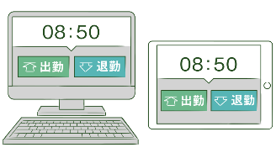
Clock-in/out
Basic info
Schedule management
Attendance data
Approve requests
Data export

Cloud
Server

Employee screen
View time card
Submit Various Requests

This Admin Manual covers the setting procedures on the Admin screen.
Some of the features described may only be accessible to users with Master Admin privileges.
If the item described is disabled or not shown on the screen, please check your Admin authorization.

- Supported browsers
The Admin screen supports the following browsers. Please use the latest version.
Google Chrome | Microsoft Edge
Windows
Mac

- Login
Use the system Sign-in URL to access the screen below.
Please use the Sign-in ID and password given to your company.
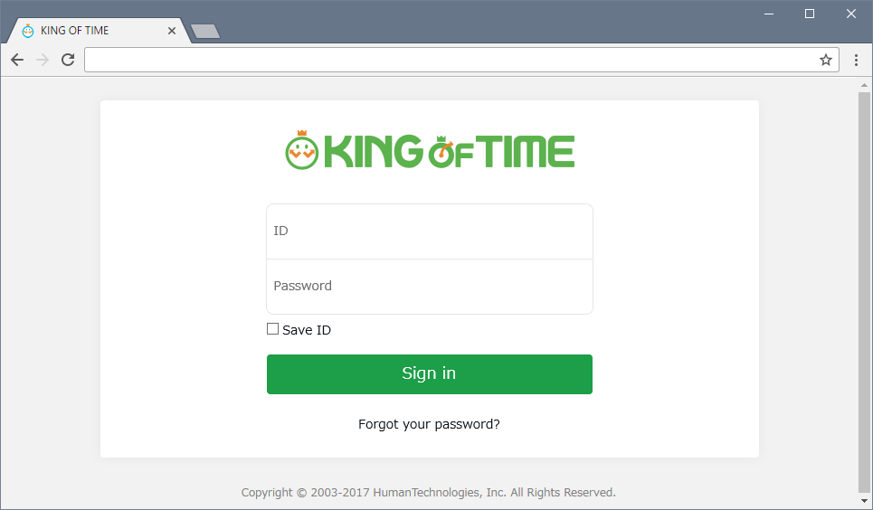

We recommend bookmarking the Sign-in URL.

- Fiscal year start date settings
If you are signing in for the first time, the Edit company details screen will be displayed. The fiscal year start date you set here will be the starting date for displaying monthly and yearly data.
* To change the settings later, you will need to contact our Support Center.
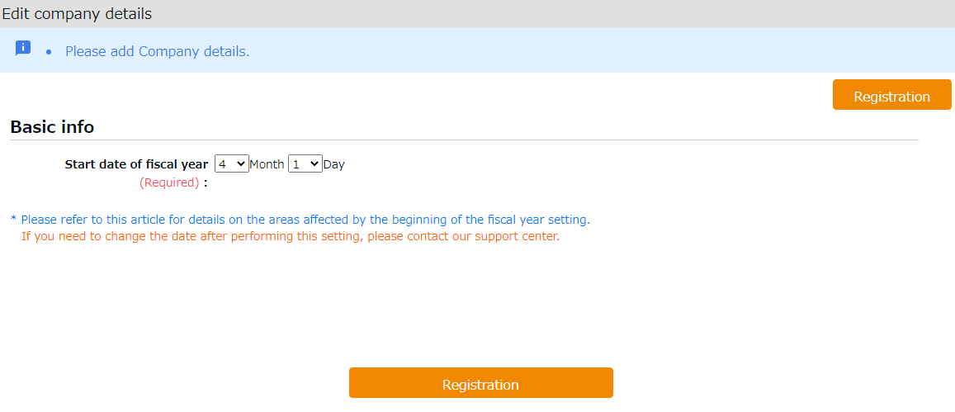

- Tutorial view
A simple instruction for Admin screen settings is shown on the screen at your first sign-in.
You can skip this tutorial by clicking outside the highlighted area. Once you have completed the tutorial, it will not be shown again, unless clearing the browser cache.
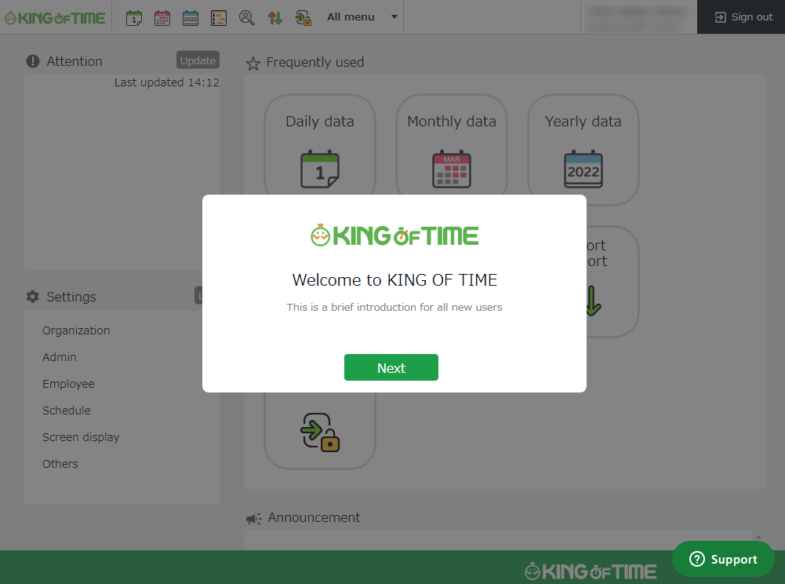

- The Admin screen
Start from [Home] after signing in.
4
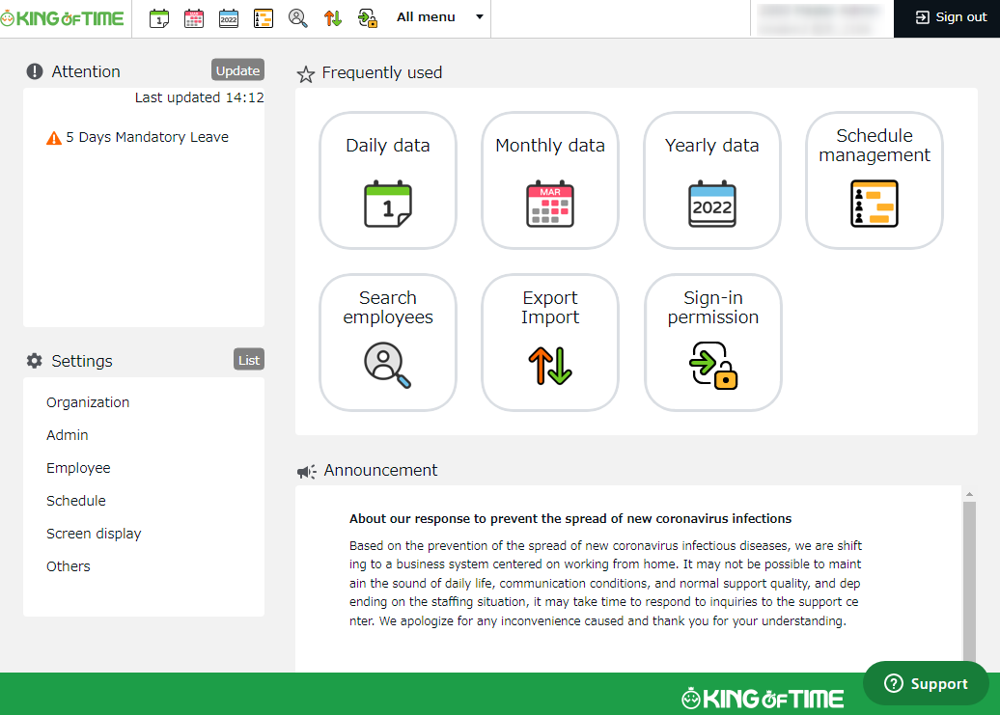
7
6
5
3
2ｚ
1ｚ

1 | Attention required | Check attendance data error and requests from your employees here.
2 | Update | Click [ Update ] to show latest alert.
3 | Frequently used menu | Shortcuts to frequently used features.
4 | All menu | Check attendance data and schedule.
5 | Settings | Configure various settings from here.
6 | Announcement | Updates on our blog on labor management and other useful features (On Google Chrome: Right-click >Translate to English).
7 | Support widget | Manned chat support and online FAQ search are available (available for Customers in Japan).

- Quick Start Guide
For quicker setup, please refer to the Quick Start Guide.

Quick Start Guide
https://kotsp.info/manualfiles/kot_quickstart_en.pdf

- Online help
Please refer to our FAQ page [Online Help] for detailed instructions and advanced settings.

Online help (Japanese)
https://support.ta.kingoftime.jp/hc/ja
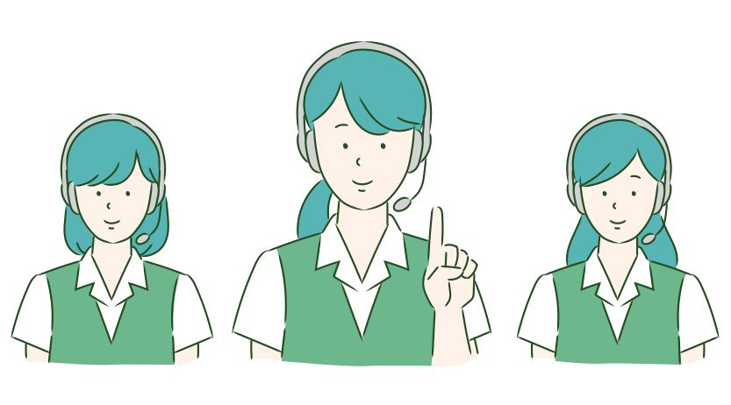

Chapter 1 Basic settings
Chapter 1 describes the basic settings.

This chapter provides information on organization and employee data settings, administration flow settings and constituting a base for schedule management.

[Settings] overview
Perform basic settings in [Settings] at the left column of the Home screen, displayed after signing in.
The settings are classified under 6 categories. Click [List] to show all categories.

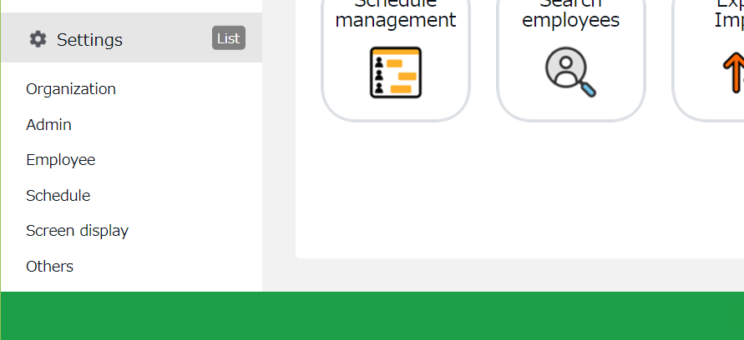
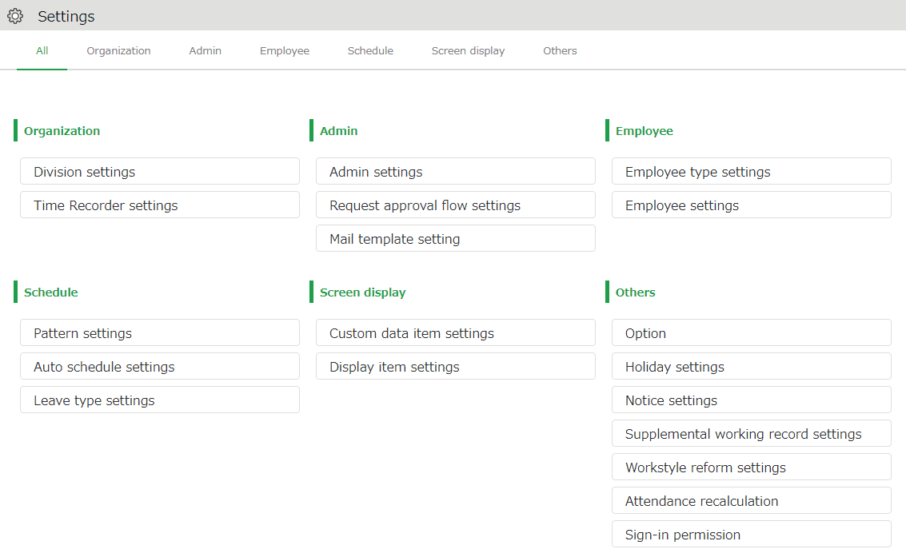

Below are descriptions of each setting screen.

Organization
Division settings | [Division settings] perform settings for [Division], a unit for managing employees. | p.11
Time Recorder  settings | Provides Time Recorder setup info.  Perform Time Recorder display settings from here. | p.13

Admin
Admin settings | Creates Admin account. | p.22
Request approval flow settings | Performs approval flow settings for processing time record and schedule requests. | p.29

Employee
Employee type settings | Creates employee types such as “Full time” and “Part time”.  Calculation method can be configured here. | p.33
Employee settings | Enter the name, division and hired date of the employee. | p.43

Schedule
Pattern settings | Create schedule patterns here. | p.65
Auto schedule settings | Performs Auto schedule settings. | p.74
Leave type settings | Creates leave types for administration.  Create leave types for administration. You can create new leave types such as “Special holiday” and “Maternity leave”. | p.54

Screen display
Custom data item settings | You can configure attendance data items that show on the Time Card screen. | p.87
Display item settings | Performs settings for the items on your Time Card.  You can hide unnecessary items. | -
Alert Setting | You can filter attendance data that is over or under a certain number on the daily or monthly data screens. | p.97

Others
Options | Turns optional functions on/off. | p.101
Holiday settings | Add national holidays and closing days of your company. | p.72
Notification settings | Set Email reminders for those who have forgotten to clock-in/out. | p.76
Supplemental working record settings | You can create additional request items (e.g. travel expense). | p.92
Workstyle reform-related settings | Perform settings for items related to Work Style Reform (Japan's plan to redress long working hours and disparities).  For details, please refer to the following document (Japanese).  https://kotsp.info/manualfiles/kot_work_style_reform_manual.pdf | -
Attendance recalculation | Recalculates attendance data.  Please run [Attendance recalculation] after configuring basic settings that affect calculations (Employee type settings, Pattern settings, etc.), if you want to apply the changes to past calculation data as well. | -
Sign-in Permission | You can grant access permission to our Support Team when you need our help. | -

Configure organization settings
This section describes the Organization settings. Instructions for [Time Recorder] settings are also included.
- [Division settings]
- [Time Recorder settings]

[Division settings]
Settings > Organization > Division settings
A [Division] is a unit for managing employees, which you can set at [Division settings].
You can think of Divisions as locations (example: branch stores and offices) to install Time Recorders.
If you are enabling the Request approval feature, note that approval flows are set by division. If you have different approval flows within a single division, we recommend creating individual divisions for each flow.

Add a Division
- Go to [Settings > Organization > Division settings].
- Click [New Registration] or [Edit] to open the registration page.
Specify the display condition

Specify the number of displaying items.
Click [Show] to view data.

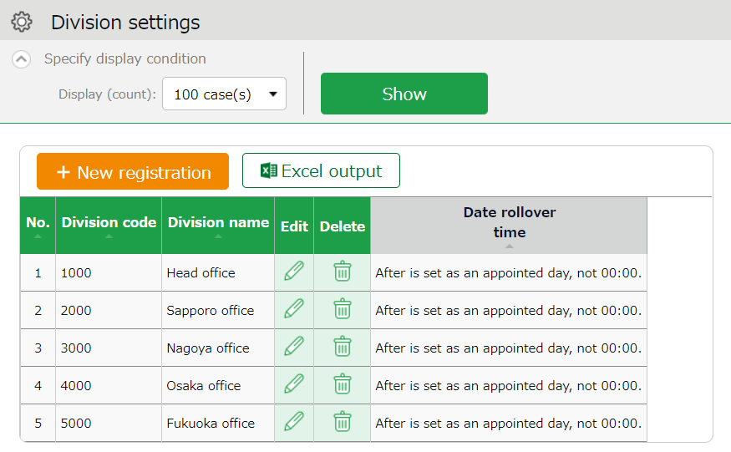

Export displayed data to Excel format.

Creates new Division.
New registration
Excel output

Edit | Edit Division data from here.
Delete | Deletes Division data.

Buttons

- In the Add division screen, enter the required info and click [Registration] to save.

Copies settings and creates new Division.
You cannot use existing codes and names.
Registration

Saves changes and returns to the previous screen.
Register as

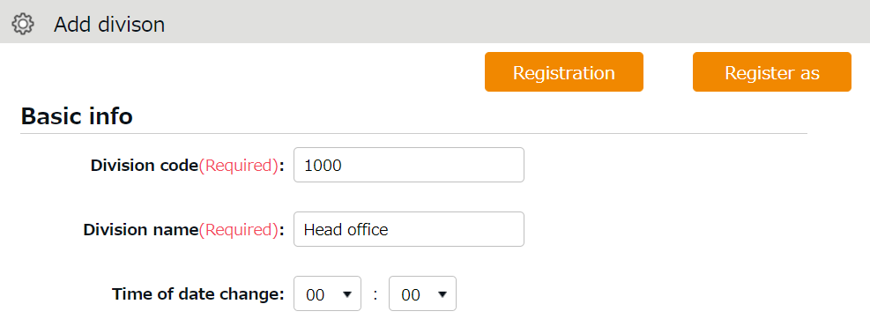

Details of the setting items are described below.

Division code | Set a code for identifying division. Enter in 3-10 alphanumeric characters. You cannot use existing codes.
Division name | Enter the name of the division. (In 50 characters or less.)  You cannot use existing names.
Time of date change | Any clock in before specified time is regarded as time record of the day before.  The date of [Clock out] and [Start/End of Break] record depend on their preceding Clock in date. However, time record date is determined by [Time of date change] if no clock-in record is found within 48 hours.
Display language | Performs Time Recorder language settings. Japanese, English, and Thai (Machine translation) versions are available.

Please feel free to use our preset sample data.

[Time Recorder settings]
Settings > Organization > Time Recorder settings
Perform settings for your Time recorder.

The 2 types of Time Recorder
There are 2 types of Time Recorder: [Personal Time Recorder] and
[Division Time Recorder].

Personal Time Recorder
You can use Personal Time Recorders on your mobile phone and PC.

Time Recorder name | Time recording method | Detail
My Recorder | Click authentication using a browser | Log in to Time Recorder with a smartphone or PC browser.
Mobile browser recorder | Click authentication using a browser | Employees are given individual URLs to clock in and out with their feature phone browser.  Also available for smartphone browsers.  Not available for PC browsers.

Division Time Recorder
This is a Time Recorder shared by multiple employees.
Division Time Recorders are usually placed in office entrances.

Time Recorder name | Time recording method | Detail
Time Recorder (Desktop version) | Biometric authentication  (Fingerprint/Finger vein authentication) | Connect the biometric scanner to the PC where you have installed the app. Place your finger on the device.
 | IC authentication | Connect the IC card reader to the PC with the app installed. Place your IC card over the device to clock in/out.
 | Password authentication | Clock in/out by entering your password into the PC with the app installed.
iPad Time Recorder | Chameleon code and Face authentication | Clock-in/out by facial image capture and Chameleon codes, using an iPad app.
Cloud Recorder | Click authentication using a browser | Access the Time Recorder URL from the WEB browser. Enter your password to clock-in/out.
PitTouch series | Time recording device  (IC authentication) | Record attendances using a dedicated device.
BT Series | Time recording device  (IC/Biometric authentication) | Record attendances using a dedicated device.  Hybrid fingerprint authentication is used as biometric authentication.

Descriptions
Settings > Organization > Time Recorder settings
Go to [Time Recorder settings] for Time Recorder setup, and to check Division Time Recorder setup info.

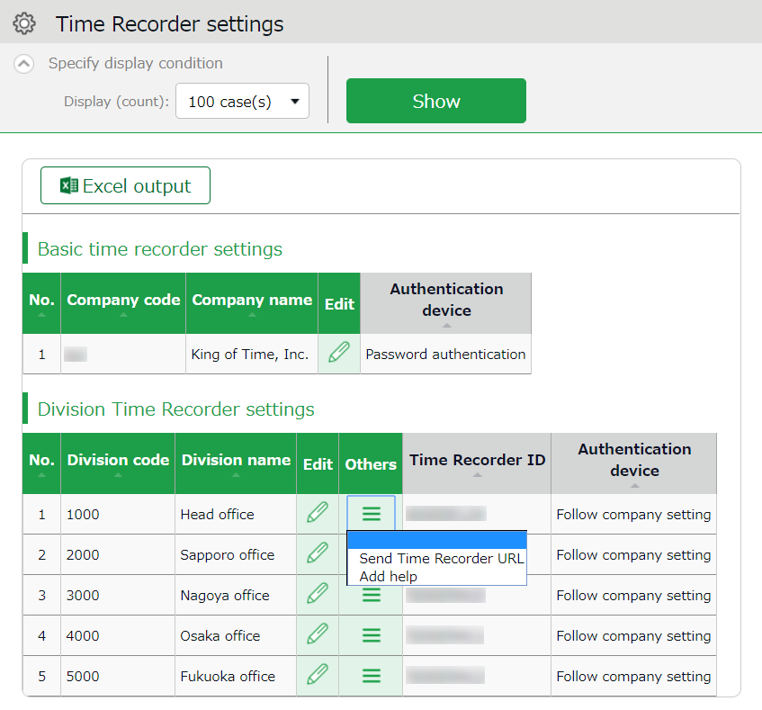

Edit

Select the type of Division Time Recorder.
You can also change operations and display settings of the Time Recorder.
To perform settings for the entire company, go to [Basic time recorder settings > Edit].
To perform settings for each division, go to [Division Time Recorder settings > Edit].

Click [ Ξ ] to open the drop-down menu.

Time Recorder  Send Time Recorder URL | Provides Division Time Recorder setup info.  You can download manuals for each Time Recorder types from here.
Add help | This permits employees from other Divisions (guest employees) to use the Time Recorder beforehand.

Others

Edit
Settings > Organization > Time Recorder settings
Perform operation and display settings for your Time Recorder.
You can also choose the type of Division Time Recorder.

For Division Time Recorders
The main setting items are described below. The displaying items vary by different authentication devices.
Please refer to the corresponding Time Recorder manual for details.
Time Recorder manuals are described in the following pages.

Authentication device | Select the type of Division Time Recorder. (IC card authentication, fingerprint authentication, etc.)  [Send Time Recorder URL] provides setup info and a Time Recorder manual for the specified authentication device.
Time record button settings | You can also set operation modes from here.
Display Time Card button | Display/hide Time record button. Employees can review their attendance data and submit requests from their Time Cards.
Display [Add help] button | Display/hide [Add help] on the Time Recorder menu. By adding Help, employees from other divisions can use the Division Time Recorder.

For Personal Time Recorders
Configure operation settings for [My Recorder] and [Mobile browser recorder].
Location acquisition mode | This setting determines whether to acquire location info when recording time.  Turn the [Disable time records when location info cannot be obtained] checkbox on to keep employees from clocking-in/out from browsers without location info.  * The accuracy of the location info depends on the positioning accuracy level of the user’s device.  * If [Obtain location info] is selected, the Time Recorder may not function on non-GPS devices.
Mobile browser time recorder - Sign-in password | Determines whether to require a password when employees access the Mobile browser recorder screen.
My Recorder  Password-required function | Determines whether to require password when employees record time by My Recorder or reviews Time card.

Send Time Recorder URL
Settings > Organization > Time Recorder settings
Provides Division Time Recorder setup info.

- Select the division where the Time Recorder is installed. Click [Send Time Recorder URL].
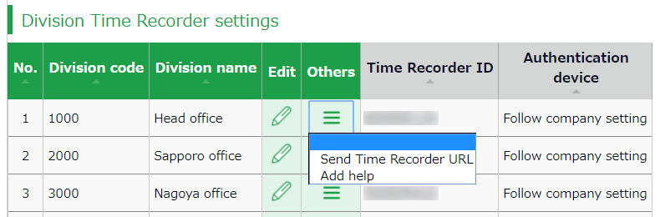

- Enter the Email address and click [Send email].
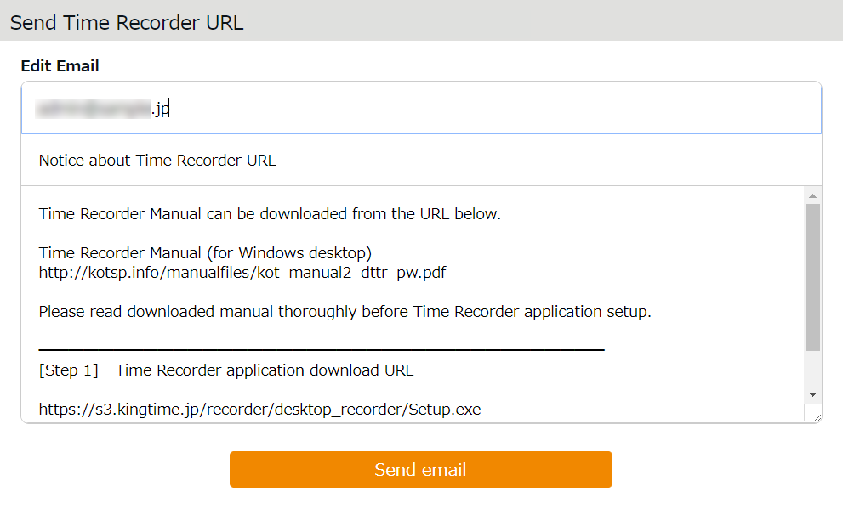
Enter Email address

- Details of Time Recorder settings are sent to the Email addresses specified in the step above.
The Time Recorder Manual is available from the URL shown in the Email. Please follow the setup instructions in the manual.
The sender of the Email is [no_reply@kingtime.jp].
The Certificate URL is only valid within 48 hours from accessing the
[Send Time Recorder URL] page.
Ensure that employees access the URL before it expires.

Settings > Employee > Employee settings]. (p.50)

About Certificate
Settings > Organization > Time Recorder settings
The Desktop Time Recorder requires a certificate. A certificate is a digitally issued word string which you cannot alter. It is used to verify the user company and divisions' identity when the Time Recorder connects to the server. When a server receives an invalid certificate, it denies the access. You cannot start the Time Recorder.

You can enforce Time Recorder’s security by updating its certificate.
By updating it periodically, you can prevent malicious third parties from activating the Time Recorder.

Select the division where the Time Recorder is installed. Click [Send Time Recorder URL].
Then click [Show certificate].
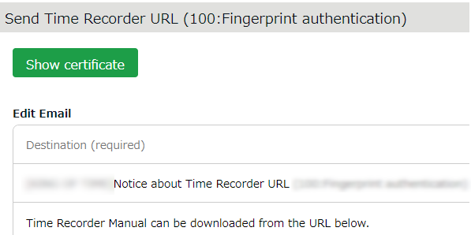
Please read each description. By turning on all checkboxes, you can activate the button at the bottom of the page.
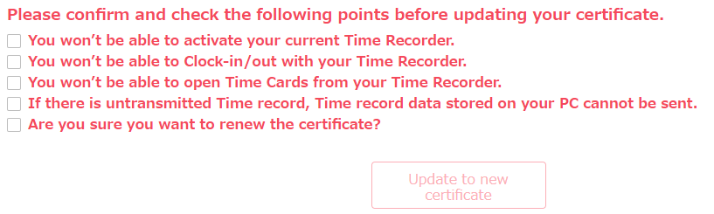
Please note that you cannot use the Division Time Recorder after updating the certificate.
Inform the employees of the new certificate through [Send Time Recorder URL],
Then copy & paste the word string into the Time Recorder Certificate field.

Add help
Settings > Organization > Time Recorder settings
A Division Time Recorder is usually installed per Division. The initial setting does not allow clock-in/outs by employees from other divisions.

Division B

Division A

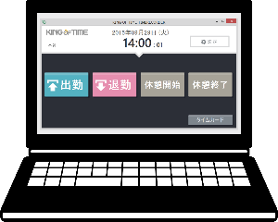
Division B
Time Recorder
Division A
Time Recorder

Available
Available
Not available

To allow employees from other Divisions (guests employees) use the Time Recorder, go to [Add help] to permit clock-in/out.
This is also useful when multiple divisions need to share a single Time Recorder.

Division A
Available

Division A
Time Recorder

Division B
Available

Add help

The Add help feature is also available from the [Add help] button on the Time Recorder screen. However, please note that the settings from this button are reset every time you close the Time Recorder screen.
If employees need to use a Time Recorder outside of their division frequently, we recommend you change the [Add help] settings from the Admin screen. Instructions to [Add help] in the Admin screen are described in the following pages.

[Add help] from Admin screen
- Select the division where the Time Recorder is installed. Click [Add help].

- Click [Add new] in the next screen.
- Select employees and click the [Registration] button.
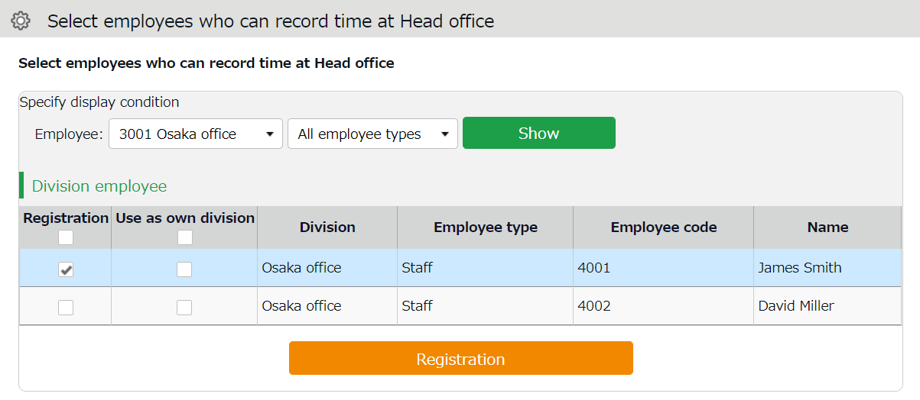

Registration | The selected employee can the Division Time Recorder. Work time recorded on this Time Recorder is regarded as work outside of their division.
Use as own division | The selected employee can use the Time Recorder. Work time is regarded as work in their own division. In this case, you cannot identify which division the work time had been recorded.
You can perform the same settings in [Settings > Employee > Employee settings > Employee data edit > Time recorder info category > Division available for Time record].

Add an Administrator
This section describes authorization-related settings, such as adding Admin and setting request approval flows.
- Admin settings
- [Request approval flow settings]

Admin settings
Settings > Admin > Admin settings
You can create multiple Admin accounts. There are different kinds of Admin account: a “Master Admin” can perform all tasks, while a “General Admin” is limited to editing and registration tasks which they are authorized to.

Add an administrator
Perform Admin account settings (Name, Email address, etc.) and set authorizations.

- Go to [Settings > Admin > Admin settings].
- Click [New Registration] or [Edit] to open the registration page.
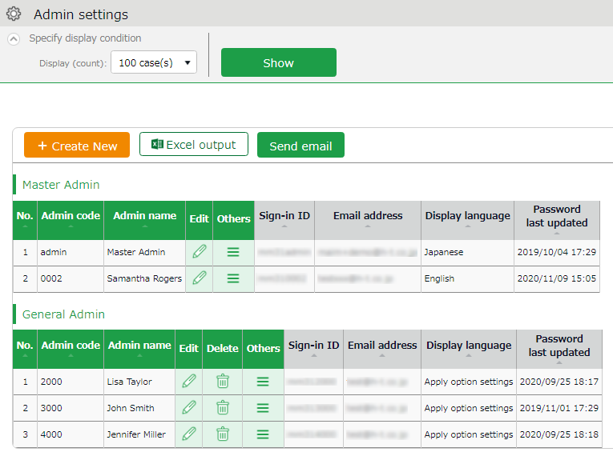

Creates Admin account.
New registration

Edit Admin data from here.
Edit

Other buttons are described in page 26.
- Enter required info then click [Registration] to save.
Details of the setting items are described below.

Basic info
Enter basic Admin info.

Admin code | Enter code for identifying the Admin user. Enter in 3-10 alphanumeric characters. You cannot use existing codes.  This code serves as a part of the user’s Sign-in ID.
Admin name | Enter name of the Admin user. (In 30 characters or less.)
Login password | Enter Sign-in password. Enter in 6-35 alphanumeric characters. The password policy can be configured in [Settings > Others > Options].  * You cannot confirm the current password.  Forgotten passwords must be changed or reset by Master Admin.
Email address | The Admin's Email address is used for the following purposes:  - Receive request notifications from employees  - Password reset notification
Display language | You can select from Japanese, English, and Thai (Machine translation).
Admin authorization | The account is granted Master Admin privileges by putting a check on the check box.  * This check box is only available to the initial Master Admin (Admin ID: ___1admin).

Master Admins can:
- Create Admin accounts
- Log in on behalf of another Admin user or an employee.
- Configure Request approval flow settings
- Perform display item settings

The initial Master Admin (Admin ID: ___1admin) can:
- Perform all the above
- Promote General Admins to Master Admins

Authorization for basic settings
Set permissions to configure basic settings.
There are 3 authorization levels.

○ View / Edit - Enables viewing and editing.
△ View only - Allows viewing corresponding items.
× No authorization - Corresponding items are hidden.

Options | Option features that are configured in [Settings > Others > Options] and can be activated/deactivated. The export layout feature at [All menu > Import/Export] is enabled when [〇 View / Edit] is set.  The feature supports Monthly, Daily and Time card data.
Division/Time Recorder settings | Sets authorization to operate [Settings > Employee > Time Recorder settings]. Required for creating and editing Divisions and sending Time Recorder URL.
Employee type settings | Sets authorization to operate [Settings > Employee > Employee type settings].  Required for adding and editing Employee types and calculation methods.
Pattern settings | Sets authorization to operate [Settings > Schedule > Pattern settings].  Required for creating and editing Schedule patterns.
Login password  Login password change rights | Go to [Settings > Admin > Admin settings] to permit changes to Admin password.

Division/Employee type Authorization
Configure authorization levels by combining [Division management] and [Employee type management] authorizations. This defines the level of authorization and range of operations the administrator can perform.

- Select authorization levels for each operation in [Division Management Rights].
(A) Perform settings at [All divisions] row to assign administrative tasks across divisions.
(B) To assign administrative tasks for a specific division, select a division from the [Please select division] drop-down list.
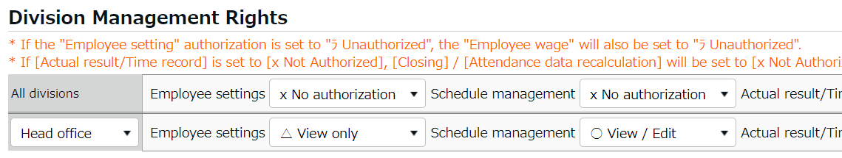
(A)
(B)

- Select authorization levels for each operation in [Employee type management authorization].
You can apply authorization settings to all or selected employee types.
- The combination of these settings defines the range of operations that administrators can perform. Lower authorization levels are recommended.
There are 4 authorization levels.

○ View / Edit - Enables viewing and editing.
■ View / Request - Enables creating or editing data with permission from a higher-rank Admin.
△ View only - Allows viewing only.
× No authorization - Corresponding items are hidden.
* [－Inherit upper level setting] will inherit [All divisions] or [All employee types] authorization settings.

The setting items are described below.

Employee settings | Sets authorization to create and edit Employee data.  The [〇 View / Edit] permission allows sending Email from the Employee setting screen.
Schedule management | Set authorization to edit schedules.  To create schedules, the [〇 View / Edit] privilege is required.
Actual result/Time record | Set authorization to manage Time record data.  To edit or delete time record, the [〇 View / Edit] privilege is required.
Data export | Set authorization to export data from [All menu > Export / Import] and other screens.
Closing | Set authorization to close attendance data.  Employees and General Admins cannot edit closed attendance data. Master Admins are allowed editing as an exception.
Attendance recalculation | Set authorization to recalculate attendance data. Attendance recalculation applies new attendance-related settings to past attendance data.

Admin Sign-in info
By creating Admin accounts, users can sign in as administrators.
Inform the Admin account user of the following Sign-in info.

Login info
Login URL | Same as Master Admin Sign-in URL.
Login ID | Generated automatically. Company code + 1+ Admin code (e.g. xyz11000) You can confirm the Sign-in Info in the Admin settings screen.
Login password | Set a password when creating an Admin account.  If the password is forgotten, change or reset it in  [Settings > Admin > Admin settings > Edit > Password].

Operation
Master Admins can perform the following tasks in the Admin setting screen.
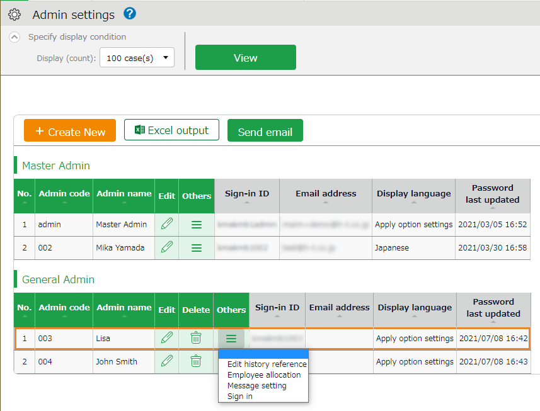
3
4
1
2

No. | Buttons | Description
1 | 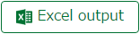 | Downloads Admin setting screen in Excel format.
2 | 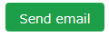 | Sends sign in credentials and URL for changing passwords to multiple admins.
3 | (Delete) | Deletes unused admin data.  * You cannot delete if the Admin belongs to a [Request approval flow].  * Deleted Admins are hidden from the attendance data edit screen and request approval logs.  * You cannot delete Master Admin.
4 | (Others) | Click here to open the drop-down menu.  Edit history reference  Shows attendance data change log of each Admin (History is available up to 10 years in the past).  Employee allocation  Links employee account with the admin account. You can add a feature that allows users to go to the management screen directly after signing in as an employee.  Request message  Sets authorization to operate  [All menu > Message management].  Login  Logs in on behalf of the Admin user.

Send Email
You can send notifications to multiple administrator accounts at once from Settings > Admin > Admin settings. In addition to editing the body of the email, you can also reset the password when you send it, add a link to change the password in the edit screen if needed.

- Click the [Send email] button.
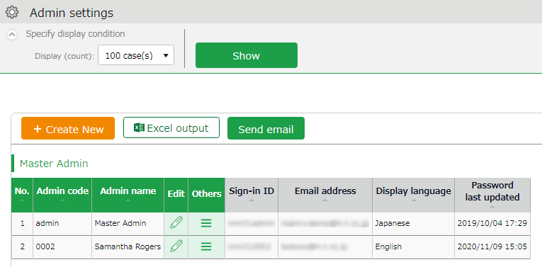

- Select an Email template, then click [Apply].
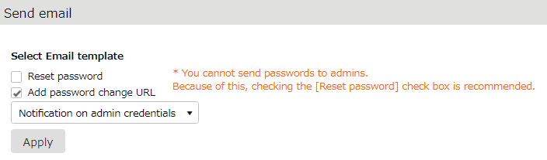

- Confirm details at the edit screen and edit if needed.
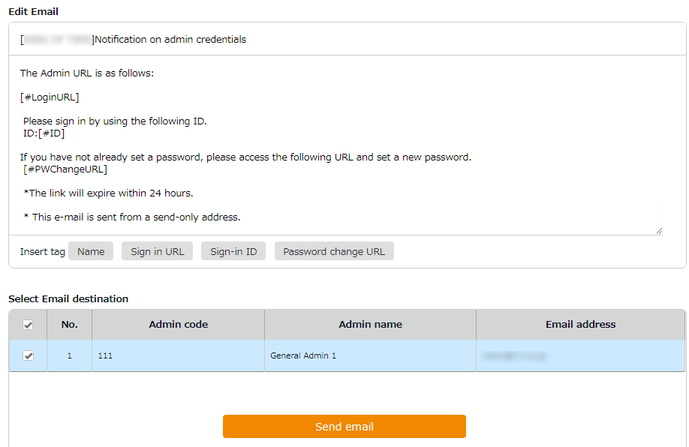

If you have deleted a tag from the text, you can insert it again from here.
Insert tags

- Click the [Send email] button, and once again in the confirmation dialog.

The sender of the Email is [no_reply@kingtime.jp].

Request approval flow settings
- Settings > Admin >
Request approval flow settings
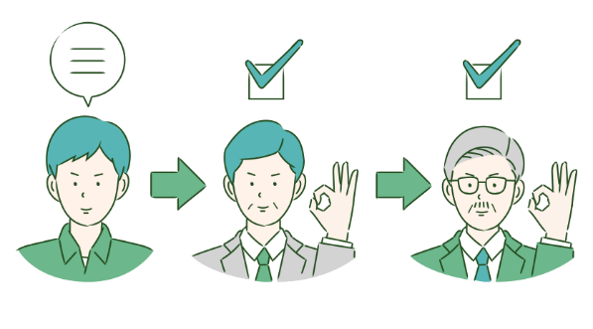
You can receive Attendance data/Schedule edit requests from employees and other administrators by using the Request approval feature.

Follow the instructions below to assign an Admin to a request approval flow.

Setting instructions
- Go to the Request approval flow settings screen, then press the [Edit] button of a division.
- Select an Admin to assign the approver role. Then click the [Registration] button.
- If there are multiple levels in a flow, add Approver 2, 3, etc. accordingly.
You may add up to 5 layers, but you do not necessarily need to do so.
- When settings are complete, click [< Return] on the upper left of the screen to return to the previous screen.
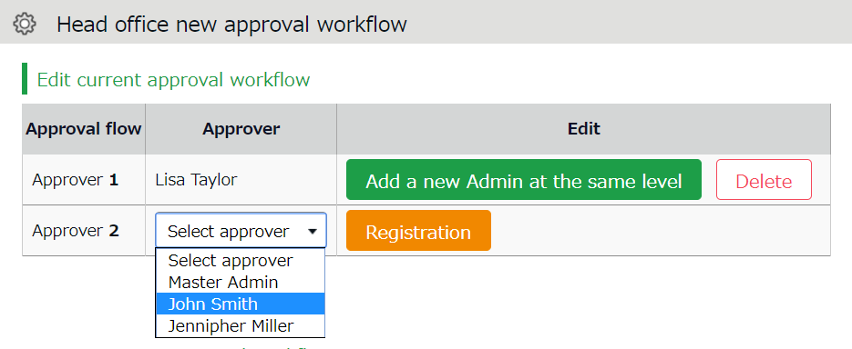

To assign multiple approvers in a level
You can assign more than one approver to the same level.
In that case, either one needs to approve the request before passing it on to the next level.

To add another approver, click [Add a new Admin at the same level], then select an administrator from the list of approvers.

Create an approval flow for each division.

Admins (Master Admin included) who are not added to the approval flow cannot confirm nor approve requests.

Import Request Approval Flow
You can set application approval flow by importing a CSV file (only available to Master Admins).

1. Go to [All menu > Export / Import ].
2. Click [Request Approval Flow Data [CSV]].

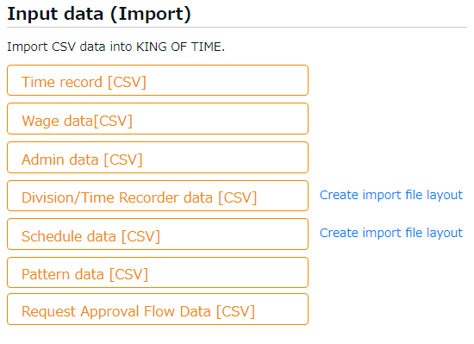

3. Click [Download template] to download the template in CSV format.

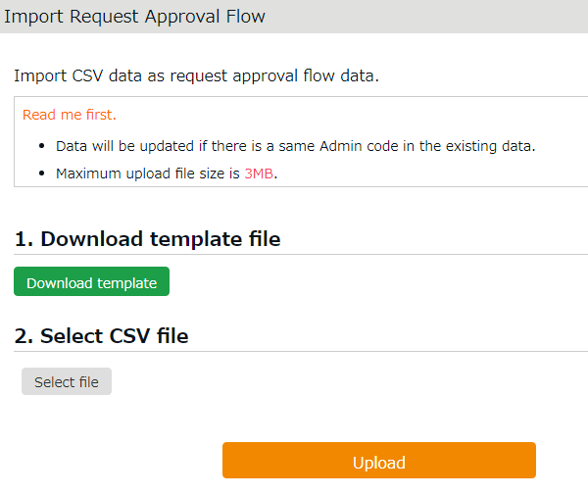
4. Open the file with Excel or Notepad and enter the following Request Approval Flow details.
- Division Code (Required)
For the basic approval flow, enter [BASIC_FLOW] in the Division Code.
- Division Name
- Approval Level (Required)
- Admin Code (Required)
- Admin Name
Opening the CSV file with Excel
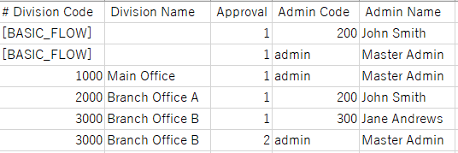

Opening the CSV file with a text editor
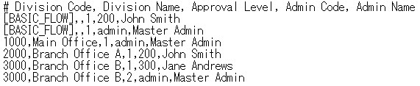

5. Click the [Select file] button and select the CSV file that you have prepared.
6. Click the [Upload] button.
7. Confirm the info at the confirmation screen.
Click [Registration] to save the settings.
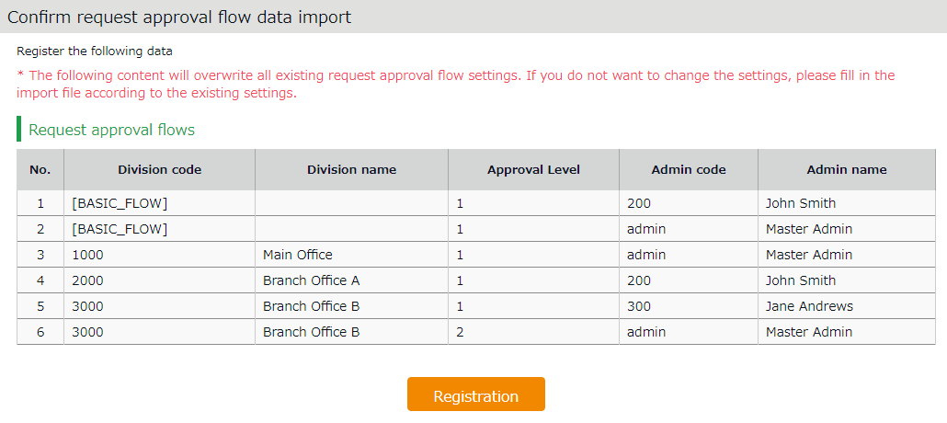

8. If there are any changes to existing settings or an unapproved request, a confirmation window appears.
Clicking on [Registration] will return unapproved requests to the first approver.

You can export Request Approval Flow data in CSV format.
To do so, go to [All Menu > Export/Import > Request Approval Flow Data (CSV)].
Requirement: Your basic permission settings must be View Only or higher.
File contents: The file contains all request approval flows.

Add employee accounts
This section describes settings related to employee data.
- Employee type settings
- Employee settings

Employee type settings
Settings > Employee > Employee type settings
Creates employee types e.g. “Full time” and “Part time”. Employee type settings include attendance calculation settings. If you have several different calculation methods, create Employee types for each method.

Add an Employee type
Click [New Registration] or [Edit] to go to the registration screen.
Enter required info then click [Registration] to save.

Copies settings and creates new Employee type. You cannot use existing names and codes.
Register as
Registration

Saves changes and returns to the previous screen.

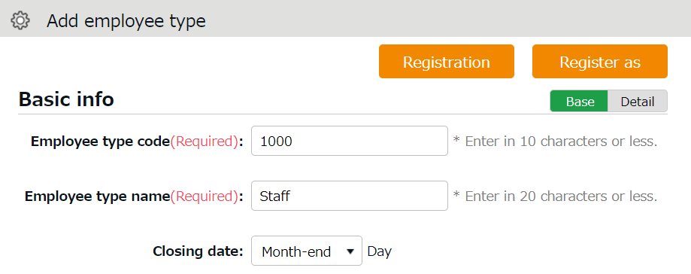

Detail

Shows advanced settings. Perform advanced settings from here.

Two preset Employee sample data are available. The sample data is a typical calculation setting. Please feel free to use it and customize accordingly.
Setting items are categorized.
Additional items in [Details] are also described in this manual.

Basic info
Employee type code | Enter a code for identifying the Employee type. Enter in 10 characters or less. You cannot use existing codes. | Basic
Employee type name | Enter the name of Employee type. (In 20 characters or less.) | Basic
Closing date | Set the day of settling (closing) attendances. You can select from the 1st to the end of the month.  For example, if you select [15th], the time card shows attendances from the 16th to the 15th of the next month. | Basic
Daily contract hours | Required for calculating deemed working hours during Paid leave. | Detail
Discretionary Overtime of the Month | Required if your company only pays overtime beyond a specified amount of time.  This item is available at Custom data item settings and Monthly data export. | Detail
Weekly closing date | Select a weekday for closing attendance data. For example, if you select [Saturday], the week starts with Sunday and ends with Saturday. | Detail
Display language | Set language settings for Employee screen (Time Card) and My Recorder. You can select from Japanese, English, and Thai (Machine translation). | Detail

Hmm…
There are so many items. Seems complicated, does not it?
Why don’t you try focusing on [Basic items] at first?
[Details/Advanced features] are for advanced settings, but not all companies need these settings. You can also use the sample data.

Workstyle
Working hours | You can choose between the regular working hours system and the variable working hours system.  If you select "Variable Working Hours", the [Variable Working Hours] button will appear for you to make detailed settings. The following options are shown.  Variable working hours per month  Automatically sets the recommended settings for monthly variable work and related calculation settings(*).  * Late night work hours slot, Late-night extra hours classification, Overtime start time, Weekly legal (statutory) working hours, How to handle leave hours and discretionary work hours on holiday and Weekly variable working hours (Carry-over).  Variable working hours per year  Specify the starting month and the monthly working hours.  Manual setting (flextime and others)  You can customize the variable working hours setting. Select this option if you want to set up flextime settings for multiple months. | -

Break-related
Time-record break | Employees use the Time Recorder to record the start and end of break.  [Do not approve] disables break time by Time Recorder. | Basic
Break time 1-3 | With this setting, employees can take breaks automatically. Enter in alphanumeric characters.  This feature takes break time automatically when work hours reaches the specified time. Break time are deduced from working hours. If the item is blank, break time is not taken automatically. Click [Add break] to add a new row. | Basic
Priority of Employee type break to subtract from | Specify which attendance category to subtract [Break time 1-3] (auto-break) from. | Detail
Break time priority | Perform settings on how to handle break time if manual break time record and auto-break mode coexist.  Auto-detection (default)  Compares [Time-record break + Break specified by Schedule pattern] and break time specified by Employee types. The longer of the two is applied.  Prioritize time record break  If breaks are recorded by Time Recorder, select “Time-record break” only.  Sum up each break type  Adds up break taken by time record, break planned in Schedule, and break time specified by employee types. | Detail
Types of break
There are 3 ways to take breaks.

- Time-record break
Employees take break by Time Recorder.
This is suitable for recording actual break time.
To disable it, you can change configurations in [Time-record break] in Employee type settings.

- Auto break
Takes break time automatically when daily work hours exceed specified time.
Configure settings in [Break time 1-3] in Employee type settings.

- Scheduled break
Adds schedule for break time.
Suitable for taking different types of breaks depending on work shift.
See “Pattern settings” (p.65) for details.

Choose a method that fits your company.
You can also combine different break types. When combining break types, configure the break priority settings in [Employee type settings > Break related > Details - Priority order of break].

Night work
Late night work slot | Any work during this time of the day is regarded as Assigned Late-night hours, Unassigned Late-night hours or Late-night overtime. Enter in [hh:mm] or [hhmm] format. | Basic
Unassigned Late-night work hour allocation type | Settings for handling unassigned work (neither included in schedule nor under Overtime/Unassigned Late-night work hours), that occur during the time specified above. | Detail

Daily overtime calculation
Overtime start time | Work time past the specified time during this day counts as [Overtime]. Turn the check box on before entering Overtime start time. To regard work hours that are past schedule as overtime work, check the box below. | Basic
Overtime (cumulative) time for early-in | Working time that exceed the specified number of hours are regarded as overtime work. This setting determines whether to start counting the working hours from actual clock-in time (if an employee comes in earlier than scheduled time). | Detail
Overtime (cumulative) time for late-in | Working time that exceed the specified number of hours are regarded as overtime work. This setting determines whether to start counting the working hours from actual clock-in time (if an employee comes in after scheduled time). | Detail
Unassigned work (hrs) start time | The system generally handles work time that are neither included in schedule, nor under Overtime/Late night time slot, as [Overtime work (Unassigned work)]. However, by configuring this item, any work outside the schedule can be regarded as overtime work. This setting is unnecessary if schedules are set every day. | Detail
Unassigned work hour allocation type | Settings for handling unassigned work (neither included in schedule nor under Overtime/Late night time slot) if there are any. | Detail

If you need to calculate overtime work by month, go to [Settings > Others > Options > Attendance management settings > Flex work setting]. Select [Apply].
[Flex work] is added under [Employee type settings > Monthly overtime work summary]. Here, you can specify when overtime work begins, every month.

Weekly overtime calculation
Weekly legal working hours | The system handles working hours that exceed the specified value as Overtime. | Basic

Schedule
Days applied to Auto schedule | Set the number of days to apply Auto schedules (p.74). | Basic
Handling of work before clock-in schedule | This setting determines whether to count work before scheduled clock-in time as work time. | Basic
Handling of work time after clock-out schedule | This setting determines whether to count work after scheduled clock-out time as work time. | Basic
Discretionary-rounding of clock-ins before scheduled time | This setting determines whether to regard clock-ins before specified minutes as “clocked-in exactly on planned time”.  [Example]  Set to 10 minutes  Clock-in schedule: 9:00 AM  Result: Any clock-ins between 8:50 AM to 9:00 AM are regarded as 9:00.  Rounding-off only takes place during the Attendance calculation process. The clock in data remains.  Maximum value is 30 minutes. | Detail
Discretionary-rounding of clock-outs after scheduled time | This setting determines whether to regard clock-outs after specified minutes as “clocked-out exactly on scheduled time”.  [Example]  Set to 10 minutes  Clock-out schedule: 6:00 PM  Result: Any clock-outs between 6:00 PM to 6:10 PM are regarded as 6:00 PM.  Rounding-off only takes place during the Attendance calculation process. The clock out data remains.  Maximum value is 30 minutes. | Detail
Handling of clock-ins coinciding with scheduled time | To regard clocks-ins that are exactly on scheduled time as “late-ins”, select [Treat as late-in time record].  * Please note that if you select [Treat as late-in time record], clock-in records that are regarded as [clock-in before scheduled time] in the [Discretionary-rounding of clock-ins before scheduled time] setting are also regarded as Late-ins. | Detail

Leave related
The following are leave related settings.
Paid leave grant | Click the [Paid Leave-related Settings] button to open the settings window (see p.58).  * Available if the Paid vacation grant function is enabled. | Basic
unit for vacation (by hour) | Specify the number of hours to take on each leave. The minimum unit is 1 hour * Available if the leave by hours feature is enabled. | Details
Addition to Fixed time when obtaining half-day or hourly leave | Determines whether to regard half-day leave and hourly leave as Fixed time (work time). Checked leave types are handled as work time when employees take half-day and hourly leaves during “Fixed time” hours. | Details
How to Handle Leave Hours | Determines how to handle deemed working hours during paid leave that are added up to work time, when calculating overtime.  - Do not include： Excludes deemed working hours during paid leave when calculating overtime work.  - Include (Don’t count as Extra Hours and Overtime)： Includes deemed working hours during paid leave when calculating overtime. However, the system will not include discretionary leave time that are past the time specified in [Overtime work start].  - Include (Count as Extra Hours and Overtime): Include discretionary leave time when calculating overtime. The system includes discretionary leave time that are past the time specified in [Overtime work start], when calculating overtime.  * Item labeled as [Discretionary vacation time's overtime calculation] depending on the internal setting. | Details
Increase/Decrease of Comp. leave leaves when Working days on holiday is taken | Determines whether to grant compensatory leaves working on holidays.  You can perform general settings in [Settings > Schedule > Leave type settings], but to perform settings by Employee type, you can do so from here. | Details
Discretionary Holiday Work Hours Setting | Determines whether to calculate deemed working hours during paid leave. Please refer to p.56 for details. | Details

Advanced features
You can perform more advanced attendance management and calculation settings.
You can change round-off settings for time record and calculations from here.
Click on the category name to show the setting items.

Time-record edit by employees | By selecting [Approve], employees can edit their time record from their Time Cards. To require employees to submit edit requests, select [Do not approve].
Detect attendance data error in discretionary work | The system may detect error, if overlapping time records exist on the day [Discretionary work pattern] (such as direct-visit/no-return work) is applied.  If you select [Don't detect], clock-ins/outs are recorded without error.  (This data will not affect attendance calculation results.)
Time Card export format | You can export Time Cards in PDF from [All menu > Daily data > Time Card > EXCEL]. You can also set different layouts by employee types.
Rounding unit of time record | Rounds off clock-in/out time record. Rounds off work time. Rounding-off takes place during the calculation process. However, clock-in/out data will remain as recorded.
Time-record round off condition time | Determines the standard time for rounding off, if [Rounding unit of time record] above is set.  Always 0 min  Round off by 0. For example, if [15 min] is set, minutes are rounded off to 0, 15, 30 and 45.  This setting may trigger some issues: If clock-in schedules are set to 8:50, and an employee clocks in at 8:48, the time record is rounded off to 9:00 when you run the calculation. Therefore, the time record is regarded as 10 minutes late-in because the clock-in schedule is set to 8:50. In this case, select either of the following.  Adjust clock-in/out time record depending on clock-in/out schedule time  Clock-in record is rounded off according to the scheduled clock-in time.  Clock-out record is rounded off according to the scheduled clock-out time.  Adjust all time record depending on clock-in schedule time  For example, if clock-out schedule is set to 8:40, and clock-out schedule is set to 17:05, monthly data is rounded off by 40 (minutes).
Monthly data round unit | This rounds off month’s calculation result.  For example, if Round Unit is set to 30 (min), 170 hours and 25 minutes of working time is rounded off to 170 hours 0 minutes. If the checkbox is turned on, working time is rounded up to 170 hours 30 minutes.  If it is set to [Round 60], values between 1-29 are rounded off. Values between 30-59 are rounded up to 1 hour. The unit specified will not affect the checkbox behind.
Daily data round unit | Rounds off the day’s calculation result.  Perform detailed settings e.g. to round up fractions of break time that are taken manually by time record.
Daily data lower validity limit | Sets the minimum threshold when displaying calculation results.  Lower values will not be shown.
Apply round off/minimum (hrs) limit | This setting determines whether to round off not only calculation results, but also scheduled time, if the value satisfies the following 2 conditions.  In the [Overtime start time] settings, working time that exceeds schedules are regarded as overtime work.  - [Rounding unit of Daily data] is set.
Round off unit for start/end of break time-record | This rounds off clock-in/out records.  For example, if you set it to 15 (min), break time started at 12:14 is rounded to 12:00. Likewise, break time ended at 12:46 is rounded to 13:00.  * Please note that break time are rounded off, and not its duration.  (e.g. 50 minute’s breaks are not rounded to 45 minutes)
Round off timing for time-record break time | To round off break time by [Rounding unit of Daily data], specify when to run the round-off process.  Round off before calculating the attendance  Converts break time into rounded value before running the attendance calculation.  Round off after Attendance calculations  Runs Break time calculation based on actual values. The results are rounded off to nice round numbers after the calculation.

Employee settings
Settings > Employee > Employee settings
You can add basic employee data in the Employee settings screen.
It also provides details on Personal Time Recorder setup, Sign-in info and password for accessing the Employee screen (Time Card). Such info can be sent to employees by Email.

Add [Employee]
Enter employee data such as Name, Hired date and Employee code.

- Go to [Settings > Employee > Employee settings].
- Click [New Registration] or [Edit] to open the registration page.

Specify the display condition

Specify the number of displaying items.
Click [Show] to view data.

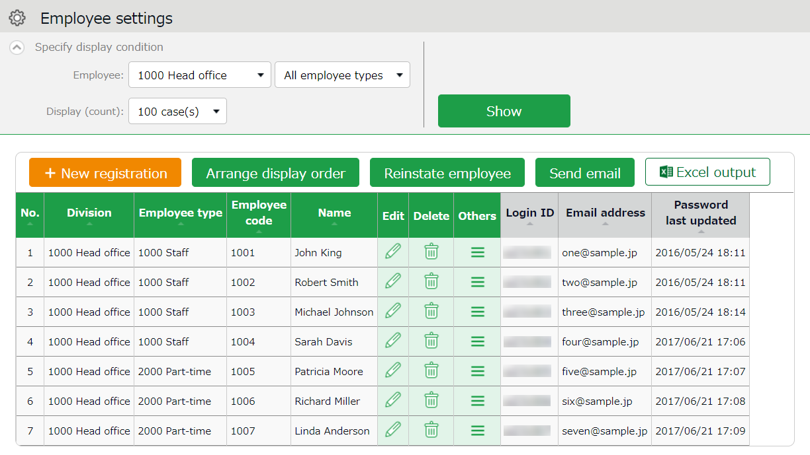

Edit
New registration

Creates employee account.

Click [Edit] to edit employee data.

* Other buttons are described in p.49.

- Enter required info in the Add division screen and click [Registration] to save.
Registration

Saves changes and returns to the previous screen.

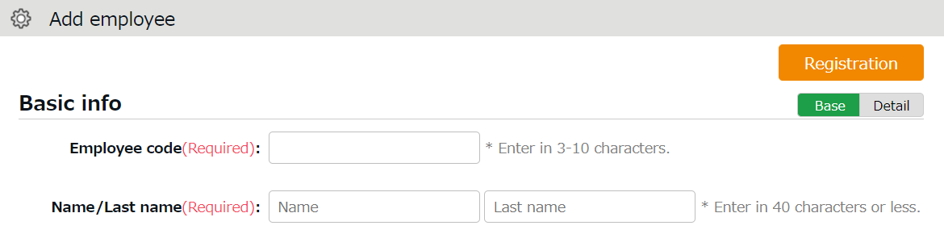

Shows advanced settings. Perform advanced settings from here.
Detail

Details of the setting items are described below.

Basic info
Employee code | Set a code for identifying employees. Enter in 3-10 alphanumeric characters. You cannot use existing codes. | Basic
Last/First name | Enter the name of employee. (In 40 characters or less.) | Basic
Last/First name (Phonetics) | Enter name phonetics. (In 40 characters or less.) | Basic
Email address | The Email address is used for the following purposes:  - To notify employees of approved/rejected requests.  - To notify missing time record  To send employees info about their Time Recorder URL and Employee screen (Time Card) Sign-in info.  - To notify employees that their password had been reset by their administrator. | Basic
Password | Required for signing into Employee screens and clocking-in/out by password authentication.  * When this is left blank, [Employee code] is used as the employee’s password.  * The password entered here are temporary.  When employees are using the temporary password on Time Records or in Attendance requests, a password reset screen is shown. | Basic
Gender | Select male or female. | Detail
Date of birth | Enter the date of birth. | Detail

Employment info
Division | Select employee’s Division. | Basic
Employee type | Select an Employee type. | Basic
Hired date | Required for paid leave administration, etc. You cannot record attendances before hire date. | Basic
Resignation date | Enter when the employee resigns. The employee will be hidden from Daily and Monthly data after the resignation date, but past attendance data will remain. You cannot record attendances after resignation date. | Detail
Daily contract hours | Required for calculating deemed working hours during Paid leave. The same item exists in [Employee type settings], but the settings in [Employee settings] are prioritized. | Detail
Weekly contract days | The number of contract days serves as the reference value for granting leaves from the Grant paid leaves feature. The same item exists in [Employee type settings], but the settings in [Employee settings] are prioritized. | Detail
Discretionary Overtime of the Month | Required if your company only pays overtime beyond a specified amount of time.  The same item exists in [Employee type settings], but the settings in [Employee settings] are prioritized. | Detail
Admin code 1 and 2 | Enter code in 50 characters or less as needed. This item can be exported from the Export menu. This item is not required for running attendance calculation. | Detail

Time Recorder info
The following are related to Time Recorder.

Personal Time Recorder button | Choosing [Display] will enable a button that allows the employee to access his/her Time Recorder from the Time Card screen.  Link to My Recorder or Mobile Browser Time Recorder appears on [Time Card > Menu] depending on your settings.  * Available if you are using My Recorder or Mobile Browser Time Recorder.
Division available for Time record | Employees can use Division Time Recorders from different divisions by changing settings from here. This way, the employee can use the Division Time Recorder without changing the [Add help] settings from the Time Recorder.
___ registration status | Indicates whether authentication info (fingerprint, IC card, etc.) had been registered. If registered, a [Delete] button is displayed. You can re-register authentication info after deleting it. Deleting the authentication info will not affect the employee’s attendance data.

Import Employee Data
All menu > Export / Import
You can import employee data in CSV format.

First, create an import file layout. You must arrange the content of the CSV file as specified in the Layout Setting. You can add employees easily by importing this file.

Create an import file layout (Only required once)
- Go to [All menu > Export / Import] and click [Create import layout] next to Employee data [CSV].
- Click [Create new] and fill in the following items in the Create employee data layout screen.

Layout name | Name the layout. (Example: New employees)
Applied type/category | To add new employees, select [New/Update].  * Select [Update only] to layouts used for updating existing employee data only. In this case, [Employee code] is the only mandatory item.

- At [Entry items], select employee info to import.
Select importing items from the [Available items] list, then click [Add]. The items added are shown in the [Items selected] list.
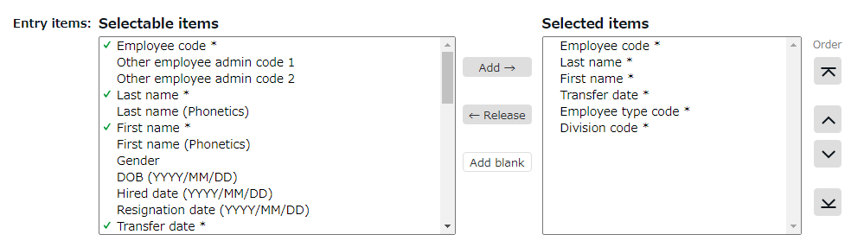

Add | Adds an item to the [Items selected] list.
Release | Removes item from the [Items selected] list.
Add blank | Adds a blank column to the [Items selected] list.  This adds a blank column to the CSV template.
Orders | Changes the order of items in the [Items selected] list.

- Click [Registration] to save the layout settings.

Import employee data
- Go to [All menu > Export / Import > Employee data] and click [CSV].
- Set following items.

Layout name | Select the layout created in the previous step.
Handling of empty items | This setting is applied when updating data of existing employees. If you select [Delete registered data], empty CSV items will clear away the items saved on the system.  * This setting will not interfere with importing new employees.

- Create a CSV template. If you already have one, please proceed to No.4.

Click [Download template] to download the template in CSV format. Save the file to your computer and open it with Excel or Notepad.
Enter required information as in the first row, then save the data in CSV format.
* For more information on entering data and creating files, please refer to [Read first] in the top of the Employee screen.
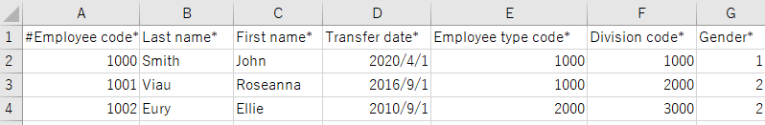
- Select importing CSV file. Click the [Select file] button and select the CSV file that you have prepared.
- Click [Upload]. Then click [Registration] to proceed. Import will start.

This causes the [Too many items] error. A comma in the end of the last item adds unnecessary items.
This causes the [No matching ___ found.] error. The comma below the last row adds unnecessary items.
Check your data with a text editor
If you created your data with Excel, please note that unintended commas (,) and spaces (blank) in the file may cause upload error in rare cases. Be sure to use a text editor to check your CSV file.
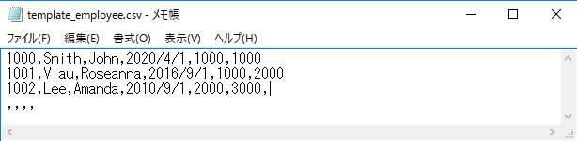

Operations
Settings > Employee > Employee settings
In addition to adding/editing employee data, you can perform the following tasks in the Employee settings screen.

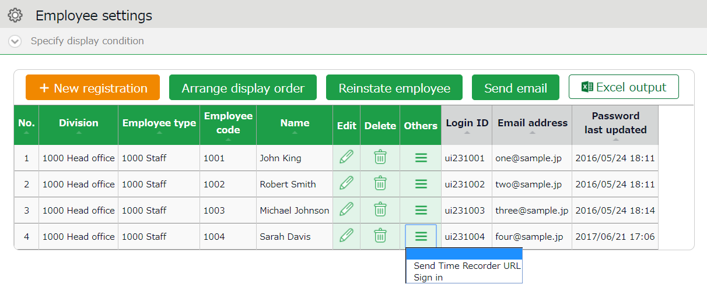
4
3
2
1ｚ

No. | Buttons | Description
1 | 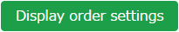 | If the employees belong to the same division, you can change the display orders.  * Only available if one division is selected.
 | 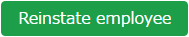 | Shows the list of deleted employee data. By clicking [Recover data] in the Deleted employee screen, you can return the data to the list of active employees.  * This button is only displayed in the Master Admin screen.
 | 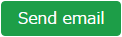 | Sends Time Recorder instructions to multiple employees by Email. Sends details on Personal Time Recorder setup, Sign-in info and password change URL. Please refer to the following pages for details.  * Only available if one division is selected.
2 |  | Downloads Employee setting screen in Excel format.
3 | (Delete) | Deletes unused employee data. Deleted employees are removed from the attendance data edit screen and request approval logs.  * Please use this feature when you registered mistaken Employee info, etc. As for the resigned employees, click [Edit] and expand [Detail] on the Employment data category. Then enter [Resignation date].  * Deleting the employee will also delete related authentication data such as Bio-information.
4 | (Others) | Click here to open the drop-down menu.  Send Time Recorder URL  Sends details on Personal Time Recorder setup to Employees by Email, individually.  Login  Logs in on behalf of the Employee.  * This button shows on the Master Admin screen.

Send Email
Settings > Employee > Employee settings
Go to [Home page > Settings > Employee > Employee settings].
Then select a division from the list and click [Show].
Click the [Send email] button displayed on the screen. Sends details on Personal Time Recorder setup, Sign-in info and password change URL.

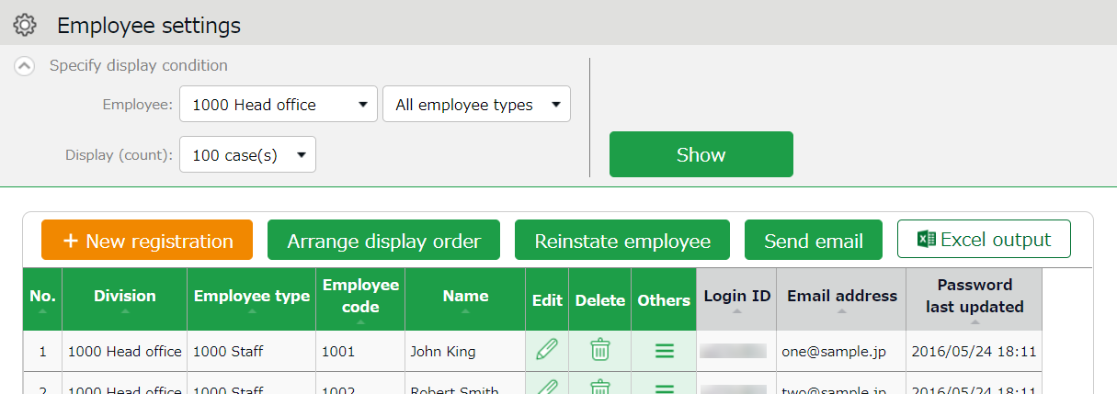

The sender of the Email is [no_reply@kingtime.jp].

Send My Recorder URL by Email
- Go to the Send email screen. Select [For My Recorder] from the Email template list, then click [Apply].
- Select destination and click [Send email] in the bottom of the screen.

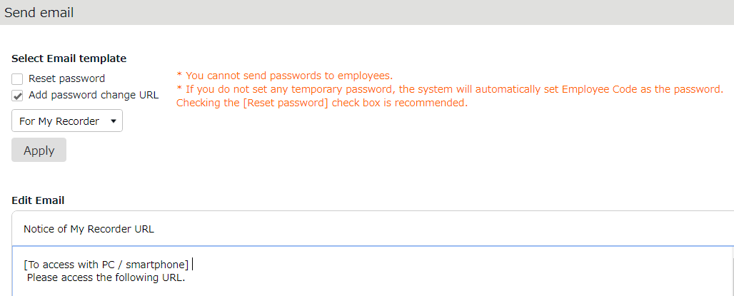

Employees can start using the Time Recorder by following the instructions sent by Email. Please refer to the [Employee manual] for information on My Recorder.

Send Login info by Email
- Go to the Send email screen.
- Select [For Time Card] from the Email template list, then click [Apply].
- Select destination and click [Send email] in the bottom of the screen.

Reset Password and Send Password Change URL
To clock-in/out by password authentication, every employee needs a password.
Please follow the following steps to have employees set their passwords.

- Select a Division or Employee type from [Specify display condition] at the Employee settings screen.
- Click [Send email].
- To reset password, select [Reset password]. If you do not want to reset password, only check [Add password change link].

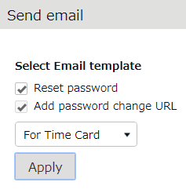

- Then click [Apply].
- Enter subject and content of the Email accordingly.
You can also add various items from [Insert tag] if needed. The tag is replaced by corresponding employee info during delivery.

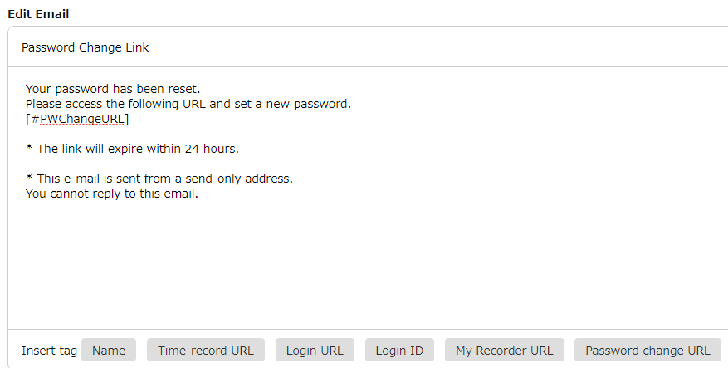
- Select destination and click [Send email] in the bottom of the screen.

The tags are converted as follows.
Item name | Tag | Function
Name | [#Name] | Converts to Employee code, Last name, First names.
Time record URL | [#TimeURL] | Converts to Mobile browser recorder URL.
Login URL | [#LoginURL] | Converts to Time Card Sign-in URL.
Login ID | [#ID] | Converts to Login ID.
My Recorder URL | [#BprURL] | Converts to My Recorder URL.
Password Change URL | [#PWChangeURL] | Converts to password change URL.

If no password is set to a new employee account, the initial password is the same as the Employee code.

Prepare for Schedule management
This section describes the settings related to Schedule management, such as work hours and leaves.
- Leave type settings
- Paid leave feature settings
- Pattern settings
- Holiday settings
- Auto schedule settings

Leave type settings
Settings > Schedule > Pattern settings
A Leave type is a unit for calculating leaves.
When you create a Leave type, a summary column is added to the Time card screen.

By selecting a leave type, you can take leave. This action will affect the number of leaves taken in the summary column.

Setting instructions
This section describes the [Leave type] settings.

Click [New Registration] or [Edit] to go to the registration screen. Enter required info then click [Registration] to save.
The setting items are described below.
Name | Enter the name of the leave. (Examples: Paid leave, Compensatory leave, Special leave, etc.)
Half-day leave | By selecting [Apply], users can take half-day leave.
Calculating obtained leaves | Choose either of the following to specify the leave calculation method.  Subtract (Subtraction)  Manages the number of granted leaves, leaves taken (used), and remaining leaves.  Generally used for managing paid leaves.  Add (Addition)  This setting can be used for managing leaves that only needs monitoring of the numbers taken.  This is generally used for managing absences and legal holidays.
Increase/Decrease of Leaves when Working days on holiday is taken | * Only shows in [Compensatory leave].  If you select [Increase by time-off clock-in], compensatory leaves are granted automatically, if working hours during [Legal or Non-legal time off] exceed specified hours.
Grant substitute time-off | Perform settings here to use this leave type as compensatory leave.  If you select [Grant substitute time-off for substitute clock-in schedule], the [Substitute clock-in] (compensatory work day) item is available in the Add schedule screen. Compensatory leaves are granted automatically when working hours in [Substitute clock-in] exceed specified hours.
Allow negative number | This keeps employees from taking leaves when there are none left.  * Only available if [Calculation method of leaves when obtained] is set to [Subtract].
Effective period | Leaves are available from its grant date until the end of the period specified in this setting. You cannot take leaves after this period. You cannot leave this field blank.
Vacation (by hour unit) | By selecting [Apply], users can take hourly leaves.  You can take Hourly leaves from the f[Subtraction] type leaves as well (maximum of 1 to 5 day’s leave). This setting can limit the amount of hourly leaves that employees can take within a year.  In addition, if the [Daily contract work hours] is specified, you can check the [Usable hourly leaves] in the leave details screen.  ＜Contract work hours less than one hour＞  Under Japan’s Labor Standards Act, annual paid leave must be rounded up if there are a fraction of contract working hours for less than one hour. However, for holidays other than paid leave, you can choose between “Round up” or “Do not round up”.
Display leave Type Color | Sets the display color of the schedule column for vacation days.
Image upload for Leave Request | Employees can attach doctor’s note when requesting sick leaves. You can select [Required], [Optional] or [Not Required] for each leave types.
Override Workday Type if schedule is set to Full-day Leave | You can specify the type of workday when you take leave.
Leave Type-only Schedule Request | This setting determines whether employees must request leaves by choosing a leave category alone or also specify the schedule.  If no work schedule (scheduled clock-in/out) is set, the system cannot calculate deemed working hours during paid leave.
Calculate Discretionary Holiday Work Hours | Determines whether to calculate deemed working Attendance hours during paid leave or count as working hours.  - Do not calculate: Does not count deemed working hours during paid leave.  - Calculate: [(Name of leave type) hours] will be available for output in Custom data items, Time card [PDF], Daily data [CSV], Monthly data [CSV]. The hours will count as working hours.  Only perform calculations for each leave type: [(Name of leave type) hours] will be available for output in Custom data items, Time card [PDF], Daily data [CSV], Monthly data [CSV]. The hours will not count as working hours.

On the time card screen, for example, leave types are displayed in the order in which they were created.
To rearrange the order, click the [Display Order Setting] button on the Leave type setting screen to open the display order setting screen.
After rearranging the order by dragging the label of leave type, click the [Save] button to reflect the display order.

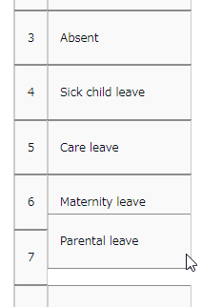
Drag-and-drop

Display target settings
You can set restrictions for each leave type to prevent access by employees of certain divisions or employee types.
Summary of such leave types are hidden from the employee screen (Time card) and prevent general admins and employees from editing and sending requests on those leave types.

This section describes settings.

- Click [ Ξ ] of the leave type to open a drop-down menu.
Click [Settings display target].

- Enter required info, then click [Registration] to save the settings.
The setting items are described below.

Restricting division | Select the division you need to prevent from using the item.
Restricting employee type | Select the employee type you need to prevent from using the item.
Display on employee time card | Specify whether or not to show the leave type in the summary column of the Time card screen for employees belonging to the division or employee type that matches the condition.
Request by employee | Specify whether or not to allow the employees belonging to the division or employee type matching the condition to submit requests.
Request by admin | This restriction applies to admins whose Schedule management authorization is set to [■ View / Request]. Specify whether or not to allow the employees belonging to the division or employee type matching the condition to submit the leave request.
Edit by Admin | This restriction applies to admins whose Schedule management authorization is set to [○ View / Edit]. Specify whether or not to allow the employees belonging to the division or employee type matching the condition to assign leaves.

This feature does not cover Time card [PDF] and Monthly data [CSV].
If you wish to export the leave types according to the division or employee types,
please create a separate layout.

Paid leave feature settings
This feature calculates the grant date and the number of eligible paid leaves. You can also send notifications related to leaves.

Function
When the grant day comes, [Eligible for annual leave] will appear under [Attention required] in the home page. By clicking this item, employees eligible for paid leaves are listed.
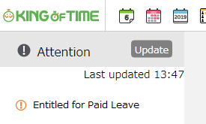

The screen shows grant date, number of days granted, and calculation method. Please confirm details and proceed.

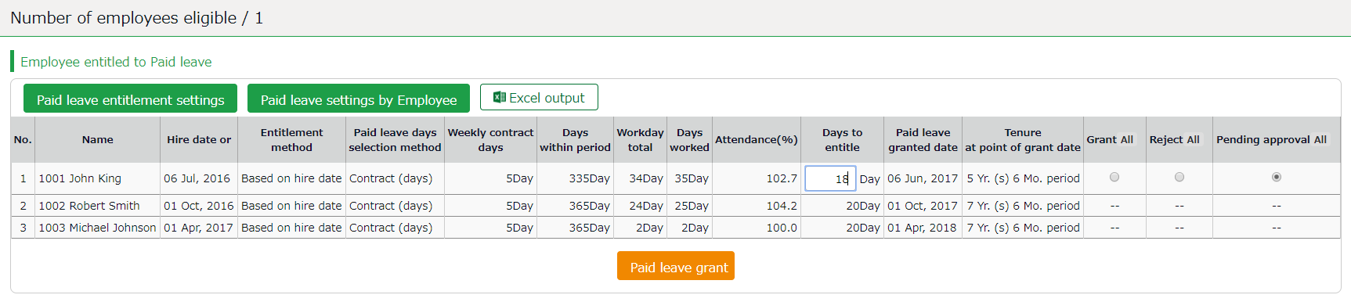
IMPORTANT:
IMPORTANT:
The system will alert paid leaves that occur in the days after all settings described in the following pages have been completed.
Please note that you cannot grant leaves back from the past date point.
To grant leaves in past date points, please do so manually (p.152).

We also recommend granting leaves manually, if your company has leave regulations that our system (refer to specifications in the following pages) does not cover.

[Specification 1] Paid leaves granted
There are two methods of managing paid leaves.
- Grant paid leaves based on hired date
- Grant paid leaves based on grant date

You can also use the "Divided leave"? feature to grant a portion of days in advance after a specified number of months from the hire date, and a feature to determine the first and second half of the year based on the grant date.
This section describes the settings for each method.

Grant paid leaves based on hired date
Paid leaves are granted for the first time, on the specified number of months after the hired date. Thereafter, paid leaves are granted every year on the same day.
Leaves granted (first time) : March 1
Leaves granted (second time) : March 1
Leaves granted (third time) : March 1
January 1st
December 31st
Hired date: September 1st

If an employee is hired on September 1st
and the first grant date is set 6 months after the hire date

Grant paid leaves by grant date
Paid leaves are granted for the first time, on the specified number of months after the hired date. Thereafter, paid leaves are granted every year on the specified date.
Leaves granted (first time) : March 1
Leaves granted (second time) : April 1
January 1st
December 31st
Hired date: September 1
Leaves granted (third time) : April 1

If an employee is hired on September 1st and the fixed grant date is set to April 1st

Grant paid leaves based on grant date (Divided leave)
A year's worth of paid leave will be granted in two installments, one on the initial grant date and the other on a divided grant date prior to the initial grant date, in the specified number of months after the employee's hired date. You can set the following year's base date as either the "initial grant date" or as a "divided grant date".
December 31st

January 1st

Hired date: September 1

Leaves granted (first time) : December 1

Leaves granted (second time) : March 1

Leaves granted (third time) : December 1

If an employee is hired on September 1st and leaves are granted on December 1 and March 1
First set of leaves are granted three months after the hired date and the rest are granted 6 months after the hired date

[Specification 2] Paid leaves calculation method
To manage paid leaves, you can choose from following two methods.

- Grant leave based on the number of workdays per week
- Grant leave based on the estimated number of workdays per week based on the number of workdays per year and total workdays

This section describes how paid leaves are calculated in each method.

Grant leave based on the number of workdays per week
Leaves are granted according to the table of proportional paid leaves. The number of years worked and workdays per week serves as the reference value to determine the number of leaves. For leave entitlement, the employee’s attendance rate must be over 80%.
If the minimum attendance is less than the specified rate, the user is entitled 0 leaves.

Grant leave based on the estimated number of workdays per week based on the number of workdays per year and total workdays
Paid leaves are granted according to the estimated workdays per week days based on the employee’s annual total of working days (does not refer to attendance rate). We recommend using this setting if the workdays per week is not fixed and you cannot set it for each employee.

Example of an employee:
* Has worked for 6.5 years
* The year’s total of actual work days: 200 days
According the table below, the employee is assumed to be working 4 days per week, giving him/her 15 leave days. (200 workdays fall under the 169-217 category)

Table – Number of leaves to grant (Statutory)
Number of workdays per week | Minimum workdays required | Timing for granting leave
 |  | 0.5 years | 1.5 years | 2.5 years | 3.5 years | 4.5 years | 5.5 years | 6.5 years and above
5 days and above | 217 days | 10 days | 11 days | 12 days | 14 days | 16 days | 18 days | 20 days
4 days | 169 days | 7 days | 8 days | 9 days | 10 days | 12 days | 13 days | 15 days
3 days | 121 days | 5 days | 6 days | 6 days | 8 days | 9 days | 10 days | 11 days
2 days | 73 days | 3 days | 4 days | 4 days | 5 days | 6 days | 6 days | 7 days
1 days | 48 days | 1 days | 2 days | 2 days | 2 days | 3 days | 3 days | 3 days

Leave-related settings

You can open the settings related to annual leave from the following screens.
- Employee type settings
- Employee settings

Requirement
Go to [Home page > Settings > Others > Options > Schedule settings].
Check to see that the "Paid vacation grant" option is set to “Apply”.

Items
Click on the [Paid Leave-related Settings] button at the Employee type settings screen.

1. Set the number of workdays designated per week (Required)
Item | Description
Number of days | Specify the designated number of workdays per week.
Calculate the prescribed number of working days per week based on the number of working days per year and all working days | Calculates the prescribed number of working days per week based on the number of working days per year and all working days.

2. Set the first reference date (Required)
Item | Description
Grant first leave for the x months after hire date and set as grant date every year | Leave will be granted after the specified number of months from the employee's hire date.
Divided leave | The system grants the designated number of leave days after the specified number of months from the hire date.
Grant leave based on Divided leave date | The option is available if Divided leave is enabled. After granting leave for the first time, leaves are granted on the specified date.

3. Set a second reference date (Optional)
You can set the second reference date together with the first.
Item | Description
Fix grant date to m/d | Set a fixed grant date once a year.
Fix the first and second half of the year based on the grant date | For example, if the fixed grant date is set to "April 1", the following applies.  First half of the fiscal year (April - End of September)  Grant date: October 1 (Applicable to employees whose hire date is in the first half of the year)  Second half of the fiscal year (October - End of March)  Grant date: April 1 (Applicable to employees whose hire date is in the second half of the year)
Prioritize the second reference date | Grant leave on the second reference date.  For example, under the following conditions, the first grant date would be April 1.  - Hired date: March 1st  - First reference date: 6 months after hired date  - Second reference date: Fixed grant date is April 1st

4. Set the proportional number of leave
The proportional number of leaves are granted by the employee’s weekly contract hours times the years of tenure.
By filling in the items, the system grants annual leaves based on the estimated workdays per year (calculated from each employee's weekly contract workdays).
Legal standard is applied to default settings, but you can make configurations that fits to your company’s rule.

5. Set the number of working days and the number of total working days
This is used for calculating attendance rates (Number of working days / Total working days ｘ 100).
You can select [Weekday work], [Legal holiday work], [Non-legal holiday work], and other leaves.

Paid leave feature settings
Please complete the following settings before beginning.

Requirement
Go to [Home page > Settings > Others > Options > Schedule settings] category. Ensure that [Paid vacation grant function] is set to [Apply].

Employee type settings
Go to [Home page > Settings > Employee > Employee type settings]. Click the [Edit] button of the employee type.
1. Click on the [Leave-related setting] button.
2. Perform settings for grant method. Please refer to [Specification 1] in p.59.
3. Specify the designated number of working days.
4. Set the reference date. Please refer to [Specification 2] in p.60.
5. Set the number of workdays and total working days.

Employee settings
Go to [Home page > Settings > Employee settings > Edit] and enter [Hired date].
If the [Hired date] is empty, the employee will not be entitled to paid leaves.

The system will start notifying paid leaves granted from the following day of completing all settings above. Please note that you cannot grant leaves back from the past date point.

Grant leaves by auto-calculation
For details, please refer to chapter 2 (p.155).

Pattern settings
Settings > Schedule > Pattern settings
This section describes the Schedule pattern settings.

About [Schedule]
By setting schedules, administrators can organize works shifts (e.g. Create early and late shifts) as well as set late-in/early-out, break time, configure overtime calculation process, etc.

Overtime start (8 hours) * Employee type settings
Clock-in
10:00 AM

Clock-out
8:00 PM
Overtime work
Work time
Example of a calculation (No schedule applied)
In this example, the time between clock-in and clock-out is regarded as working hours.

Overtime start (8 hours, break time not included) * Employee type settings
Clock-in
10:00 AM
Clock-out
8:00 PM
Clock-in schedule
9:00 AM
Clock-out schedule
6:00 PM
Overtime work
Unassigned work
Late-in
Break schedule
12:00-1:00 PM
Break time
Work time
Example of calculation (No schedule applied)
The difference between clock-in schedules and actual clock-in records is calculated as [Late-in time].
In addition, any work that exceed scheduled time, but finished earlier than overtime hours, are calculated as [Unassigned work]. Schedules can be used to run various calculations.

Why do we create Schedule patterns?
It is hard to set clock in/out schedules manually every day. You can make it easier by creating a pattern for schedules and shifts. You can set clock-in/out schedules and related settings just by applying the pattern you created.

2 types of schedule patterns
There are two types of schedule patterns. Each function differently.

Schedule type | Function
Normal work | This is a clock-in/out schedule pattern.  By setting clock-in/out schedules, late-ins and early leaves are calculated.  You can also set break schedules.
Discretionary work (Deemed work) | This schedule pattern handles a day as workday, even if employees have not used the Time Recorder. This is useful when employees cannot use the Time Recorder during their business trip.

Create schedule patterns
Settings > Schedule > Pattern settings
Click [New Registration] or [Edit] to go to the registration screen.
Enter required info and click [Registration] to save.
Register as
Registration

Saves changes and returns to the previous screen.

Copies settings and creates new Pattern. You cannot use existing Division names and codes.

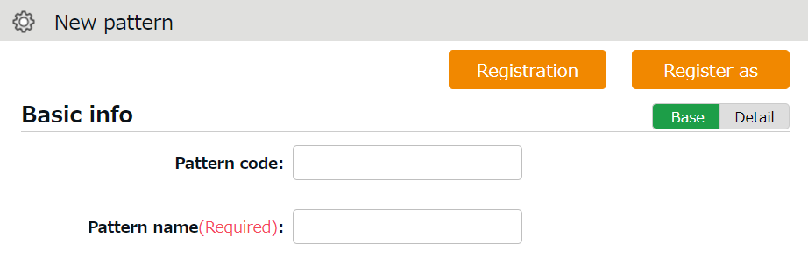

Detail

Shows advanced settings. Perform advanced settings from here.

Normal (regular) work day pattern
Settings > Schedule > Pattern settings
This section describes settings to create regular work day pattern.

Basic info
Pattern code | Enter the code for identifying schedule patterns. Enter in 3-10 alphanumeric characters. Schedule patterns are arranged in ascending order of pattern codes. You cannot use existing codes. | Basic
Pattern name | Enter the name of the pattern in 20 characters or less.  * PDF may not be exported properly if full-byte and half-byte characters are mixed.  There are 2 types of this Recorder. | Basic
Schedule type | Select [Normal work].  * Once you create a pattern, you cannot edit the associated schedule type. | Basic
Pattern color | Set a color of the pattern. You can set background and font colors. Colors can be used to distinguish different schedules on the Schedule management screen. | Basic
Division to apply | Select divisions that can use this pattern. | Detail
Employee type to apply | Select employee types that can use this pattern. | Detail

Plan
Clock-in schedule  (Core-time start) | Set a clock-in schedule.  Clock-ins later than this time are regarded as late-in. | Basic
Clock-out schedule  (Core-time end) | Set a clock-out schedule.  Clock-outs earlier than this time are regarded as early-out. | Basic
Late-in/Early-out judgment | This counts late-ins and early-outs. Select [N/A] when not in use. | Detail
Work fixed start time | This specifies the range of attendance calculation. Regardless of clock-in time, only the hours after the specified time are calculated as work time. | Detail
Work fixed end time | This specifies the range of attendance calculation. Regardless of clock-out time, only the hours before the specified time are calculated as work time. | Detail
Discretionary work hour | Select the calculation method for discretionary work hours during leave. By selecting [Calculate discretionary work hour], the system calculates the deemed work hours during leave based on [start/ end time]  * This feature is only available if the leave management method is set to [Leave type] mode. | Detail

Break schedule
Break setting 1-3 | Employees can take breaks automatically at the specified time.  To add up discretionary work hours, specify how many hours to regard as working hours. Click [Add break] to add a new row. | Basic
Break schedule (hrs) | Specify the duration of auto-break time in minutes. | Detail

Half-day work
Add AM work pattern | Add a schedule to take half-day leave in the afternoon.  Click [Settings] to open a pop-up window.
Add PM work pattern | Add a schedule to take half-day leave in the morning.  Click [Settings] to open a pop-up window.

Advanced features
Click on the category name to show setting items.
Force settings of workday type | This pattern overwrites Workday type settings.
Note | Enter a description for this pattern.  Notes are shown in [Available schedule pattern] in the Employee screen (Time Card > All menu > Available schedule pattern).

About [Workday type]
There are 3 types of workday: [Weekday], [Legal time off], and [Non-legal time off].
Workday types determine whether to count working time as regular workday or as work on holiday (legal/non-legal).

Set Workday types as follows.
The priority order is 1 > 2 = 3 > 4 > 5.

1. Override schedule pattern (Force workday type)
2. Set workday type when setting schedules manually (p.141)
3. Set workday type by submitting schedule requests
4. Set workday type by auto schedule (p.74)
5. Don’t set any workday type

If none of 1 to 4 are specified, workday type is automatically set to [Weekday].
* Workday types are always set to workdays that have schedules or attendance records. You cannot set it to [None].

Discretionary work pattern
Settings > Schedule > Pattern settings
By setting clock-in/out time, the system can also calculate attendances for employees who cannot use their Time Recorders during business trips, etc.

When creating such schedule patterns, please select either of the following in [Schedule type].
* Direct-visit (discretionary clock-in)
* No-return (discretionary clock-out)
* Direct-visit/no-return (discretionary clock-in/out)
* Once you create a pattern, you cannot edit the associated schedule type.

The other setting items are the same as creating a regular work day pattern.

Schedule type | Function
Direct-visit (discretionary clock-in) | The system will run calculations based on clock-in schedule, instead of the actual clock-in time, if none are available. Employees do not need to use the Time Recorder to clock-in when this pattern is applied to their schedules. Only clock-out is required.
No-return (discretionary clock-out) | By selecting this item, the day that sets this schedule type is regarded as a work day, even when employees cannot clock-out with the Time Recorder. Employees do not need to clock-in/out if this pattern is applied to their schedules. Only clock-in is required.
No-return (discretionary clock-in/out) | By selecting this item, the days applying this schedule type are regarded as work day, even when employees cannot clock-in/out with their time recorder. This is useful when employees are away on business trips and cannot use the Time Recorder. Employees do not need to clock-in/out when this pattern is applied to their schedules. The specified hours are deemed as working hours on that day.

Holiday settings
Settings > Others > Holiday settings
To handle national holidays as regular holiday or distinguish from other weekdays, perform settings from here.

To schedule national holidays, please refer to [Auto schedule settings] in the following pages. Holidays are indicated in red font color in Time Card screens, etc.

To add Japanese national holidays
To add Japanese national holidays, click [Add Japanese national holiday] to view the list of national holidays.
Select division(s) to apply the holidays and click the [Registration] button.

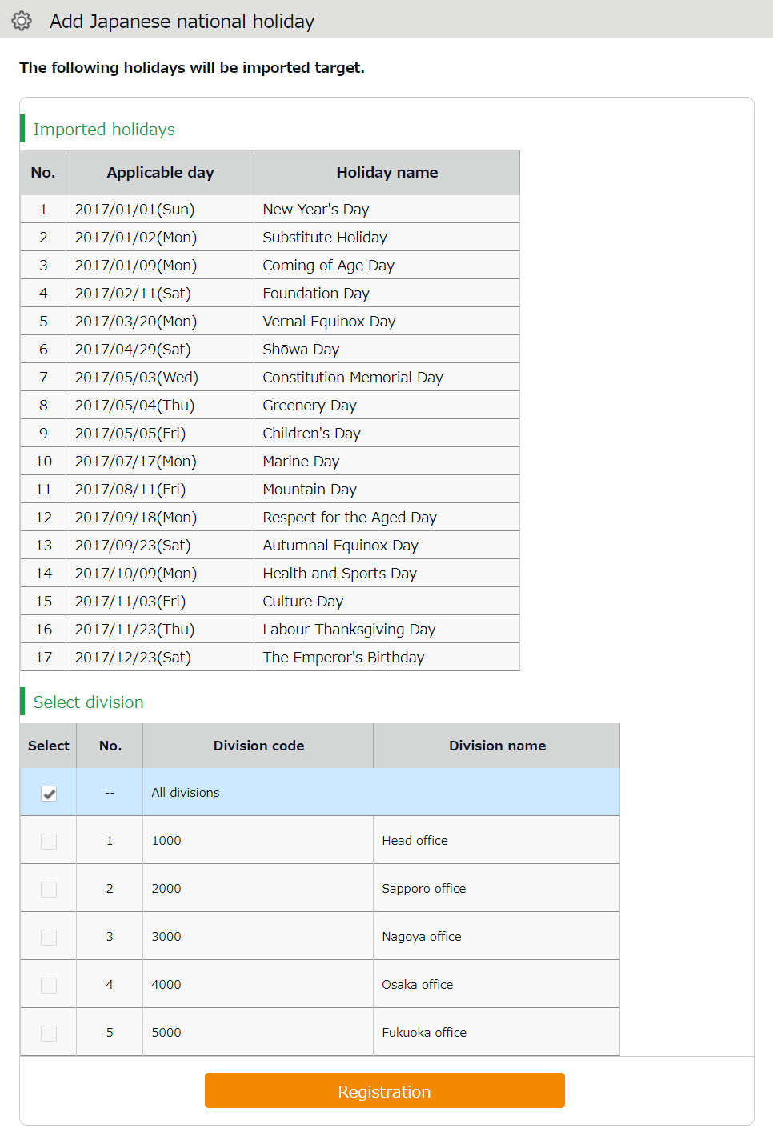

Add custom holidays manually
To add custom holidays such as your corporate anniversary, click [New registration].
Enter the name, date of the holiday and select divisions to apply the holiday. Click the [Registration] button.

Auto schedule settings
Settings > Schedule > Auto schedule settings
This feature adds schedules automatically.
Set schedules for each day of the week. The schedules are created according to different employee types and division.

Descriptions
Specify the display condition

Specify a division, employee type, etc.
Click [Show] to view data.

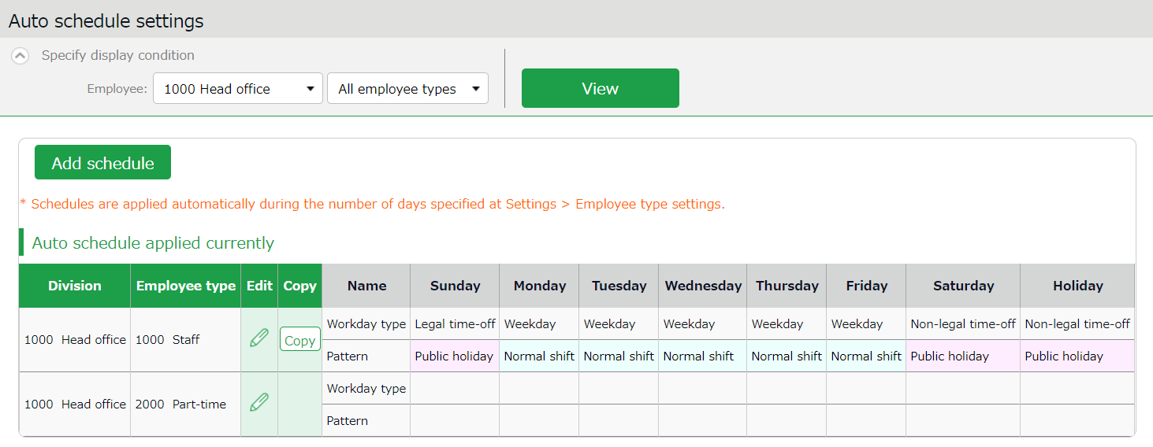

1ｚ

2

Shows Auto schedule.
The schedules are created by different employee types in each division.
Currently applied auto schedules

No. | Buttons | Description
1 | 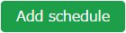 | Adds a schedule to all employees displayed on the screen.
2 | (Edit) | Configures settings for employee types in each division.
 | 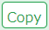 | Copies auto schedule settings to different employee types and divisions.

Setting instructions
Click [Add schedule] or [Edit] in the Auto schedule settings screen.
Specify a [Workday type] , [Pattern] or a [Leave type] for each weekday.

Workday type | There are 3 types: [Weekday], [Legal time off], and [Non-legal time off].  Workday types determine whether to count working time as regular workday or as work on a holiday (legal/non-legal).
Patterns | Set an auto schedule pattern.
Leave type | Set the Leave type to automatically apply.

When auto schedule settings are reflected
Auto schedule settings are registered under the following circumstances.

When clocking-in/out
Schedules are added automatically when employees clocks-in/out or edits the attendance data.
This will not overwrite existing schedules.

Once a day (night time)
The schedules of the employees are registered when the system runs a regular update (takes place once a day during night).
Settings in [Home page > Settings > Employee type settings > Edit screen > Days to apply Auto schedule] are needed before beginning.
The settings are enabled from the following day of the setting.
You cannot apply new auto-schedules to past records and existing schedules.

You cannot apply auto schedules to employees with Resignation date set in the
Employee setting page.

Email notification feature
The system can send notifications to employees and administrators according to different conditions.
This section describes three types of notifications.
- Settings > Others >
Notification settings> Missing time record

Missing time record notification
The system can send notifications if no clock-in/out is recorded by the scheduled time. You can also send Emails to remind employees to clock-in/out before time.

Basic info
Specify when and who to notify.

You can set notification conditions by Time record types. (Clock-in/out, Start/End break, etc.)
The system sends notification [0 to 60] minutes [before/after/before and after] the scheduled time has passed.
You can set it [Before], [After] and [Before and after] the scheduled time.
Before | The system sends notification __ minutes before the scheduled time.  This is useful to prevent employees from forgetting to clock-in/out.
After | If no clock in/out is recorded by the specified time, the system sends a notification ___ minutes after the schedule. Use this setting to notify employees that they have forgotten to clock-in-out.
Before and after | The system will send notification ____ minutes after and before the scheduled time.
* The Missing Time record notification feature only supports Japan time.
Notification timing

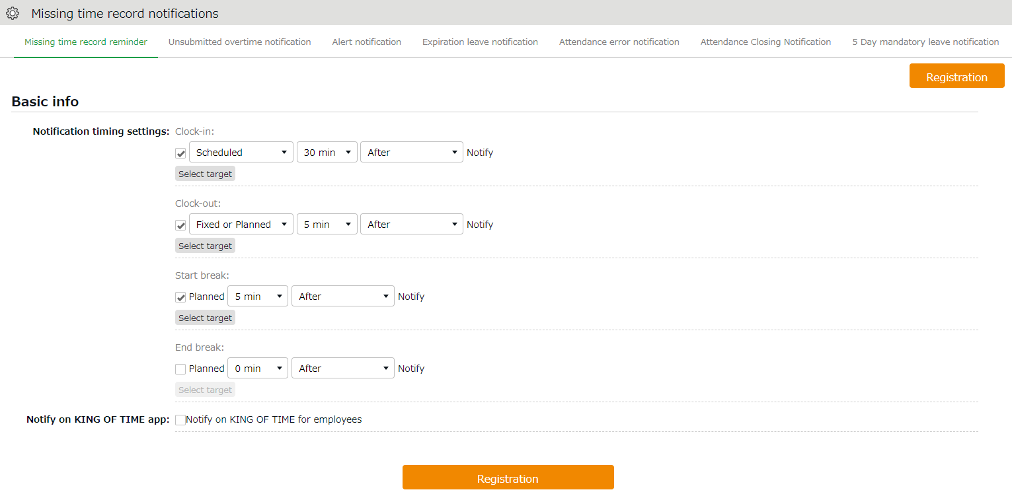
Notification ON/OFF

Select notifying Time record type.

Select notifying/monitoring users. (see following pages)
Select target notifying/monitoring users.

Saves changes.
Registration

Notify on Smartphone app for Employees

Check on the box to notify on Smartphone app for Employees.

Choose [Schedule] or [Fixed or planned].
Example: Send reminder 5 minutes after specified time.
1st drop-down: Select [Fixed or planned]
2nd drop-down: Select [5 min]
3rd drop-down: Select [After]
Select Schedule

Select notifying/monitoring users.
From the [Select target] button, you can confirm the list of notifying employees.
The same instruction applies to all notification related settings.
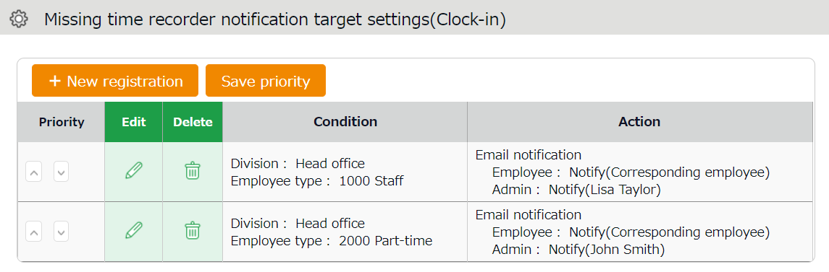
2ｚ
1ｚ

3ｚ
4ｚ

No. | Buttons | Description
1 | New registration | Creates notification target setting.
2 | Save priority | Saves changes to priority.
3 | Priority | Set priority if you have multiple conditions. The one closer to the top is prioritized. You can change the order using the up and down buttons. Click [Save priority] to save changes.
4 | Edit / Delete | Edit or delete condition.
You can set Notification target settings from [+ New registration] or the (Edit) button.
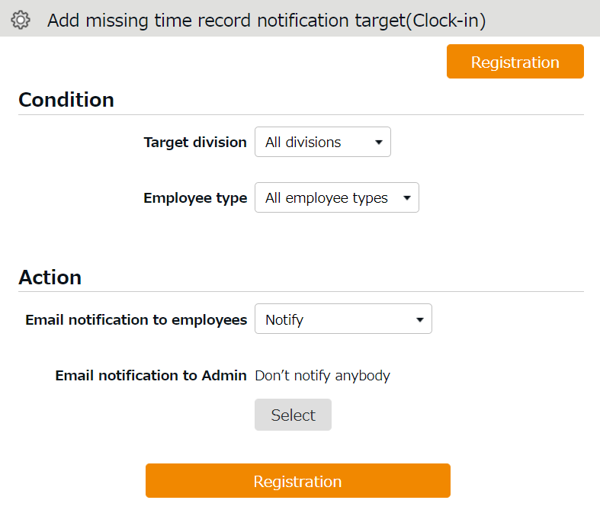
1ｚ

2ｚ

3ｚ

No. | Item | Description
1 | Condition | Shows Division and Employee type to notify.
2 | Action | Shows whether you notify specified employees and Admins or not. You can decide which Admin to notify, from the [Select] button.
3 | Registration | Saves changes.
- Settings > Others >
Notification settings >
Unsubmitted overtime notification

Unsubmitted overtime notification
The system can notify unreported overtime in the previous day and unapproved overtime requests by Email.

Basic info
By selecting [Apply], at [Notification feature], you can set Notification Timing.
Click the [Registration] button to save the settings.
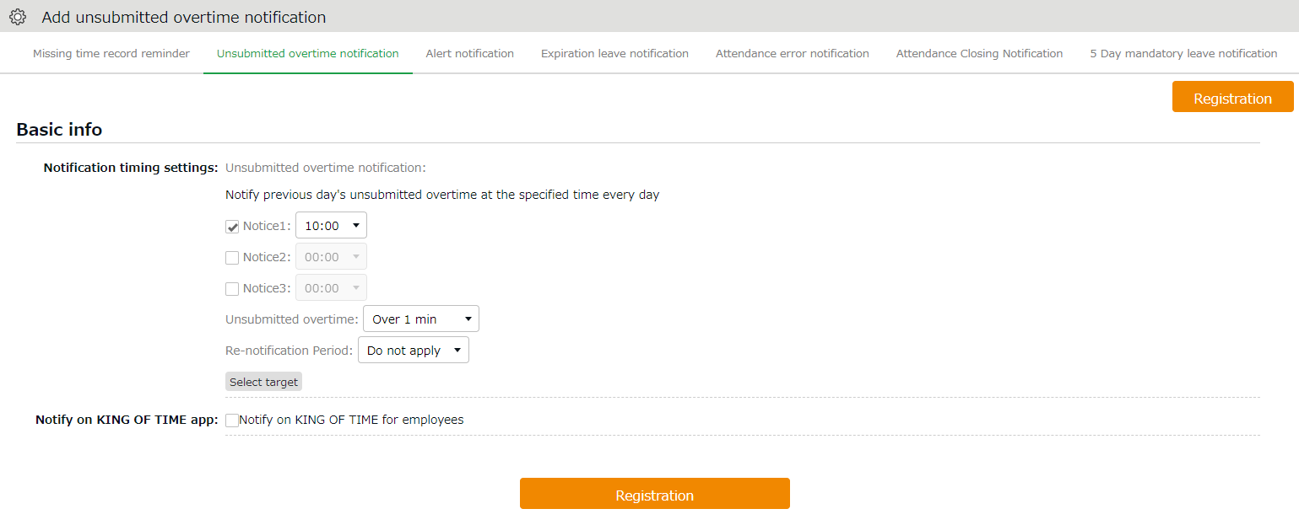
Notification timing

You can choose from every 30 minutes throughout the day (*).

Unsubmitted overtime

The system will notify unreported overtime that exceeds the specified amount of time. You can choose the amount of time ranging from [1 minute or more] to [120 minutes or more].

Select target

Same as in Missing time record notification (p.76).

Check on the box to notify on Smartphone app for Employees.
Notify on Smartphone app for Employees

* [09:00] and [09:30] are disabled to reduce server load. Existing notifications set to these options will function, but you cannot re-select the same option once you change the setting.

Alert notification
Settings > Others > Notification settings > Alert
Notifies you by Email when the attendance data exceeds the specified value.

Basic info
Set up email notifications using the conditions set in Settings > Screen display > Alert settings (p.97). To receive a notification when the attendance data reaches or exceeds the threshold, check the box next to the name of the alert setting (Email notifications are not available for conditions set to [or less] or [less than] the specified time).
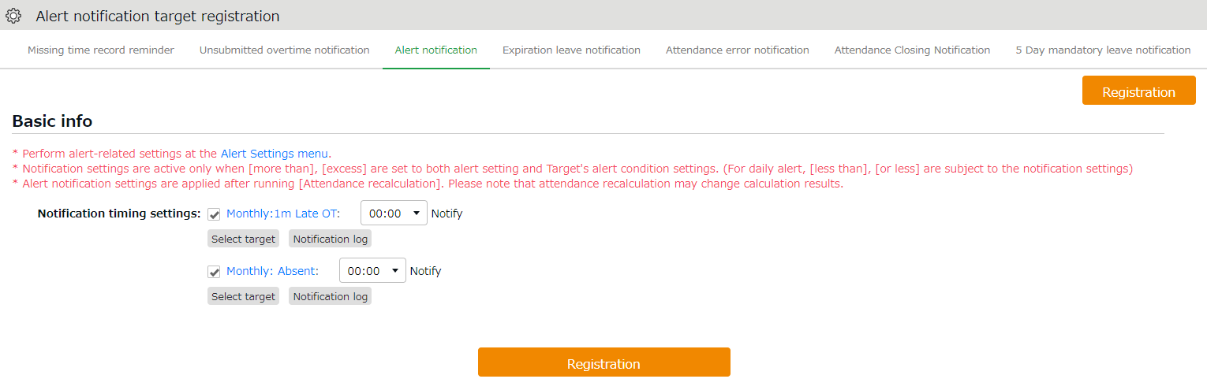
Notification Log

If the alert setting applies for monthly data, you can check the notification results in the Alert Notification Target screen.

You can choose from every 30 minutes throughout the day (*).
Notification Timing Settings

Same as in Missing time record notification (p.76).
Select target

* [09:00] and [09:30] are disabled to reduce server load. Existing notifications set to these options will function, but you ca152nnot re-select the same option once you change the setting.

Alert notification target
If the alert setting is aimed at monthly data in the Alert settings screen (（p.97), you can check the notification log in this screen. You can use this feature to check how the alert notification was sent.
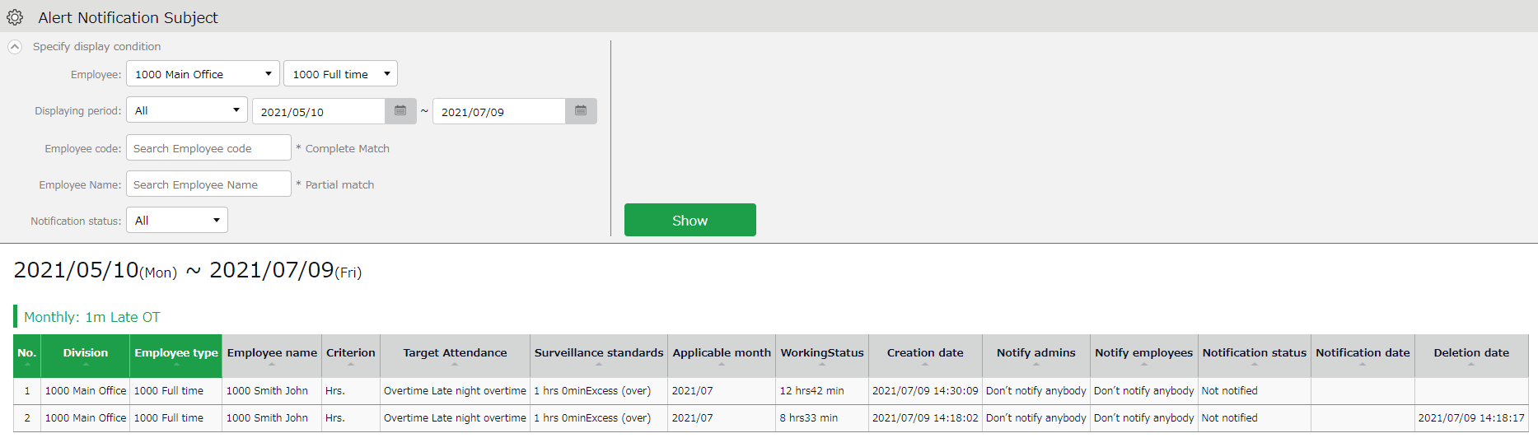
Specify the display condition

You can also narrow down your search by various criteria other than divisions and employee types.
Notification status:
- Notified (Notification Email sent)
- Not notified (Notification Email not sent)
* There may be a time lag of a few minutes between the notification time setting and the actual notification date.

Leave expiration notification
Settings > Others > Notification settings>
Expiration Leave Notification
This setting alerts leaves that are expiring soon.

Basic info
To enable the leave expiry notification, ensure the following.
- [Calculation method of leaves when obtained] is set to [Subtract].
- [Valid period] is specified. Click the [Registration] button to save the settings.
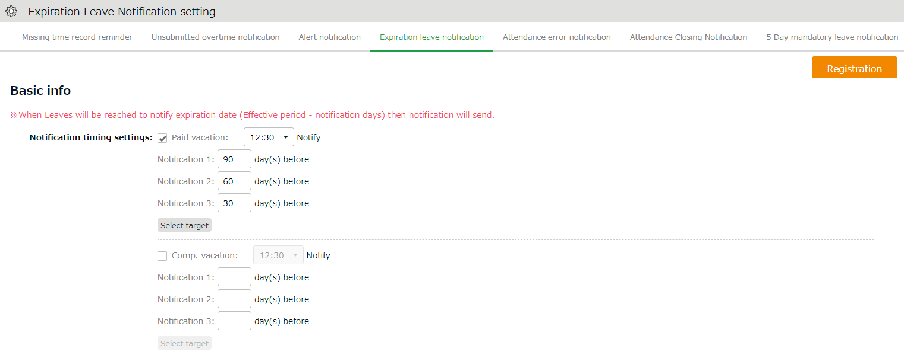

You can choose from every 30 minutes throughout the day (*).
Notification timing

Specify when to send the notification (__ days before expiration).
Notify _ days before expiry date

Same as in Missing time record notification (p.76).
Select target

* [09:00] and [09:30] are disabled to reduce server load. Existing notifications set to these options will function, but you cannot re-select the same option once you change the setting.
- Settings > Others > Notification settings >
[Attendance data error notification

Attendance data error notification
The system can send notifications to employees and administrators when attendance error occurs.

Basic info
The system can send notifications to employees and administrators when attendance error occurs.
The following are notified:
- Attendance data error
- No time record/ Schedule set (*1)
- Time record/ Schedule not set (*1)
- Consecutive work (*2)

*1 To enable this feature, select [Display] at Options > Attendance data error settings.
*2 The system will keep sending the notification every day, in case the number of consecutive working days reaches the threshold.
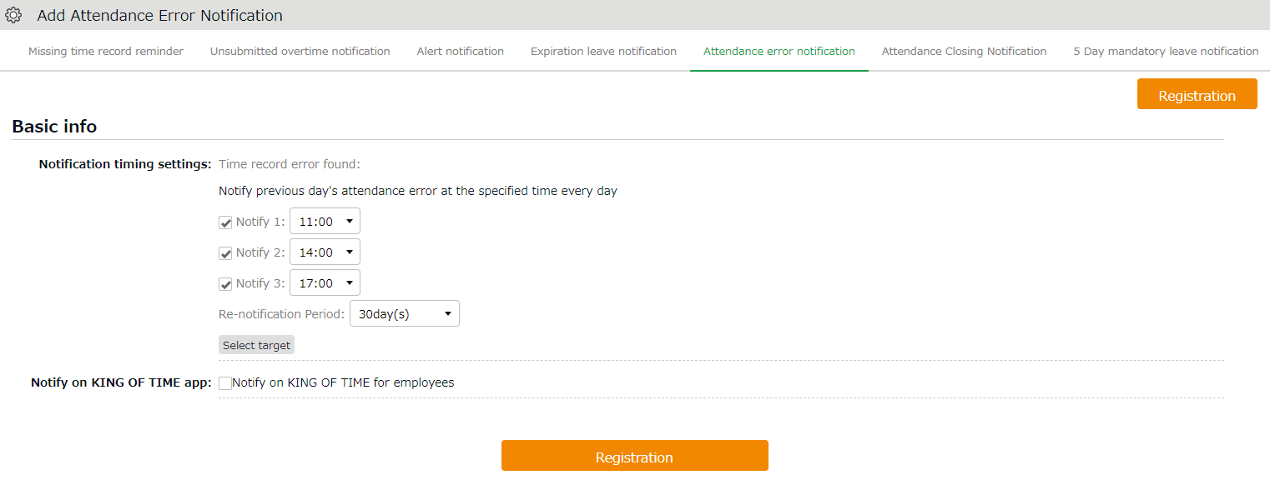

You can set notifications up to 3 times a day, in minimum 30 minutes intervals (*).

Notification timing

If you select an option other than [Do not use], you receive Email notifications regarding attendance data error ranging from the specified number of days until the day before.
The system continues to send the notification until the error is corrected.
Renotification Period

Same as in Missing time record notification (p.76).
Select target

Check on the box to notify on Smartphone app for Employees.
Notify on Smartphone app for Employees

* [09:00] and [09:30] are disabled to reduce server load. Existing notifications set to these options will function, but you cannot re-select the same option once you change the setting.

Setting instructions
- Go to Settings > Others > Notice settings > [Attendance Error Notification Settings] tab.
- Specify the notification timing.
- Number of notifications: Up to 3 per day
[09:00] and [09:30] are disabled to prevent server load. Existing notifications set to these options will function, but you cannot re-select the same option once you change the setting.
- Reminder Period: Select from [Do not use] or 1 - 30 days.
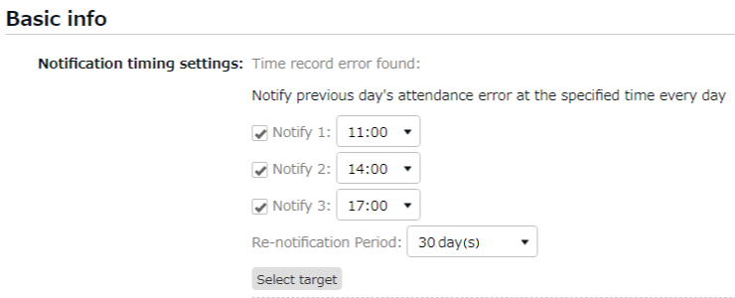

- Click [Select target].
- Click [Create new] and specify the Email recipient.
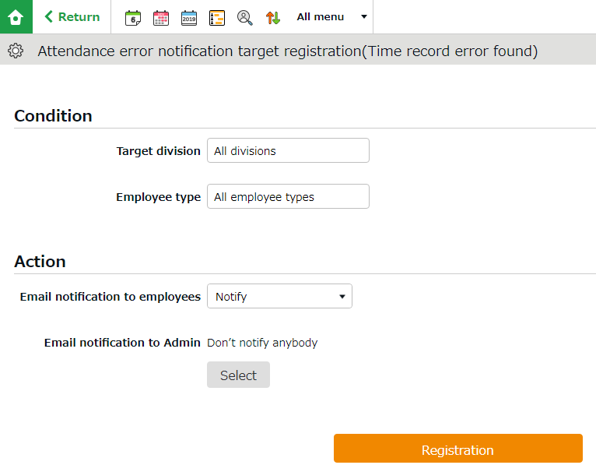

To notify employees
Specify the Division and Employee Type, then select [Notify] at [Email notification to employees]. The system sends notifications to Email addresses set at Employee settings.

To notify Admins
Select the Admin from [Select] at [Email notification to Admin].
The system sends notifications to Email addresses set at Admin settings.

- You can set multiple conditions. You can set priority by changing the order at the [Priority] column if you have more than one condition. Please remember to click the [Save priority] button to save the setting.

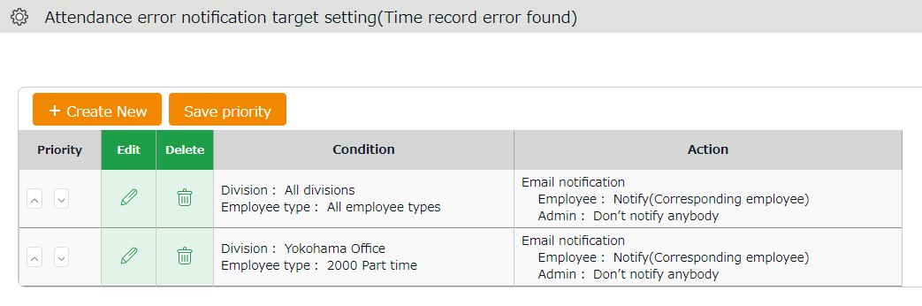

You can change orders by clicking [^] and [v]. Click [Save priority] to save changes.
Priority

Priority
The system will check for matching users by applying the conditions in order of the list. Narrower settings should come on top of broader conditions.

Attendance closing notification
- Settings > Others > Notification settings >
Attendance Closing Notification
If the Close Attendance feature is active, you can send remind admins by Email. If the Attendance Confirmation feature is active, you can send the reminder to admins and employees.

Basic info
The system can send notifications to employees and administrators when attendance error occurs.
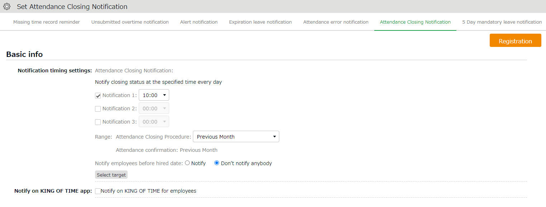

Notification Timing Setting

You can choose from every 30 minutes up to 3 times per day (*).

Specify the check range. Available options depend on the settings.
Range

Notify employees before hired date

Check on the box to notify on Smartphone app for Employees.
Notify on Smartphone app for Employees

Specify whether to notify employees before the hired date.

Select target

Same as in Missing time record notification (p.76).
Please note you cannot send closing status info to employees.

* [09:00] and [09:30] are disabled to reduce server load. Existing notifications set to these options will function, but you cannot re-select the same option once you change the setting.
*2: Not available if the Close Attendance feature is disabled.

5 Days Mandatory Leave Notification
The system can notify admins and employees of the 5-day mandatory leave by Email.
This will encourage employees who have taken less than 5 days of annual leave to take more leave. Admins can also check the alert on the admin screen, but Email notifications allow them to keep track of their employees’ mandatory leave status even while they are not logged in.

Basic info
The system can send Email notifications to admins and employees if they have not taken more than 5 days leave within a year.
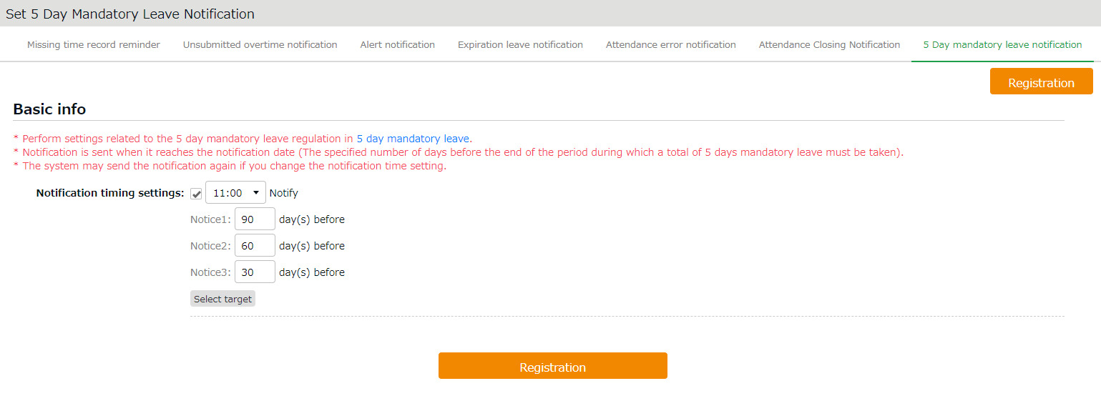
Select target

You can choose from every 30 minutes throughout the day (*).
Notification timing

Specify when to send the notification (__ days before the end of the 5 day mandatory leave period).
Notify _ days before end of year

Same as in Missing time record notification (p.76).
Please note you cannot send closing status info to employees.

* [09:00] and [09:30] are disabled to reduce server load. Existing notifications set to these options will function, but you cannot re-select the same option once you change the setting.

Custom features
This section describes the following customizable items to summarize attendance data.
- Custom data item settings
- Supplemental working record settings

Custom data item settings
Settings > Screen display > Custom data item settings
You can create a customized attendance data item by combining (add/subtract) multiple items.
You can also rename or change display orders of the items as needed.

Add custom items
Perform custom data item settings as follows.

1. Go to [Settings > Screen display > Custom data item settings].
2. Click [Daily] or [Monthly], then click the [Create New] button.
Enter required info, then click [Registration] to save.
If you need the same items for both Daily and Monthly view, you will need to create one for each.
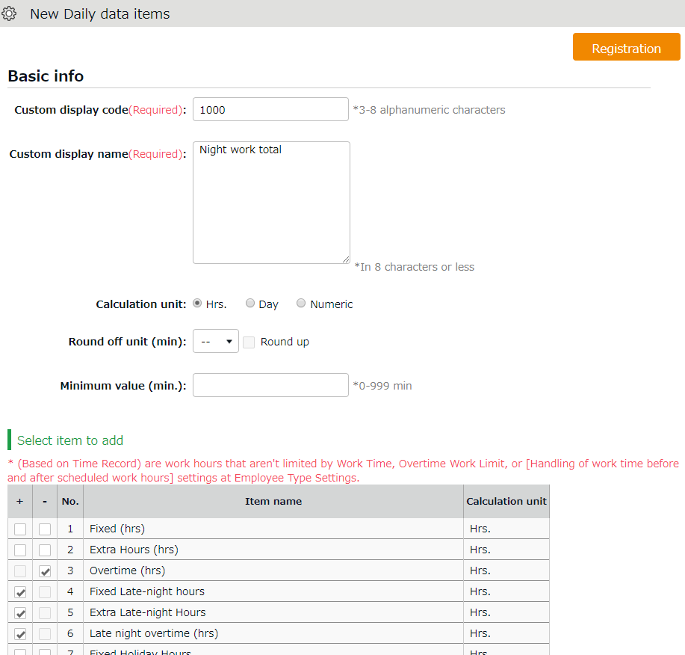
* You can create up to 20 items for each.

Enter the name of the custom data item.
Custom display name

[+] adds the value, while [-] subtracts the value of the item.
Check box

Details of the setting items are described below.
Custom display code | Set a code for identifying the item.  Enter in 3-8 characters.
Custom display name | Enter the name of the custom data item (In 25 characters or less) . You can enter names vertically if it is too long to show horizontally.
Calculation unit | Select from Hrs (Hours), Day and Numeric. Note: You cannot combine attendance data items with different units.  e.g. (hrs) and (days)
Round off unit (min) | Rounds off the calculation result by the specified threshold. Turn the [Round up] checkbox to round up any fractions less than 1.  Turn the checkbox off to round off fractions.  You can perform the same settings under Employee Type Settings. However, please note that setting both will double the calculation process, causing inaccurate results. We recommend using either one.
Minimum value (min.) | Ignores attendance hours less than the specified value.  e.g. To count out late-ins under 15 minutes, enter [16].  This process takes place after the value is rounded up/off.
Select item to add | [+] adds the value, while [-] subtracts the value of the item. This way, you can combine multiple items.

View custom items
You can check the items at Time Card, Daily, Monthly and Yearly data screens.
Here are the details of each screen.

Time Card screen
You can switch to the Custom view from the top of the Time Card screen.
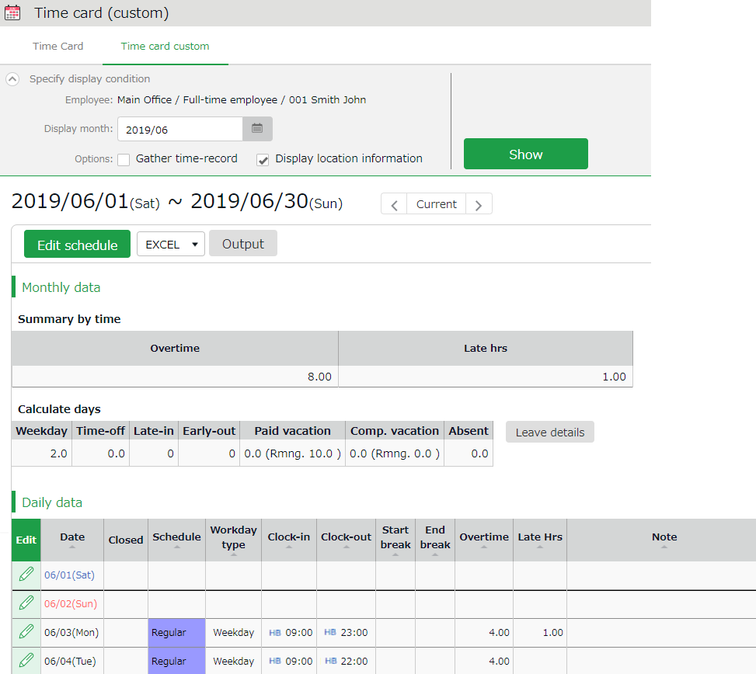
Switch tabs

From here, you can switch from Time Card to Time Card Custom screen. (Note: Employees can only view either of the two, set as default.)

Custom data items created under [Custom data item settings > Monthly]
Monthly (Custom)

Custom data items created under [Custom data item settings > Daily]
Daily (Custom)

* To change default Time Card view to Custom, please contact our support team.
Daily/Monthly data
Go to [Daily data] or [Monthly], then click the [Normal condition (Custom)] tab.
You can check the summary of the Custom items you have created.
See Check daily data (p.115) for details.
Tabs

You can switch Normal and Custom view from the tabs above.

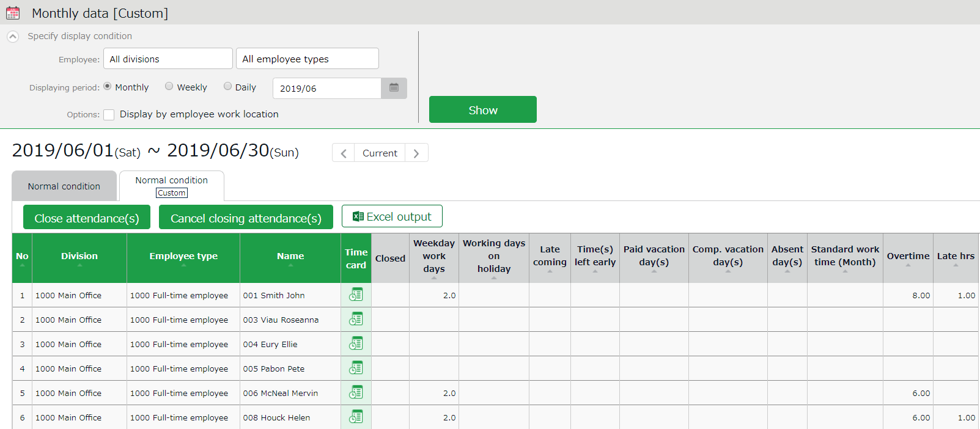

Calculation results

The summary on custom item data shows at Daily data Custom and Monthly data Custom view.

Yearly data
Go to [Yearly data > Click the Select button at Select items > Custom]
Custom data items are listed.
Check the items as needed, then click [Select]. Click the [Show].
(You can select items under Normal and Custom together if needed)
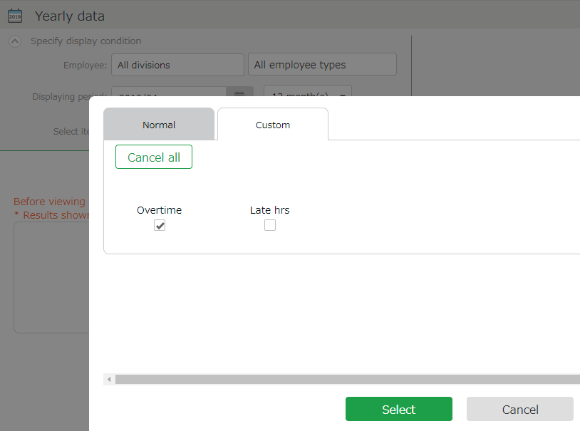

Click the Custom tab to select Custom data items.
Select Custom items

Export Custom items
You can export the custom data from the Export/Import screen.

1. Go to [All menu > Others > Export / Import].
2. Click [Create export file layout] under [Output data (Export)].
3. Click [Create New] at Monthly data layout settings.

Every Custom data item have the prefix [Custom)].
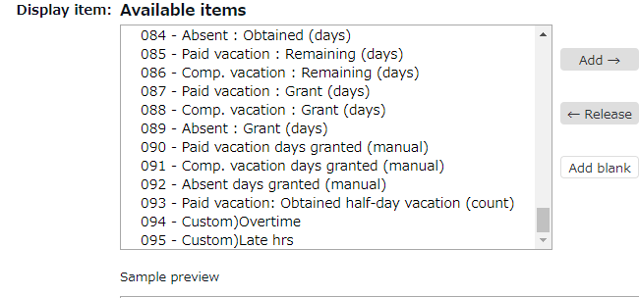

See “The Export menu” (p.157) for details.

Sort Custom data items
You can sort the items as follows.
Settings > Screen display > Custom data item settings
Move the item by drag and drop (to hold down the mouse while moving it to another position). Click [Save Order of Display] to save the order.
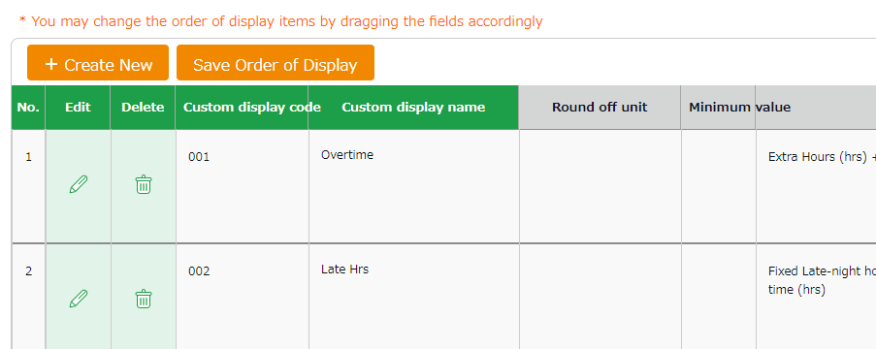

- Settings > Others >
Supplemental working-
record settings

Supplemental working record settings
You can create input fields for each division or employee type (e.g. Task duration etc.).
Supplemental items can sum up data that attendance data does not cover. They can be useful along with Custom data items.

Add Supplemental items
Select the input type; Time, Numeric (value) and Dropdown.
You can set name the item freely.

To use the Supplemental Item, you will need to perform settings at [ Supplemental working record settings], [Access Group Settings], and [Access Pattern settings]. All 3 of the above are required.

Supplemental working record settings
First, decide what kind of data to collect through this item.
(e.g. Task duration time, errands, etc.)
Settings > Others > Supplemental working record settings > Create New
Code | Enter the code for identifying the item. Enter in 3-10 alphanumeric characters. You cannot use existing codes.
Item name | Enter the name of the item. (In 40 characters or less.)
Input Unit | Enter the input type.  Select from Time span,Value, and Dropdown.  * If you select Dropdown, you are required to set options after saving this item.
Maximum value | * Available if input type is set to Value.  Sets the maximum threshold for displaying its sum.  Higher values will not be shown.
Minimum value | * Available if input type is set to Value.  Sets the minimum threshold when displaying calculation results.  Lower values will not be shown.
Digits after decimal point | * Available if input type is set to Value or Dropdown.  Set the number of digits after the decimal point.  Select from 0 to 3.
Unit | * Available if input type is set to Value.  Enter its unit (e.g. Tickets, kg, km, etc.). (In 10 characters or less.)
Type | * This item is displayed only if Options > Supplemental item edit is set to [Apply].  Determines whether employees are allowed to edit or submit request on the Supplemental item.  If you select [Edit], employees can edit the data on their timecard screen without approval from their admin.

Access Group Settings
Next, create a group that can use this item by setting its code, name and items to use.
You can choose multiple items for a single Access Group.
Settings > Others > Supplemental working record settings > Access Group Settings > Create New
Access Group Code | Enter the code for identifying the group. Enter in 3-10 alphanumeric characters.
Access Group Name | Enter the name of the pattern (In 40 characters or less.)
Supplemental Working Records | The items created in the previous step are listed.  Check the items this group is using.

Access Pattern settings
Finally, select the Division, Employee Type and the Schedule Type using the item(s).
Settings > Others > Supplemental working record settings > Access Group Settings > Click [Create New]
Division | Select division.
Employee type | Select Employee type.
Schedule type | Select Schedule type.
Access Group | Groups created in the previous step are listed.  Choose one from the dropdown list.

Edit Supplemental items
Admins can add and edit the items from the Daily data screen.
Add items as needed from [Edit work data > Edit supplemental working record > Item]. Then click [Save].
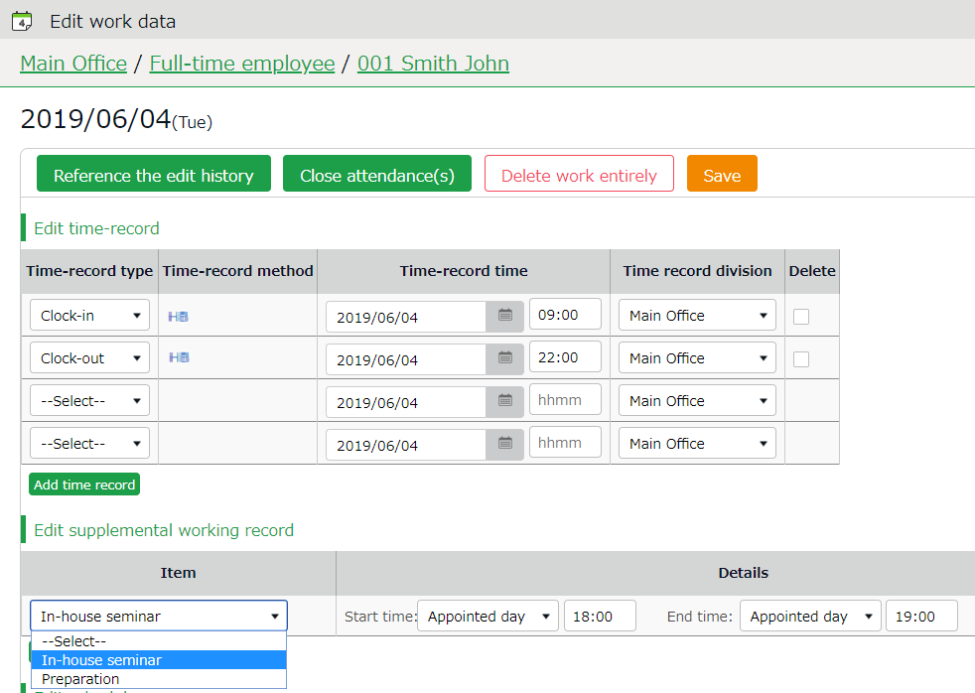

Edit supplemental working record

Input method depends on its setting, Time, Value and Dropdown.

By default, employees are required to submit request to edit or add data on Supplemental items.
Setting the item type to [Edit] allows the employee to edit the item directly without having to ask the admin for approval.
Please refer to p.92 for details on settings.

Confirm Supplemental item
By adding the Supplemental item at Custom Item Settings, you can also check them at Time Card, Daily and Monthly data screens.
They are listed under [Select item to add].
Enter required info, then click [+] next to the Supplemental item listed.
(If items are using the same unit (minutes or hours), you can combine them with default attendance items using [+] and [-].)

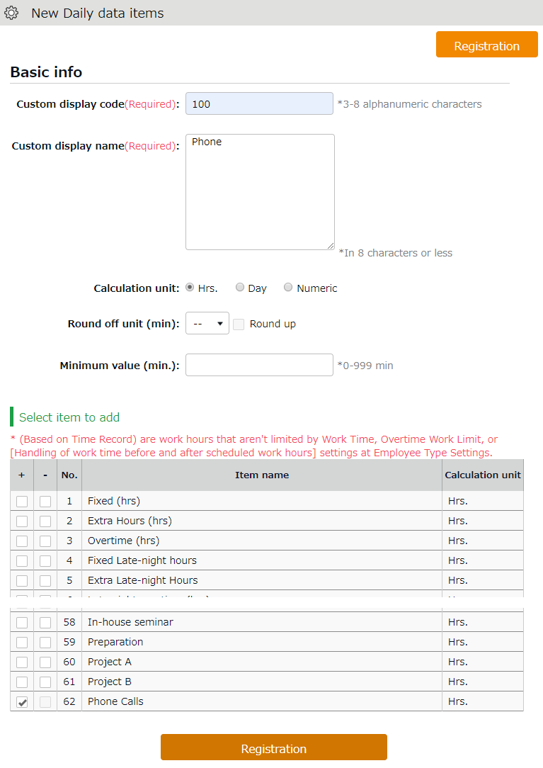
Custom display name

Name the custom item to show on the Time Card.

Supplemental items are listed here along with attendance items.
Select items

You can check the summary on the items at Daily and Monthly custom screens by creating custom items for each Supplemental item.

Export Supplemental Working Record Data
If you are a General Admin and the Output Data authorization setting is set to [〇 Allow], you can export Supplemental Working Record data in CSV format.

- Click [Supplemental Working Record [CSV]] at All menu.
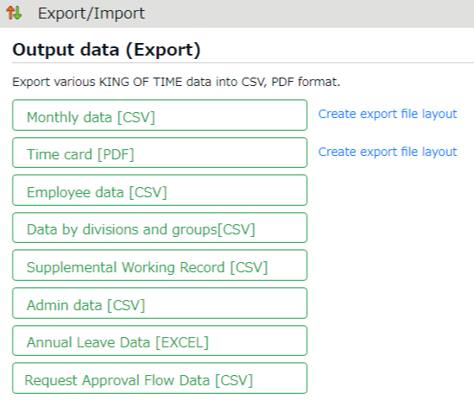

- Supplemental Working Record Specify the Period, Export Type, Data Type and Employee.

Period | Specify the year and month of the data.
Export Type | Select from [Daily Data] or [Summary].
Data Type | Select from Time span,Value, and Dropdown.  If you have chosen Time span, you can choose the time format in decimal, 60 decimal or minutes.
Employee | Specify the Division, Employee Type, Employee Group, etc.

- Click [Data output].
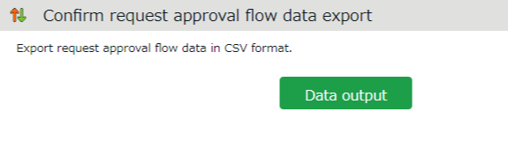

Alert settings
Setting > Screen display > Alert settings
By using Alert settings, you can filter attendance data that is over or under a certain value on the daily or monthly data screens. You can also combine this feature with the alert notification setting（p.80）to send Email notifications when attendance data reaches the conditions specified in the alert setting.
* You cannot use the Email notification feature if the condition is set to "or less" or "less than".

Alert Settings
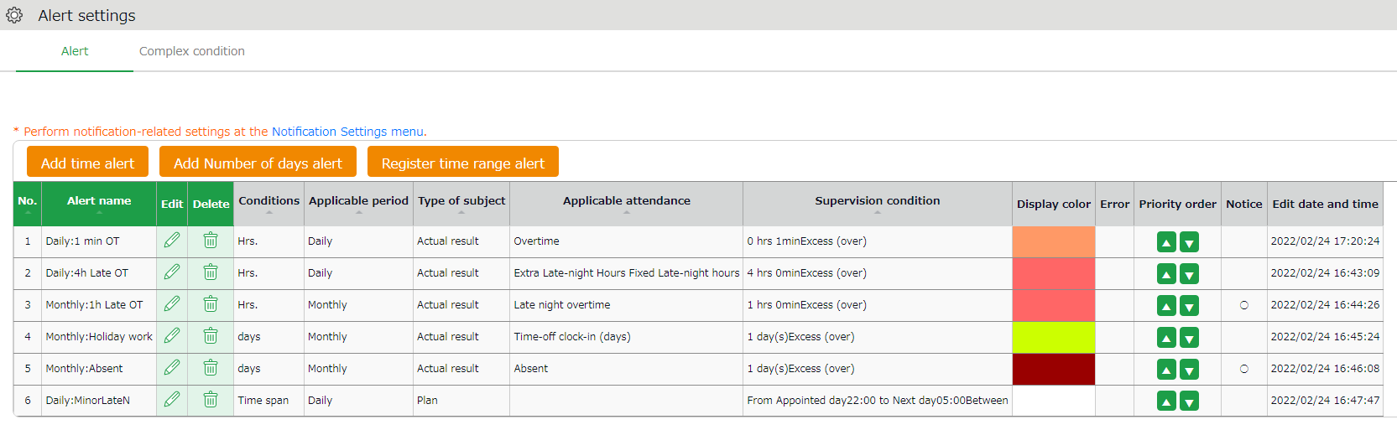
4
3
2
1

1 | Add time alert | Add an Alert setting for filtering attendance data that is over or under a certain number of hours.
2 | Add number of days alert | Add an Alert setting for filtering attendance data that is over or under a certain number of days.
3 | Register time range alert | Add an Alert setting for filtering employees who are scheduled to clock in/out during a specific period.
4 | Break time priority | Changes the order of the alert.
5 | Notice | Alert settings that are used in the Alert notification settings are marked [○].

Alert Registration Screen
To add an alert setting, click the corresponding button of the alert needed. You can set alerts by hours, days, or for a specific time range. Set the following items as needed. The items displayed will vary depending on the type of alert you are setting.
Alert name | Set the name of the alert.
Condition | Displays the condition for the alert (number of hours/days).
Applicable period | You can choose from [Daily], [Weekly] and [Monthly].
Condition | * The item will only appear in time range alerts.  You can choose between "Actual" and "Planned".  Actual result  The actual attendance record (clock in/out data) is subject to the alert.  Plan  The scheduled attendance is subject to the alert.
Error detection | * The item will only appear if you select [Plan] as the Type of subject.  You can select how you want to be alerted for Time range alerts (Planned).  Handle as error (default)  Error occurs to prevent registration when attempting to register a schedule that applies to the alert condition.  Handle as alert  You can check for any schedule treated as alert in All menu > Attendance error.
Alert target attendance | Select the attendance data subject of the alert.
Alert target custom item | Select custom data items from here.
Alert | Specify the threshold of the alert.
Display color | Select a color in the palette. The color selected is used to indicate the data has reached the specified threshold.
Select employee | Specify the age or gender of the employee.
Select employee type  Select division | Specify the employee type or the division of the subject.

Monthly data screen
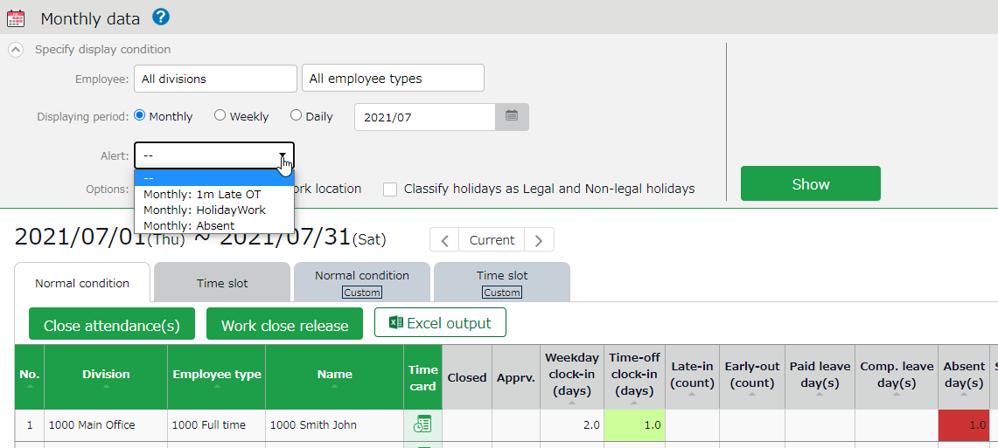
On the Monthly and Daily data screens, attendance data matching the conditions are highlighted in the specified display color. In the Monthly data screen, you can filter the data that matches the condition from [Specify display condition].

Complex condition alert
This feature is useful when you want to combine multiple alerts to create a single condition.
For example, the following Complex condition can filter employees who have worked overtime for more than 1 minute but less than 4 hours.
- Alert 1 (Daily: 1min OT): More than 1 minute of overtime has accumulated.
- Alert 2 (Daily: 4h OT): Less than 4 hours of overtime accumulated.
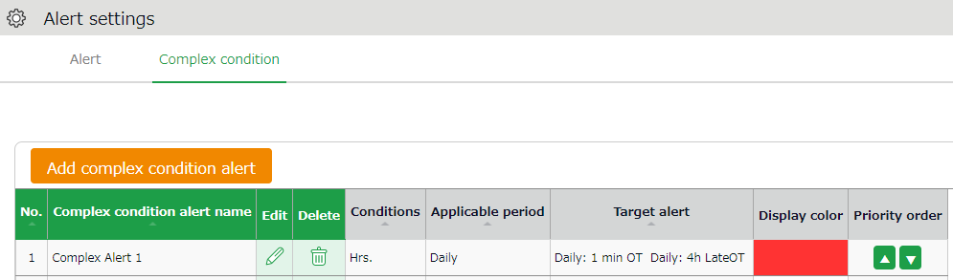

Complex Condition Alert Registration Screen
To create a complex condition alert setting, go to [Alert settings > Complex condition alert] and click on the [Add complex condition alert] button. Set the following items as needed.

Complex condition alert name | Set the name of the complex alert.
Condition | Select either [Hours], [Days] or [Time range].
Applicable period | You can choose from [Daily], [Weekly] and [Monthly].
Alert | Select the conditions you want to combine from the alerts you have already created.  You can only select alerts that match the period specified in the [Condition] and [Applicable period] on the same screen.
Display color | Select a color in the palette. The color selected is used to indicate the data has reached the specified threshold.

IMPORTANT
Alerts used in combined alerts will no longer function on their own.

Optional features
The optional features provide more advanced calculations and attendance management.

Options
Settings > Others >Options
This section describes Optional features.

Usage data
The user statistics are provided.

User statistics (Current Mo.) | Shows the number of users with time record (including discretionary work hours) within this month. Please note that deleted employees are also subject to calculation.

Company info
The following are some basic information on your company.

Company name | The name of your company is displayed.
Fiscal year start date | The fiscal year starts on the specified date. The date you set when you first signed in is displayed. To change this setting, please contact the Support Center.
Password policy settings | This feature adds requirements for employees’ Sign-in passwords, such as minimum password length and password duration.
Two-factor authentication feature | In addition to password authentication, you can implement two-factor authentication using the authentication app (available for admins only).
 | Selecting [Apply] adds the two-factor authentication option in the Admin registration screen.
Admin-employee link feature | This allows users to switch between admin and employee accounts if they have both. After signing in as an employee, the user can switch to the admin account.

Attendance management settings
The following are advanced settings for attendance management.
Time-slot category settings | This feature divides a day into a maximum of 8 time slots, and calculates working time occurred in each time slot.  This is useful when wages differ from a time slot to another.
[Apply] enables the following.
- [Time-slot category settings] under [Settings > Schedule].
- By selecting [Apply], time-slot categories are set to schedules in the Schedule management screen.
- Adds the [Time-slot category] tab in the Attendance data screen. There, working hours are shown by time-slot categories.
Working time in each time slot can be exported in the [Export / Import > Monthly or Daily data] screen.
Labor cost estimate output | This feature provides a simple summary on labor costs based on the attendance data.  First, set transportation expense and wages for each employee or by Employee type. The system calculates labor cost estimations according to this setting. The results are shown in the Attendance data screen.
[Apply] enables the following.
[Wage] button in [Settings > Employee > Employee type settings and Employee settings].
- Labor cost estimation is available in the Attendance data screen.
- Labor cost estimation is data available from the Monthly and Daily data export screen.
Alert feature | Set colors by criteria (greater than, less than) to daily/weekly/monthly attendance data.
[Apply] enables the following.
- [Alert settings] under [Settings > Display settings].
- Attendance data (see Monthly and Daily data screen) are colored to indicate the alert.
You can filter Monthly data that indicate alert, from display conditions on the top of the screen.
Flex work setting function | This feature handles working time that exceed specified hours (set by month or week) as overtime work.  You can set calculation settings such as  - Regard working time that exceed ___ hours per month as overtime work  - Regard working time that exceed ___ hours per week as overtime work  This is useful for collecting Flex-time work data.
[Apply] enables the following.
[Flex work] under [Employee type settings > Monthly overtime work summary].
Putting a check on [Display standard work (hrs)] enables the following.
If flextime work is set by month, this will show standard work time in the Monthly data and Time Card screens.
If flextime work is set by week, [Weekly calculation] under display condition is enabled. From here, you can check the weekly standard time.
Bonus wage overtime aggregate function | This feature handles unassigned working time that exceed specified hours (set by month) as [Bonus wage overtime]. Up to 2 stages can be set to Bonus wage overtime. For customers in Japan, this is useful to calculate extra overtime work, to comply with the 36 Agreement (Work agreement on overtime and holiday work).
[Apply] enables the following.
[Bonus wage overtime] under [Employee type settings > Monthly overtime work summary].
- This shows the items related to Bonus wage overtime in Monthly data and Time Card screens.
Summerize attendance data by | This setting determines whether to organize data (Daily data, Monthly data and Data by divisions and groups) by division or work location, when displaying and exporting.
[Apply] enables the following.
New display option in the Attendance data screen. From [Display by employee work location], you can view attendance data by work locations.
New display option in the Export screen. You can export attendance data by work locations.
Division group functions | Select [Apply] to manage several divisions in a group.  By doing so, you can view data summary and export data by groups. You can also organize groups in a tree structure.
[Apply] enables the following.
- [Division group settings] is added under [Settings > Organization].
- After creating division groups, they are available as display options.
You can also use division groups to filter export data.
Employee group functions | This feature provides an alternate way to group employees, other than [Division] and [Employee type].  The Employee groups created are available as display options to filter data.  This is useful to organize employee data by smaller units than Divisions (e.g. Temp agencies, etc.)  An employee may belong to more than one Employee group.
[Apply] enables the following.
- [Employee group settings] under [Settings > Employee].
You can filter data by Employee groups (Attendance data screen, Data export screen, etc.).
Count shortages of intervals between work | This feature counts the number of times intervals between the clock-out time of the previous day and the following clock-in time (intervals between work) were lacking.  If the interval is less than the specified Interval hours, it will be counted as 1 lack of interval.
By selecting [Apply], the information on shortages of intervals between work are shown in the following screens.
- Monthly data screen, Time Card screen
- Settings > Export/Import > Create export file layout (Monthly data or Time card)
Attendance confirmation feature | You can enable or disable the Confirm attendance data feature.  This feature allows employees to confirm that they have checked all their attendance for the month (this is a feature different from the closing function).  It can also send Email reminders to admins and employees if attendance data are not confirmed by the employee.  We recommend the [Use (Employee confirms data)] option. Selecting this option adds the following.  - Shows employees who have confirmed their attendances at [All menu > Monthly data screen].  - The [Confirm Attendance Data] button on the timecard screen for employees with no attendance error or pending requests.  - [Attendance confirmation: Previous month] option at [Settings > Others > Notification settings > Attendance Closing Notification]
Display hours in office when confirming attendance data | Displays Hours in the office, Total working hours, and Break time in the Confirm attendance data screen.  This feature is available when the Attendance confirmation function is set to [Apply].
 | Selecting [Apply] will display the following items on the Confirm attendance data screen: Hours in the office, Total working hours, and Break time when confirming attendance data or submitting the Attendance confirmation request.
Supplemental item edit function | To allow employees to edit the item directly without having to ask for approval, select [Apply].
 | Selecting [Apply] adds the [Item type] option in the Supplemental item registration screen, which allows you to set whether each item should require approval by the admin or not.

Schedule settings
The following are advanced features related to schedule management.

Plan/actual | The Plan/actual feature compares planned (scheduled) working hours and actual working hours.  If the [Time-slot category feature] is active, you can check data by time-slot categories.
[Apply] enables the following.
- [Plan/actual] tab in the Attendance data screen.
By putting a check [Can compare with confirmed schedules], the following are enabled.
- Adds [Save for plan/actual comparison] button to the Schedule management screen.You can view comparison data by clicking this button.
Grant paid leaves | The Grant paid leaves feature calculates the grant date and the number of paid leaves eligible.  This is initially set to [Apply].
[Apply] enables the following.
- [Leave-related settings] under [Settings > Employee> Employee type settings > Leave-related].
- [Employees entitled to Paid leave] link under [All menu > Schedule > Leave management] screen.

Leave types to show remaining leaves in Add schedule | Number of remaining leaves are shown in [All menu > Schedule management > Add schedule]. The information is useful to plan schedules. Remaining leaves under the checked leave type is displayed.

Request approval settings
The settings related to request approval flows are available here.

Request approval email notification | Sends Email notification when a request had been submitted or approved.  Settings > Admin > Admin settings  Settings > Employee > Employee settings  Emails are sent to the addresses entered in the [Send email] screen.
Contact person for schedule, time-record, or overtime requests | By performing this setting, employees can either submit requests to an administrator in their work location, or to an administrator in charge of their own division.
Request message requirement | This determines whether to require Request messages when employees submit requests. By selecting [Apply], users are required to enter a message when submitting a request.
Time recording division (Mobile request screen) division settings | Show or hide Clock-in/out Division on the Request screen (Mobile version).  [--] indicates the division the user is assigned to.
Image upload at Leave Request | When set to [Use], the [File Upload] feature will become available on the employees’ Time Record Request screen. Employees can attach delay certificates and other files to the request (Supports jpg, jpeg, png, gif, bmp, and pdf formats).

Display settings
Change display settings from here.
Display language | Select the default language for the entire account.  You can select from Japanese, English, and Thai (Machine translation).
Display format | Select a name format for employees. If you include middle names in the format, the middle name field will be displayed in [Settings > Employee > Employee settings].
Time display format | Select the time format.  60 decimals (Base 60)  Time is shown as follows:  1 hour 15 minutes -> 1.15  1 hour 30 minutes -> 1.30  1 hour 45 minutes -> 1.45  10 decimals (Decimal, or Base 10)  Time is shown as follows:  1 hour 15 minutes -> 1.25  1 hour 30 minutes -> 1.50  1 hour 45 minutes -> 1.75
The handling of the third decimal place for 10 decimal display | If [Time display format] is set to [10 decimal], values such as 7.6666...are rounded in their 3rd decimal places. This setting determines the rounding method,
Break-in/out (time record) | Show or hide break time record field in Daily data, Time Card and Attendance data edit screens.
Attendance data display | Available if the [Time-slot category] feature is active.  Specify which tab to show initially, in Daily data and Monthly data screens.
Image File URL Expiration Time | You can set a time limit for Image file URL and Attendance data integration file URL. URLs expire in 5 minutes if set to expire.  * For iPad Time Recorder images.
Display period for resigned employees on the employee list | Resigned employees are shown in the Employee settings screen for the specified period.  * Deleted employees are hidden from the Employee settings screen after the specified period. Specify the period in months.
Default value settings | Specify the number of items to show in a screen.  If you choose to show alert when displaying all items in a screen, users are alerted that it may take time to show all data.
Display/hide settings | Perform settings for items displayed in menus.
Default value settings | Set default values for check boxes and radio buttons in each screen.
Mo. display range | This sets an alternate display range if closing date is set to a day other than the end of the month. Example: Displaying data in April  If the closing date is set to the 10th, and the display range is set to [Display range including next month], data between March 11th and April 10th are displayed. If the display range is set to [Display range including next month], data between April 11th and May 10th are displayed.

Attendance data error settings
This extends the scope of error in attendance data.

No time rec./Schedule | Handles attendance data with schedule but without clock-in/out record, as attendance error.  You can use this to detect absences and to check if there are any overlooked leave requests.
Unregistered schedule | Handles attendance data with clock-in/out record but without schedule, as attendance error.  You can use this to detect any attendance data without schedules.
Check consecutive work | If employees work more than the specified days in a row, information is shown in [All menu > Attendance data error >Working days on legal holidays tab].
Leave type to count as working days in a row | Any work during this leave type is counted as “consecutive work”. This function is available if [Check consecutive work] (see above) is turned on. You can count certain leave types as consecutive workday by checking the box.
Clock-out auto overwrite mode | Activating this feature will overwrite clock-outs with the latest record, automatically.  It could also prevent attendance errors caused by clocking in/out through Web API and Time Recording device.

Account Integration
Determines whether to use SAML account integration. Perform the setting here to use the single sign-on feature.

SAML account integration | Select [Apply] to sign in using the single sign-on feature. Click the [SAML account integration] button to register the IdP information. You can also grant permission for each user type, such as administrator or employee.  Allow employee users to sign in normally  Allow administrator users to sign in normally

Integrating External Services
Provides integration with external services. After selecting [Apply] and accepting the license agreement, press the [Registration] button to enable the integration feature.

Money Forward | Integrates employee and attendance data with Money Forward Cloud Payroll.
LINE WORKS | By enabling this feature, employees can clock in/out by texting specified messages at LINE WORKS.
KING OF TIME Web API Settings | Provides direct access to our Web API.

Log
You can check the account activities of the admin screen.

Sign in/out log of the user | Records of signing in/out of the administration screen can be viewed and exported in CSV format.

Start operating
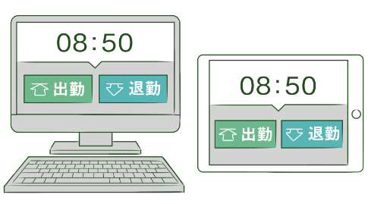
If you have completed the basic settings, get ready to share them with your employees.

Configure Time Recorder settings
Log into Employee screen

Configure Time Recorder settings

Personal Time Recorder
Send information on Personal Time Recorder setup to employees by Email (p.43).

Division Time Recorder
Send Division Time Recorder setup info to employees by Email (p.18).
Please follow the setup instructions in the manual (link available from Email).

Log into Employee screen
You can receive Attendance data/Schedule edit requests from employees through the Request approval feature. Please instruct the employees to submit requests from the Employee screen. There are 2 ways to sign in.

Send Sign-in info to employees by Email
Sends Sign-in info to employees by Email. (p.50)

Log in from Time Recorder
Press the [Time Card] button on the Time Recorder and authenticate by fingerprint, IC cards or passwords. If the authentication succeeds, the employee’s Time Card displays.

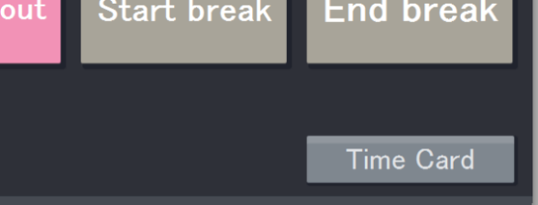
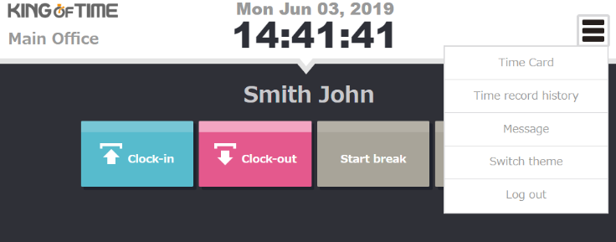

Please note that you cannot sign into Time Cards from dedicated devices such as the PitTouch series.

Chapter 2 Operation method
Chapter 2 describes the operation method.

This section describes how to manage time record data, schedules and leaves.

All menu
Perform day to day operations from [All menu] at the top of the screen.
Here, you can review and edit attendance data, set schedules, manage leaves, and export data.

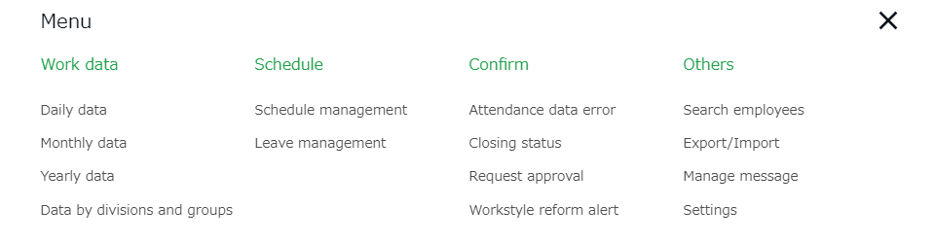

Descriptions for each item are provided below.

Attendance data
Daily data | Shows daily time record, schedules and auto-calculated attendance data. | p.115
Monthly data | Shows monthly data such as the number of days/hours of work and leave. | p.118
Yearly data | This screen shows up to 12 months' data. It provides the summary of days/hours worked and leaves taken. | p.122
Data by divisions and groups | This screen shows monthly data calculated by divisions and employee types. | p.123

Schedule
Schedule management | Check and add schedules from here. | p.140
Leave management | Check the number of leaves taken/remaining from here. | p.147

Check
Attendance data error | Shows errors in attendance data (incorrect data caused by missing time records and lack of remaining leaves, etc.). | p.129
Closing status | Check closing status here. | p.137
Request approval | Approve/reject requests from employees and other administrators. | p.138
Workstyle reform | Shows employees subject to Workstyle reform-related Alert (Upper Limit Regulations of Overtime, Highly Professional Worker’s Program and 5 Day Annual Mandatory Holidays). For details, please refer to the following document (Japanese).  https://kotsp.info/manualfiles/kot_work_style_reform_manual.pdf | -

Others
Search employees | Search employees by name or employee code. ﻿  You can perform the following tasks from the result.  - View Time Card screen  - Edit employee data  - Send Time Recorder URL (Personal Time Recorder)  - Export daily data  - Export Time Card  - Delete employee data  - Log in on behalf of the user (Master Admin only)  etc. | p.164
Export / Import | Exports and imports data.  You can export data such as Daily data, Monthly data and Time Card data.  In addition, Employee data can be imported through this feature. | p.157
Message management | You can use this feature to show messages on [Time Recorder (Desktop version)] and [My Recorder]. | -

Check attendance data
This section describes the steps to check attendance data recorded on the system. Data are available by day, month and year.

Check daily data
Shows daily time record, schedules and auto-calculated attendance data.

[Where to look] All menu > Attendance data > Daily data

Descriptions

Set a division, employee type or date.
Click [Show] to view data.

Options:
Display by employee work location - Show data of employees who worked in a division.
Gather time-record - Arranges time record data to a single cell.

Specify the display condition

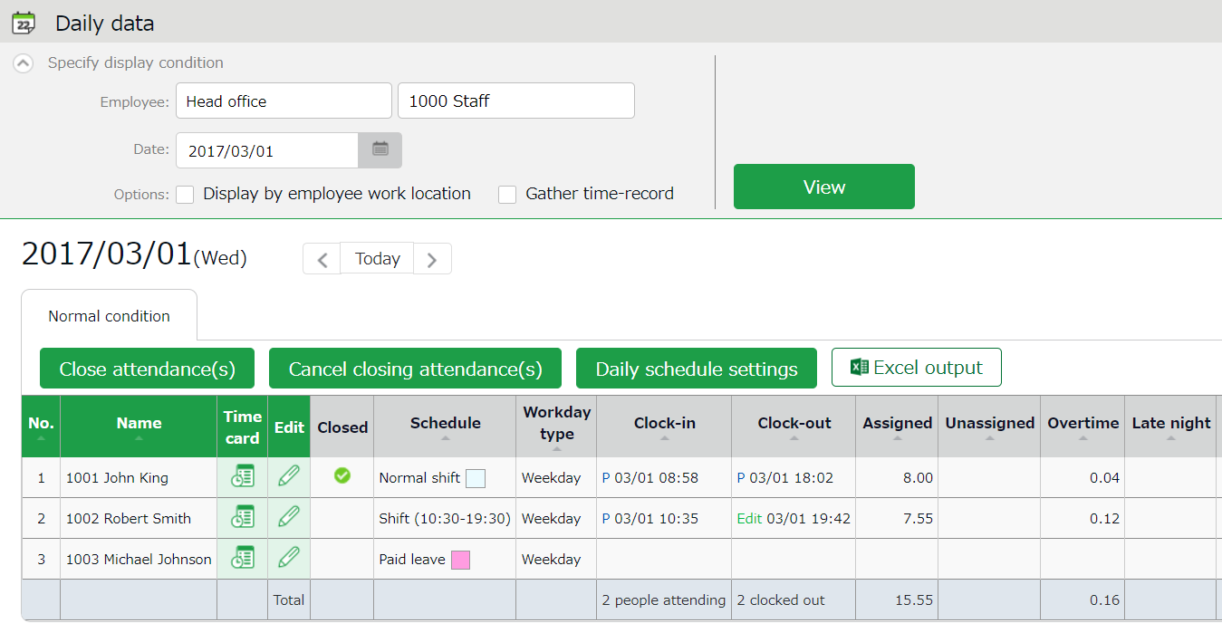

Daily data

Shows the time record, schedules and auto-calculated attendance data that correspond to the specified day.
Please refer to the following pages for details.

Daily data items
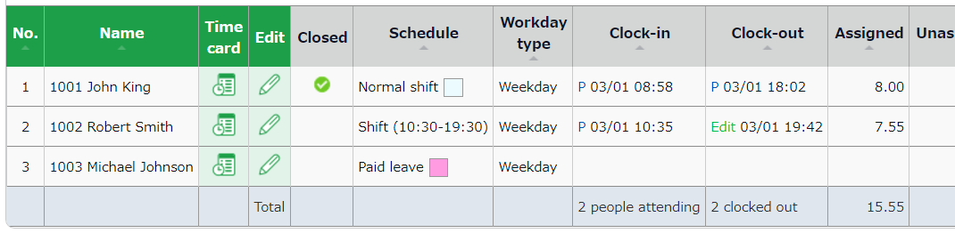

Cl.(Close) | If the user’s attendance data is closed (p.135), a check mark () shows in the corresponding date.
Schedule | Shows schedules and leaves. If an Admin creates and applies a Pattern (p.65) to a schedule, the name of the pattern shows in the grid. [Shift] indicates the schedule does not belong to any pattern.
Workday type | Workday types (p.70) are displayed.
Clock-in/out | Clock-in/out time and method are shown.  Please refer to p.125 for the abbreviations of time record method.
Note | Enter notes or comments at the Attendance data edit screen (p.124), if needed. You can also choose whether to reflect request messages to the text field when approving requests (p.139).

Please refer to p. 165 for table of attendance items.

Operations
You can perform the following tasks in the Daily data screen.
1ｚ
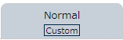
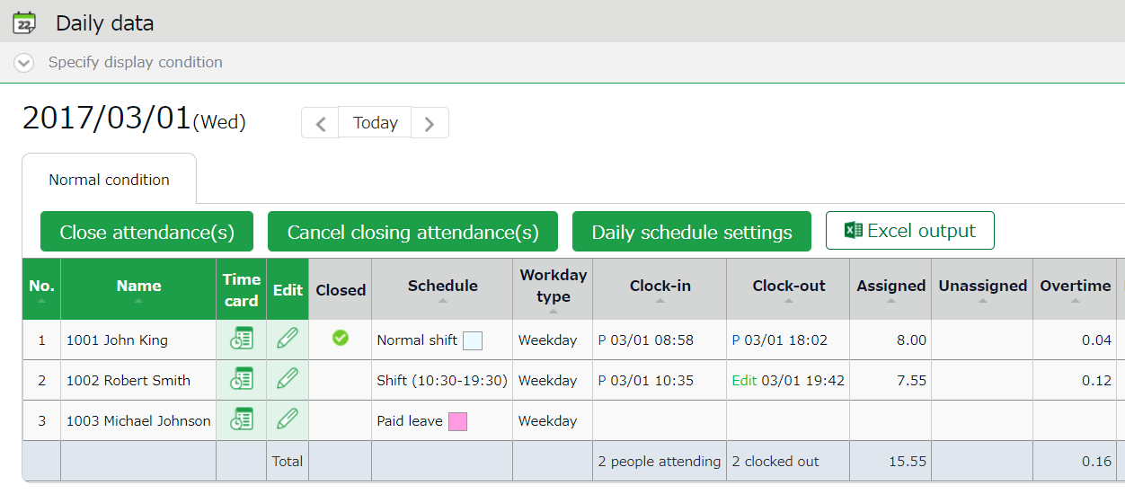
2ｚ
3
4

No. | Buttons | Description
1 | Tabs | Selecting a tab switches the display items.  Normal Condition  Displays default attendance data items.  Normal [Custom]  Displays attendance items set in the custom data item settings.
2 | 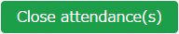  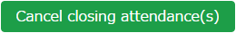 | Closes or uncloses attendance data (p.135).  * Only available to administrators with closing privileges.
 | 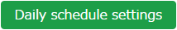 | You can check and edit schedules of the selected day by divisions (p.145).  * Only available if one division is selected.  * Only available to administrators with schedule management privileges.
3 |  | Monthly data can be downloaded in Excel format.  * Only available to administrators with data export privileges.
4 | (Time Card) | Shows the Time Card screen (p.120).
 | (Edit) | Edits attendance data (p.124).

Check monthly data
Shows monthly data such as the number of days/hours of work and leave.

[Where to look] All menu > Attendance data > Monthly data

Descriptions
Specify the display condition

Select a division, employee type or display period.
Click [Show] to view data.

Displaying period
Monthly - Shows work data by month.
Weekly - Shows work data by week.
Daily - Shows data that correspond to the specified period (up to 3 months).

Options:
Display by employee work location - Show data of employees who worked in a Division.
Classify holidays as Legal and Non-legal holidays - You can check holiday work hours according to workday type.

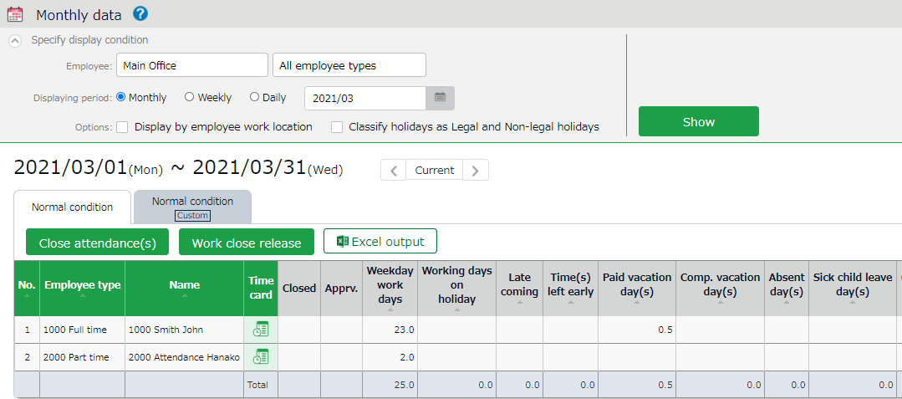

Shows data such as the number of working days/hours and leaves taken.

[Cl.(Close)] - Indicates closing status (p.135).
In the Monthly data screen, the mark is shown only if all days within the period have been closed.

Monthly data

Operations
You can perform the following tasks in the Monthly data screen.

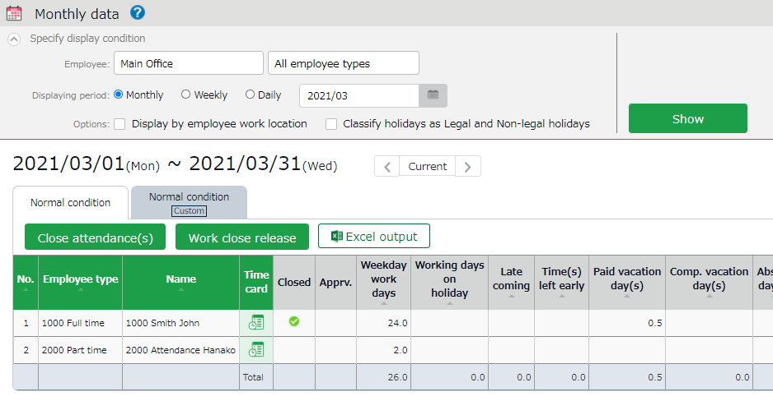
1ｚ
4
3
2ｚ

No. | Buttons | Description
1 | Tabs | Selecting a tab switches the display items.  Normal Condition  Displays default attendance data items.  Normal [Custom]  Displays attendance items set in the custom data item settings.
2 |  | Closes or uncloses attendance data (p.135).  * Only available to administrators with closing privileges.
3 |  | Monthly data can be downloaded in Excel format.  * Only available to administrators with data export privileges.
4 | (Time Card) | Shows the Time Card screen (p.120).

Check Your Time Card
The Time Card screen shows daily or monthly attendance data of each employee.

[Where to look] All menu > Attendance data > Monthly data > Time Card button
* The Time Card button is also available in the Daily data and Schedule management screens.

Descriptions

Select a month and click [Show] to view data.
Options
Gather time-record: Arrange time record data to a single cell.
Weekly summary: Displays overtime hours after applying statutory working hours per week.
Display by employee work location: Displays location information recorded when clocking in/out.
Classify holidays as Legal and Non-legal holidays: You can check holiday work hours according to workday type.
Specify the display condition

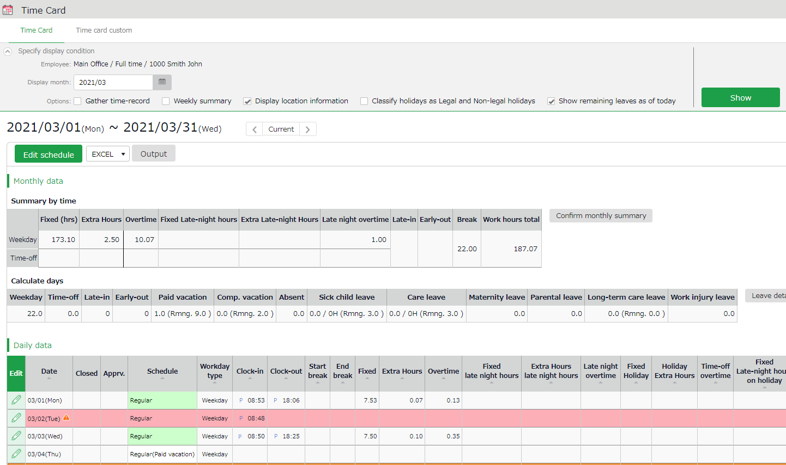

Shows data such as the number of working days/hours and leaves taken.
Monthly data

Check time record, schedules and attendance calculations.
The mark next to a date indicates Attendance error that need resolving. They are highlighted in light red.
Daily data

Operations
You can Perform the following tasks in the Time Card screen.
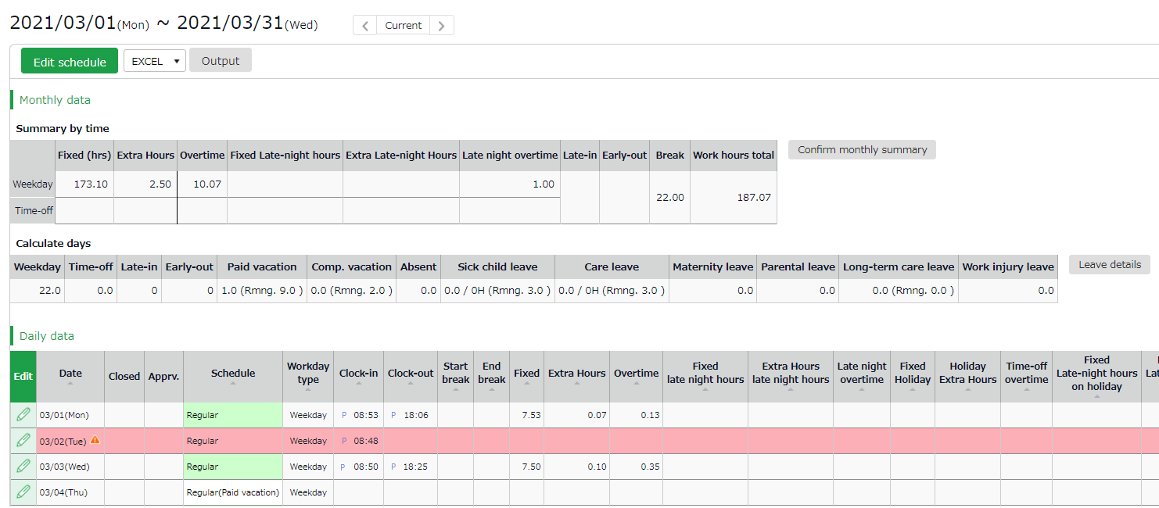
2
1ｚ

3

4

5

No. | Buttons | Description
1 | 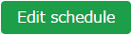 | You can bulk-edit a month’s schedule (p.143).  * Only available to administrators with [Schedule settings: Request] or higher privileges.
2 | 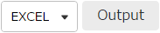 | You can download Time Card data in Excel format.
3 | 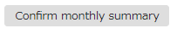 | You can check the value of each item added up for each day, before rounding and before adding bonus wage overtime.  * Only available to administrators with Master Admin privileges.
4 |  | Shows Leave details (p.152).
5 | (Edit) | Edits attendance data (p.124).

Check Yearly Data
This screen shows up to 12 months' data. It provides the summary of days/hours worked and leaves taken.

[Where to look] All menu > Attendance data > Yearly data
* Before viewing Yearly Data, you need to press the [Show] button on the Monthly Data screen for every month.
The results on the Monthly Data screen directly affects the info on Yearly Data screen.

Descriptions
Specify the display condition

Select a division, employee type or specify the display period (up to 12 months).

Click [Select] to select attendance data items.
Select items as needed.

Click [Show] to view data.

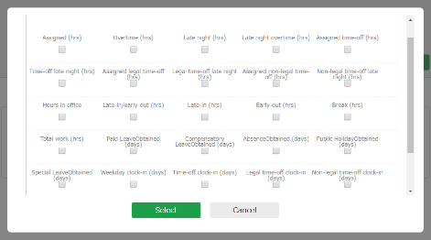

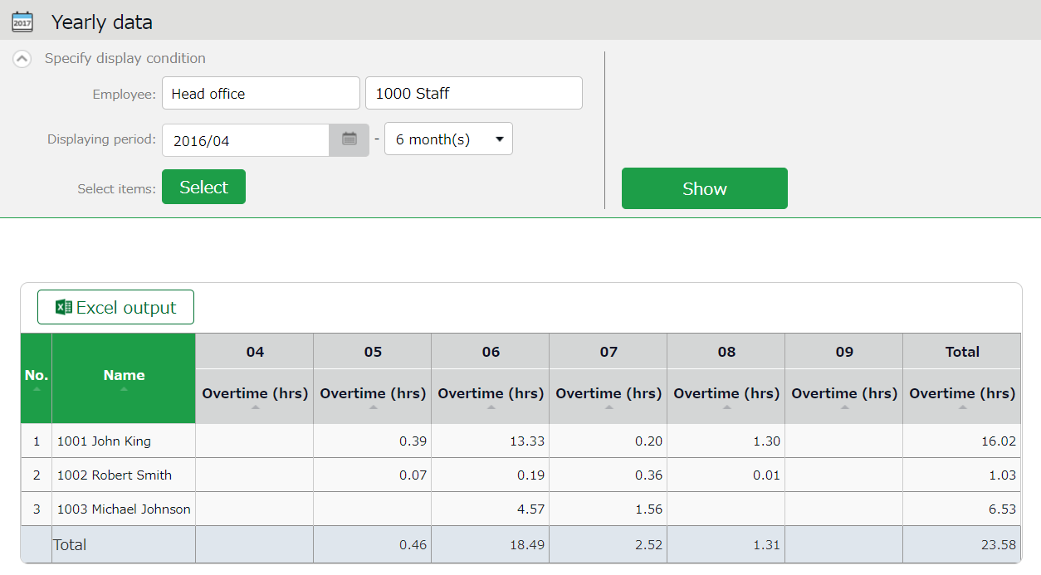

Shows the summary of the specified month.
Yearly data

Operations
You can download Yearly data in Excel format.

Confirm data by divisions and employee types
This screen shows monthly data calculated by divisions and employee types.

[Where to look] All menu > Attendance data > Data by divisions and groups

Descriptions
Specify the display condition

Select a division, employee type or display period.
Click [Show] to view data.

Summerize attendance data by
Select a calculation unit, such as a division, employee type, etc. You can select multiple options.

Options:
Display by employee work location - Show data of employees who worked in a Division.
Classify holidays as Legal and Non-legal holidays - You can check holiday work hours according to workday type.

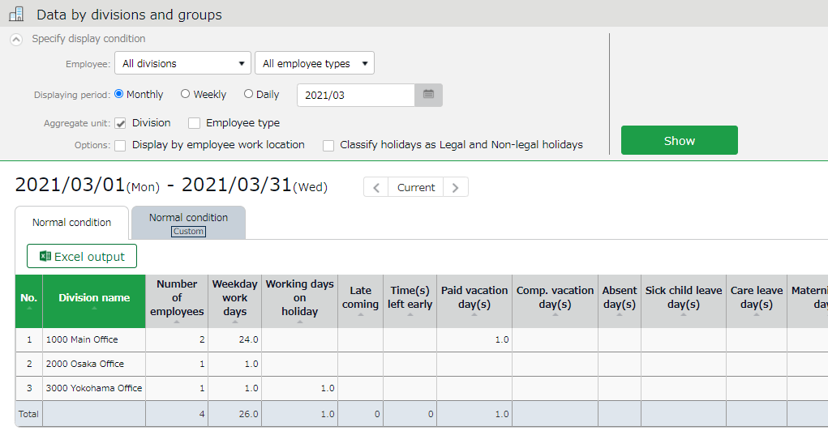

Data by divisions and groups

Shows data such as the number of days/hours of work and leave. The data is displayed by divisions or employee types.

Operations
Downloads data by organizations (divisions, employee types) in Excel format.

Edit attendance data
You can correct errors caused by missing time records and schedule errors.

To edit attendance data
This section describes the Time record and Schedule screens in edit mode.

[Where to look] All menu > Attendance data > Daily data > [Edit] button
* The Time Card button is also available in the Time Card screen.

Descriptions
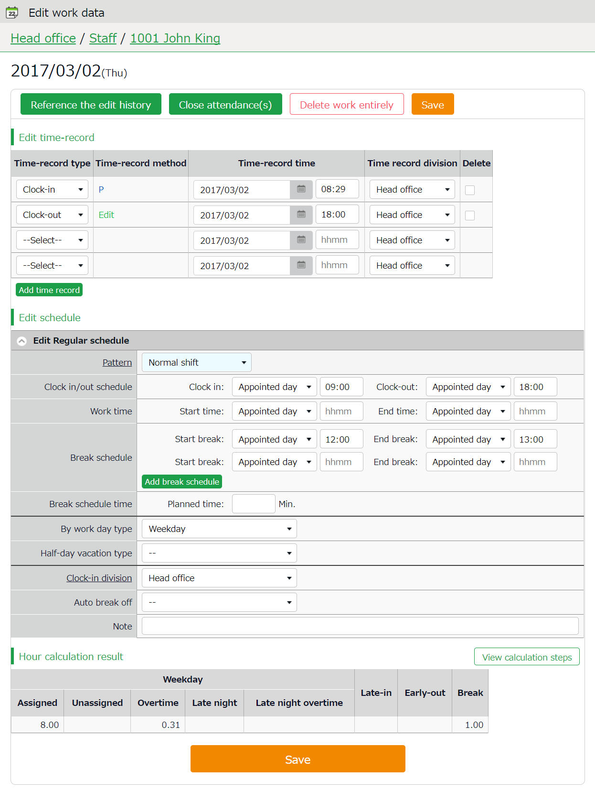
Hour calculation result

Shows daily summary. Press the [View calculation steps] button to confirm the calculation process.

Saves changes.
Save
Edit time record
Edit schedule

Edits time record data.

Edit time record data.

Edit time record
Edit time record data.
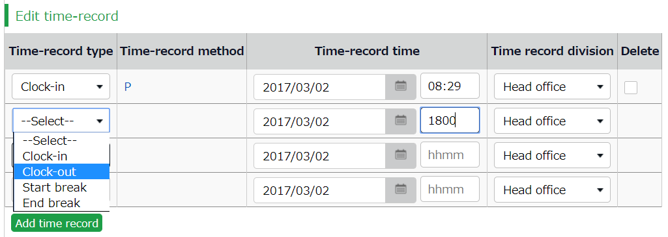

Time-record type | Select a time record such as Clock in, Clock out, Start break and End break.
Time record method | Time-record method is displayed automatically.
Time record | Shows time record. To edit, enter the time in the field.  Enter in [hh:mm] or [hhmm] format.
Time record division | The Division Time Recorder being used is applied automatically.
Delete | Turn on the check to delete time record data.
Add time record | Press this button to add a new time record field.

You can use the following time record method.

HB | Hybrid finger scanner or the BT series
Vein | Finger vein scanner
Finger | Fingerprint scanner
IC | IC card reader, Pit Touch Pro, BT-2000
Face | Face authentication recorder
CC | Chameleon code recorder
P | Password authentication
C | Click authentication (No password required)
Mobile | Time record using smart phones and mobile phones
Location | Time record with location info
A | Time record by External system through Web API service
LW | Time record by LINE WORKS
AK | Time record by Akerun
SL | Time record by Secure Login
PC | Time record through SmartOn ID and Lanscope Cat integration
Edit | Indicates edited time record
Approve | Indicates edited time record approved by the administrator

Edit schedule
If you select a [Pattern], the scheduled time in Pattern settings are applied.
You can enter items directly as well.
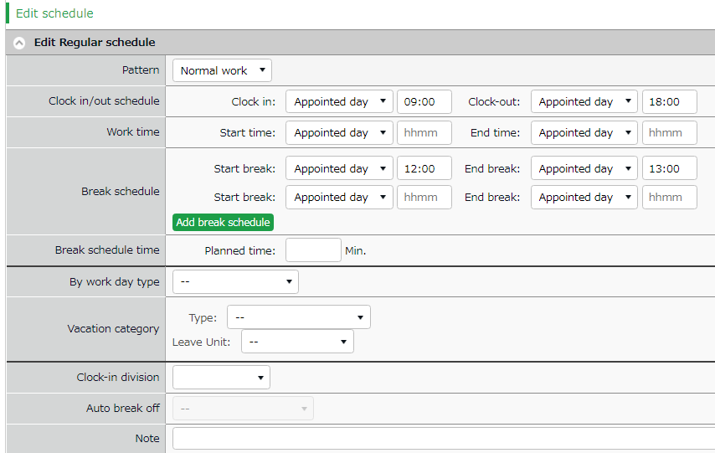

Patterns | Select a pattern. To create patterns, please refer to [Pattern settings (p.65)].
Clock-in/out schedule | Set a clock-out schedule.
Work time | Specifies the time to run attendance calculations.  Any work before scheduled clock-in time and after clock-out time will not be included in the calculation.
Break schedule | The time between [Start break] and [End break] are regarded as break time.
Break schedule (hrs) | Calculates the entered amount of time as break time.  You cannot specify a timeslot for break time.
Workday type | Determines whether the work took place during holiday or not. If none is specified, workday type is set to [Weekday].  If you choose [Non-legal time off] or [Legal time off], work time during that day will be added up to [Legal time-off work days], [Assigned time-off (hrs)], [Unassigned time-off (hrs)], [Assigned Late-night hours on holiday], and [Unassigned Late-night hours on holiday].
Vacation category | When taking leave, select the type of leave (e.g., Annual leave, comp leave etc.) and its unit (e.g., full-day leave, AM leave, PM leave, etc.).
Clock-in division | Shows where the employee clocked in.  The name of the last used Division Time Recorder is automatically applied.
Auto break off | This will disable the Auto-break feature and break time setting by schedule.
Note | Enter comments or notes in 250 characters or less if needed.

Operations
Descriptions for the buttons in Attendance data edit screen are provided below.
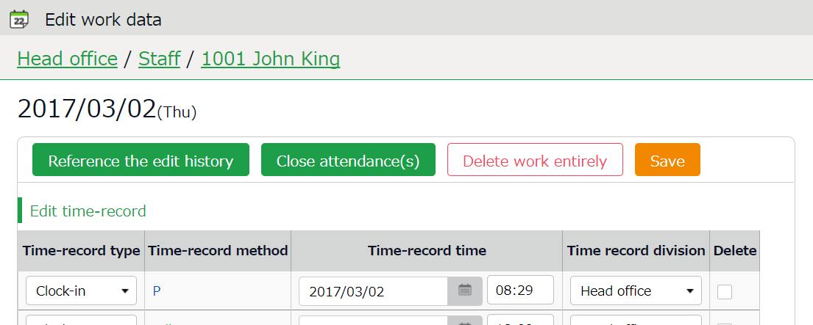

2
1ｚ

No. | Buttons | Description
1 | 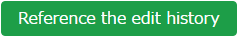 | Shows attendance data edit log.  * Available in edited attendance data screens.
Closes the attendance data (p.135).
* Only available to administrators with closing privileges.
 | 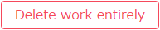 | Deletes all attendance data of the day.  However, change logs will remain.
2 | 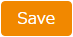 | Saves changes. To return to the previous screen after saving,  click [Return] in the top of the screen.

Check attendance data errors
Errors in attendance data are caused by missing time records and lack of remaining leaves, etc.

The [Attention required] []mark in the home page indicates that there are one or more errors in the attendance data.
By clicking these items, the corresponding attendance data error screens are displayed.
You can also access from [All menu > Attendance data error].)

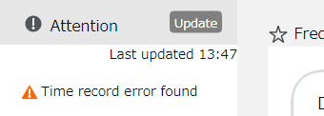

Switch tabs

The screen shows the list of the type of Attendance data error you selected on the Home screen. You can also view data under different error types by switching tabs.

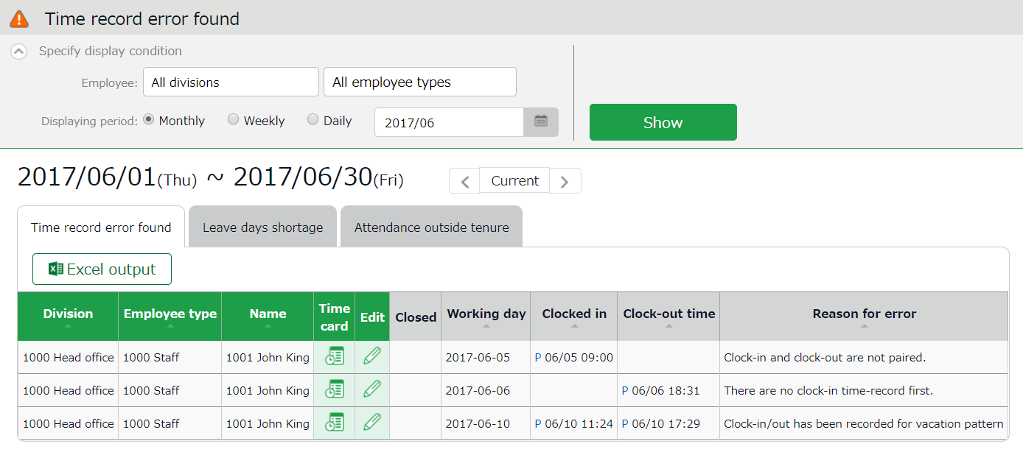

Time Card | Shows the Time Card screen.
Edit | Edits attendance data.

Buttons

To correct errors
This section describes the steps to correct errors in attendance data.

Attendance data error
The causes and solutions for common errors are described below. Time record or schedules need to be corrected.

Cause of error | To correct errors
Clock-in time-record is consecutively recorded. | There is an inconsistency in the time record.  Correct any errors in the attendance data by editing or submitting change requests.
Clock-in and clock-out are not paired.
No clock-in time record has been made first.
Clock-in/out record exists in a holiday/leave day schedule pattern. | The system detects error if time record exists on the day a holiday/leave schedule pattern is applied.  By changing the day’s schedule pattern from holiday/leave pattern to a work day pattern, the system can run the calculations correctly.

Shortage of leave days
More than remaining number of leaves have been taken.
Please adjust the number of remaining leaves in the Leave management screen (p.147).
The following setting may prevent users from taking more leaves than they have left, and thus prevent leave errors.

Allow negative number
Check the [Disable leave when it reaches zero] check box at [Home > Settings > Schedule > Leave type settings > Edit > Allow negative number].
Tips: Attention column in the home screen
Attendance error: Indicates there are one or more errors within the past 2 months of attendance data.
Attendance outside tenure: Indicates that attendance record exists outside of working years (tenure), within three months before the present time.

Check attendance outside working years
[Attendance outside tenure] are time records and schedule data that exist outside of working years(tenure), within three months before the present time.

If there are any attendance record outside of an employee's working year (tenure),
[ Attendance outside tenure] mark will show in [Attention required]. From here, you can check the [Attendance outside tenure] tab in the Attendance error screen.
You can also access from [All menu > Confirmation > Attendance data error > Attendance outside tenure tab].)
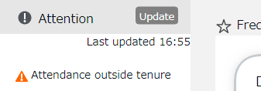

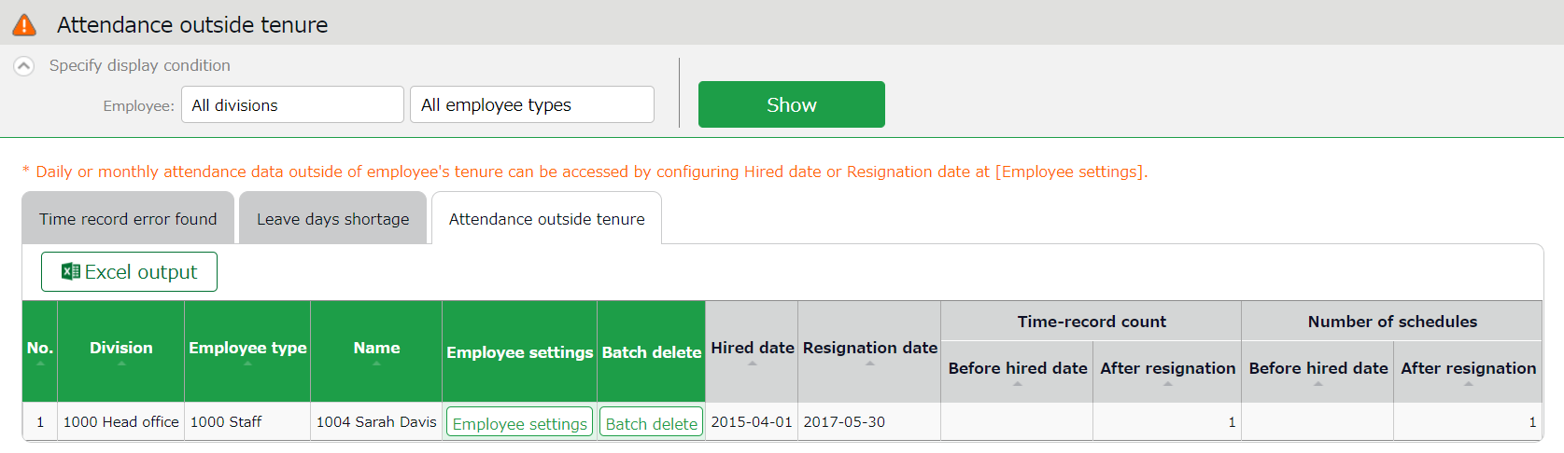

Shows the following data before hired date/after resignation date.
- Number of days with time record
- Number of days with schedule
Time-record count/
Number of schedules

Employee settings | Shows the Employee settings screen.
Batch delete | Deletes all data before hired date/after resignation date completely.

Buttons

To correct errors
You can correct an [Attendances outside of tenure] error by using any of the following methods.

Confirm details and correct resignation date or attendance data
- From the [Attendance outside tenure] screen, click [Employee settings] to edit the employee’s data.
Press the [detail] button under the Employment info category. To correct the employee’s resignation (or hired) date, delete the existing dates first and then re-enter.
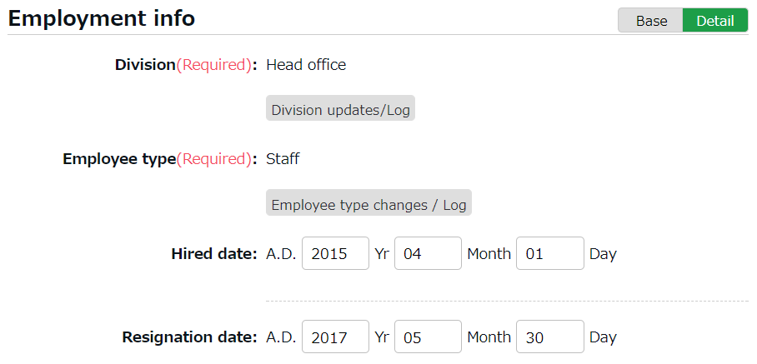

- Go to [All menu > Attendance data > Monthly data], then press the [Time Card] button of the employee.
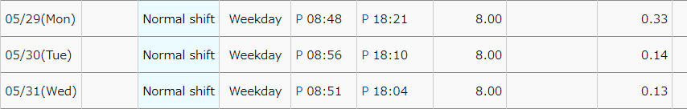
By deleting the resignation (or hired) date in the previous step, attendance data after the resignation date (or before the hired date) are shown. Check the details.

- If the resignation date is incorrect, return to the Employee settings screen and enter the correct date.
If the attendance data is mistaken, delete the data and re-enter the employee’s resignation date.

Delete all attendance data outside working years
To delete all attendance data after resignation and before hired date, click [Bulk delete] in the Attendance outside tenure screen. Confirm deletion to delete all attendance data before hired date and after resignation date.
This operation will not affect other employee data nor other attendance data within the period.

If there are any attendances recorded by mistake, please delete attendance and schedule data outside tenure (changes are recorded as change log).

Close attendance data
You can lock attendance data by closing it.
This prevents employees and administrators from making further changes. Only Master Admins can edit closed attendance data.
Locking the attendance data prevents attendance data from being modified after payroll calculations, etc.

To close attendance data

[Where to look]
You can close attendance data by either of the 3 screens described below.
- All menu > Attendance data > Daily data
- All menu > Attendance data > Monthly data
- Daily data or Time Card > Edit attendance data

Press the [Close attendance] button in the screen. The process is complete when the confirmation screen is shown. You cannot close the attendance data if there are any data errors in the specified period.

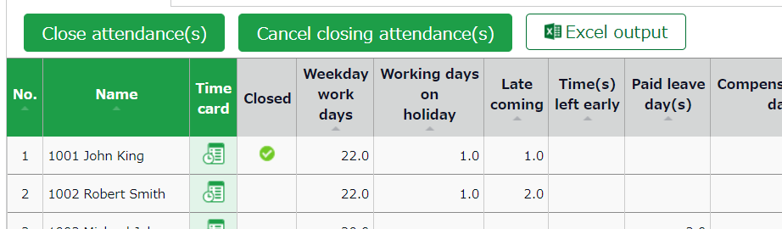

The mark in the [Closed] column (Daily data and Time Card screens) indicates that attendance is closed.
In the Monthly data screen, the mark shows only if all days within the period are closed.

Who can close attendance data?
Master admins and General admins with closing privileges can close attendances.

The [Close attendance] and [Cancel closing attendance] buttons are available only if you sign in as an administrator with closing privileges.
You can assign the privilege by creating an Admin account in the Admin settings screen.

Check closing status
You can check closing status from the Closing status screen.

[Where to look] All menu > Confirm > Closing status

You can also send Email notifications on attendance closing/confirmation status. Please refer to p. 85 for details.

Descriptions

Check the checkbox to include employees before their first day in the office (hired date).
Include employees before hired date
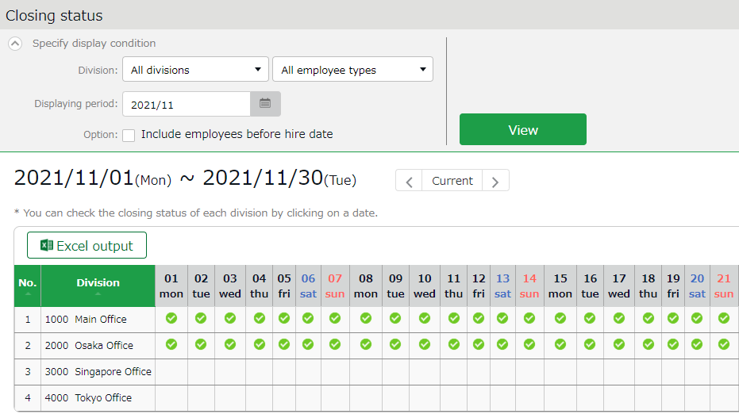

Closing status

You can check daily closing status by divisions.
The mark indicates that attendance data of all employees in the division are closed.

You can check closing status (whether attendances are settled or unlocked) in a pop-up window, by clicking on a date.

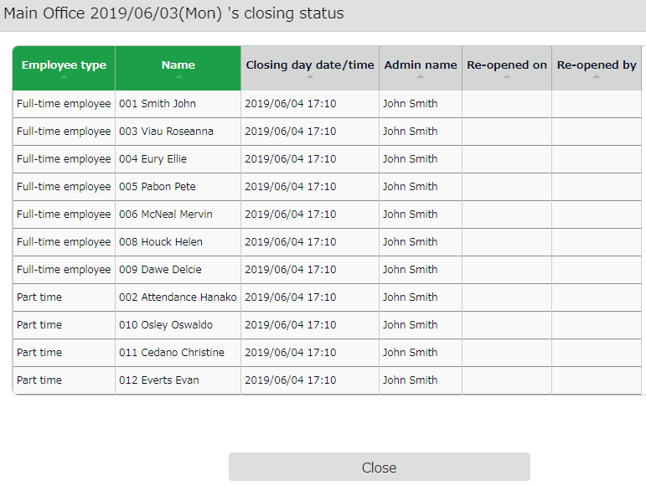

Approve requests
You can receive attendance data/schedule edit requests from employees and other administrators through the Request approval feature.

Check requests
Check request progresses in the Request approval screen.
[Where to look] All menu > Confirm > Request approval

Descriptions
Specify the display condition

Select a division, employee type or display period.
Click [Show] to view data.

You can search request messages by entering keywords, for example, “private matter” and “attend wedding”.
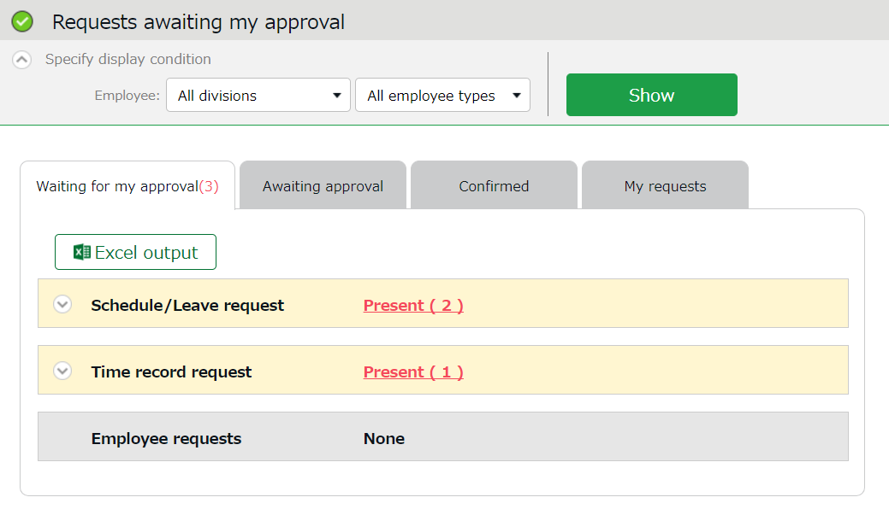

Request info are arranged in 4 tabs, each representing the request approval process.
Tab name | Description
Waiting for my approval | Shows the requests that need your approval.
Awaiting approval | Shows any requests that include you in its Approval flow.  - Requests that require confirmation by a higher approver after your approval  - Requests that require your approval after the lower approver’s
Confirmed | Confirmed requests that include you in the approval flow. Requests are regarded as confirmed when it is approved or rejected by you or the final approver.
My requests | This area shows the progress of requests which you, an administrator, have submitted on behalf of employees.  Administrators with [View / Request] privileges (Admin settings screen) can submit requests on behalf of employees.

Request approval menu

Approve requests
- Any requests that require your approval are shown in [Attention required], in the home screen. They are shown as [Schedule /Leave request] and [打刻Time record request].
Click the items to show requests that need your approval.
You can also access from [All menu > Confirm > Request approval]

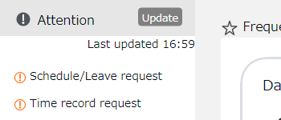

Set the display condition and click [Show]. Click [Present] to show details. You can approve or reject the request from here.
Operation details

From here, you can either [Approve] or [Reject] requests (actions here are processed instantly).
If either of [Request message] or [Admin’s comment] under [Copy data into time card] is checked when the final approver operates, either of the comments are copied to the [Notes] field in the employee's Time Card.

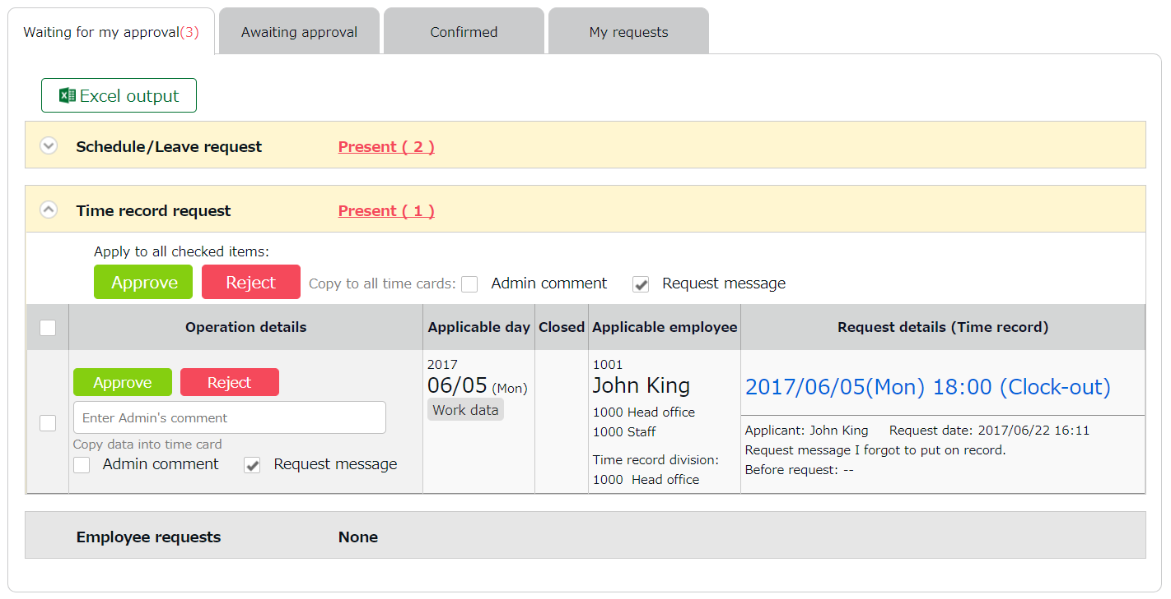

Check for attendance data details.
Attendance data
Approve all requests that are checked.
- An email notification is sent to the administrator when submitting a request. When a request is approved or rejected, employees are notified by email.
- Administrators and employees must set Email addresses to their accounts, to receive notifications by Email.

Manage schedules
This section describes the Schedule management feature.

Set schedules
You can create schedules by any of the four methods listed below.

Apply schedules automatically
If you have already performed [Basic schedule settings], schedules are automatically set.

Submit schedule requests
Employees can submit schedule change requests through their Time Cards.
This feature is useful to take leaves and submit shift change requests.

Set schedules
You can set schedules manually through the admin screen. The instructions are in the following pages.

Import schedules
You can also set schedules by CSV file import in [All menu > Export / Import > Input data (Import) > Schedule data CSV].

Set schedules
Set or confirm schedules from the Schedule management screen.

[Where to look] All menu > Schedule > Schedule management

Descriptions

Select a division, employee type or display period.
Click [Show] to view data.

Displaying period
Monthly - Confirm schedule data by month.
Weekly - Confirm schedule data by week.
Daily - Confirm schedule data that correspond to the specified period (up to 3 months).

Options:
Do not shorten pattern name - Names of schedule patterns are not abbreviated when displayed.

Specify the display condition

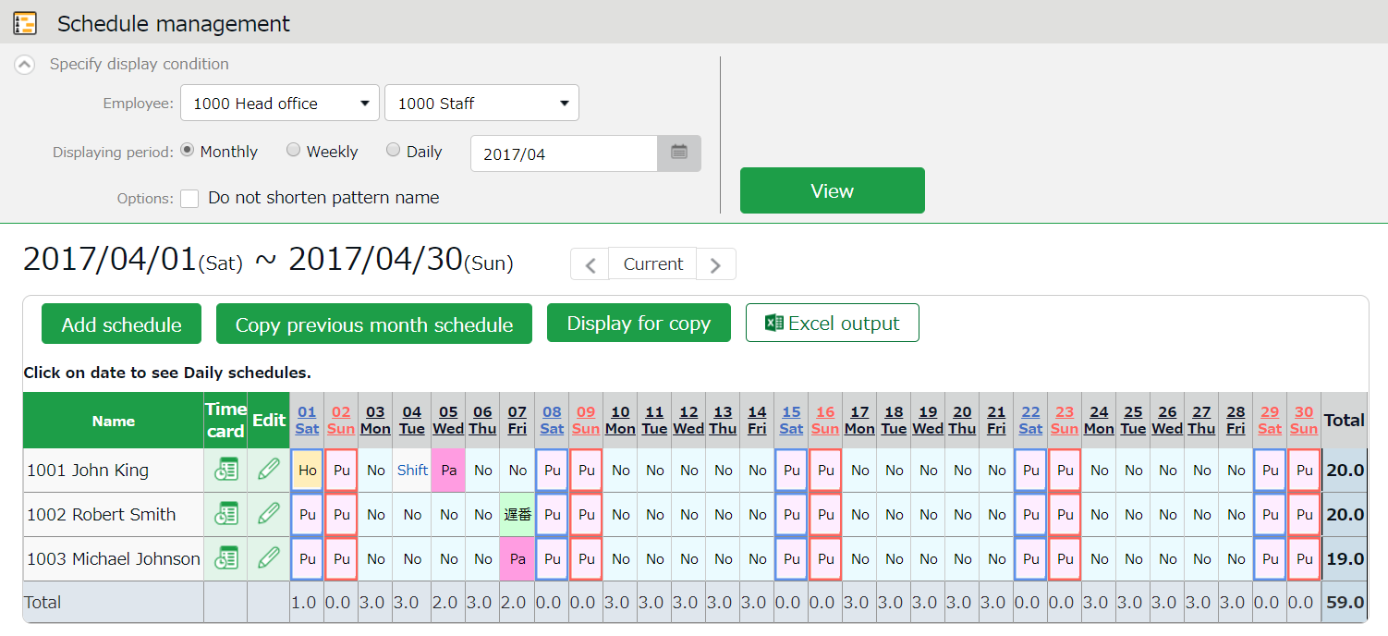

Schedules

Shows existing schedules.
[Shift] indicates a schedule that does not belong to any pattern.
Work day types are indicated in different colored lines:
Legal time off - Red
Non-legal time off - Blue
The [Total] on the last row indicates the total number of attending employees, based on the schedule.

Operations
You can perform the following tasks in the Schedule management screen.

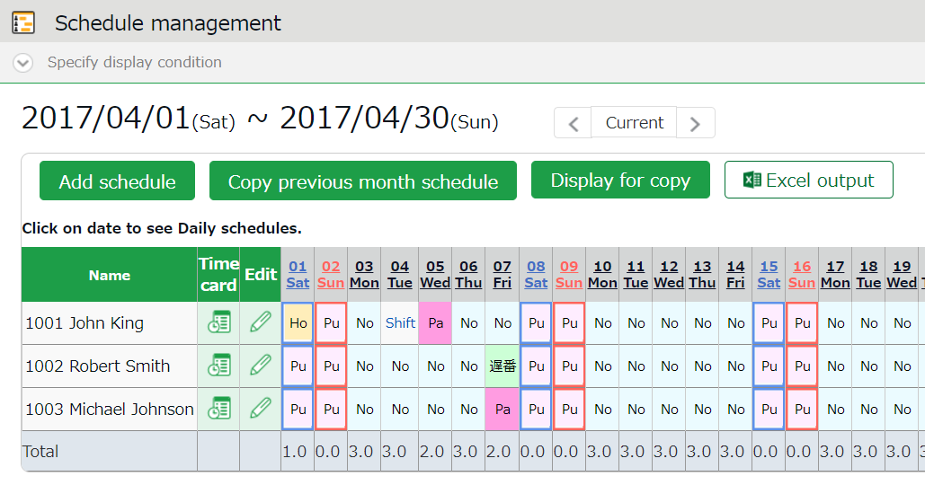

4
3
1ｚ
2
No. | Buttons | Description
1 |  | Bulk-registers schedules by divisions (see following pages).  * Only available if one division is selected.
 | 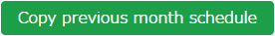 | Copies schedules of the previous month. The same schedules may be used repeatedly.  * Only available if one division is selected.
 | 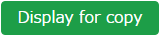 | Shows the page for printing out.  * To print in color from Google Chrome, go to [Chrome menu > Print > Page Setup > Print Background Colors and Images] and check the check box.
2 |  | You can download data on the schedule management screen in Excel format.
3 | (Time Card) | Shows the Time Card screen (p.120).
 | (Edit) | Shows the Monthly schedule edit screen (p.144).  Sets schedules for each employee.
4 | (Date) | Available only when you select one division. Daily schedule edit screen (p.145) is shown by clicking on the date.  You can edit schedules of the selected day by divisions.

Set schedules
This section describes the steps to create a work shift table by divisions.

- Go to the Schedule management screen, then select one division.
Press the [Add schedule] button displayed on the screen.

- The schedule set to [Original schedule] is applied to the checked day's attendance data.
Repeat this step to complete the month’s work shift table.
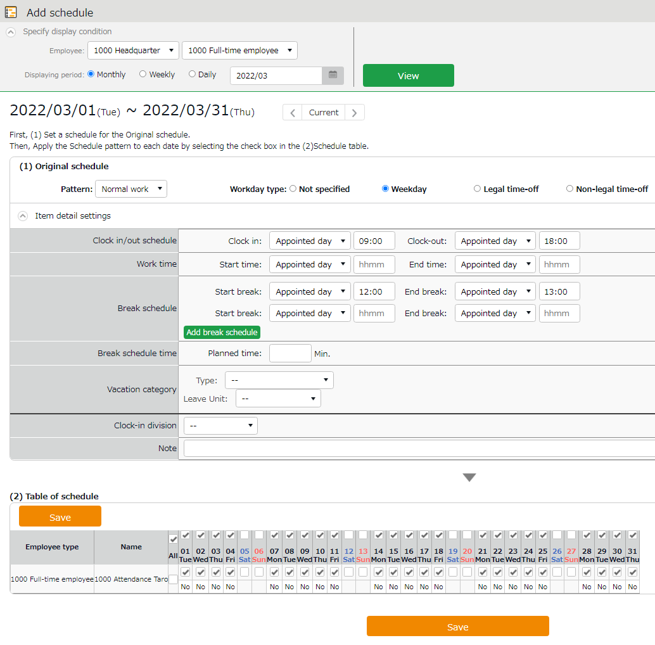
Original schedule

Enter schedule. To apply pre-configured time schedule, select a pattern.
You can also enter the items manually by clicking [Item detail settings].

Apply

The list of employees and applying dates are shown.
The schedule set to [Original schedule] is applied to the checked day.
If you check [All], the schedule settings are applied to all employees and dates below.
Target

- Click [Save] to save the schedules.

Set schedules to each employee
This section describes the steps to set schedules for each employee.

- Press the [Edit] button in the Schedule management screen.
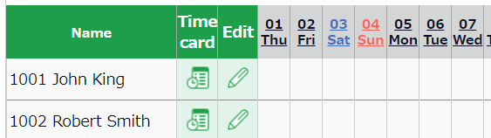

- The Monthly schedule screen is shown. The schedule set to [Original schedule] is applied to the checked day's attendance data.

Enter schedule. To apply pre-configured time schedule, select a pattern.
You can also enter the items manually by clicking [Item detail settings].
Original schedule
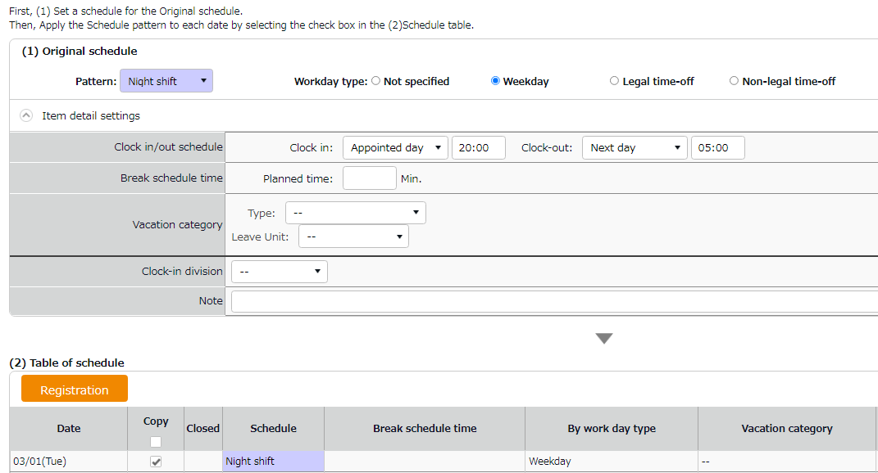

Apply

The list of applying dates are shown.
By putting a check, the schedules set above are applied to the selected day.
Target

- Click [Save] to save the schedules.

Set daily schedule
When setting up a schedule, you can check the number of attendants in the time slot and division.

- Go to the Schedule management screen, then select one division.
Click on a date.
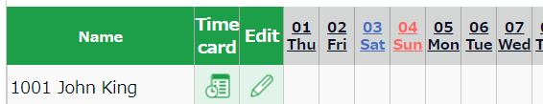

- The Daily schedule screen is shown.

Set a division, employee type or date. Click [Show] to view data.

Displaying period
Other than the day selected (24 hours), it can show schedules of the previous/following day, or schedules for both previous and following days (72 hours).

Options:
Include time-record - Show actual time record as well.
Shift only - Show schedules only.
Do not shorten pattern name - Shows non-abbreviated schedule pattern names.
Clock-in order display - Sorts schedule by clock-in schedule ascending order.
Display by employee work location - Show data of employees who worked in a Division.
Specify the display condition

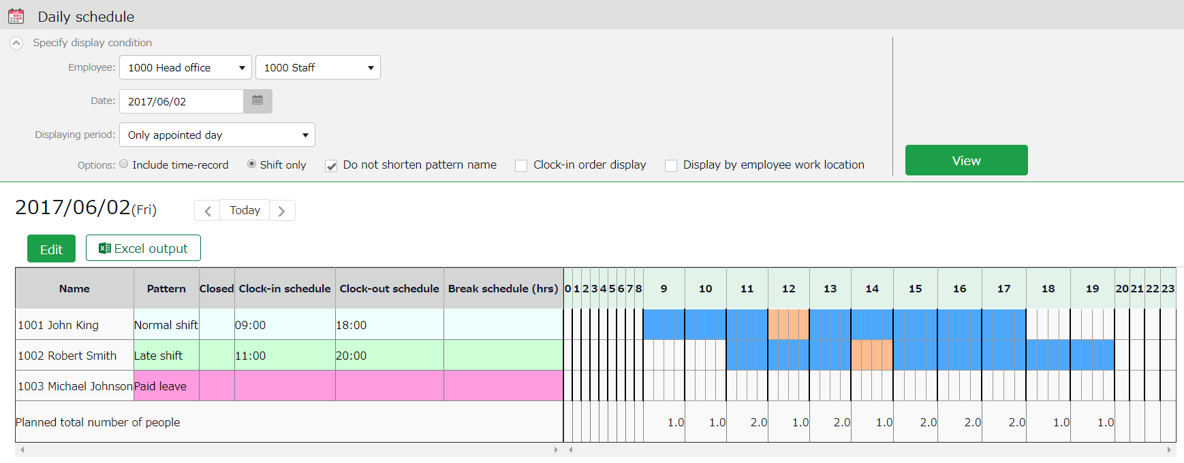

Visualizes schedules and actual time record.

The [Total] on the last row shows the total number of employees attending in each time slot.

Schedule
Blue - Scheduled working hours
Orange - Break time
Daily schedule
Actual working hours
(Shown when [Include time-record] is selected in the display condition)
Black - Working hours (Actual time record)
Red - Break time (Actual time record)

Edit Schedule
Edit

- Press the [Edit] button to edit schedule. You can edit Schedules at the [Add daily schedule] screen.
Edit your schedule.
Either select a pattern or enter clock-in/out schedule.
Click [Detail] to open the [Break time settings] window. Enter the break time schedule.

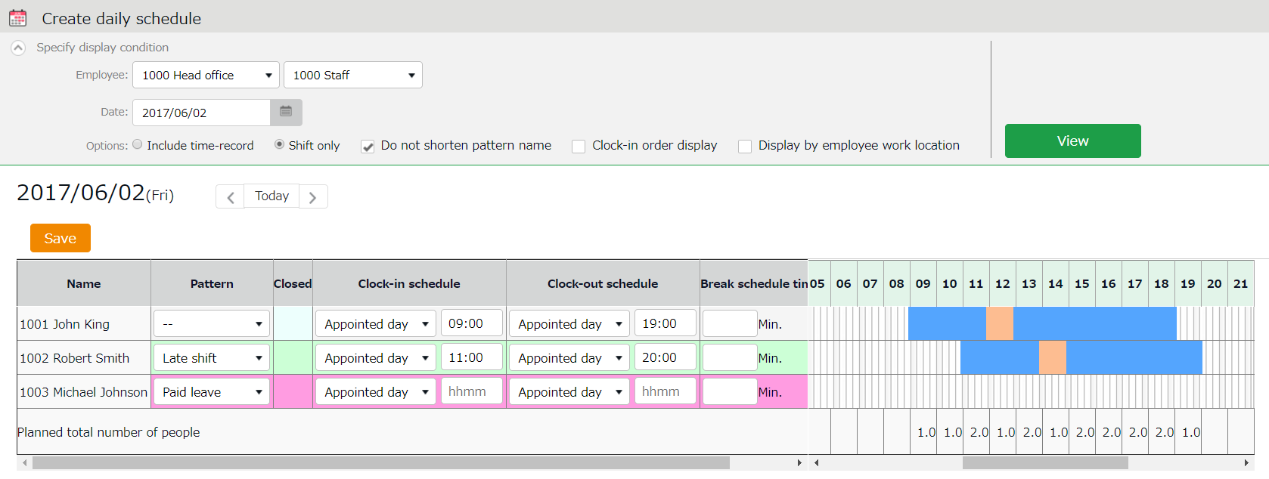
You can also extend/shorten the time by grabbing it with your mouse cursor.

- Click [Save] to save the schedules.
To return to the previous screen, press the [Return] button in the top of the screen.

Manage leaves
This section describes the Leave management feature.

Take leave
In the Schedule management screen, set a pattern or half-day leave type accordingly.
[All menu > Schedule > Schedule management]

Check the number of leaves taken/remaining
You can check the number of leaves taken/remaining in the Leave management screen.

[Where to look] All menu > Schedule > Leave management

Descriptions
You can switch contents from [Leave type] .

If [All leaves] is set
[All vacations] in [Leave type] shows the number of remaining or taken leaves.

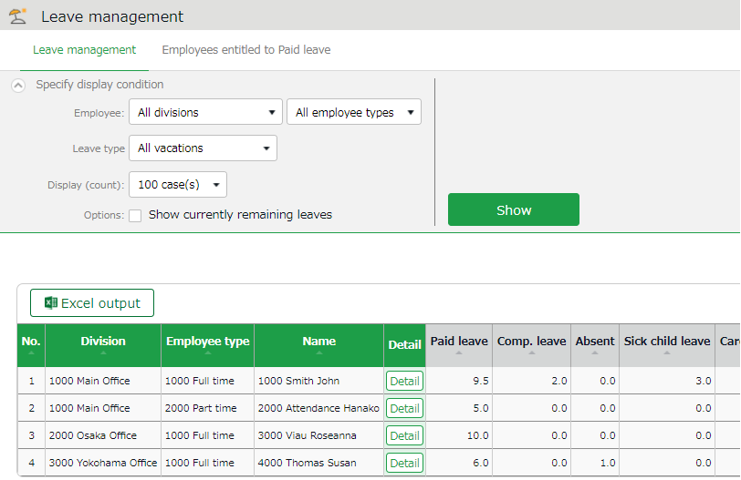

If the leave is a [Subtract] type (the leaves taken are subtracted from the remaining leaves), number of currently remaining leaves are shown.
Remaining leaves
Select [All vacations]

If the leave type is an [Add] type, the total number of leaves taken this fiscal year are shown.

Leaves taken

About Subtract and Add leave types
Settings > Schedule > Pattern settings
Shows the setting status of [Calculation method of leaves when obtained] (p.54).

Filter data by leave type
To filter data, select a [Leave type] under [Specify display condition].
You can check the number of leaves taken, remaining, and expired during the fiscal year (if it is an “Add” type, leave it only shows the number of taken leaves).

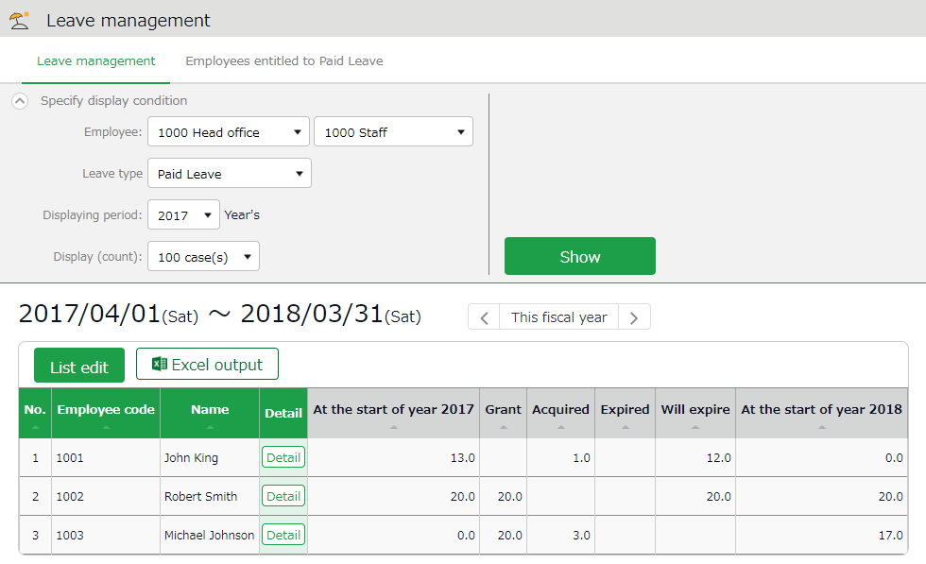
Leave data

Check the total number of leaves taken/remaining from here. The items are described below.
Select a leave type

At the start of year | Shows the number of remaining leaves at the start of the year.  This does not include leaves granted at the start of the year.
Grant | Shows the number of leaves taken this year.
Acquired | Shows the number of leaves taken this year.  * For “Add” type leaves, this is the only info provided.
Utilized Ratio | This shows the percentage of leaves (rounded off to the nearest whole number) taken during the specified period.  It does not count carry-overs from the previous year.
Expired | Shows the leaves that are expiring/has expired during this period.  Data collection period depends on the fiscal year being displayed.  - If past year’s data is displayed - Data are collected from the beginning of the year until the end of the year.  - If this year’s data is displayed - Data are collected from the beginning of this year until now.
Will expire | Shows the leaves that expired during this period.  Data collection period depends on the fiscal year being displayed.  - If this fiscal year’s data is displayed - Data are collected from now until the end of this fiscal year.  - If future year is displayed - Data are collected from the beginning of the year until the end of the year.
(Next year) Start of year | Shows the number of remaining leaves at the start of the year. This does not include leaves granted at the start of the year.

Operations
You can perform the following tasks in the Leave management screen.

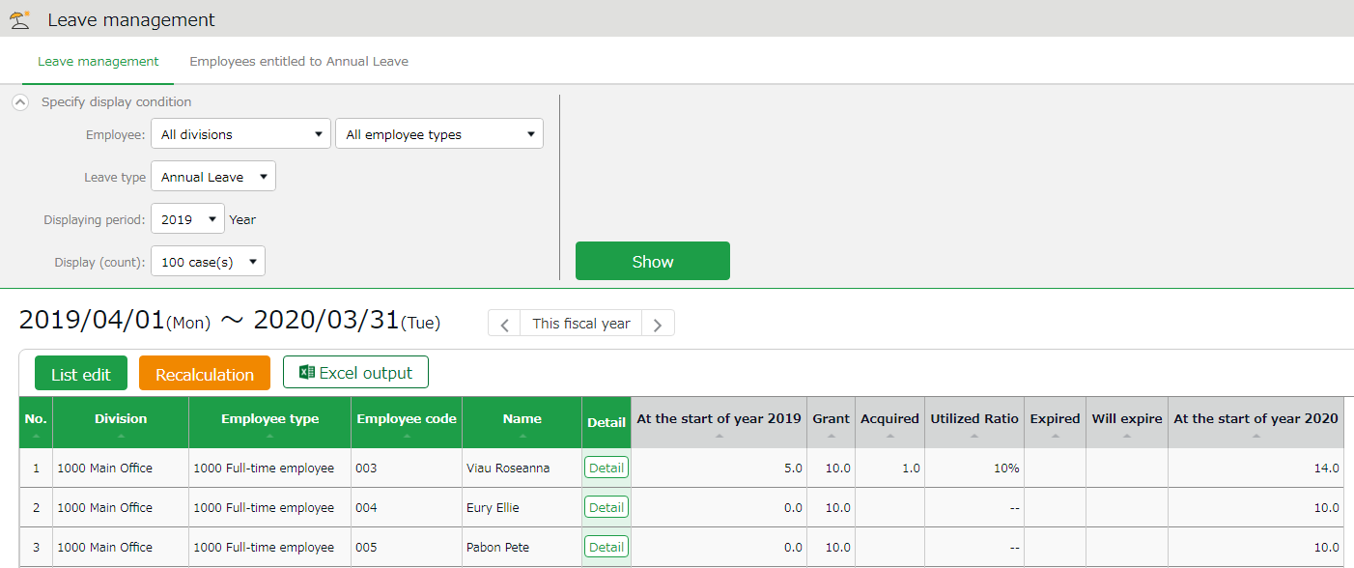
4
1ｚ
2
3

No. | Buttons | Description
1 | 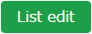 | Grants leaves to multiple employees at once (p.154).  * Available when a “Subtract” leave type is set to the display condition.
2 | 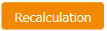 | This button shows when Leave Type is specified in the Display Condition settings. It recalculates leave data.
3 |  | The Leave management screen can be downloaded in Excel format.
4 |  | Confirm leave grant/obtained date of each employee.  You can also grant leaves here. Please refer to the following pages for details.

Grant leaves to each employee
The screen below shows the details of the leave for each employee.
[Where to look] All menu > Schedule > Leave management > Employee [Detail] screen

Descriptions
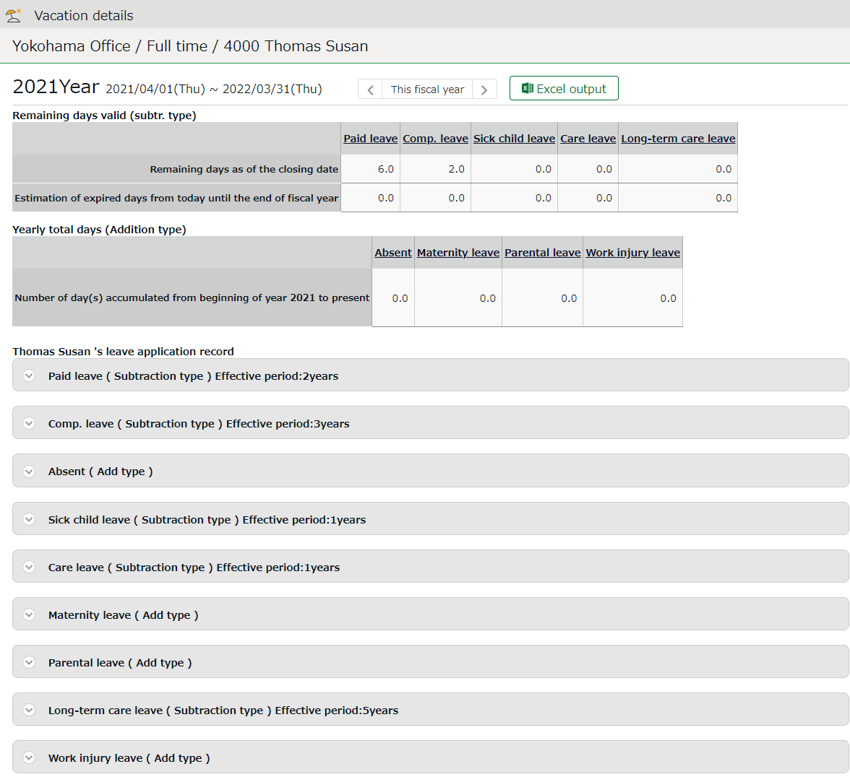

Shows the number of leaves remaining as of the closing date and leaves that are expiring from this day until the end of the fiscal year.
Remaining days valid (subtr. type)

Yearly total days (Addition type)

Shows the total leaves taken this year.

Click here to show when the leaves were granted or taken.
You can also grant leaves from here.
Shows the number of leaves remaining as of the closing date and leaves that are expiring from this day until the end of the fiscal year.
Leave application record

Grant leaves
- Go to the Vacation details screen for leave details.
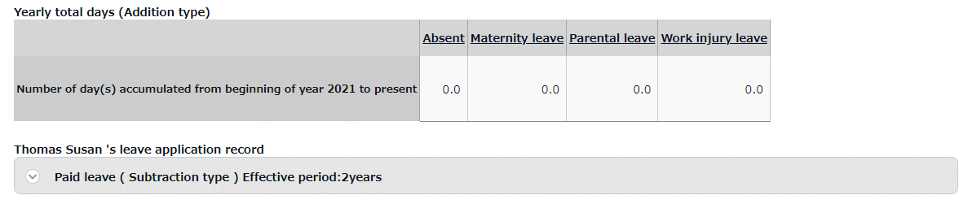

- Enter [Grant date] and [Grant days]. Click [Save].
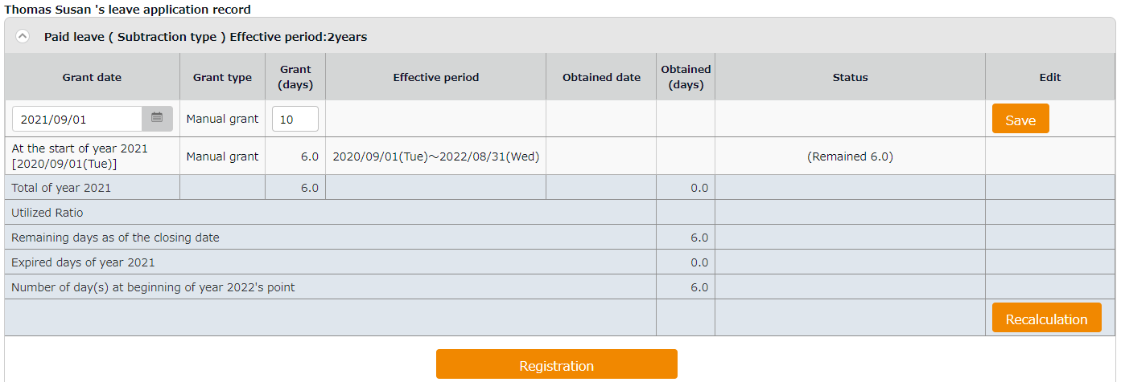
The total number of leaves taken/remaining are shown.

Item | Description
Total of (year) | Total leaves granted and taken during the year, regardless of expiration date.
Utilized Ratio | This shows the percentage of leaves (rounded off to the nearest whole number) taken during the specified period.  It does not count carry-overs from the previous year.
Number of days remaining as of the closing date | Shows the number of leaves remaining as of the closing date.
Expired days of (year) | Shows the number of leaves expiring this year. The [Status] column shows the total of remaining leaves that are labeled as [Expiring].
Number of day(s) at beginning of (next year)'s point | Shows the number of remaining leaves at the start of the next year.  These are carried over to the next year.

Grant leaves to multiple employees at once
- Go to the Leave management screen, then select a [Leave type] under [Specify display condition] to filter data.
Press the [List edit] button displayed.
- Enter a value in [Increase/decrease grant (days)] in the next screen.
To apply the value to all employees displayed in the screen, click [Copy].
- Click [Registration] to save the settings.

Check the number of leaves taken each month
To check how many leaves are taken every month, go to the Yearly data screen (p.122).

[Where to look] All menu > Attendance data > Yearly data

Grant leaves by auto-calculation

Before starting, please complete the Grant paid leave settings (p.58).

The [Attention required ] mark in the home page indicates there is an employee entitled to paid leaves, based on the grant policy. Click this item to view the list of employees who are eligible for paid leaves. You can also access from [All menu > Leave management > Employees entitled to Paid leave].)

Instructions
- Confirm the employee’s [Grant days] and [Grant date].
Grant days are automatically calculated. However, you can also edit the values manually.
- Select the [Grant] radio button on the right.
- Click [Grant paid vacation]. Click [Apply] in the next screen.

Change paid leave grant policies from here. These settings can also be performed in the Employee type settings screen and Employee settings screen.
Paid leave entitlement settings/Paid leave settings by employee

Shows the number of employees that are entitled to paid leave.
Number of employees eligible

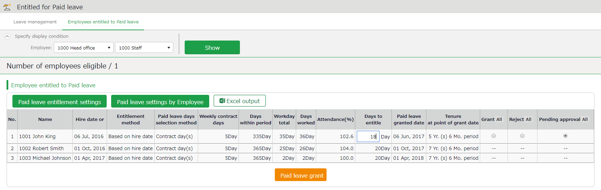

Shows the employees entitled to paid leaves, grant policy (condition), and the reference attendance record.
Please refer to the following pages for details on related items.

Descriptions
Here are descriptions of terms in the [Entitled for Paid leave] screen.

Hired date or Last granted | The employee’s hired date is displayed until leaves are granted for the first time. After them, the date last granted will be shown.  Instead of the past grant date, the grant date may also be based on Leave-related settings and Hired date.
Grant method | The paid leave grant method specified in Leave-related settings are shown.  This is either [Hired date] or [Grant date criterion].
Paid leaves grant selection method | The selection method for the number of leaves, specified in Leave-related settings are shown.  This is either [Contract days] or [Work days].
Weekly contract days | The following contents are shown, as specified in Paid leaves grant selection method.  - If set to [Contract days] - The specified number of workdays per week is shown.  - If set to [Workdays] - The number of workdays per week, that fulfills the minimum workdays required for paid leave entitlement is shown in parentheses (). Yellow indicates that the number of workdays per week is 0.
Days within period | Shows the number of days of period required for granting leaves.
Total working days | The number of days specified as [Total working days] (see Leave-related settings) during [Days within period].
Working days | The number of days specified as workday (at Leave-related settings) during [Days within period].
Attendance rate (%) | Number of days worked / Total working days = Attendance rate  Yellow indicates that the number of attended days is less than the minimum attendance required (80%).
Granted days | Shows the number of leaves to grant. Red indicates zero leaves.
Grant date | Shows the date of when the paid leaves were granted.
Tenure at point of grant date | Shows the number years the employee worked at the grant date’s point.

Export data
This section describes the data export feature.

The Export menu
You can export time record, auto-calculated attendance data and employee data from the Export/Import screen.

[Where to look] All menu > Others > Export / Import

Initially available data
Item name | Function | Format
Monthly data | Exports data that correspond to the specified period (3 months or less).  Used for integrations with payroll software. | CSV
Daily data | Exports data related to everyday work, such as attendance data and schedule. | CSV
Time Card | Export Time Card. | PDF
Employee data | Exports Employee data in Excel format. | CSV
Data by divisions and groups | Exports attendance data (calculated by Divisions and Employee types) that correspond to the specified period (3 months or less). | CSV
Supplemental Working Records | Exports Supplemental Working Record registered in Schedule. For details, please refer to p.92. | CSV
Admin data | Exports Admin permission data. | CSV
Annual Leave Data | Exports annual leave data (details such as when it was granted and taken). | EXCEL
Request Approval Flow Data | Exports all Request Approval Flow data in a single CSV file. | CSV
Attachments for Leave requests | Export request info and files attached to leave requests. | ZIP

Description
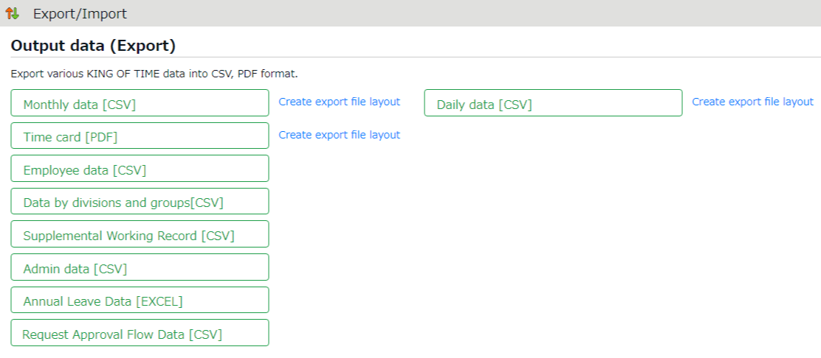

When exporting monthly, daily and time card data, you must first perform its layout setting.
You can use the basic layout for Time Card data export, but you can also create your own layout.
Create export layout

Export menu

Exports data

Create export file layout
The export file layout specifies the display order of data within the export file.

- Go to [All menu > Export / Import] and click [Create export file layout] next to Monthly data [CSV] (or Daily data [CSV], Time Card [PDF]).
Click [Create new] in the next screen.
- Enter the items required.

Layout name | Enter the layout name in 20 characters or less.
Data orientation | This defines the arrangement of the data. Data is generally arranged vertically.  * Only available in the Monthly data layout setting screen.
Export item name | This determines whether to include title row (e.g. Assigned hours, Overtime work, etc.) in the file.  To change the name of the items, enter the items in the [Custom item name] field, each separated by a comma (,).  * Available in Monthly data and Daily data export layout settings screen.
Quoted string | This determines whether to enclose every data with quotation marks (“).  * Available in Monthly data and Daily data export layout settings screen.
Time display format | You can select the time format from here. To configure settings for the third decimal place, go to [Home > Settings > Options] and change [The handling of the third decimal place for 10 decimal display].
Signed name | Enter the names required in the signature line.  * This field only shows in [Time card layout settings].

- Select items from the [Available items] list as needed, then click [Add ->].
The [Add blank] button adds a blank column to the [Items selected] list.
Preview is available in the bottom of the screen.

- Select items as needed and click [Registration].
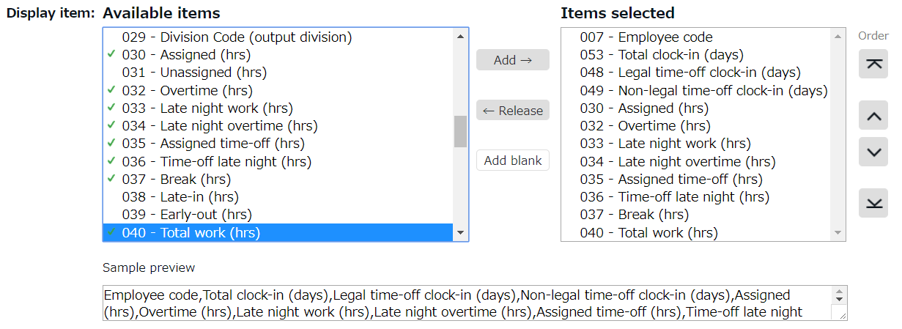
- To specify a default layout template, press the [Set to default] displayed on the list. The selected layout is specified as default when exporting the data.
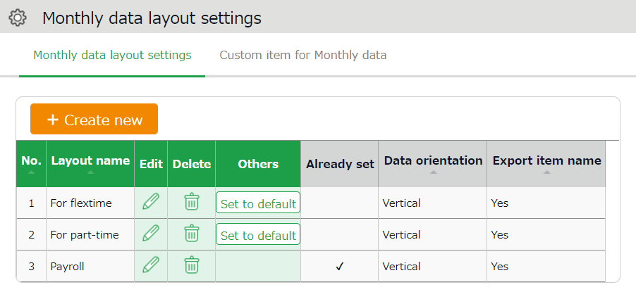

Create custom items
You can create original export items by combining existing attendance-related items (e.g. An item that adds up Overtime work and Late-night overtime work).

- Go to [All menu > Export / Import] and click [Create input layout] next to Monthly data [CSV], Daily data [CSV] or Time card [PDF].
Then, click [Custom item for Monthly data (Daily data custom item/Customize Time Card items)].
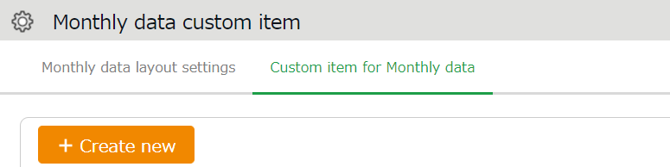

- Click [Create new] and enter the items required.

Basic info
Custom item name | Enter custom item name in 20 characters or less.
Calculation unit | Select either [Hrs.(Time)] or [Day].
Results | If you turn on the checkbox at [Don't export negative values], calculation results with negative numbers are displayed as 0.

To apply fixed value
Fixed value | Enter any value in 50 characters or less.
Apply to calculation value | This setting determines whether to add the fixed value to attendance related items (specified in the bottom half of the screen).  - [Don't use (Export fixed value)] - Fixed value is displayed/exported as specified.  [Use (Sum up fixed value and attendance data item)] - Fixed value is added up to the attendance related items checked below.  If you set it to [Use], please enter the Fixed value in minutes.  If the [Export as 0 if total of items selected is 0 min/0 days] check box is turned on, the calculation results exports as 0 when the sum of the selected items are 0.

- Select items.
Check the [+] column to add up items, then check the [-] column to subtract items. You cannot choose items in different units (time/days).
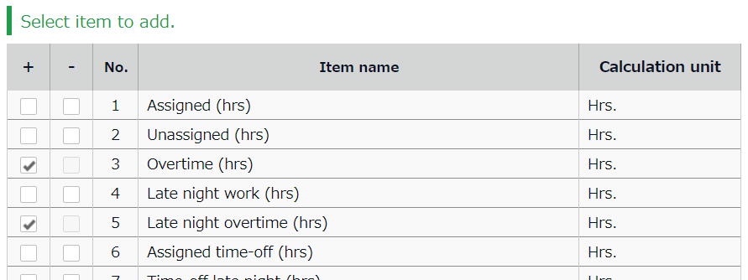

- Click [Registration] to save the settings.
- The new custom is added to the [Available items] list.
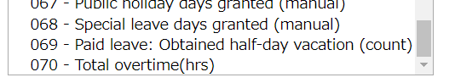

Export
This section describes the steps to export data.

- Go to the Export / Import screen and click [Monthly data CSV]
- Specify exporting conditions such as data period, export layout and division. Click [Data output].
- Displays the [Confirm data export] screen.
Confirm details and click [Data output] to download the data.
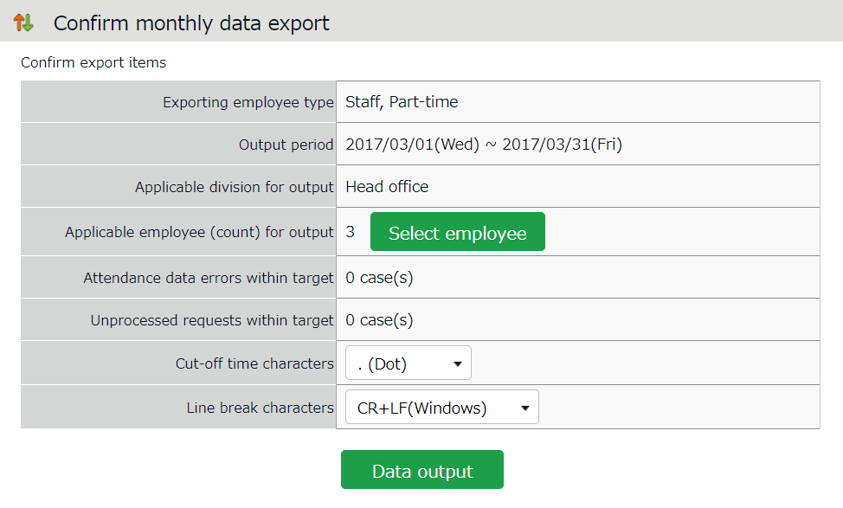

Applicable employee (count) for output | Shows the number of employees exporting. To export data of some of the employees, select employees from [Select employee].
Attendance data errors within target | Shows the number of attendance error data within the specified period. You can export data regardless of attendance data errors. However, some data might be incorrect. Please make sure to check the details of the errors in the Attendance data error screen.
Cut-off time characters | You can use either dot (.) or colon (:) in the time format.  * Not available in Time Card output.
Line break characters | Change the newline character if needed. Please choose a character compatible with your system, especially if you are using operating systems other than Windows. * Not available in Time Card output.

Time range of data
You can also export data by month.

Set the time range of exporting data
Go to the Export data screen and click [Set date] in [Output applicable date]. Specify the range of period (3 months or less).
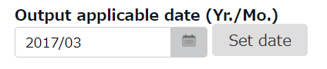

Export 5 Years’ Data
Up to 5 years of data (Daily data [CSV] and Time Card [PDF]) can be exported, if you are exporting 1 employee’s data at a time.

[Where to look] All menu > Others > Search employees

- Search an employee by name or employee code.
Click [ Ξ ] of the employee to open a drop-down menu. Click [Export data by day] or [Time Card output] in the menu.
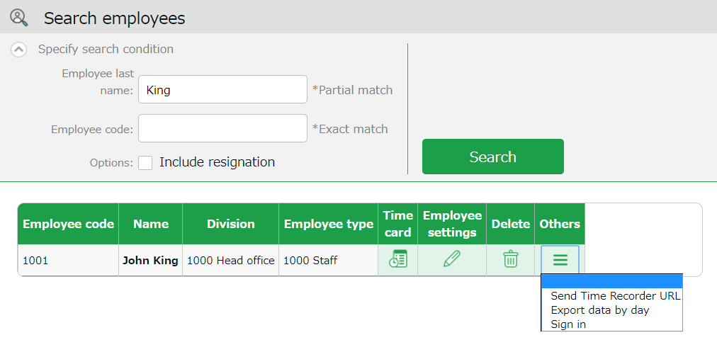

- Go to the Export data screen and click [Set date] in [Output applicable date]. You can set data period to a maximum of 5 years. For Time Card export: If you check [Calculate by closing date] under [Export options], monthly data will be organized in different pages.

Table of Attendance Data Items
The definition of attendance items in this system are described below.

Time calculation
Working time is defined by [Workday type], [Employee type] and [Time record].
Even if an employee clocks in/out several times throughout the day, working time calculates as 1 day’s work.

Attendance items | Detail | Workday type
Fixed hours | This is the work hours between clock-in and clock-out. The calculation is based on the calculation method specified in Schedule (clock in and out schedule) and Employee type settings. | Weekday
Unassigned work  (Unassigned work time) | Work time after scheduled Clock-in/out hours is regarded as [Unassigned work time]. However, working time past Overtime work start time is classified as [Overtime work]. Working time that takes place during Late night overtime work hours are classified as [Late night overtime work]. They are both calculated separately from [Unassigned work]. | Weekday
Overtime work | Overtime work is calculated according to the rule set in [Employee type > Overtime start time]. This is usually set to [8 Hrs. excess work will be counted as overtime]. This means working for more than 8 hours is regarded as overtime work. (Weekly and monthly overtime calculations are available by applying the Flextime work feature.) | Weekday
Assigned Late-night hours | Calculated according to the rule set in [Employee type > Late night work (hrs) slot]. This is usually set to 22:00 - 5:00 (following day). | Weekday
Unassigned Late-night hours | Work time after Late-night hours schedule is regarded as [Unassigned Late-night hours]. Work time past Overtime start time is counted as [Late night overtime hours]. | Weekday
Late night overtime hours | Sums up working hours that satisfies both [Overtime] and [Night work] conditions. [Overtime work] and [Late night work] are calculated separately and do not overlap. | Weekday
Assigned time-off hours  Assigned Late-night hours | Working hours during [Legal time off] or [Non-legal time off] workday types are regarded as [Assigned time-off hours]. This sums up working hours under Legal holidays and Non-legal holidays. The definition of “late night” is described above. | Legal time off  +  Non-legal time off
Unassigned time-off hours  Unassigned Late-night hours | Working hours during [Legal time off] or [Non-legal time off] workday types are regarded as [Unassigned time-off hours]. This sums up working hours during [Legal time off] and [Non-legal time off] days. The definition of “late night” is described above. | Legal time off  +  Non-legal time off
Assigned legal time-off hours/  Assigned Late-night hours on Legal holiday | Working hours during the [Legal time off] workday type is classified under this category. The definition of “late night” is described above. Available in Data export. | Legal time off
Unassigned legal time-off hours/  Unassigned Late-night hours on Legal holiday/ | Unassigned working hours under [Legal time off] is classified under this category. The definition of “late night” is described above. Available in Data export. | Legal time off
Unassigned legal time-off hours/  Assigned Late-night hours on Non-legal holiday/ | Working hours during [Non-legal time off] workday type is classified under this category. The definition of “late night” is described above. Available in Data export. | Non-legal time off
Unassigned non-legal time-off / Unassigned Late-night hours on Non-legal holiday | Unassigned working hours under [Non-legal time off] workday type is classified under this category. The definition of “late night” is described above. Available in Data export. | Non-legal time off
Late-in | Early leaves. Compares clock-in schedule with actual time record. | -
Early leave | Early leaves. Compares clock-out schedule with actual time record. | -
Total work hours | Shows the total working hours. | -
Break time | Calculates break time from time records or employee types and schedules. Break time is subtracted from working hours. | -

Day calculation
A working day is counted as 1 day, regardless of how many hours the employee worked.
Even if an employee clocks in/out several times throughout the day, they count as working time if they are recorded on the same day.

Calculated items | Detail | Workday type
Weekday clock-in days | Number of days worked on weekdays (i.e. Workday type set to [Weekday]). | Weekday
Time-off clock-in days | Number of days working on legal and non-legal holidays. Number of working days under [Legal time off] and [Non-legal time off] workday types. | Legal time off  +  Non-legal time off
Legal time-off clock-in days | Number of days attended on the [Legal time off] workday type. | Legal time off
Non-legal time-off clock-in days | Number of days working on the [Non-legal time off] workday type. | Non-legal time off
Total clock-in days | Total days worked. | -

Unauthorized copying and replication of the contents of this guide, text and images are strictly prohibited.
The contents of this guide are subject to change without prior notice, for revision and further improvement.

Copyright © 2022 Human Technologies, Inc.

Last Updated – July 10, 2022

